Homework 3
Kevin Lopez Sepulveda
Problem 1: Consider a unit square S with vertices A = (0, 0), B = (0, 1), C = (1, 1) and D = (1, 0). For each question below write the corresponding matrix and show the result of applying this matrix to the original square S by writing oout the new vertices A′ , B′, C′ and D′. Use the subplots in Python/R
- M₁ - expand x by a factor of 1.5
- M₂ - contract y by a factor of 0.75
- M₃ - shear along x by a factor of 2
- M₄ - shear along y by a factor of 1.25
- M₅ - counterclockwise rotation by π/4
- M₆ - clockwise rotation by π/6
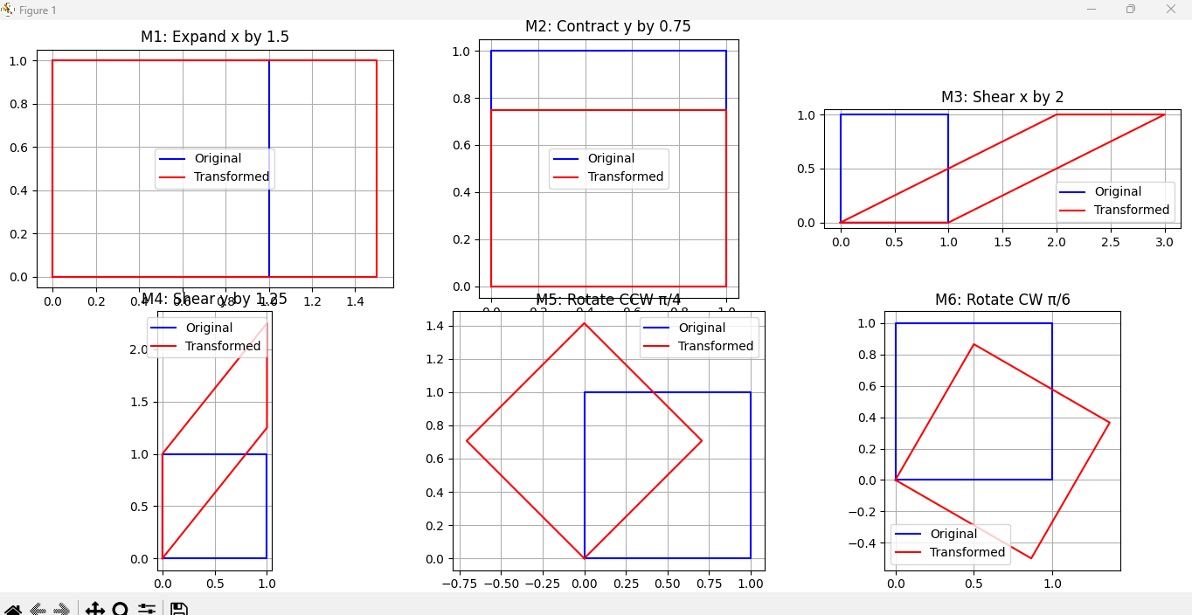
Problem 2: Recall that the inverse M⁻¹ for a 2 × 2 matrix
M can be computed as follows:
M = a b 1→ M−1 = 1 d −b
c d
(ad − bc)
−c a

For each matrix M₁, . . . , M₆ above compute the corresponding inverses M₁⁻¹, . . . , M₆⁻¹ (both by hand and by Python/R).

Problem 3: Consider the same unit square S with vertices
A = (0, 0), B = (0, 1), C = (1, 1) and D = (1, 0). Compute
(by hand and by Python/R) the new vertices A′ , B′, C′ and D′ and plot the quadrilateral A′B′C′D′ (4-sided polygon) after applying the following transformations (from left to right) to S
- (M₁²)(M₃³)M₅
- (M₂⁻¹)(M₄⁻²)M₆
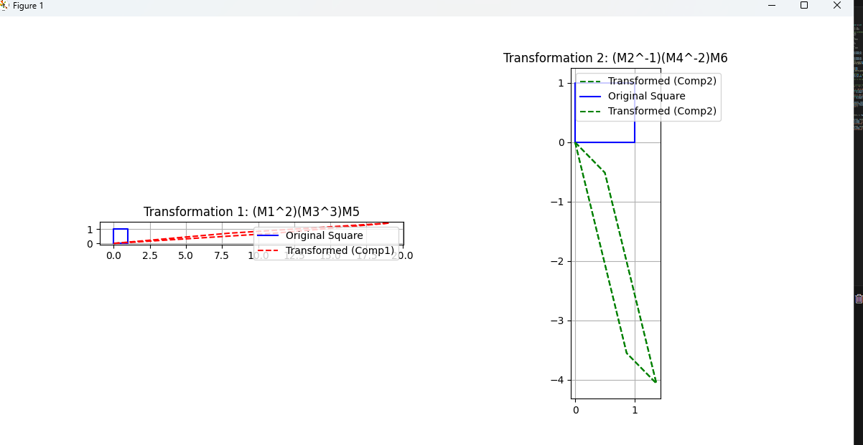
Problem 4: Invert the following matrices using the Gauss- Jordan method
 

A = 1 2

3 4

, B =
2 1 0
5 9 , C = 3 6 1

 
2 5 5 7 1

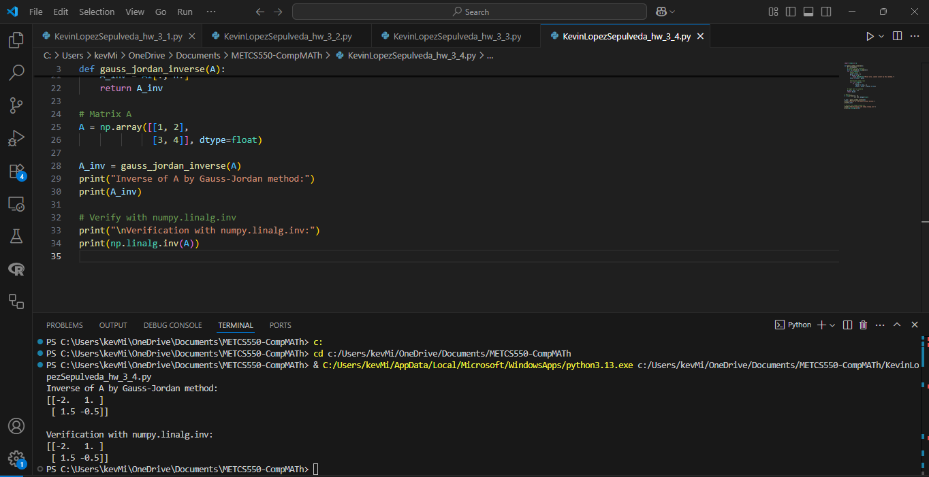
Problem 5: Consider the following expansion for the loga- rithmic function:

log x = (x − 1) −
1(x − 1)² +
2
1(x − 1)³
3
− · · ·

We can define logarithm of any square matrix M as follows:

log(M) = (M − I) −
(M − I)² 2
(M − I)³
+
3
− · · ·

Consider the matrices
A = 1 2 , B = 5 9
3 4
2 5

Compute the following logarithms of matrices (take the first 3 terms only in the expansion for log(M)):
- log(A)
- log(A⁻¹)
- log(B)
- log(B⁻¹)
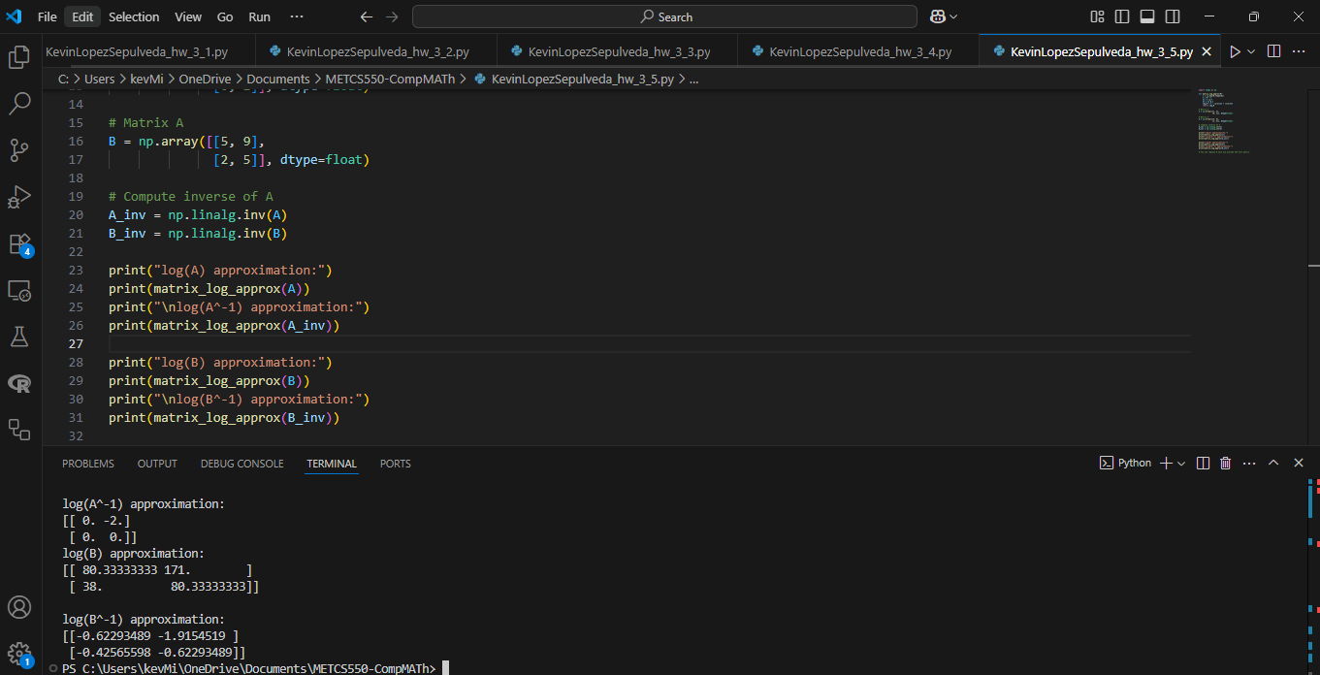
Problem 6: Solve the following systems of equations by Gaussian elimination and by Python/R
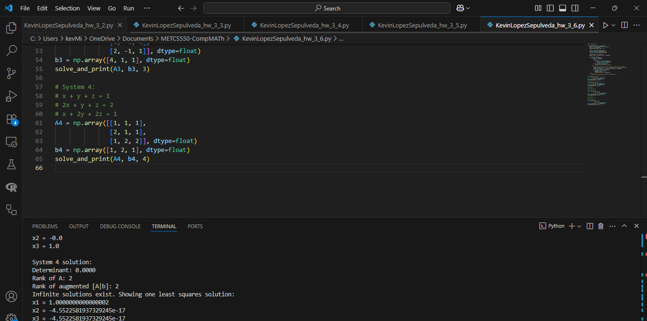

1.

2x + 3y = 8
2x − y = 0
2.

x + 2y = −2
2x + y = 2
3.

2x + 3y + 4z = 4
x − y + z = 1
 2x − y + z = 1

4.

x + y + z = 1

2x + y + z = 2
x + 2y + 2z = 1

