Kevin Lopez Sepulveda

Euler’s Conjecture On Sums of Like Powers
In 1769 Leonhard Euler considered the following to be true: For all integers n, k > 1, if the sum of n k − th powers of
positive integers is itself a k-th power than n ≥ k
a^{k} + a^{k} + · · · + a^{k} = b^{k} → n ≥ k
1 2 n
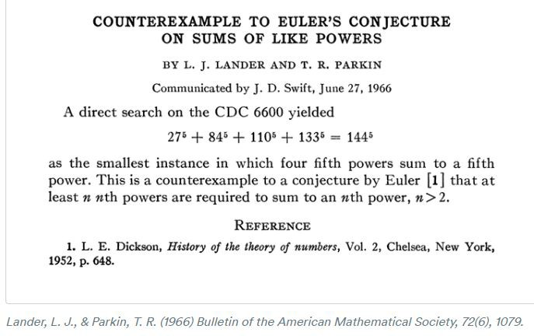
This was disproved using a computer in 1966:

Problem 1
- Write a Python (no Numpy) program to compute the solu- tion. Consider the following intervals for your computation:
20 ≤ a₁ ≤ 40
80 ≤ a₂ ≤ 100
100 ≤ a₃ ≤ 120
120 ≤ a₄ ≤ 140
140 ≤ b ≤ 160

- Compute the execution time (using timeit
https://docs.python.org/3/library/timeit.html
Check python File
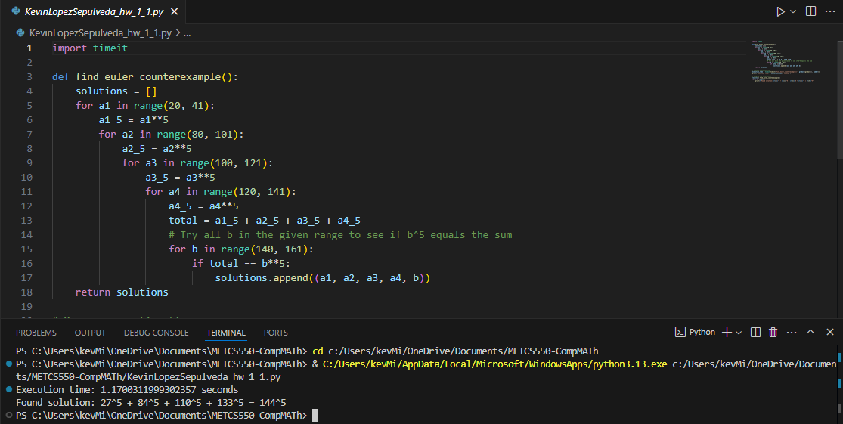
The solution is a1=27, a2=84, a3=110, a4=133, and b=144.
Problem 2. A palindromic number reads the same both ways. For example, 9009 is a palindromic number. In fact, 9009 = 91 × 99. This is the largest palindromic number, a product of two 2-digit numbers. Find the largest palindrome made from the product of 2-digit and 3-digit numbers.
Check python File
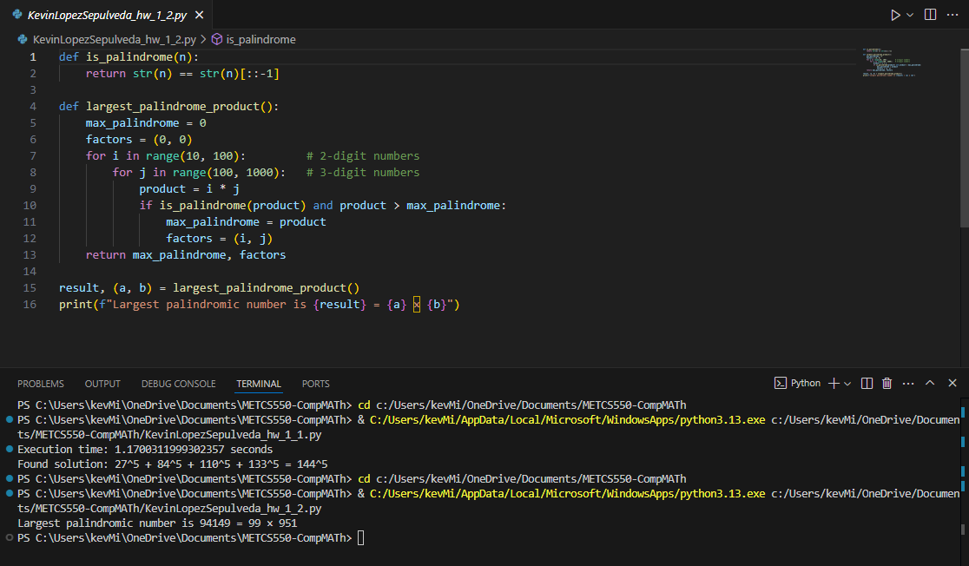
The largest palindrome made from the product of 2-digit and 3-digit numbers is 99 × 951=94149
Problem 3. Consider the calendar. September, April, June, and November have 30 days. All other months except February have 31 days. February has 28 days in most years and 29 in leap years. Recall that a leap year occurs on any year evenly divisible by 4 but not on a century unless it is divisible by
400. The first of January in 1900 was a Monday. How many
Mondays fell on the second day of the month during the 20-th century (from 1/1/1901 to 12/31/2000)?
Check python file
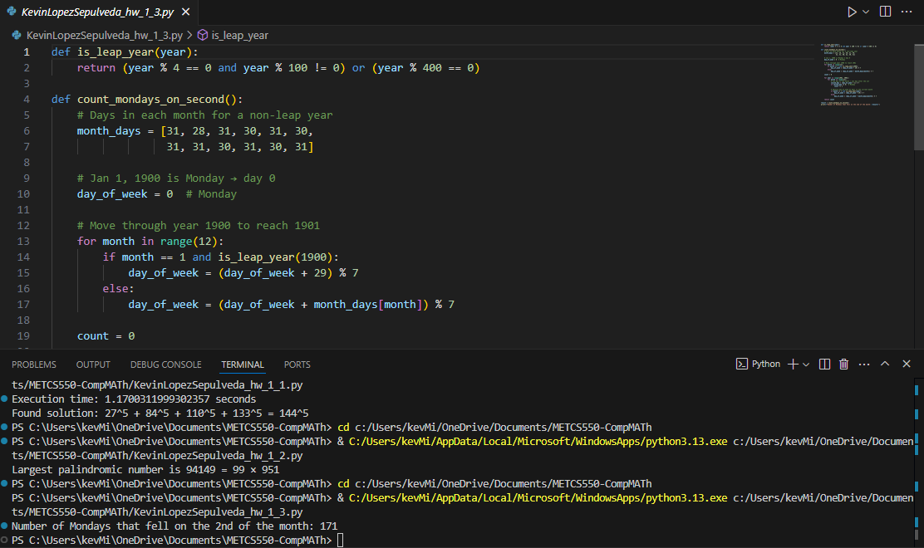
The Number of Mondays that fell on the 2nd of the month is 171.
Problem 4. An 18-th century mathematician, Christian Goldbach, proposed the following conjecture: every odd com- posite number can be written as the sum of a prime and twice a square.
9 = 7 + 2 × 1²
15 = 7 + 2 × 2²
21 = 3 + 2 × 3²
25 = 7 + 2 × 3²
27 = 19 + 2 × 2²
33 = 31 + 2 × 1²
Find is the smallest odd composite that cannot be written as the sum of a prime and twice a square.
Check Python File
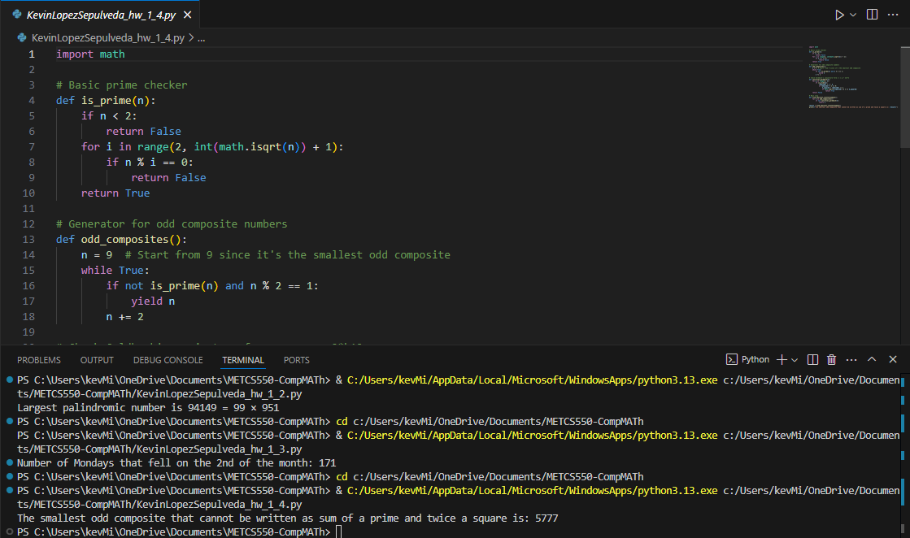
The smallest odd composite that cannot be written as sum of a prime and twice a square is 5777
Problem 5. A Pythagorean triplet is a set of three natural numbers, a < b < c, for which a² + b² = c² For example, 3² + 4² = 5² and therefore (3, 4, 5) is a Pythogorean triplet. Exactly one Pythagorean triplet exists for which a + b + c = 1000. Find the product abc for such a triplet.
Check Python file
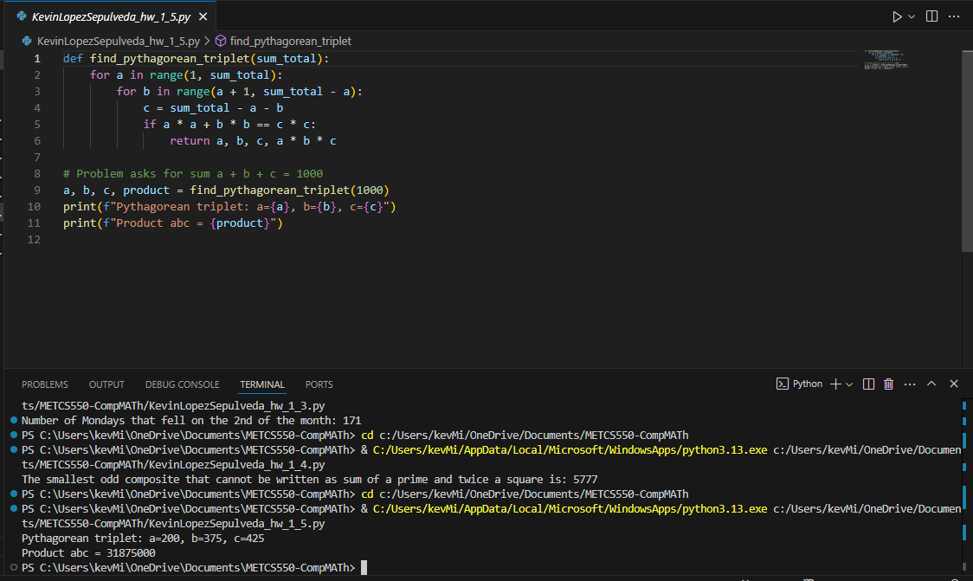
The Pythagorean triplet: a=200, b=375, c=425
Product abc = 31875000

