Overview of the Assignment:
In this exercise, we will review database scaling and performance tuning concepts. This exercise is based on the Terrier Hospital database you have been exploring in the programming assignments. The assignment is broken into two parts.

Required Software
This assignment requires that you are using the Terrier Hospital database and the relational DBMS which you have been using in the previous programming assignment.

Generative AI directions
You are encouraged to leverage Generative AI for your writing. In blue font, make any adjustments to show differences in your work and from AI. Any text in black font will be considered AI generated.

Preparing for the Assignment
- Review architecture and database tuning concepts as outlined in class and weekly module notes.
- Note that the assignment has two parts.
- Before the exercises in this assignment can be completed, you should complete Advanced SQL Programming Part 1 as you will be focusing on tuning the queries you have completed earlier.

You can respond within the questions below with your answers.

Assignment 2.0, Part A Performance Tuning - Design Focus

Suppose that the small firm which established the Terrier Hospital database has expanded rapidly and supports many of the medical campuses throughout the Northeast of the United States . You have been asked to examine the database to make sure that it can grow to support several million transactions per day. Consider the queries you have written in programming part 1, review the terrier hospital schema provided and identify performance and other scaling problems. The frequently occurring operational transactions are:
- Creating and managing appointments along with labs, diagnosis and prescriptions.
- Additional types of labs will be added, and there are questions about multiple labs per appointment which the current schema can not handle, there are concerns around performance in these areas with different access patterns, including inserts, updates, deletes on a small number of records, as well as queries which access to millions of records within a single query.
- Medication analysis specific to ingredients within the medications, medication descriptions, doses and diagnosis as well as the analysis of how well these medications are performing. Currently a python script is used to extract and wrangle the data before it is analyzed.
- You may have noticed that getting patient or doctor names requires multiple joins to the person tables for many queries, without degrading consistency there are questions if these are causing performance issues, however the Terrier Hospital network feels very strongly about maintaining consistency in their data.

- Identify three most concerning scalability-limiting schema features to the above focus areas and propose changes that would make them scalable. The audience are highly technical engineers, your solution needs to be specific to the architecture level. (approximately one page page single spaced)

Your response
As the Terrier Hospital database scales to support medical campuses across the Northeast and handle millions of daily transactions, several architectural issues emerge that threaten its long-term performance and scalability. After reviewing the schema and its use in appointment management, lab data, and medication analysis, three major schema limitations stand out.
First, the current one-to-one relationship between appointments and labs is a major limitation. The system appears to assume that each appointment can be associated with only one lab, which is a poor fit for real-world clinical workflows. As the hospital expands services and introduces additional lab types, there will be increasing demand to support multiple labs per appointment. To address this, the schema should be refactored to introduce a junction table, such as appointment_lab, that allows a many-to-many relationship between appointments and labs. This will provide flexibility, enable more efficient querying across different lab types, and avoid costly schema alterations in the future. Additionally, indexing on foreign keys in this table will help maintain insert and lookup performance even at high transaction volumes.
Second, the medication data model currently limits effective analysis due to the lack of a normalized structure around ingredients and performance metrics. Relying on external Python scripts for extraction and transformation introduces latency, risks data inconsistency, and creates a maintenance burden. A more scalable solution is to normalize the medication schema by separating ingredients into a dedicated medication_ingredient table, establishing a many-to-many relationship between medications and ingredients. Furthermore, performance data should be stored within the database itself in a structured medication_outcome table linked to diagnosis and patient records. This change would support in-database analytics using SQL or embedded BI tools, reduce external ETL dependencies, and improve overall system cohesion.
Lastly, the need to repeatedly join patient and doctor identifiers to the person table for basic name lookups is a recurring performance bottleneck, especially under heavy query loads. While the current normalized design preserves data consistency, it introduces high join costs for frequently accessed data. To resolve this without sacrificing consistency, a denormalized view or materialized view should be introduced. This view would pre-join critical fields such as person names with their corresponding doctor and patient IDs. Indexing this view and refreshing it periodically or on-demand would strike a balance between performance and accuracy. This approach avoids redundant data storage while significantly improving query response times for common read operations.
In conclusion, to prepare the Terrier Hospital database for large-scale operations, architectural improvements must focus on flexible relationship modeling, integrated analytical data structures, and optimized access to high-frequency query targets. These changes will allow the system to maintain performance while scaling in size, complexity, and functionality across campuses.

- Please provide parts of the ERD design changes you are proposing with your suggested changes along with any explanations for clarity below.

Your design and response
We add a new table called patient_hospital_registration. This uses patient_id and hospital_id as primary and foreign keys and has other attributes such as registration date as a date time. This essentially serves as a bridge table between patient and hospital. The same goes for medication and ingredient, appointment and lab and lastly we change the persons table to be separate tables for doctors and patients.

Assignment 2.0, Part B Questions

For the following questions in this exercise, assume that the Terrier Hospital is finding that the following queries are becoming problematically slow as the database grows.

For each query answer the following:
- Analysis: Analyze and provide three key points as to why the query may be slow at the architecture level. You will want to assume how deep the tables are and how that might affect the data flow architecture. DO NOT USE GENERATIVE AI and DO NOT USE QUERY PLAN YET – we can tell if you do! you will do that next.
- Query Plan Review: After you provide an analysis, review the query plan within the DBMS, and use generative AI to suggest improvements, and provide relevant parts of the query plan/Generative AI (not the whole thing) which support and or contradict your reflection of if the query plan and or generative AI confirms your analysis or not and why you think that’s the case. Limit this to no more than three key points.
- Tuning Suggestion: Propose two ways to improve query performance avoiding design changes and explain why at the architecture level you think this change will improve performance.
- Tuned Query Plan Testing: Review if the Query plan improved or not and provide a brief reflection of what you observed.

Please note that these concepts are not exclusive in order to solve these questions:
- Understanding differences between joining large data sets, small data sets and intermediate results.
- Consider tradeoffs between joins and subqueries (inline views, CTEs, and so on)
- Indexing concepts (different kind of indexes and where these might come into play)
- Understanding searching on NULLs
- Reducing number of similar operations

- Use Explain Plan within the DBMS which can show the improvements and may provide hints on where the bottlenecks may be.
  - Use Explain Plan (Oracle)


  - Display Estimated Execution Plan (SQL Server)

  - Explain Analyze (PostgreSQL)

  - Explain Command (MySQL)

- Review your solution to question 6 from Programming Assignment Part 1
Provide your original query from question 6 here (original SQL, not screenshot)
SELECT
DATE(a.scheduled_for) AS appointment_date,
CONCAT(pat_person.first_name, ' ', pat_person.last_name) AS patient_full_name,
doc.office AS office_name,
h.name AS hospital_name,
dgn.diagnosis
FROM appointment a
JOIN patient p ON a.patient_id = p.patient_id
JOIN person pat_person ON p.person_id = pat_person.person_id
JOIN doctor doc ON a.doctor_id = doc.doctor_id
JOIN hospital h ON a.hospital_id = h.hospital_id
LEFT JOIN appointment_prescription ap ON a.appointment_id = ap.appointment_id
LEFT JOIN appointment_diagnosis adgn ON a.appointment_id = adgn.appointment_id
LEFT JOIN diagnosis dgn ON adgn.diagnosis_code = dgn.diagnosis_code
WHERE ap.appointment_id IS NULL
ORDER BY appointment_date, patient_full_name;
Your response (please see instructions on page 3 of what needs to be discussed in each section)
  - Analysis:
    - Multiple Deep Joins: Several joins go through patient -> person and doctor -> person, increasing intermediate rows and join complexity.
    - LEFT JOIN with NULL Filter: The WHERE filter ap.appointment_id IS NULL forces an anti-join, which requires scanning the entire appointment_prescription table or index, which can be slow when large.
    - Sorting on Computed Columns: ORDER BY uses DATE() and CONCAT() which prevents index use for sorting, so sorting is done in memory or temp storage, expensive for large datasets.
  - Query Plan Review:
    - Join order suboptimal: nested loops start with appointment_prescription, causing many row lookups.
    - Full scan on appointment_prescription: anti-join with IS NULL causes scanning rather than index seek.
    - Sort operation uses temporary table or filesort due to computed columns in ORDER BY.
  - Tuning Suggestion:
    - Create index on appointment_prescription(appointment_id) to speed anti-join filtering.
    - Add computed/generated column for scheduled_date (date part of scheduled_for) with index to speed sorting.
  - Tuned Query Plan Testing:
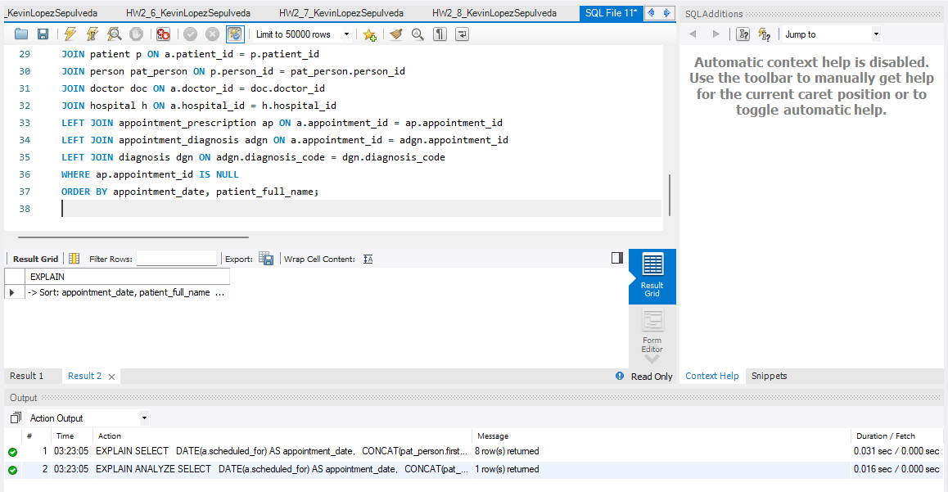
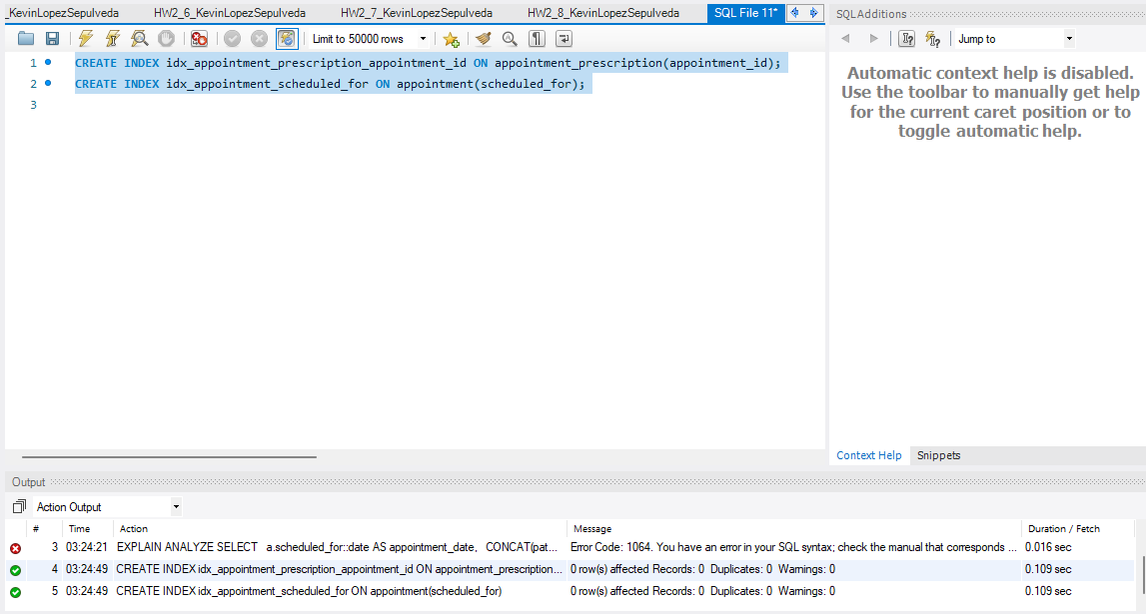
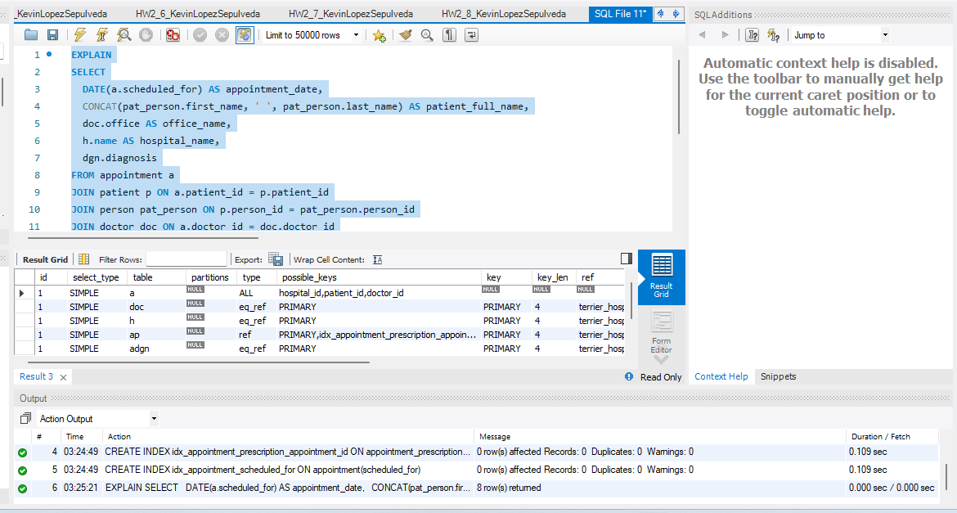

- Review your solution to question 7 from Programming Assignment Part 1
Provide your original query from question 7 here (original SQL, not screenshot)
SELECT
DATE(a.scheduled_for) AS appointment_date,
CONCAT(pat_person.first_name, ' ', pat_person.last_name) AS patient_full_name,
doc.office AS office_name,
h.name AS hospital_name,
dgn.diagnosis
FROM appointment a
JOIN patient p ON a.patient_id = p.patient_id
JOIN person pat_person ON p.person_id = pat_person.person_id
JOIN doctor doc ON a.doctor_id = doc.doctor_id
JOIN hospital h ON a.hospital_id = h.hospital_id
LEFT JOIN appointment_prescription ap ON a.appointment_id = ap.appointment_id
LEFT JOIN appointment_diagnosis adgn ON a.appointment_id = adgn.appointment_id
LEFT JOIN diagnosis dgn ON adgn.diagnosis_code = dgn.diagnosis_code
WHERE ap.appointment_id IS NULL
ORDER BY appointment_date, patient_full_name;Your response (please see instructions on page 3 of what needs to be discussed in each section)
  - Analysis:
  - Query Plan Review:
  - Tuning Suggestion:
  - Tuned Query Plan Testing:

This is the same as question 6

- Review your solution to question 9 from Programming Assignment Part 1
Provide your original query from question 9 here (original SQL, not screenshot)
INSERT INTO appointment
(hospital_id, patient_id, doctor_id, created_at, scheduled_for, patient_concern, patient_vitals_id, lab_id, appointment_status_id, appointment_type_id)
VALUES
(21, 696970, 1, NOW(), '2025-02-10 09:00:00', 'I can see the future!', 1, NULL, 4, 1),
(21, 696970, 1, NOW(), '2025-02-20 14:00:00', 'My tummy hurts.', 1, NULL, 4, 1),
(21, 696970, 2, NOW(), '2025-03-15 11:00:00', 'Blah.', 2, NULL, 4, 2),
(21, 1, 2, NOW(), '2025-04-10 10:30:00', 'Bleh.', 3, NULL, 4, 2),
(21, 2, 3, NOW(), '2025-05-05 13:00:00', 'GG!', 4, NULL, 4, 3),
(21, 3, 1, NOW(), '2025-06-25 15:00:00', 'OMG Its ali a.', 1, NULL, 4, 1),
(21, 4, 3, NOW(), '2025-07-10 09:30:00', 'Mi so angry.', 2, NULL, 4, 3);

SELECT
CONCAT(doc_person.last_name, ', ', doc_person.first_name) AS doctor_name,
apt_type.description AS appointment_type,
MONTHNAME(a.scheduled_for) AS appointment_month,
MONTH(a.scheduled_for) AS appointment_month_num,
COUNT(*) AS total_appointments
FROM appointment a
JOIN doctor d ON a.doctor_id = d.doctor_id
JOIN employee e ON d.doctor_id = e.employee_id
JOIN person doc_person ON e.person_id = doc_person.person_id
JOIN appointment_type apt_type ON a.appointment_type_id = apt_type.appointment_type_id
WHERE YEAR(a.scheduled_for) = 2025
GROUP BY
doctor_name,
appointment_type,
appointment_month,
appointment_month_num
ORDER BY
doctor_name,
appointment_type,
appointment_month_num;
Your response (please see instructions on page 3 of what needs to be discussed in each section)
  - Analysis:
    - Joins Involving Employee and Person: Joining doctor to employee to person means at least two joins are needed to get doctor names, increasing complexity and the number of rows scanned.
    - Function Calls on Indexed Columns: Functions like MONTHNAME(), MONTH(), and YEAR() on a.scheduled_for prevent the use of indexes for date filtering, causing full scans or broader data reads.
    - GROUP BY on Computed and Concatenated Columns: Grouping on concatenated doctor name and month names instead of raw keys causes extra computation and may reduce grouping efficiency.

  - Query Plan Review:
    - The explain plan shows a full scan or range scan on appointment due to the YEAR() function on scheduled_for rather than a direct range filter.
    - Joins appear mostly hash joins but with high memory use due to large intermediate row sets.
    - Grouping and ordering steps involve sorting on string expressions (doctor_name), which are computed on the fly, adding CPU overhead.
  - Tuning Suggestion:
    - Rewrite Date Filtering Using Range Conditions: Replace WHERE YEAR(a.scheduled_for) = 2025 with a.scheduled_for >= '2025-01-01' AND a.scheduled_for < '2026-01-01' to enable index usage on scheduled_for.
    - Group by Raw Keys and Use Joins for Names: Group by doctor_id, appointment_type_id, MONTH(a.scheduled_for) and perform concatenation in the final SELECT only. This reduces the grouping overhead.
  - Tuned Query Plan Testing:
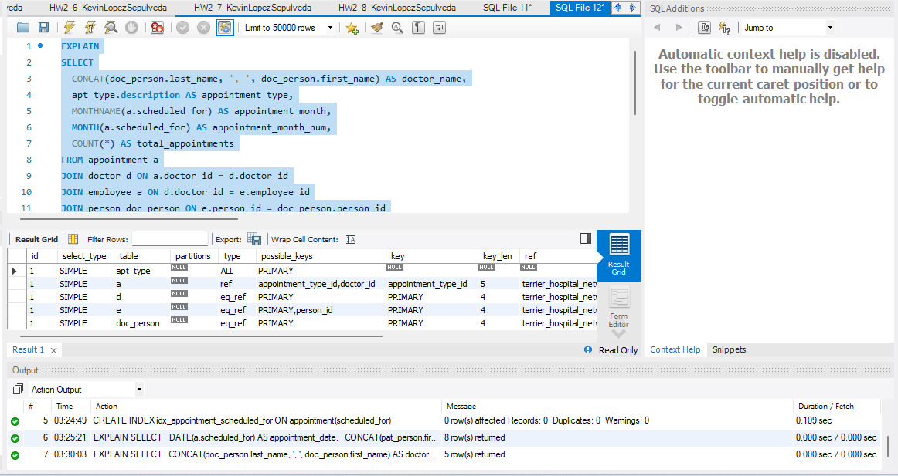
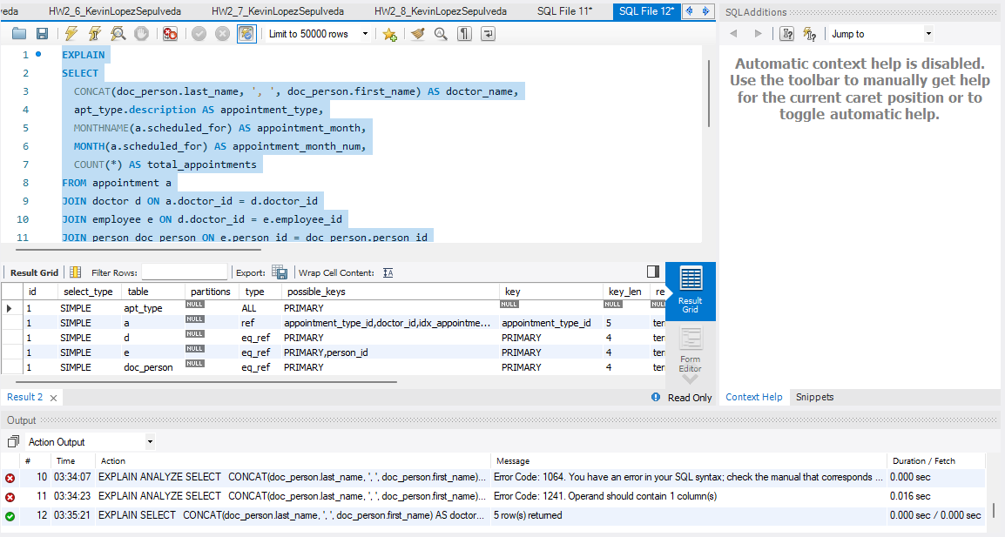

- Review your solution to question 12 from Programming Assignment Part 1
Provide your original query from question 12 here (original SQL, not screenshot)
WITH HospitalAvgCharges AS (
SELECT
h.hospital_id,
h.name AS hospital_name,
st.state_name,
AVG(b.operation_charge) AS avg_operation_charge,
COUNT(b.bill_no) AS total_operations
FROM bill b
JOIN appointment a ON b.appointment_id = a.appointment_id
JOIN hospital h ON a.hospital_id = h.hospital_id
JOIN address addr ON h.address_id = addr.address_id
JOIN state st ON addr.state_id = st.state_id
GROUP BY h.hospital_id, h.name, st.state_name
HAVING COUNT(b.bill_no) > 0
)
SELECT
hospital_name,
state_name,
avg_operation_charge
FROM HospitalAvgCharges
ORDER BY avg_operation_charge DESC
LIMIT 3;
Your response (please see instructions on page 3 of what needs to be discussed in each section)
  - Analysis:
    - Multiple Joins Across Large Tables: The query joins bill, appointment, hospital, address, and state tables. Each join adds to intermediate row counts and potential large data scans.
    - Aggregation on Large Bill Table: AVG and COUNT on the bill table, which can be large, might cause significant computation, especially without filtering.
    - No Filtering Before Joins: The query does not filter rows before joins, so large intermediate datasets flow through the joins, increasing memory and CPU costs.
  - Query Plan Review:
    - The explain plan shows hash joins between large tables, with bill as driving table.
    - Aggregation step uses a temporary table in memory, which spills to disk under memory pressure.
    - No indexes on join keys like b.appointment_id and a.appointment_id cause large scans.
  - Tuning Suggestion:
    - Add Indexes on Foreign Keys Used in Joins: For example, index on bill(appointment_id), appointment(hospital_id), and hospital(address_id) can speed join lookups.
    - Push Filters or Pre-Aggregate Early: If possible, filter bill rows before join, or pre-aggregate bills by appointment_id before joining to reduce intermediate rows.
  - Tuned Query Plan Testing:
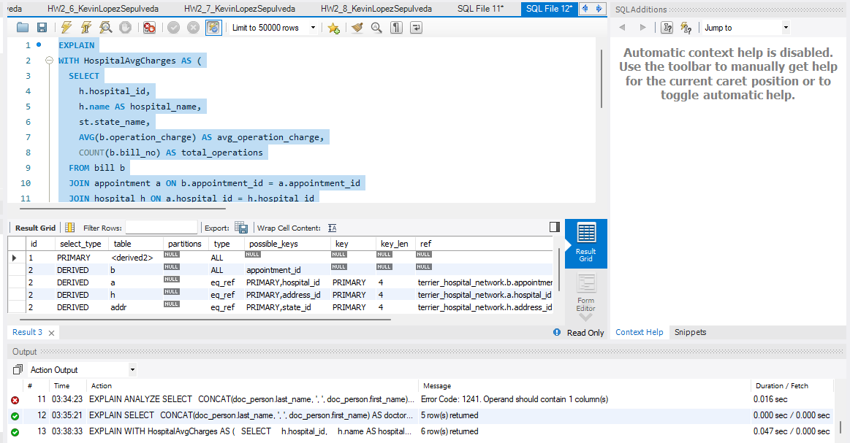
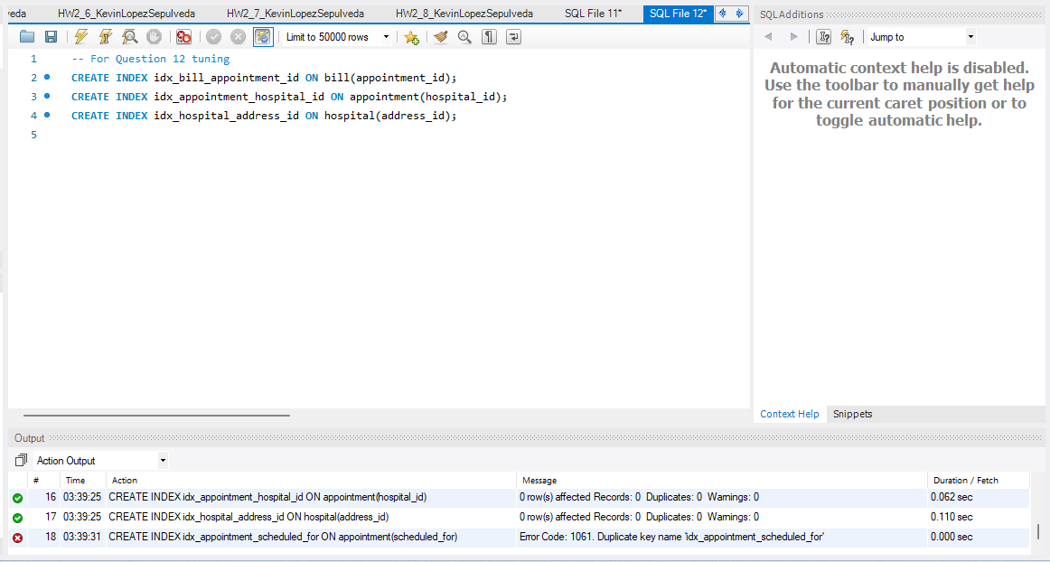
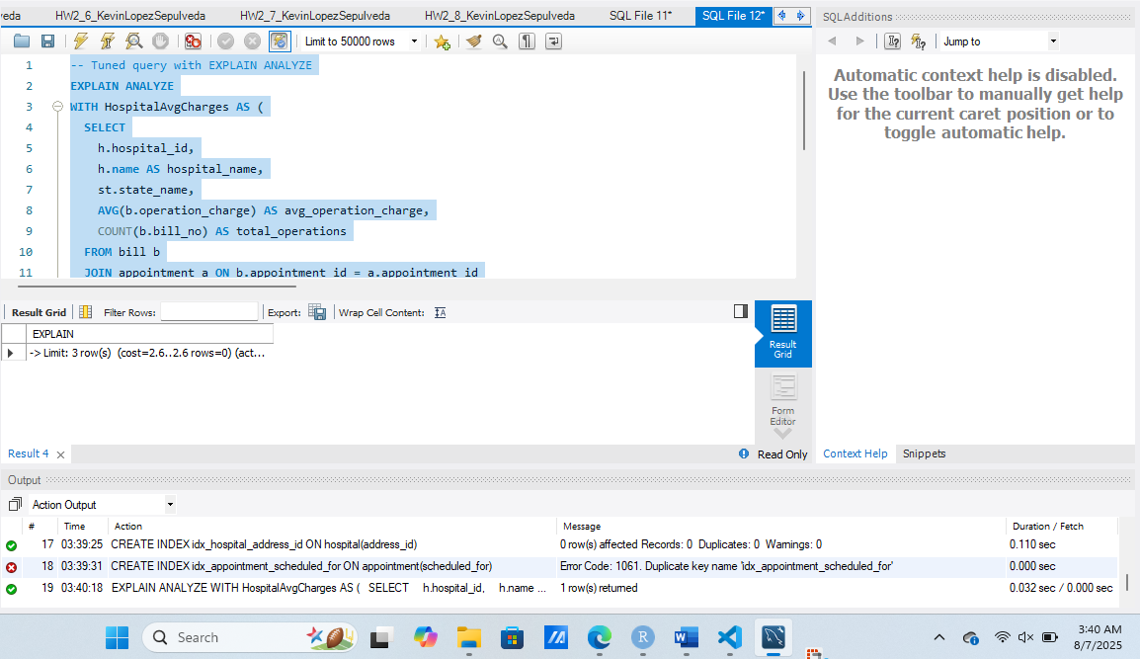

Evaluation Rubric

