Then answer the following questions:
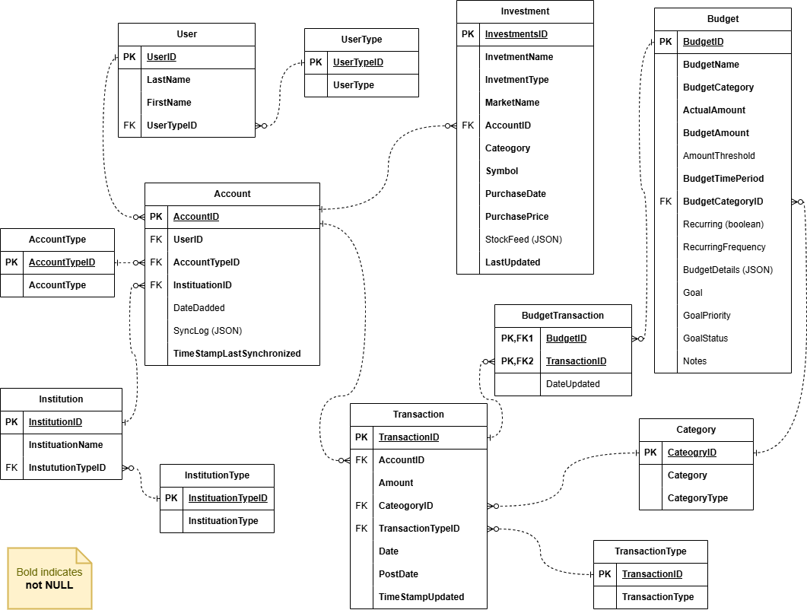
Budget Table
- BudgetName: Name or title of the budget.
- BudgetCategory: Category to which the budget is assigned.
- ActualAmount: Actual amount spent within the budget.
- BudgetAmount: Planned or allocated budget amount.
- AmountThreshold: Threshold amount triggering alerts or notifications.
- BudgetTimePeriod: Time period for the budget (e.g., monthly, weekly).
- BudgetCategoryID: Foreign key referencing the budget category.
- Recurring (boolean): Indicates whether the budget is recurring (true/false).
- RecurringFrequency: Frequency of recurrence for the budget (e.g., monthly, weekly).
- Budget Details: flexible JSON column containing specifics around each budget. See examples below.
- Goal: Associated financial goal or target.
- GoalPriority: Priority level of the financial goal (e.g., High, Medium, Low).
- GoalStatus: Status of the financial goal (e.g., Not Started, In Progress, Completed, Failed).
- Notes: Additional notes or comments related to the budget.

Review the table and evaluate it for BCNF.
- In one sentence outline what is the key purpose of evaluating if Budget table is in 3NF or not – be specific to the scenario.
- Be as specific as possible to demonstrate how Budget table meets or does not meet the goal of 3NF. Make sure to consider the JSON field as part of your solution. Use and adjust the sample table in the Answer Template for sample data. Note to focus on the attributes which you have most concern about. Provide one key specifc reason this table is also in BCNF or not. Your response can include a brief description no longer than three sentences.
- Adjust the design ERD focusing specifically on the Budget table with any improvements specifically with the goal of 3NF in mind (do not consider performance just yet). You do not need to re-create the entire design – focus on the Budget table and any tables related to it, this may include any new tables that you suggest adding. Limit yourself to no more than 3 suggested changes which will help improve the design toward meeting 1b. Make sure your design changes are in bold and or different color so it’s easy to tell what the change was.
To submit your answer:
- Download the Question1 Answer Template
- Provide your response to the questions
- Upload your completed Answer Template in the File Response upload area

Question 1: Review the table and evaluate it for Normalization.

- Be as specific as possible to demonstrate how specific the specific TABLE outlined on your exam does not meet the goal of Normalization. Make sure to consider the JSON field as part of your solution. Use and adjust the sample table in the Answer Template for sample data. Note to focus on the attributes which you have most concern about. Your response can include a brief description no longer than three sentences.
  - As for why the budget table needs to be in BNCF form, it is because It will need to be used for analysis when the company goes through a change in financial quarter and data anomalies will slow this down. Joins and searches on the table for quick information will also need to be efficient and there is a large amount of information for the table to output when selected. The due dates are also not mentioned so they should be changed to have a specific date and partner with the procedure, or trigger if today is the date on the budget.

Your response:
If we did a join on budget name and budget category, two duplicate fields will appear.In addition, budget details should be another table with the intricate fields of the budget. Recurring is a true/false and also has another column for when it occurs which is redundant and should eventually be a procedure or separate table all together. Goal should be a separate table connected to budget as well because of its redundant information in the same table.

BudgetID | BudgetCategory | CategoryID | Category | BudgetDetails | Recurring | Reccuring time
1 | food | 1 | food | Long Json | True | weekly
2 | cleaning | 2 | cleaning | Long Json | False | NULL
3 | stocks | 3 | stocks | LongJson | False | NULL

- Adjust the design ERD focusing specifically on the specific TABLE outlined on your exam with any improvements specifically with the goal of BCNF in mind (do not consider performance just yet). You do not need to re-create the entire design – focus on the specific TABLE outlined on your exam e and any tables related to it, this may include any new tables that you suggest adding. Limit yourself to no more than 3 suggested changes which you think will help improve the design toward meeting Specific goal outlined on your exam specifically. Make sure your design changes are bold and/or different color so it’s easy to tell what the change was.
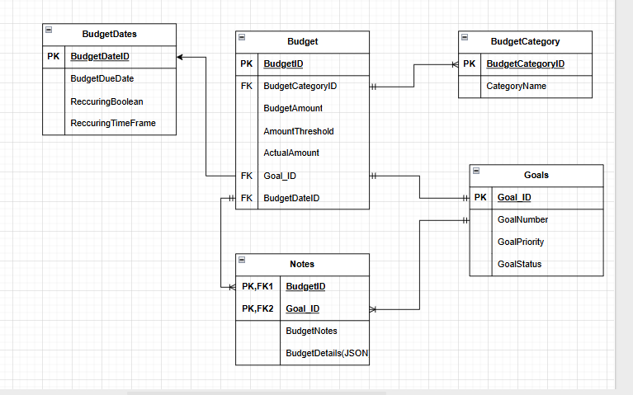
As we can see, I have normalized the table further creating a single table for budget category to remove duplicates. Goals have also become their own separate table to reduce redundancy and budget dates have their own table as well for the same reason. I personally Included the Notes table for further on when there are large scans of the table to remove the hassle of reading each part of the notes and pairing it with the budget notes as they are important for both the goals and budgets table.

Paste your model here:

