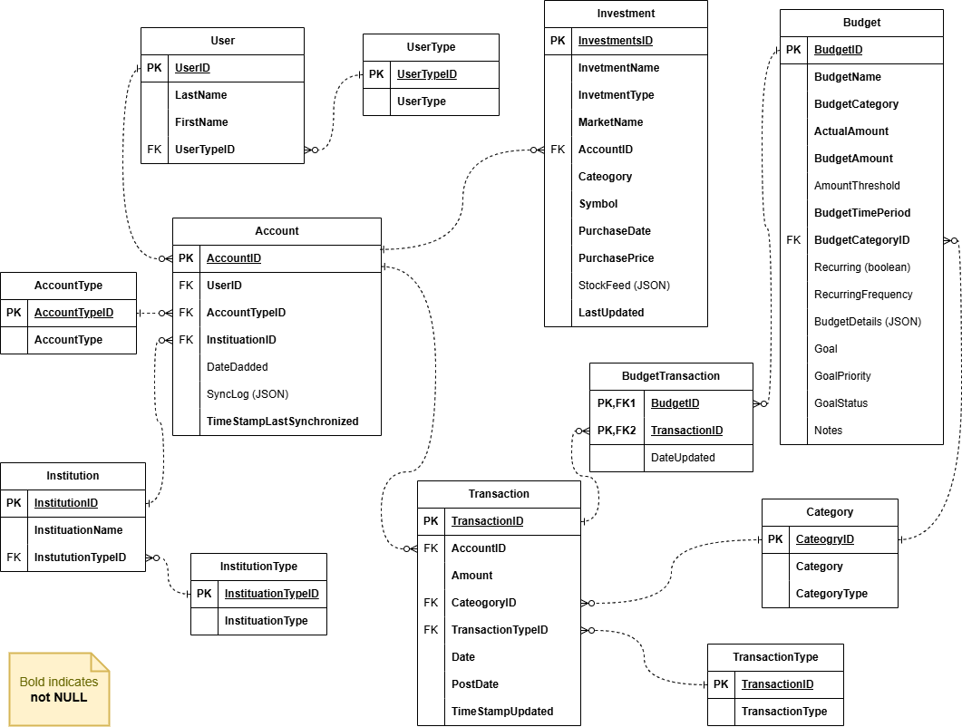
ample XML/JSON data for SyncLog in account table:
"syncLog": {
"transactionID": 123,
"syncStatus": "Success",
"syncTimestamp": "2023-01-01T15:30:00",
"errorDetails": null

Review the scenario presented in question 1. Then answer the following questions:
- Re-evaluate the Account table, specifically focusing on adjusting design for performance. Consider that this table is both written into often and queried often for analysis. Your solution should be no longer than four sentences.
- You are given the following query which the client reporting is running slow, Assume that Account and Transaction tables are enormous compared to other tables. All the FKs have already been indexed. Explain why you think this is the case specifically (recall this is a highly technical interview – and you can’t say “this has too many joins”). Your explanation and assumptions should be no longer than four sentences.
Select
User.LastName,
User.FirstName,
UserType.UserType,
Institution.InstitutionName,
InstitutionType.InstitutionType,
Account.DateAdded,
Investment.Name,
Investment.InvestmentType
FROM Account, Investment
JOIN Instituation on Institution.InstitutionID=Account.InstitutionID
JOIN InstitutionType on Institution.InstitutionTypeID=InstitutionType.InstitutionTypeID
JOIN User on Account.UserID=User.UserID
JOIN AccountType on Account.AccountTypeID=AccountType.AccountTypeID
JOIN Transaction on Account.AccountID=Transaction.AccountID
Where InstitutionType.InstitutionType='Bank' and Account.DateAdded is not NULL
Sort By InstitutionType.InstitutionType

- Provide performance improvement specifically resolving the one issue you have identified in 2b which you think will provide the most improvement, rewrite the query to support this. Explain briefly why the re-written query performance should be improved as technically as possible. Your solution should be no more than three sentences.

StockFeed in Investment table
"stockFeed": {
"symbol": "AAPL",
"companyName": "Apple Inc.",
"currentPrice": 150.25,
"currency": "USD",
"stockExchange": "NASDAQ",
"lastUpdated": "2025-01-01T12:45:00",
"dailyChange": {
"amount": 1.25,
"percentage": 0.84
},
"weeklyChange": {
"amount": 3.50,
"percentage": 2.38
},
"monthlyChange": {
"amount": -5.75,
"percentage": -3.72

Question 2: Performance Tuning

- Re-evaluate the specific TABLE outlined on your exam, specifically focusing on adjusting design for performance. Consider that this table is both written into often and queried often for analysis. Your solution should be no longer than four sentences.

Your response:
Considering the table is written often and queried for analysis. A major problem with the table is the sheer size of information stored on it. Like part b there are many tables that it references as well. You can horizontally partition the table based on date synchronized to retrieve the last month of accounts which may prove more useful in retrieving the information required. If Indexes are not used you can create an index table for the value UserID as this probably will have the most entries and effectively sorting through these values will help the overall performance.

- You are given the following query which the client reporting is running slow, additional characteristics outlined on the exam. All the FKs have already been indexed. Explain why you think this is the case specifically (recall this is a highly technical interview – and you can’t say “this has too many joins”). Your explanation and assumptions should be no longer than four sentences.
Select
User.LastName,
User.FirstName,
UserType.UserType,
Institution.InstitutionName,
InstitutionType.InstitutionType,
Account.DateAdded,
Investment.Name,
Investment.InvestmentType
FROM Account, Investment
JOIN Instituation on Institution.InstitutionID=Account.InstitutionID
JOIN InstitutionType on Institution.InstitutionTypeID=InstitutionType.InstitutionTypeID
JOIN User on Account.UserID=User.UserID
# Why do we need this? JOIN AccountType on Account.AccountTypeID=AccountType.AccountTypeID
# WHY DO WE NEED THIS TOO? JOIN Transaction on Account.AccountID=Transaction.AccountID
Where InstitutionType.InstitutionType='Bank' and Account.DateAdded is not NULL
Sort By InstitutionType.InstitutionType

Your response:

This query may be too slow because it is first joining all the tables and across all rows then filtering it after based on the condition (InstitutionType.InstitutionType='Bank' and Account.DateAdded is not NULL). This type of query takes too long to process by not filtering any type of data first before the joins. A minor improvement to this will also be to remove the second hald of the conditions as it is unnecessary and does an extra scan of the table to prove that the date added is not null, when this can be avoided since it should create a datetime every time. If it was not added before creating the table you can generate a set date time before new ones were created to speed up this process. L
- Provide performance improvement specifically resolving the one issue you have identified in 2b which you think will provide the most improvement, rewrite the query to support this. Explain briefly why the re-written query performance should be improved as technically as possible. Your solution should be no more than three sentences.

Your response:
With FilteredInstitution as (Select InstitutionType from InstitutionType where InsitutionType = ‘Bank’)
Select
CONCAT(User.LastName, ', ', User.FirstName) AS UserName,
UserType.UserType,
Institution.InstitutionName,
InstitutionType.InstitutionType,
Account.DateAdded,
Investment.Name,
Investment.InvestmentType
FROM Account, Investment
JOIN Instituation on Institution.InstitutionID=Account.InstitutionID
JOIN FilteredInstitution on Institution.InstitutionTypeID=InstitutionType.InstitutionTypeID
JOIN User on Account.UserID=User.UserID
# Why do we need this? JOIN AccountType on Account.AccountTypeID=AccountType.AccountTypeID
# WHY DO WE NEED THIS TOO? JOIN Transaction on Account.AccountID=Transaction.AccountID
As you can see, we pre filtered the institutions where type=”bank” to run a faster query since it is pre processed and will not run on the larger table of joins. Secondly I commented out some questionable joins that had no effect on the query and removed the “sort by” since all of the values will be of type “bank” so any additional sorting will slow down the query time. This should run faster. I concatenated the first and last name as well.

