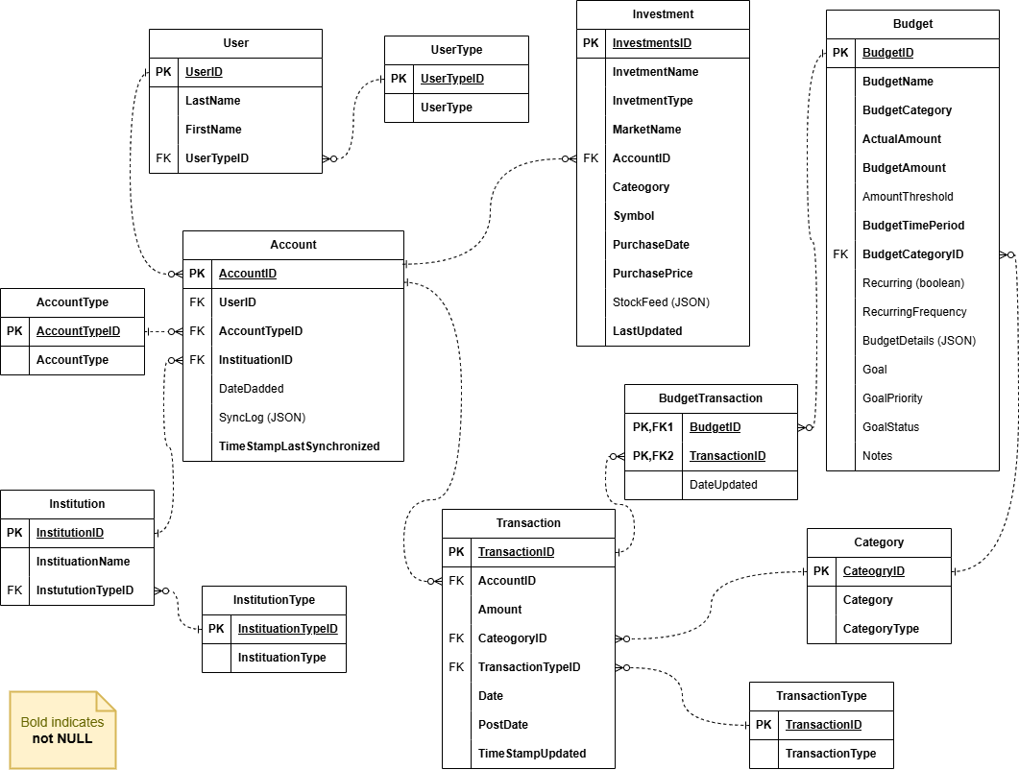
Review the scenario presented in question 1. Then answer the following questions:
  - MyBudget would like to improve the allocation of their design by becoming distributed, however they would only like to focus on Replication at this time. Suggest a distributed design goal and design which focuses on Replication specific to this scenario. No more than four sentences to explain your design.
    - To support replication, we can do a Full replication of the entire database to support transactions being handled specifically when it comes to maintaining investments from users as well as allowing the account holder to share access to different transactions at the same time. The goal would be to replicate the database to be accessed synchronously across multiple sites and this will ensure that potential investments and transactions will not be lost completely. In addition, the publisher site can be the bank and the subscriber will be the user, after making changes to an account the bank will update the user and in return the user uses another platform to make these requests to be handled by the bank to make changes.
  - Explain the tradeoff in not focusing on Fragmentation of distributed design specific to this scenario. No more than two sentences.
    - The tradeoff here is that the read times of a replicated database especially for the newest or up to date corrections is based solely on internet speed. Fragmenting and keeping information locally will be more helpful for a local environment where a person or institution does not need outsider or multi person input.
To submit your answer:
  - Download the Question3_Template
  - Provide your response to the questions

Question 3: Distributed Design

- Scenario outlined in exam would like to improve the allocation of their design by becoming distributed, however they would only like to focus on a distribution strategy outlined in your exam at this time. Suggest a goal and a design which focuses on distribution strategy outlined in your exam. No more than four sentences to explain your design.

Your response:

- Explain the tradeoff in not focusing on another distribution strategy outlined in your exam of distributed design. No more than two sentences

Your response:

