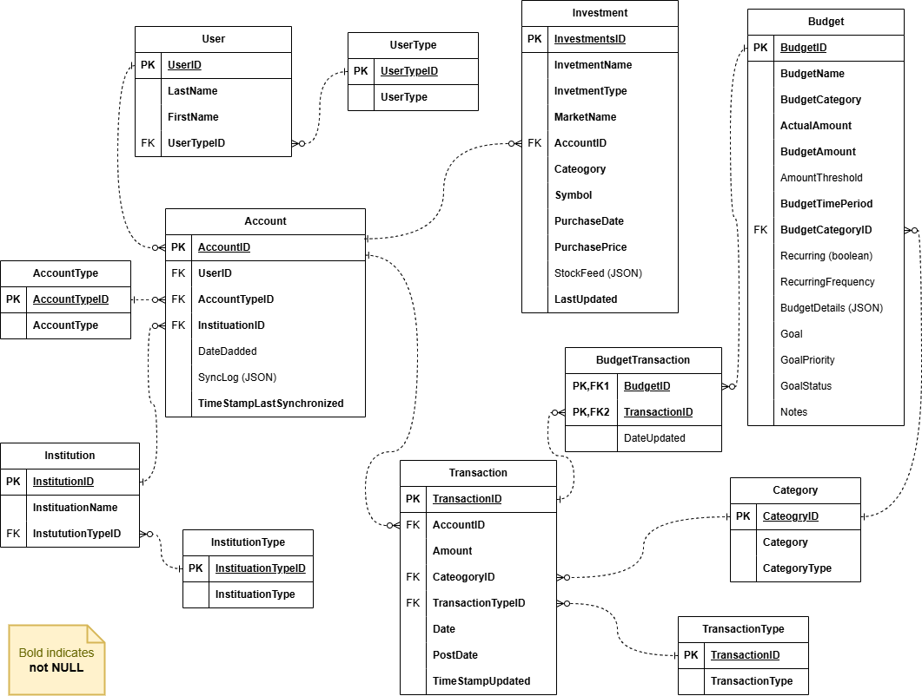
Investment Table
- InvestmentName: Name or title of the investment (e.g., "Apple Inc. Stock").
- InvestmentType: Type or category of the investment (e.g., "Stock").
- MarketName: Name of the market or exchange where the investment is traded.
- Account: Account or portfolio to which the investment belongs.
- Category: Category to which the investment is assigned (e.g., "Technology Stocks").
- Symbol: Unique symbol or ticker representing the investment on the market (e.g., "AAPL" for Apple Inc. stock).
- PurchaseDate: Date when the investment was purchased.
- PurchasePrice: Price at which the investment was purchased.
- LastUpdated: Date and time when information about the investment was last updated.

StockFeed in Investment table
"stockFeed": {
"symbol": "AAPL",
"companyName": "Apple Inc.",
"currentPrice": 150.25,
"currency": "USD",
"stockExchange": "NASDAQ",
"lastUpdated": "2025-01-01T12:45:00",
"dailyChange": {
"amount": 1.25,
"percentage": 0.84
},
"weeklyChange": {
"amount": 3.50,
"percentage": 2.38
},
"monthlyChange": {
"amount": -5.75,
"percentage": -3.72

Review the scenario presented in question 1. Then answer the following questions:
- MyBudget CEO walks in, and raises the following question “I would like to gain insights from the data that we collect, can you help me distinguish where a data warehousing and where a big data solution might help? By the way I have no idea what any of this means, but my lead engineer does, if you can impress them, you got the job!” CEO walks out, and you are left with the lead data engineer who would specifically like for you to propose a relational data warehousing analytics solution. Come up with a business question for the scenario focusing on the Investment table and answer it with a star schema design (scope of a single fact table and several dimensions). Part of your solution needs to focus on the StockFeed attribute.
  - Provide your business question
  - Provide your star scheme design
  - Specifically how your design answers your business question
Business Question: How can we organize the investment table to deal with changing stock prices, times and how will they be reflected in the total profit and loss of an account’s investment?
- Design:
  - Fact Table: Full Investment table with below dimension tables, LastUpdated, Stock Information, and Account as PK,FK
  - Stockfeed broken up to different dimension tables
  - Slowly Changing Dimension on Account Table linked with the FK of the fact table
  - Time Dimensional Table as LastUpdated on stock price movement with daily, weekly and monthly change on it
  - Price dimension on Stock Price for the most fast up to date information on a stock in a daily trade
  - Stock Information dimension for the Name, Symbol, stock exchange and currency which will all update to reflect stock splits and other changes in the stock itself. As time goes on different companies merge or have specific changes to their stock such as splits and other changes. This will be reflected in this table.
This design answers the business question by allowing different types of dimensions to adjust with changes that happen in real time. As stocks get traded between internal accounts, the account dimension table changes to reflect the trade. Since this does not happen too often it is a slowly changing table. The time dimensional table is updating every minute during the trading day with up to date information on stock price and how it has changed on a given monthly basis. Price dimension shows the changes in profit and loss as it is sold and contributes to the total of an account. Lastly, the stock information changes as company information changes.
- Explain what the difference in would be implementing database solution in a document store instead of RDBMS database. Avoid boilerplate technical fluff answers, this needs to be concrete and specific as to why your solution should be adopted for this scenario. Limit your response to three sentences.
  - The limited amount of information specifically for the Investment Table and Stock Feed allows us to not focus specifically on a targeted reads and writes that will cost the company money. The consistency is poor in document store and will end up breaking the company if it is unable to change the stock trades in time for Users losing them money. My solution provides a secure way to ensure the customer’s transactions do not break the system or trade itself for the user.

Question 4: Analytics, BigData– and CS779
- CEO walks in, and raises the following question “I would like to gain insights from the data that we collect, can you help me distinguish where a data warehousing and where a big data solution might help? By the way I have no idea what any of this means, but my lead engineer does, if you can impress them, you got the job!” CEO walks out, and you are left with the lead data engineer who would specifically like for you to propose a relational data warehousing analytics solution. Come up with a business question for the scenario focusing on the specific TABLE outlined on your exam and answer it with a star schema design (scope of a single fact table and several dimensions).

Provide your business question- Your response:

Provide your star scheme design- Your response:

Specifically how your design answers your business question - Your response:

- Explain what the difference in would be implementing database solution in NoSQL Implementation outlined on your exam. Avoid boilerplate technical fluff answers, this needs to be concrete and specific as to why your solution should be adopted for this scenario. Limit your response to three sentences.

Your response:

