Term Project Report
Lebanese Pizzeria Inventory and Sales Database
Kevin Lopez Sepulveda
Summer 2025
- Introduction
  - This project implements a fully functional relational database system for a Lebanese pizzeria. The database is designed to manage inventory, menu items, customer information, and sales transactions. It integrates advanced database concepts learned in this course, including schema normalization, transaction management, indexing, and cloud deployment. The goal is to demonstrate how a business can optimize operations, automate reporting, and maintain data integrity in real-time.
- Conceptual Design and ERD
- 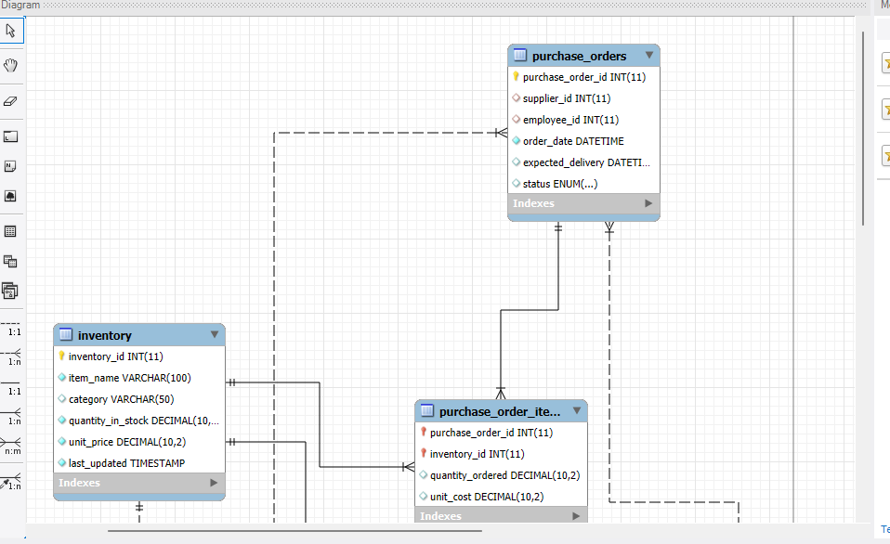
- 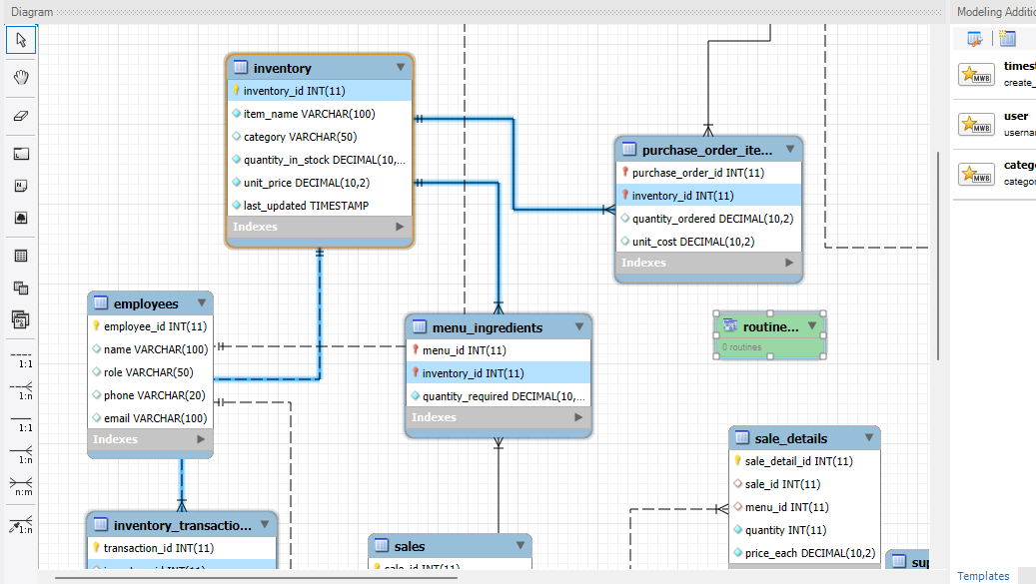
  - 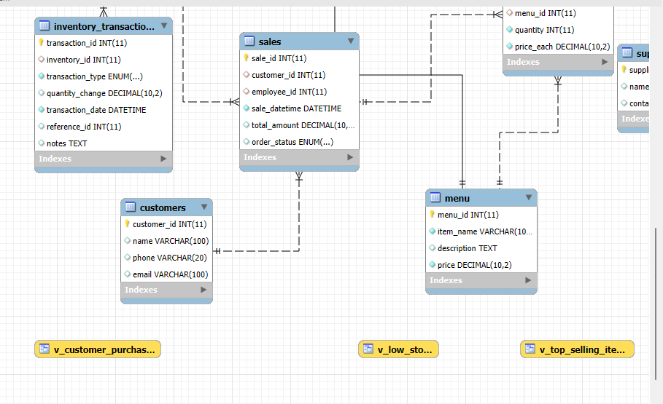
  - 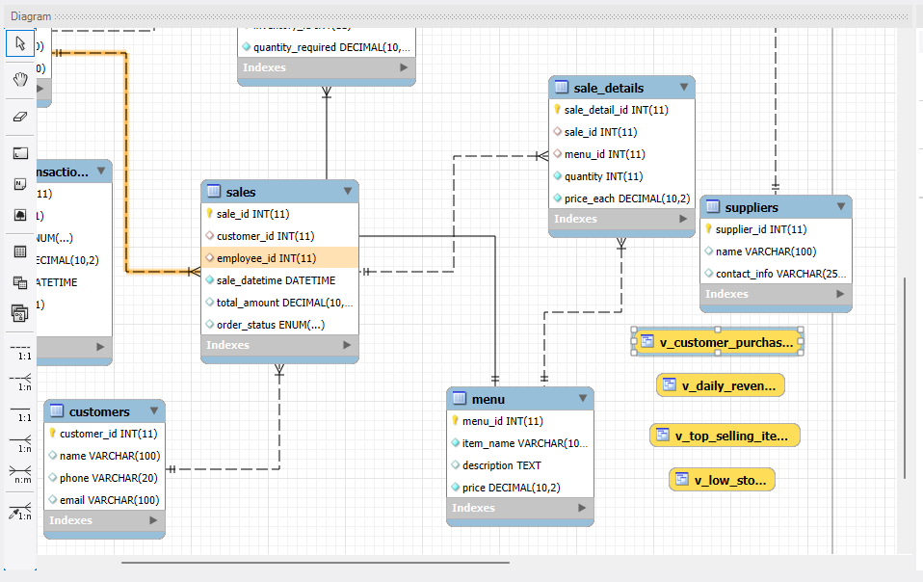
  - Relationships: All strong and weak relationships are properly indicated.
  - Cardinality: One-to-many and many-to-many relationships are clearly defined.
  - Optionality: Mandatory and optional attributes are indicated to maintain business rules.
  - Diagram Layout: Lines are minimized for crossings, ensuring clarity.
  - ERD Description:
  - Inventory ↔ Menu: One-to-many; a menu item can reference one inventory item, inventory can support multiple menu items.
  - Menu ↔ Sale Details: Many-to-many implemented via sale_details junction table.
  - Sales ↔ Sale Details: One-to-many; a sale can have multiple items.
  - Customers ↔ Sales: One-to-many; a customer can make multiple purchases.
  - (Insert ERD screenshot here)
  - Database Schema and Sample Data
    - The schema includes five tables: inventory, menu, customers, sales, and sale_details. Below are sample SQL INSERT statements:
      - Inventory Table
    - INSERT INTO inventory (item_name, category, quantity_in_stock, unit_price) VALUES
    - ('Cheese', 'Dairy', 50, 2.50),
    - ('Olives', 'Produce', 100, 1.50),
    - ('Flatbread', 'Bakery', 75, 1.00);
      - Menu Table
    - INSERT INTO menu (item_name, description, price, inventory_id) VALUES
    - ('Cheese Manoushe', 'Flatbread with cheese', 5.00, 1),
    - ('Meat Pizza', 'Pizza with beef shawarma', 10.00, NULL),
    - ('Olive Manoushe', 'Flatbread with olives', 6.00, 2);
      - Customers Table
    - INSERT INTO customers (name, phone, email) VALUES
    - ('Ali Hassan', '555-1010', 'ali@example.com'),
    - ('Maya Nader', '555-2020', 'maya@example.com');
      - Sales Table
    - INSERT INTO sales (customer_id, sale_datetime, total_amount) VALUES
    - (1, '2025-08-01 12:15:00', 11.00),
    - (2, '2025-08-01 13:00:00', 6.00);
      - Sale Details Table
    - INSERT INTO sale_details (sale_id, menu_id, quantity, price_each) VALUES
    - (1, 1, 1, 5.00),
    - (1, 3, 1, 6.00),
    - (2, 3, 1, 6.00);
  - Chat GPT was used to generate a large amount of data for the table
  - 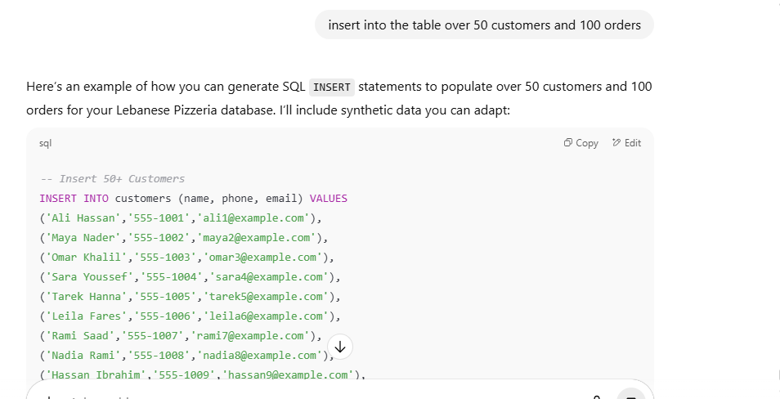
- Strategic Business Questions and SQL Analysis
  - Which menu items are selling the most?
    - Importance: Identifies popular items to optimize menu offerings.
      - SQL Query:
      - SELECT m.item_name, SUM(sd.quantity) AS total_sold
      - FROM sale_details sd
      - JOIN menu m ON sd.menu_id = m.menu_id
      - GROUP BY m.item_name
      - ORDER BY total_sold DESC;
  - Which inventory items are low in stock?
    - Importance: Prevents stockouts and ensures availability.
      - SQL Query:
      - SELECT item_name, quantity_in_stock
      - FROM inventory
      - WHERE quantity_in_stock < 10;
  - How many sales does each customer make?
    - Importance: Identifies loyal customers and purchasing patterns.
      - SQL Query:
      - SELECT c.name, COUNT(s.sale_id) AS total_sales
      - FROM customers c
      - JOIN sales s ON c.customer_id = s.customer_id
      - GROUP BY c.name
      - ORDER BY total_sales DESC;
  - Total revenue per day
    - Importance: Tracks business performance and peak hours.
      - SQL Query:
      - SELECT DATE(sale_datetime) AS sale_date, SUM(total_amount) AS revenue
      - FROM sales
      - GROUP BY sale_date
      - ORDER BY sale_date;
  - Which items require restocking immediately?
      - Importance: Automates operational monitoring to reduce manual errors.
      - SQL Query:
      - SELECT item_name, quantity_in_stock
      - FROM inventory
      - WHERE quantity_in_stock <= 5;
- Indexing and Performance
  - Indexed columns: sale_details.menu_id, sale_details.sale_id, sales.customer_id.
    - Reasoning: These columns are frequently used in JOIN operations and aggregations.
    - Foreign keys: Default indexing is provided by MySQL; additional indexing was added only for performance optimization.
- Work automation
  - Started script to provide texts to manager that will let them know when items run out.
    - Eventually will have automated to order automatically.
- Lessons Learned
  - Constructing complex JOIN queries requires careful planning and understanding of table relationships.
  - Indexing improves performance but must be strategic.
  - Automation with Python and SMS APIs bridges database management with real-world operations.
  - Cloud deployment introduces considerations such as latency, connectivity, and transaction consistency.
  - Proper ERD design reduces errors and ensures clarity in relational structures.
  - Removed repetitive cursors that were unable to be explained with code
DatabaseCredentials:
'host': 'sql5.freesqldatabase.com',
'user': 'sql5794428',
'password': '7qm3Q2ln6Q',
'database': 'sql5794428'

