Kevin Lopez Sepulveda
Disclaimer: I used a lot of AI on this assignment. My time is crunched now as I have to pick up extra shifts to keep afloat with the economy. I hope you understand, and I will do a better job at doing more working with a schedule that allows me to do my work properly. I have Thursdays off for homework exclusively for all my classes but will aim to do some after my overnight shifts so this will not happen again. Thank you.

Overview of the Assignment
In this exercise, we will review advanced programming components, specifically looking at DML, DDL, triggers, stored procedures, functions and code reuse. There are a number of more advanced optional extra credit problems at the end, to make sure that there are challenges for more advanced students. The problems are organized in five parts:
Part 1: Schema, DML and DDL
Part 2: Joins and Subqueries
Part 3: Aggregates and Grouping
Part 4: OLAP and Grouping Functions
Part 5: Putting it all together
Part 5: More Advanced Extra Credit Problems
All of the problems begin with the learning objectives of the problem, in square brackets.

Preparing for the Assignment
Step 1: You will need to install an RDBMS prior to starting this assignment. You can download our Oracle, PostgreSQL, MySQL or Microsoft SQL Server installation guides from bu.edu/csmet/forms.
Create scripts and insert scripts for sample data are in separate files in the assignment area of the web site for Oracle, PostgreSQL, MySQL and Microsoft SQL Server. See Appendix for how to create the database schema.

The Terrier Hospital Schema
You have been hired by BU to solve various questions within the Terrier Hospital Schema. Your assignment is to implement the following requirements.
If you need help: If you encounter any mysterious SQL or RDBMS errors just paste the error (error code such as “ORA-12345” ) into Google and see what that returns (this is what SQL developers do). There are many tutorials stack overflow is a great resource You can try generative AI for an example. If this doesn’t tell you enough, email your facilitator. It helps us if you paste the SQL and client screen shot into the email. Don’t panic if you feel stuck; we will get you unstuck.

Part 1: The Terrier Hospital Schema, DML and DDL
What you need to review: Primary and foreign keys, constraints, altering tables, selecting and inserting data to correct and verify results.
- When selecting data, it is best to select specific columns rather than just SELECT * FROM <table name>
- Understand the importance of the WHERE clause, especially when updating or deleting data.
Before you begin: Create the Terrier Hospital database schema and pre-populate the tables using the scripts provided. There are separate scripts for Oracle, PostgreSQL, MySQL, and MSSQL. You are welcome and encouraged to to add additional data to this schema through the assignment.
- [ Learning objectives: adding and populating columns, SQL string operators]
Examine the doctor table. Note that each doctor has an assigned office, which includes a 3 digit number (room number) and a character that indicates the building where the room is located (building code).
- Select all data from the Doctor table and review it.
  - 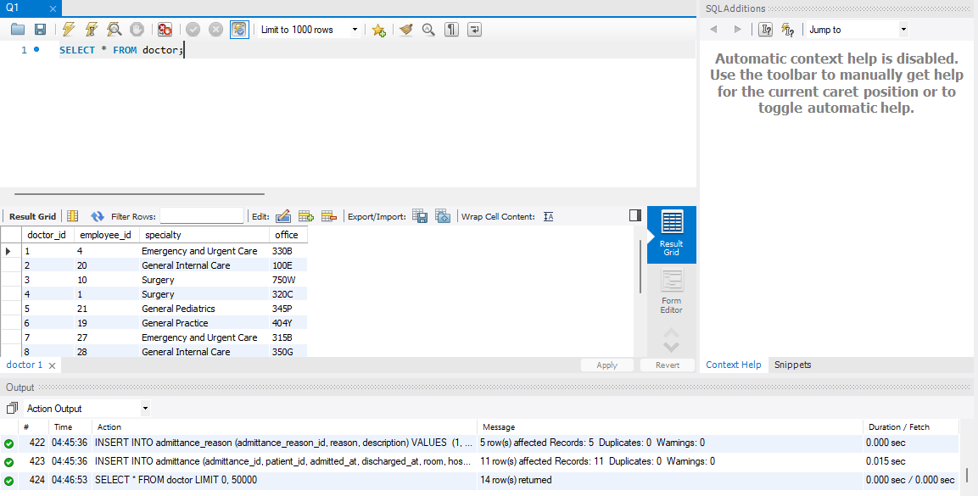

Your code and screenshot of the executed code

- Add an attribute called room_number that represents the room number of a doctor’s office. For example, the record ‘330B’ should become room_number ‘330’ and so on
  - 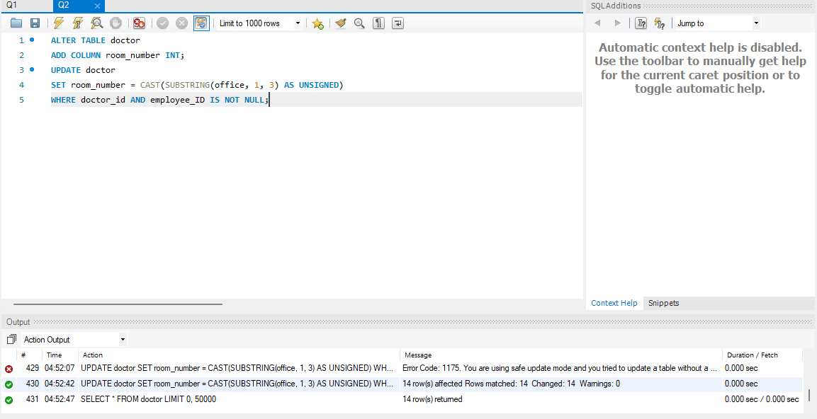

Your code and screenshot of the executed code
- Next, add another attribute called building_code that represents the building in which the office is located. For example, the record ‘330B’ should become building_code ‘B’ and so on.
  - 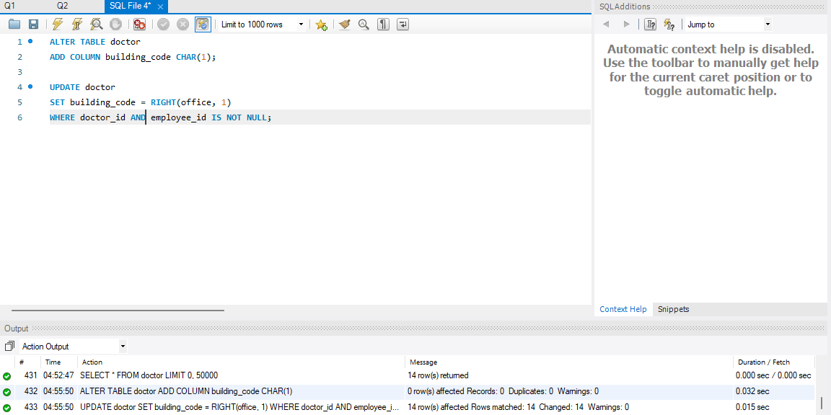

Your code and screenshot of the executed code

Hint for b and c: The office values always begin with a 3-digit number, followed by a singular letter character. HINT: Review Substring() and or LEFT(), RIGHT() functions. The DBMS you are working with might have a different way to accomplish this. You are welcome to solve the above with two steps (b) update the table adding two columns (c) update the two columns with the data in a single command, or you can do each field one at a time.

Your code and screenshot of the executed code

- Select all data from the doctor table to verify that you obtained the intended results from the previous two sections.
  - 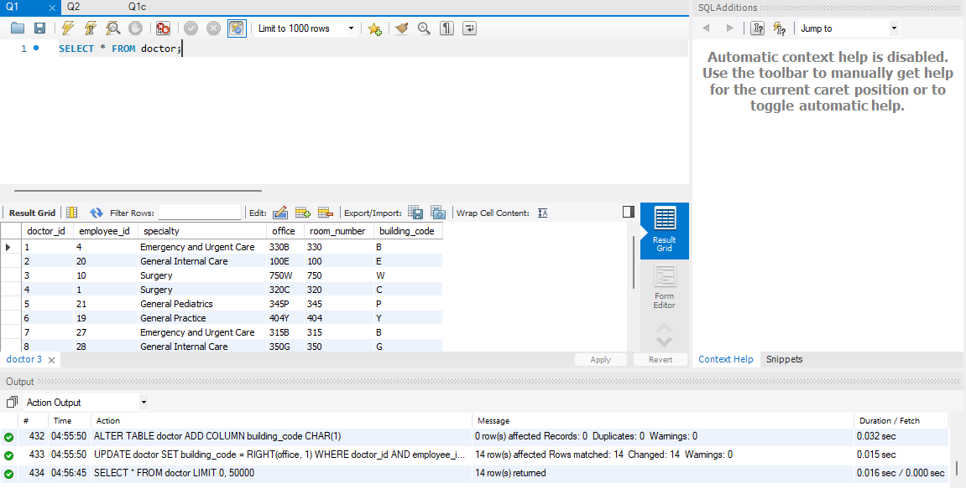

Your screenshot of the executed code

- [ Learning objectives: design ] Provide one suggestion to improve consistency of the design of the entire doctor table with your adjustments from question 1 and how would you go about not just altering tables and relationships but the data itself (make sure to account for all the columns). Consider a business case that a doctor may be in multiple rooms and within different office buildings. You do not need to implement the changes as this is a conceptual question. Provide a small updated ERD of the design and an explanation of your design choice as well as how you would go about converting the data. The goal should be the highest level of data consistency in terms of normalization.
  - To combat the inconsistency, we can split office number and building code into a separate table with a separate number special to them both as the primary key. The foreign keys are the room_id and Building_code and hospital_id. Then have an assignment table with two date times to determine start and end times and a Boolean to check if it is assigned to a doctor at a given time with the Doctor_id and room number as primary keys and foreign keys. This small shift normalizes the data so that it will not have repeated times as well as is easy to change start and end dates for doctors on different schedules. With this we can alter the doctor table to just have the doctor_id, employee_id and specialty.
  - For ERD Check attachment.

Your design and response

- [ Learning objectives: sequences]
As you examine the schema, you will notice the synthetic primary keys are not automatically incremented by the DBMS, even though it has this ability. Your task is to determine which attributes would benefit from primary keys that increment automatically using sequences, or serial/identity/auto_increment (mySQL note: you will need to drop PK/FK constraints potentially first) Sequences are database objects that don’t depend on tables. They are used as scalable, distributable counters to produce unique numbers such as synthetic keys.] You may use the “identity” or “serial” instead of sequence if you wish.
- Implement a single sequence (alternatively identity or serial or auto_increment) on the primary key of the appointment table. You do not need to delete any data from the tables or change any of the current (synthetic) primary keys. There is a parameter for the initial starting value of a sequence that you will need to set, based on the legacy synthetic keys, when defining each sequence.
  - 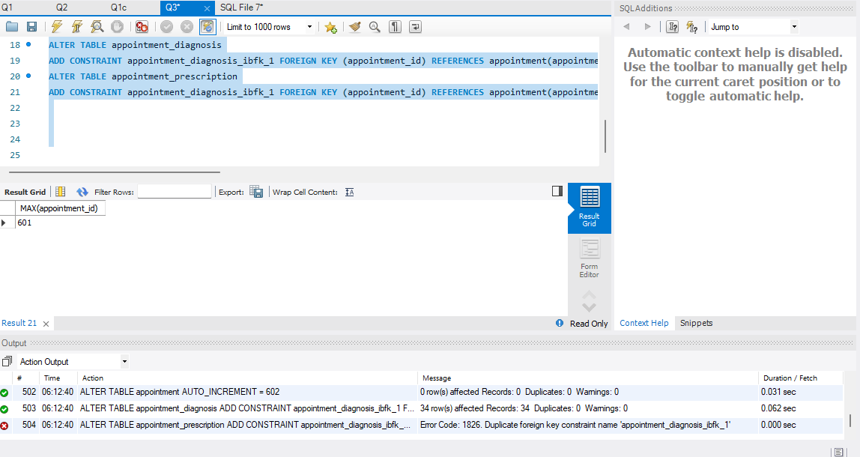

Your code and screenshot of the executed code

- Demonstrate sequence by inserting two new records into the appointment table. The first record should be for any existing patient and the second for yourself as if you were the patient. Before adding the appointment, you will need to add yourself as a patient. Make sure to capture screenshots as well. The variable “created_at” should be today’s date and time, while the “scheduled_for” should be a future date during this semester. Refer to the "doctor" table and select any "doctor_id" you wish. Appointment status should be “scheduled”, Provide a patient concern, keep it to a few symptoms, a short sentence - please be creative. Finally “lab_ID should” be NULL.
  - 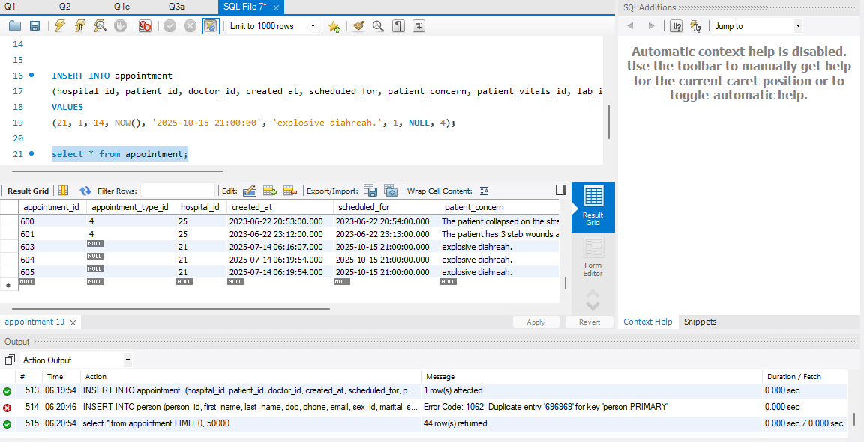

- [ Learning objectives: schema augmentation, nullability, CHECK]
The firm would like to implement doctor reviews. There is a rule that a patient can only leave one review per a doctor, so it is natural that the database representation of reviews includes a “doctor_review” table, linked to the patient and doctor tables. You will need to determine what the PK should be (surrogate or composite?). Your solution for parts a-e below should be a single DDL statement (*with the exception of item F). The following are the constraints you will want to implement:
- Create foreign key constraints on doctor_review to the doctor and patient tables to assure that the patients and doctors are valid!
- review_date: of the review, which cannot be null and defaults to today’s date.
- rating: will have a check constraint that only allows values of A,B,C,D,F.
- patient_review: a column for comments so the patient can leave a written review.
- If you end up using a synthetic surrogate primary key, look to use a sequence/identity/serial to manage the primary key.
  - 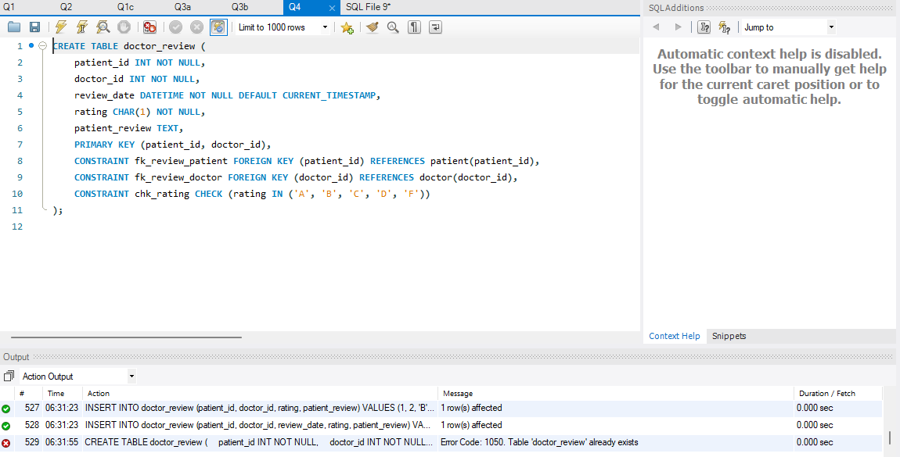

Your DDL code and screenshot of the executed code

- [ Learning objectives: testing schema augmentation, DBMS date function, view, code reuse]
- Insert three records into the doctor_review for patients and doctors of your choice, with one of these being your personal patient record. Make sure the data contains the following:
  - One of the reviews has to be for today’s date.
  - One of the reviews should not explicitly use a date and should utilize the default constraint that you added.
  - The last review needs to use the date of our first day of class this semester.
    - 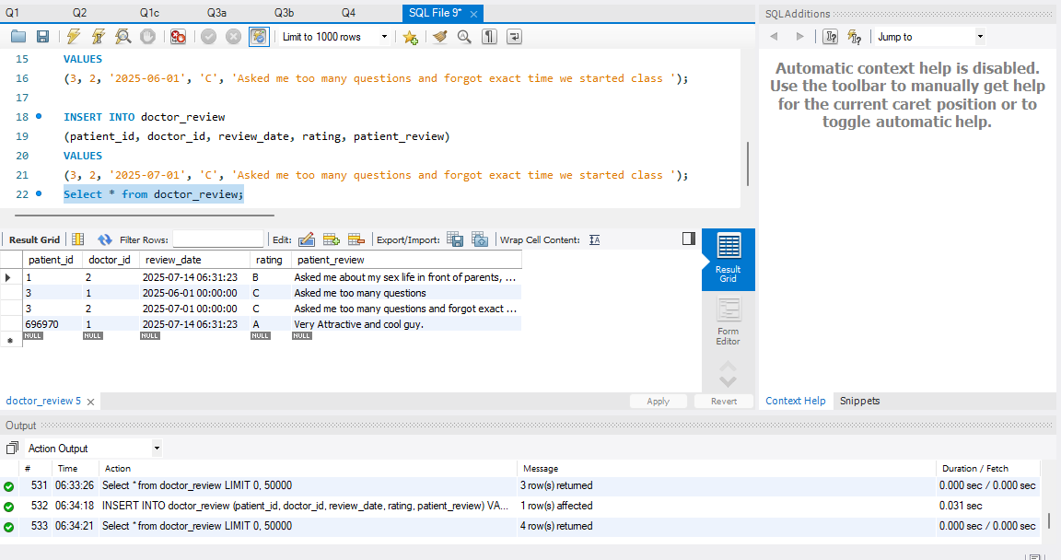

Your code and screenshot of the executed code

- Write a view that returns the following columns: a concatenated Patient full name containing their first and last Name, doctor’s full name (also concatenated), and the review itself, including rating, review_date and comment. Avoid using old-style joins where the join constraints are in WHERE clauses, because these are not compliant with current good practice or ANSI standards. Instead, use the JOIN keyword. Demonstrate that the view works by selecting the reviews which you have added for yourself as a patient. You will find the name of the person and doctor in the person table, recall that a doctor is an employee, so there are a few tables to join here to get the names. Recall how to use aliases to join the same table for different purposes in a query.
Your code and screenshot of the executed code
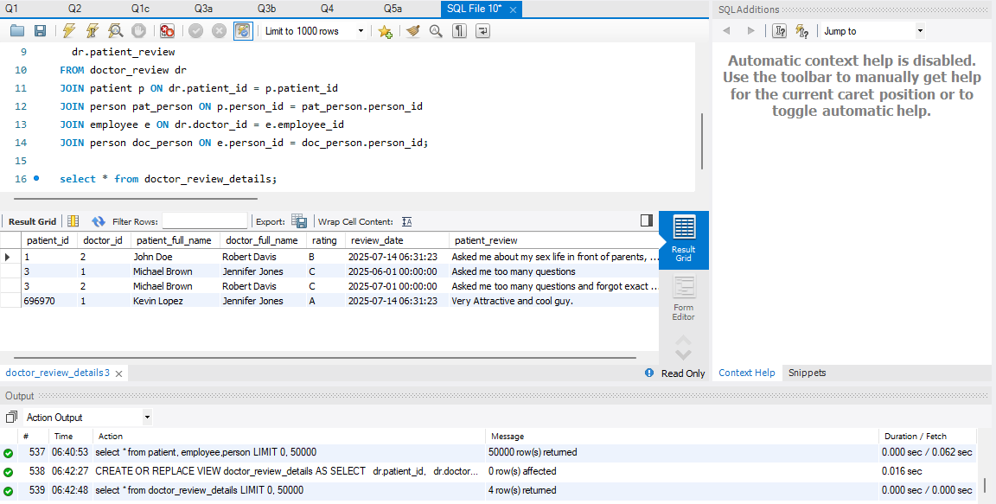

- Write an insert statement that attempts to insert a review violating the rating check constraint.
Your code and screenshot of the executed code
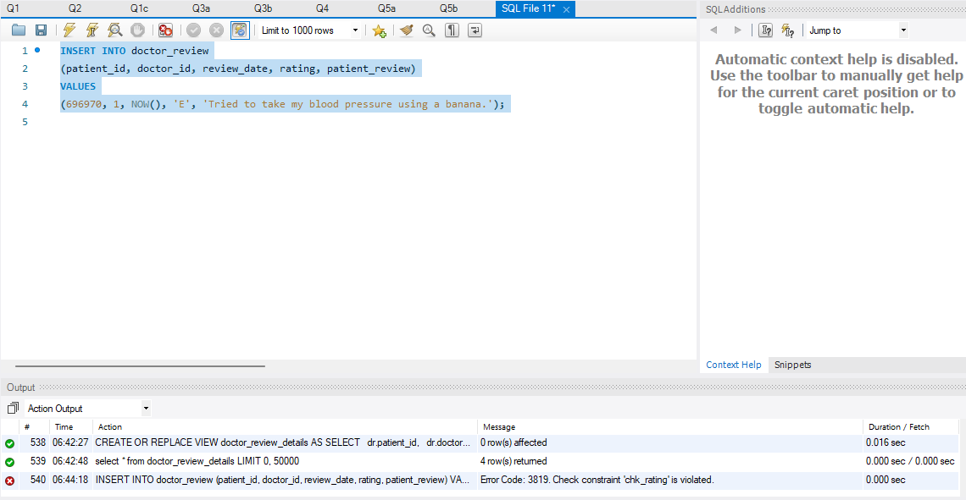

- Suppose that a patient of your choice changed their mind about a review for a specific doctor. Write an update statement to change a specific patient’s review for a specific doctor of your choice. Run the view above (b) to verify your results.
Your code and screenshot of the executed code
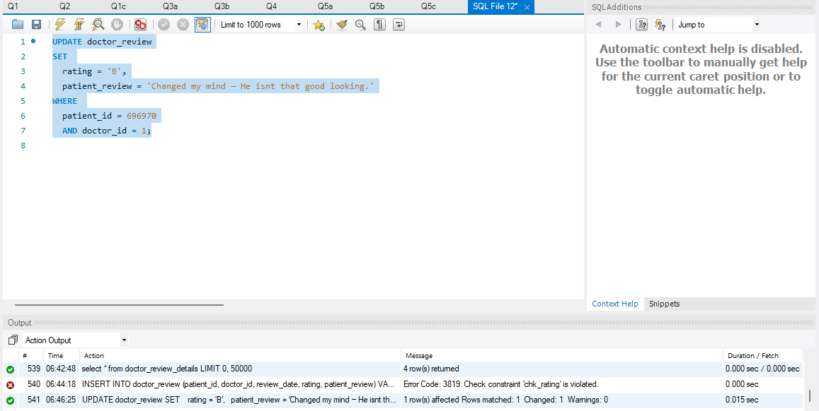
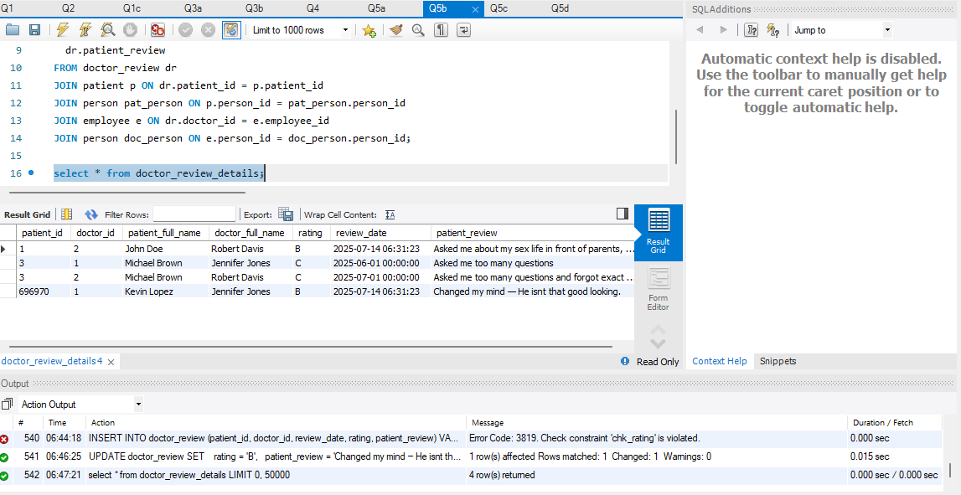

- Suppose that a patient changed their mind about another review for a specific doctor and they want it deleted. Write a delete statement to delete a specific patient’s review of your choice. Run view above (b) to verify your results.
Your code and screenshot of the executed code
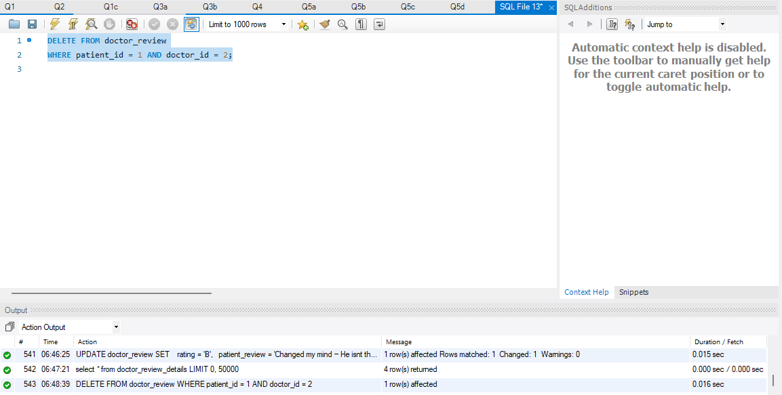
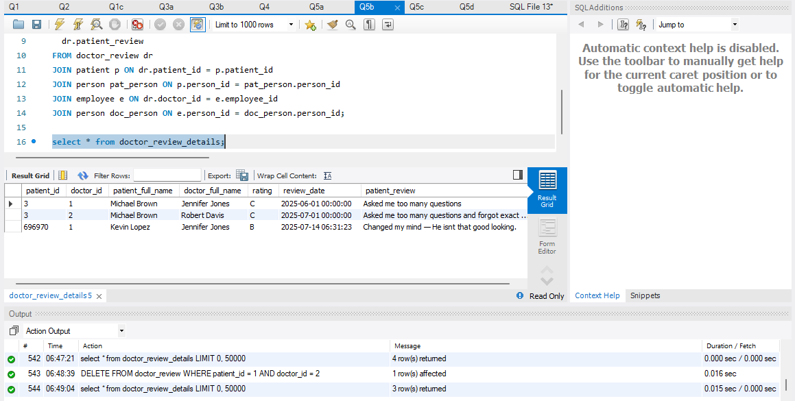

Part 2: Joins and Subqueries
What you need to review: Joins or Subqueries.
- Avoid using old-style joins, as these are not compliant with current good practice or ANSI standards.

- [ Learning objectives: review of SELECT with inner and left joins]
Write a select statement that lists appointment scheduled date and time as separate fields (you will need to figure out a way to extract the date and time), patient last and first name (combine these), hospital name, and doctor last name and first name (combine these) for an appointment type of your choice. Include MCV value from the blood test for the appointment (hint, not every appointment has a lab and you need to account for this). The last attribute in this query should be patient concern (from appointment). Filter appointment type by the description, and not the id. Sort by appointment date and time, and then patient name. Make sure that the resulting set includes a record for your own patient and appointment information which you inserted earlier.
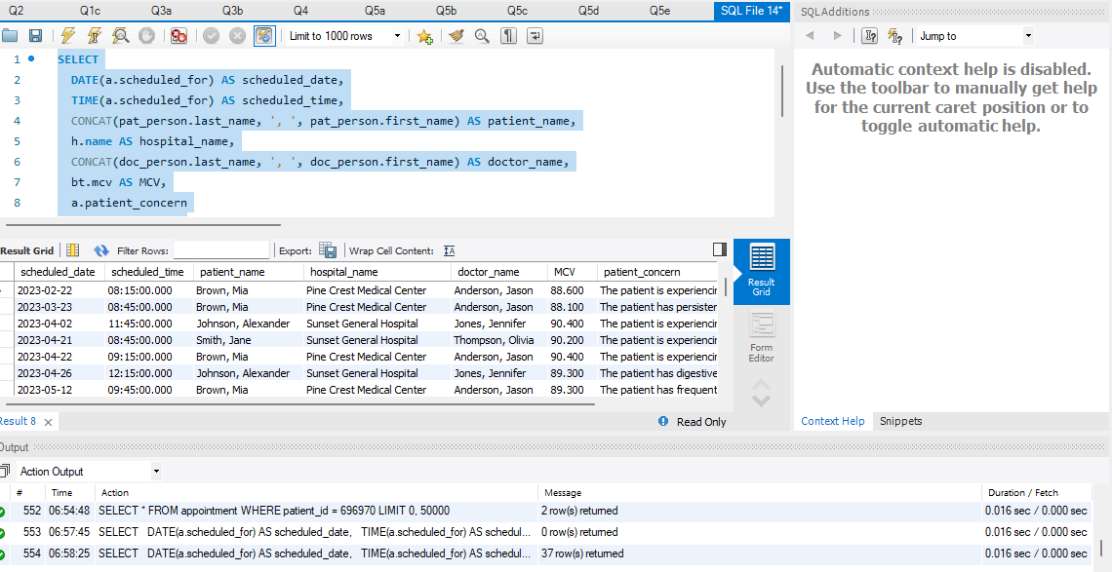
Hint on tables that you need: (in no particular order): doctor, patient, employee, person, hospital, appointment, lab, blood_test and appointment type.

Your code and screenshot of the executed code

- [ Learning objectives: IS NULL, left joins, subqueries]
List all appointments where patients did not receive a prescription (hint: it’s possible that an appointment may not have a related appointment prescription record). You need to include the following: date of appointment (not time), concatenated full name of the patient, the office where the appointment took place (based on Doctor’s office), the hospital name, and the diagnosis names if one exists for the appointment (if an appointment has multiple diagnosis, it will show several times, and this is ok). You will want to add some additional test data- for example, a prescription record and or diagnosis record to demonstrate that your query is working. Make sure that the resulting set includes a record for your own patient and appointment information which you inserted earlier.
- The resulting solution will be a mix of inner and left joins and one or more sub-queries.
- Hint: you will need the same tables listed in question 6 as well as appointment_prescription.
- Hint: It may be helpful to solve this in a few steps breaking down each requirement. For example, first try to figure out which appointments do not have a related prescription.

Your code and screenshot of the executed code
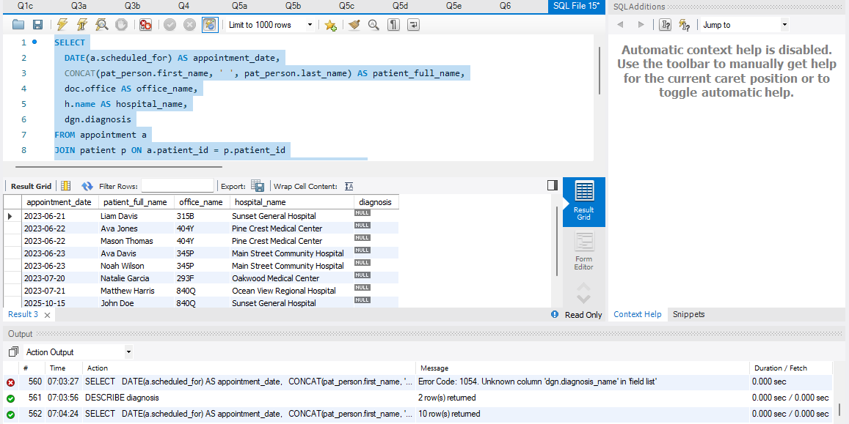

Part 3: Aggregates and Grouping
What you need to review: DISTINCT, GROUP BY clause, HAVING clause, and aggregate functions such as COUNT, SUM, AVG, MIN, and MAX. Your result may be a single number for each one of these queries.

- [ Learning objectives: aggregates, joins, GROUP BY]
Count the number of blood tests for employees who performed them. In other words, not all employees perform these tests. Include the first and last name of the employee, their department, the hospital where they work, the number of blood tests they have performed. Filter the results for employees who performed a total of five or more tests.
Hints/Notes:
  - Break the process into steps - first joining all the tables you need and reviewing the results, then aggregating the data. Review the relationship between "department" and "hospital" tables.
  - Think about what you need to GROUP on, and what you will need to aggregate such as COUNT or SUM.
  - Tables to be included in the query will be employee, department, hospital, and blood_test.

Your code and screenshot of the executed code
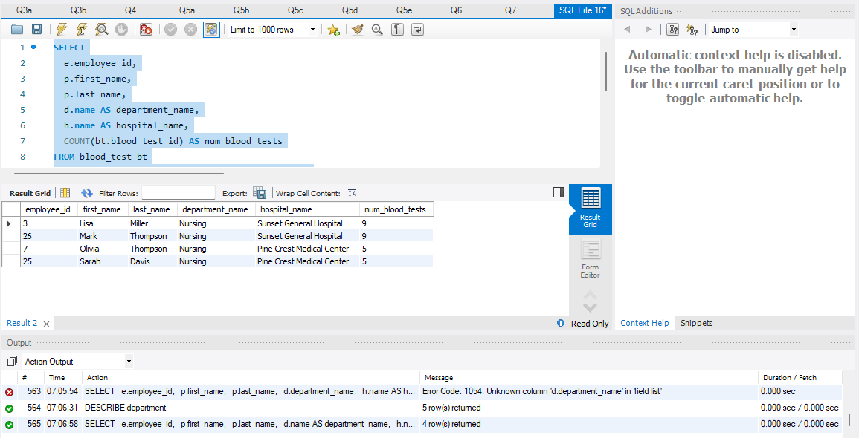

- [ Learning objectives: aggregates, date differences, grouping]
Write a query returning doctors and the number of appointments they have by appointment type and month of appointment for the year of your choice. You need to include doctor last and first name (concatenated), appointment type and month of appointment, as well as total number of appointments for each within the aggregate. Please add a few extra records for a few of the existing patients as the original data may not provide enough information.
Hints/Notes:
  - Think about what you need to GROUP on, and what you will need to aggregate on and what to filter and where.

Your code and screenshot of the executed code

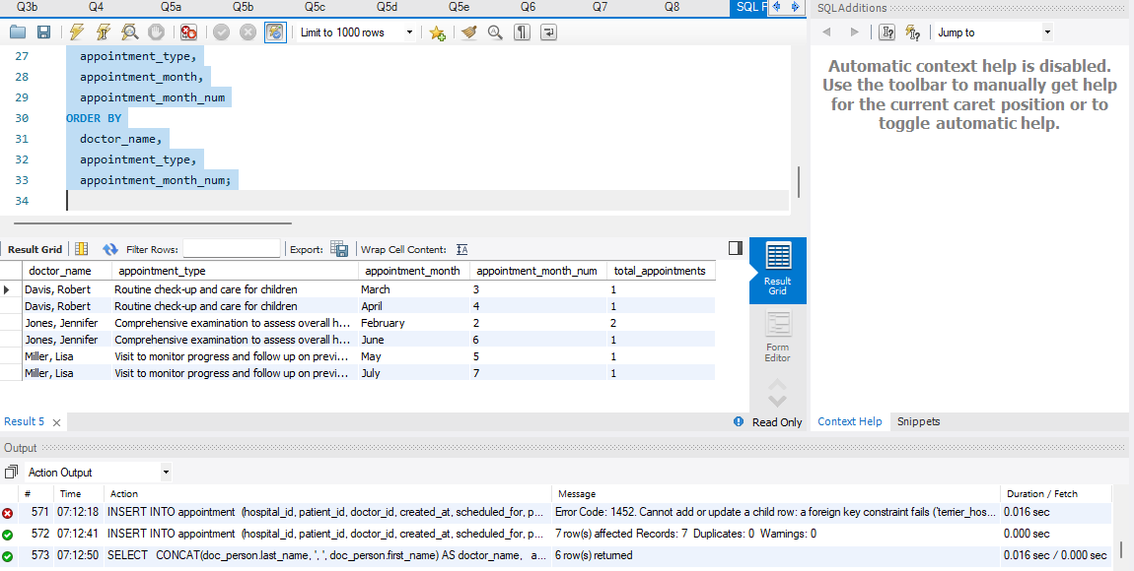

Part 4: OLAP and Grouping Functions
What you need to review: how you answered the previous questions.
- Review the ROLLUP, CUBE, and RANK functions.

- [ Learning objectives: ROLLUP, CUBE]
Write a query that returns the number of appointments made by marital status and ethnicity. The Query should include subtotals and grand totals utilizing ROLLUP and or CUBE.

Your code and screenshot of the executed code
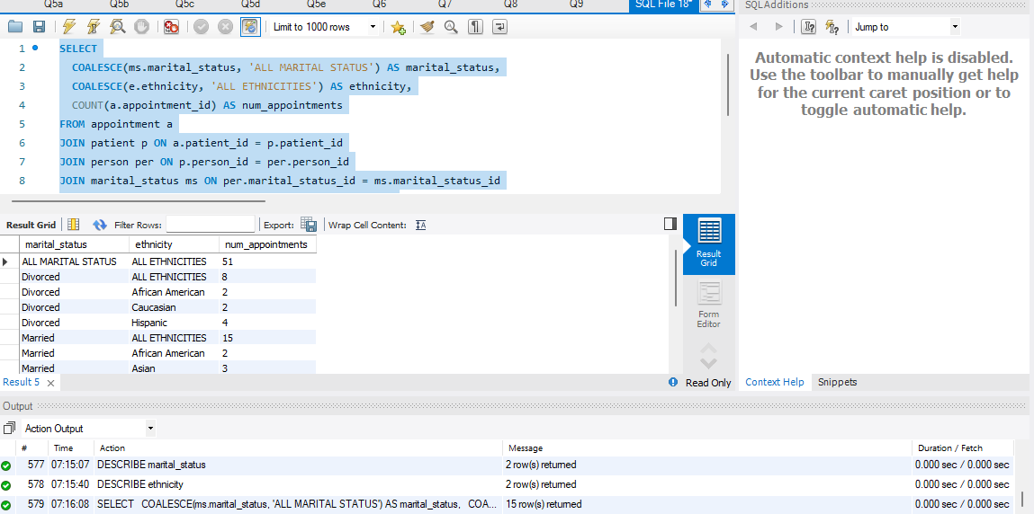
- [ Learning objectives: RANK, GROUP BY]
List age groups of patients by rank based on the protein levels in urine (recall the lab table for each appointment will link to a urinalysis table). You will have to manually create age groups yourself (Child is 0-17, Adult is 18-59, Senior is 60+). You should have two query results, one rank, and one using dense rank.
  - Review the appointment, lab and urinalysis tables
  - To create age groups figure out how to determine age and use a case statement
  - Think about what you need to GROUP on, and what you will need to COUNT.
  - Review the RANK and ROW_NUMBER window functions

Your code and screenshot of the executed code
There are only adults in the data as no entries lie outside that range.

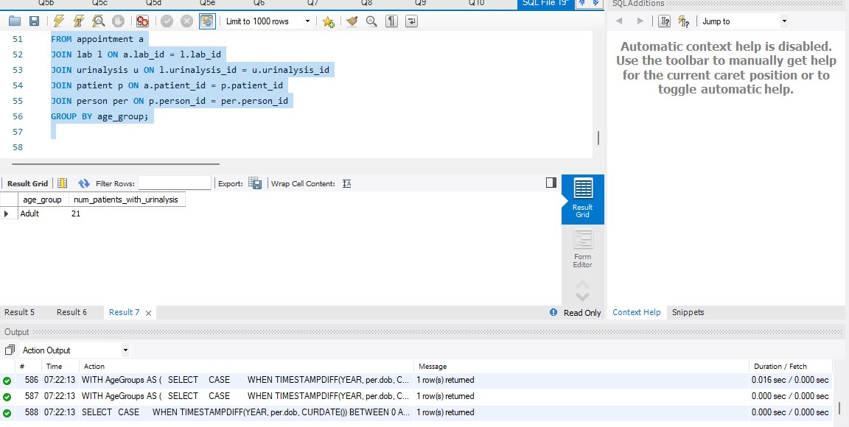

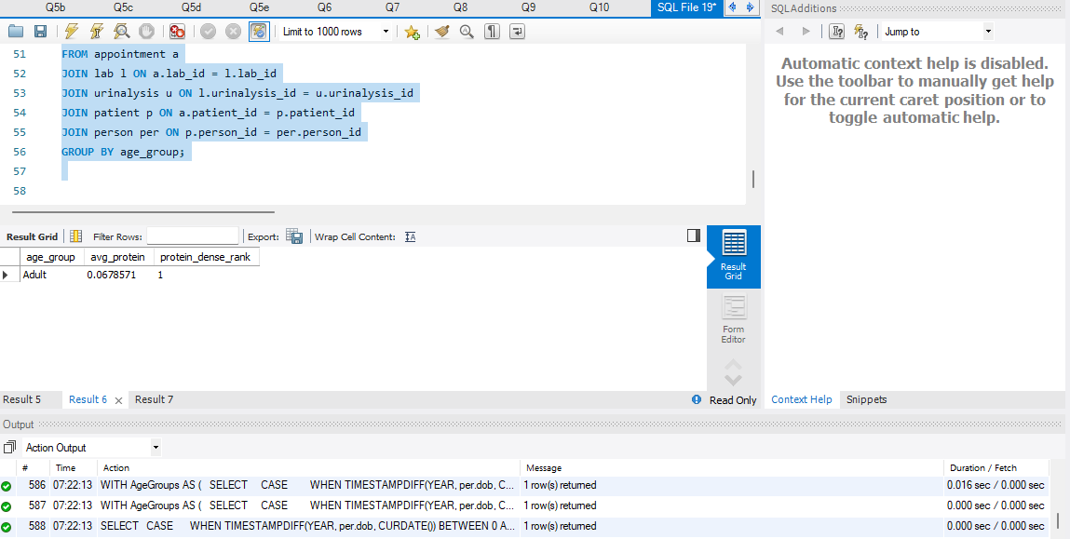

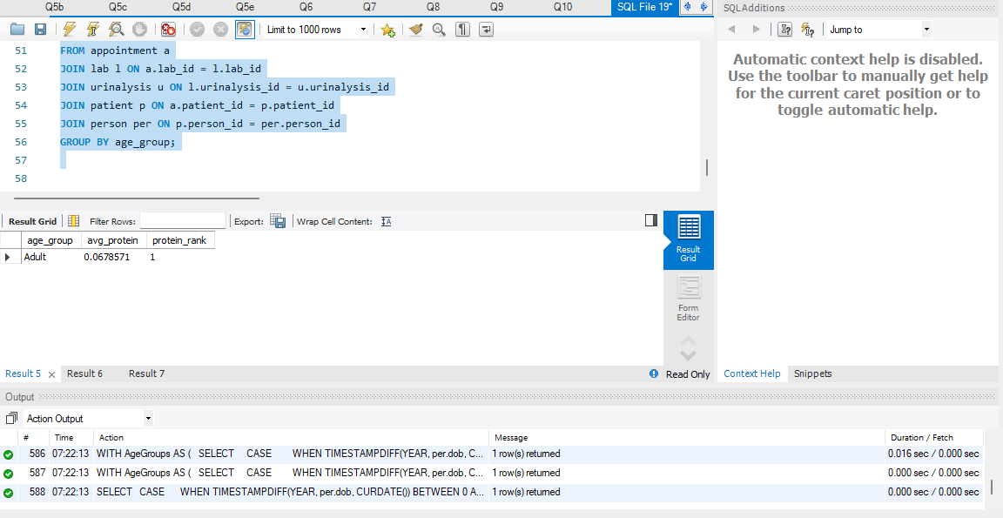

Part 5: Putting it all together

- [ Learning objectives: aggregates, TOP, Filtering within Having clause, CTE/Subquery]
Utilize a common table expression (CTE) as part of your solution to write a query that returns top 3 hospitals with the highest operation charges (on average). The query should return the name of the hospital, the state where it is in, and the average operation charge.
  - Think about what part of this query can be first solved within the CTE.
  - Use Count and think about what to group on.
  - Think about how to filter aggregate data.
  - To determine the operation charge, review how the bill table links to the appointment table.
Your code and screenshot of the executed code
We only use 1 hospital in the database.
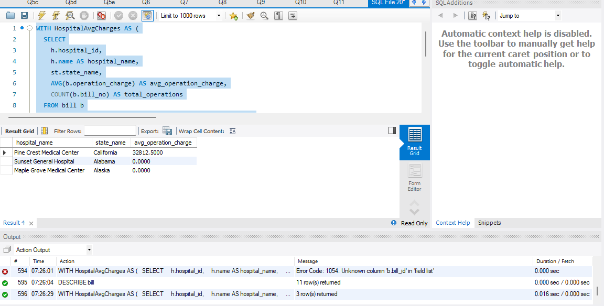

- [ Learning objectives: Correlated subqueries, inline views, window functions]
For each (medical) supplier, list the 2 most expensive drug names it supplies, and the manufacturer name of the drug. Some of the tables use “name” as the column name for the columns, look to rename these to have a better meaning.

- This can be solved via a correlated subquery, or via in inline view with a window function Hint: Solve this one in steps
- Review supplier, medicine and manufacturer tables.
- Look to utilize inline views and or common table expressions.
Your code and screenshot of the executed code

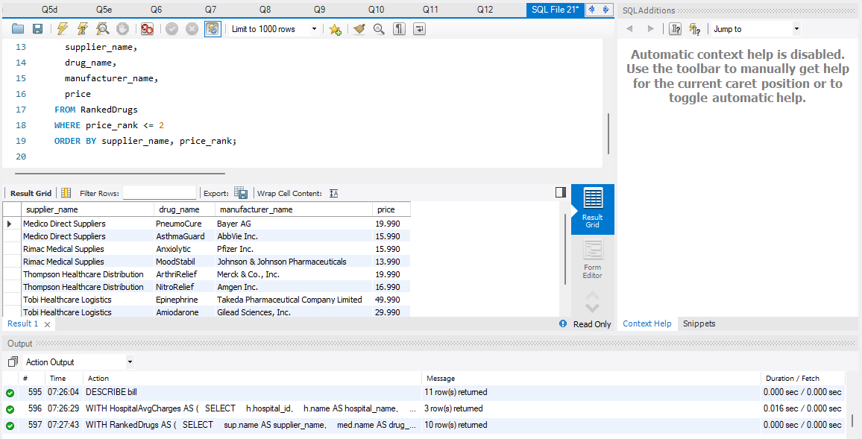

Part 6: Extra Credit Problems
You can pick and choose what you want to work on. If you solve all 4 extra credit problems correctly, you will earn 5 extra credit points. We don’t provide hints for extra credit.

- [ Learning objectives: CTE, inline views, window functions] (1 point)
Take your solution from question 13 which was: for each (medical) supplier, list the 2 most expensive drugs it supplies, the manufacturer of the drug, NEW PART: and for each drug the last time it was prescribed, and what its diagnosis is (name, not code).
Your code and screenshot of the executed code
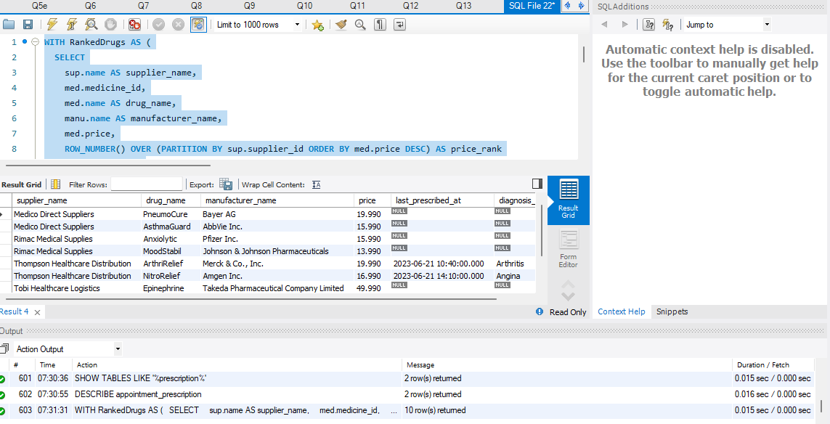

- [ Learning objectives: PIVOT] (1 point)
Write a query that lists the number of medicines prescribed for each manufacturer and supplier. Then PIVOT this so that each manufacturer is listed as a column heading with one row for each supplier.
Your code and screenshot of the executed code
I was stuck on this
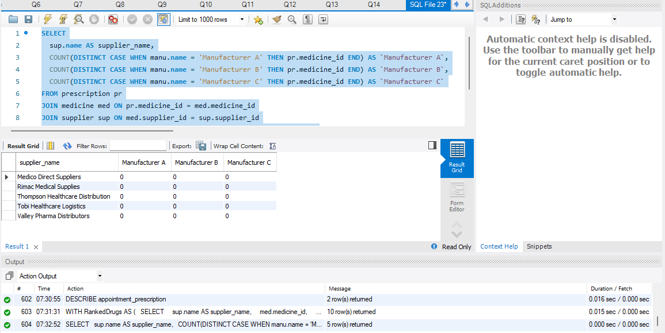

- [ Learning objectives: Normalization] (up-to 3 points)
Notice that the active_ingredient in the medicine table is a repeating group, and this table is not yet in first normal form, correct the schema and the data to make sure it is normalized. Note that ingredients can be part of many medicines.
Your code and screenshot of the executed code

- [ Learning objectives: aggregates, date differences, grouping] (2 points)
Write a query returning patients that have more than one appointment, the average days between appointments for each patient (use the scheduled date). You need to include patient first and last name, DOB with US format (month, day, year) and email. Please add a few extra records for a few of the existing patients as the original data only provides a single appointment per patient. Your results should show a few patients having an average greater than 0 days.
Your code and screenshot of the executed code
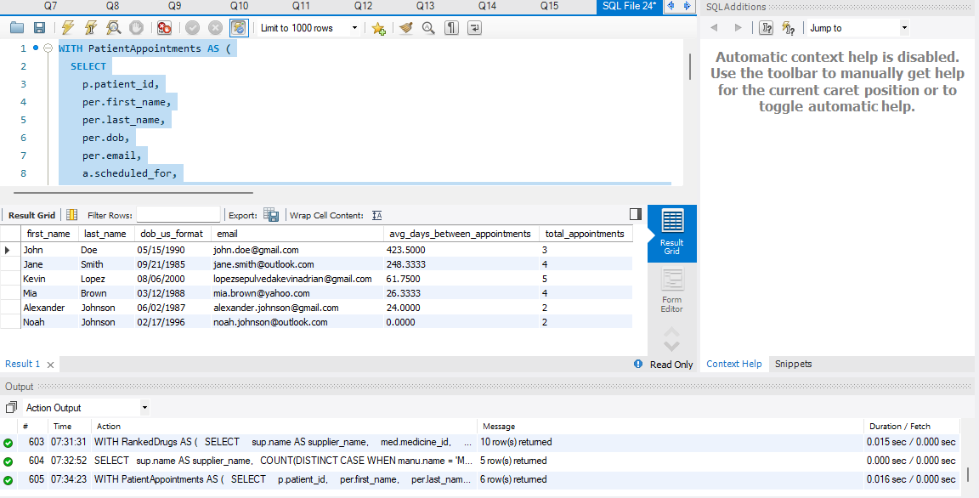

Use the Ask the Teaching Team Discussion Forum if you have any questions regarding how to approach this assignment.
Save your assignment as lastnameFirstname_progPart1_0.docx and submit it in the Assignments section of the course.
For help uploading files please refer to the Technical Support page in the syllabus.

Grading Criteria

Criterion | F | D | C | B | A | Letter Grade
Correctness and Completeness of Results (65%) | Virtually none of the step's results are correct and complete | About ¼ of the steps' results are correct and complete | About half of the steps' results are correct and complete | About ¾ of the steps' results are correct and complete | All steps' results are entirely complete and correct
AI Integration, Explanations and constitution of SQL/Python (35%) | Work is mostly AI-generated with minimal or no student effort, original code, or explanation. | Heavy reliance on AI with little student reasoning. SQL/Python use is weak and explanations are unclear. | AI appears to drive major portions of the work. SQL/Python and explanations are present but show limited student insight. | AI supports problem-solving, with student voice still evident. SQL/Python use is solid and explanations are mostly clear. | AI is used thoughtfully to enhance or validate student work. SQL/Python is strong, and explanations show clear understanding and originality.

Appendix

For students using Oracle: It is highly recommended that you create and login as a non-system user, to reduce the risk of damaging the database. You can create a user with the following commands:
CREATE USER <username> IDENTIFIED BY <password> DEFAULT TABLESPACE users TEMPORARY TABLESPACE temp;
GRANT connect, resource TO <username>;
Example:
CREATE USER NetflixUser IDENTIFIED BY NetflixPassword DEFAULT TABLESPACE users TEMPORARY TABLESPACE temp;
GRANT connect, resource TO NetflixUser;
For students using Microsoft SQL Server: It is highly recommended that you create and use a database other than the Master database. You can do so with the following commands:
CREATE DATABASE <database_name>;
GO
USE <database_name>;
SQL Server Example:
CREATE DATABASE Netflix;
GO
USE Netflix;

Saving Your Data
If you choose to perform portions of the assignment in different sittings, it is important to commit your data at the end of each session. This will make permanent any data changes you have made in your current session, so that you can resume working without issue in your next session. To do so, simply issue this command:
COMMIT;
The ANSI SQL specifications require that changes that you make with any database connection (such as an Oracle Developer client) are only visible to that one client, and to no other clients (user sessions) until you specify that they are to be made public and durable using the COMMIT command.
The ANSI specifications also require that if you normally exit a database client such as Oracle Developer that the RDBMS will automatically commit the data for you. The ANSI specifications require that the RDBMS roll back (undo) any uncommitted data changes (DML) if the client terminates abnormally. In Oracle if you kill the database client without exiting it normally, your uncommitted data changes will be lost. Commit data changes at any time by typing the COMMIT command.
Oracle: Oracle by default conforms to the ANSI standards, so data are not committed until you request it with a COMMIT or terminate the client normally. To override the default type SET AUTOCOMMIT ON. This will cause Oracle to perform an implicit commit after each change that you make. DDL such as CREATE TABLE is always committed.
PostgreSQL: PostgreSQL by default auto-commits the data. PG admin documentation provides information on how to change autocommit option:
Click the Execute/Refresh icon to either execute or refresh the query highlighted in the SQL editor panel. Click the down arrow to access other execution options:
- Add a check next to Auto rollback on error? to instruct the server to automatically roll back a transaction.
- Add a check next to Auto commit? to instruct the server to automatically commit each transaction.
https://www.pgadmin.org/docs/pgadmin4/development/query_tool_toolbar.html

MySQL: https://dev.mysql.com/doc/refman/8.0/en/commit.html
SQL Server: The default configuration of MSSQL does not follow the ANSI specification. By default, MSSQL commits all database changes automatically after each request. This prevents MSSQL from correctly executing transactions that involve multiple requests. MSSQL databases used in transaction processing should turn this off using the command:
SET IMPLICIT_TRANSACTIONS OFF
An explicit COMMIT is not required when working with SQL Server with IMPLICIT_TRANSACTIONS ON. You may want to experiment with turning auto commit off. You can accomplish this with the commands:
SET IMPLICIT_TRANSACTIONS { ON | OFF }
For additional information on SET IMPLICIT_TRANSACTIONS, consult the MSDN article: http://msdn.microsoft.com/en-us/library/ms187807.aspx.

