Overview of the Assignment:
The assignment simulates a real-world environment of walking into a working system and adding additional functionality. In this exercise we will continue working through advanced programming components, specifically looking at triggers, user defined functions, stored procedures and code-reuse. We will also be thinking about implementing a basic data pipeline via a trigger. This assignment also prepares you for the rigors of testing your solutions, something that’s very important in the industry.

Preparing for the Assignment

Before the exercises in this assignment can be completed, you should complete Advanced SQL Programming Part 1.

It is strongly recommended that you review and be familiar with the Terrier Hospital schema and the questions before beginning the assignment.

Make sure to document and test your code:
- Adding code comments will help us understand what you are logically trying to do and is a great habit to get into for code readability, flexibility and reusability.
- In the case of triggers, provide screen-shots of before and after of the data (i.e. what the history table looks like before the trigger is fired, and what it looks like after.)

Advanced Programming Part 2 Questions

You have been asked to make additional programming changes to the database and add new functionality. Your assignment is to implement the following additional requirements. Note that you should review your solution to Advanced Programming part 1 and reuse the components which you developed there.

- Evaluate and implement (create) an appointment_history table for the hospital network database. This could be a denormalized design or an audit design, or a combination of both. Review the next few questions to see what you might want to include within the history table:
- Consider denormalization and what might be useful within the history table for reporting purposes to reduce the joins. A denormalized design should focus on 1:1 relationship with appointment table
- Your history table could be an audit table, or a denormalized design, or a combination of both.
- Consider what happens at insert, update and delete on the appointment? In both designs we don’t want to allow deletions in the history table, but how do we track updates and deletes in the history table?
- Explain your design, the purpose of your history table, and include reasoning for denormalization.
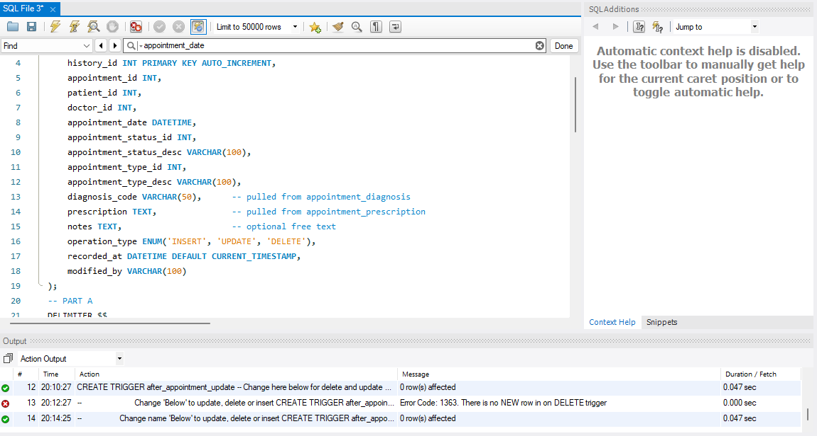

- Explain the design of your history table and state if you are denormalizing, auditing, or both. If denormalizing, what tables and columns will be used to populate it. If auditing, which columns are you capturing in the audit? What happens at insert, update and delete? Please provide an ERD of your history table design as it relates to other tables in the original design (if any).
  - The history table is denormalizing and auditing. It denormalizes the table by combining patient name, doctor name and department name from their respective tables and combining it to this one, creating duplicate entries. It is auditing by creating or deleting new rows for update, delete and update on the appointment table. It also uses values from the other tables automatically. The auditing is also done by a trigger that is easily modifiable. As for the design, it has standard patient details and doctor information such as their IDs. It also combines information via a trigger for prescription information. In the trigger it also pulls and changes status and type descriptions of the appointment. This provides a clean view of all necessary information of what the appointment accomplishes for doctors to review. If the table did not have a trigger it would have to consistently add inserts, updates and deletes to both tables with possibility for error.

Your history table design and explanation

- Provide history table DDL, and initial populate script – since the appointment table already has some test data look to bring the initial records into your history table to catch these up with the appointment.

Your code and screenshot of the executed code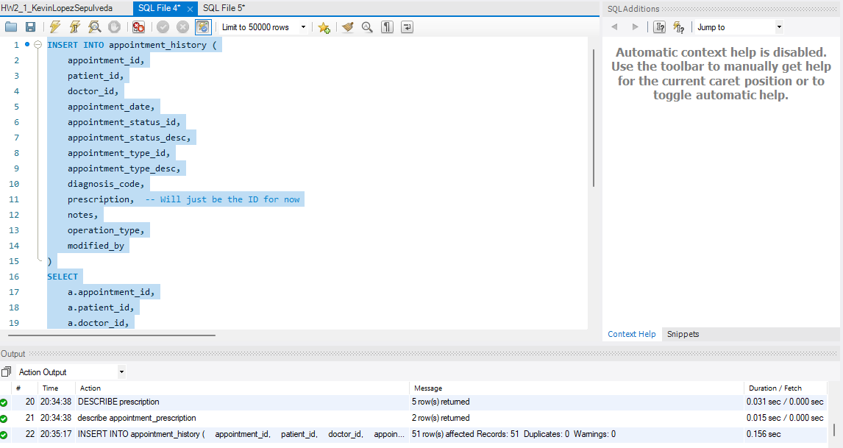
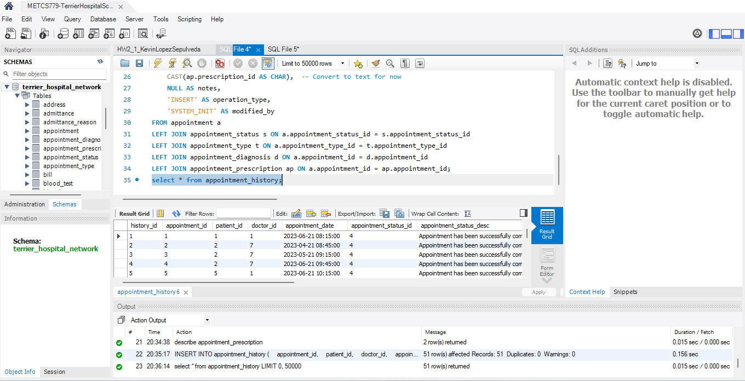

- Implement a trigger for this new appointment_history table that prevents deletions from the table using error handling logic.

  - Your code and screenshot of the executed code of the trigger
  - Test case: demonstrate that you can’t delete a record from the history table.
    - I thought of creating the triggers immediately after question 1 part 1. I will Create a new trigger that undoes this and makes this correct trigger. The original trigger deleted from the table.
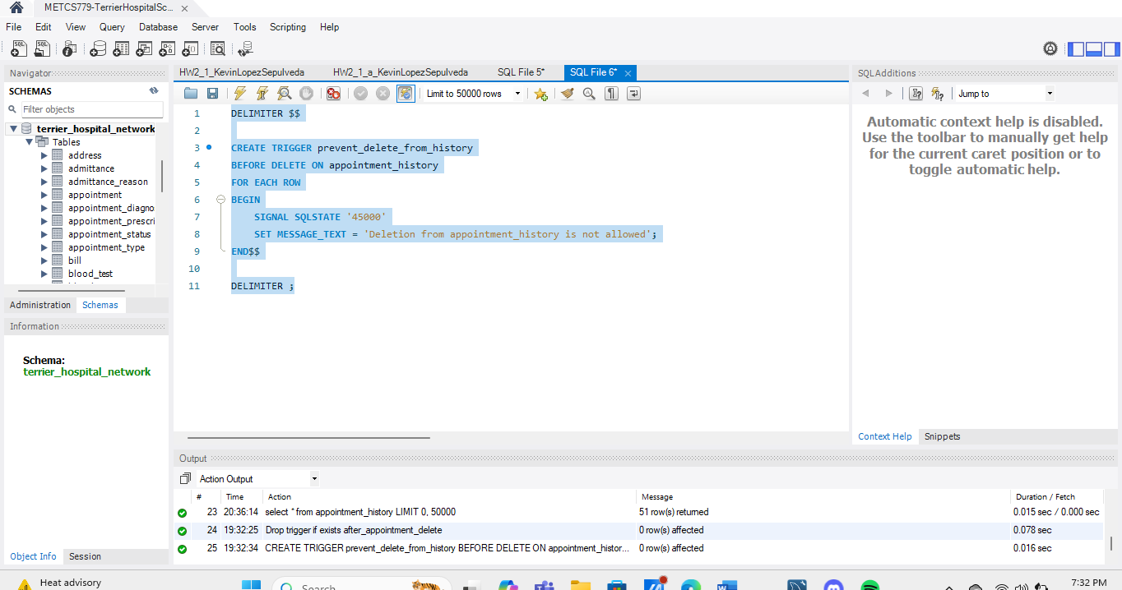
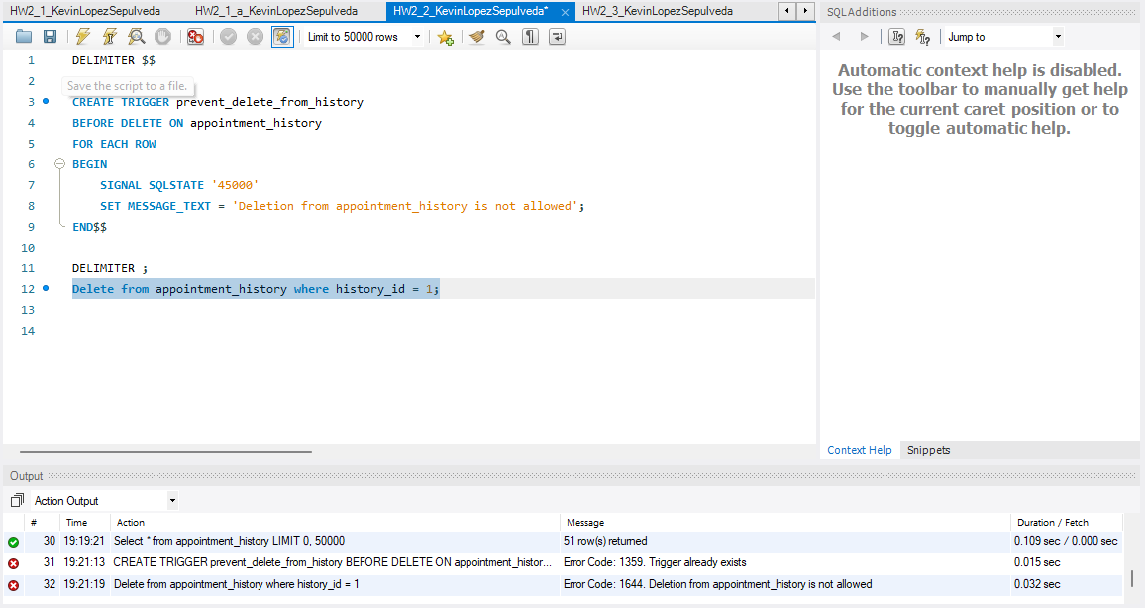

- Implement a trigger that maintains the appointment based on the transactions made to the appointment table. Make sure to consider insert, update and delete transactions.

  - Your code and screenshot of the executed code compiling of the trigger
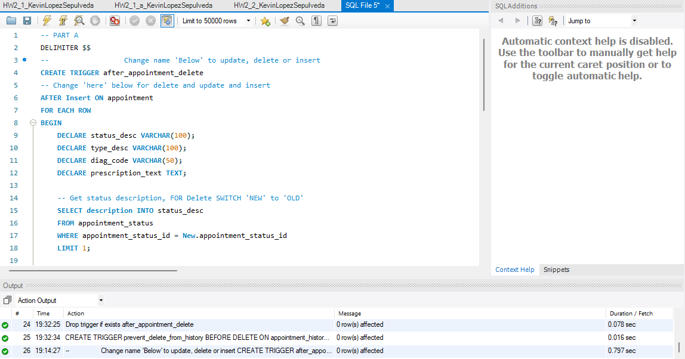

  - Show what the history looks like before each of the following test operations.
  - 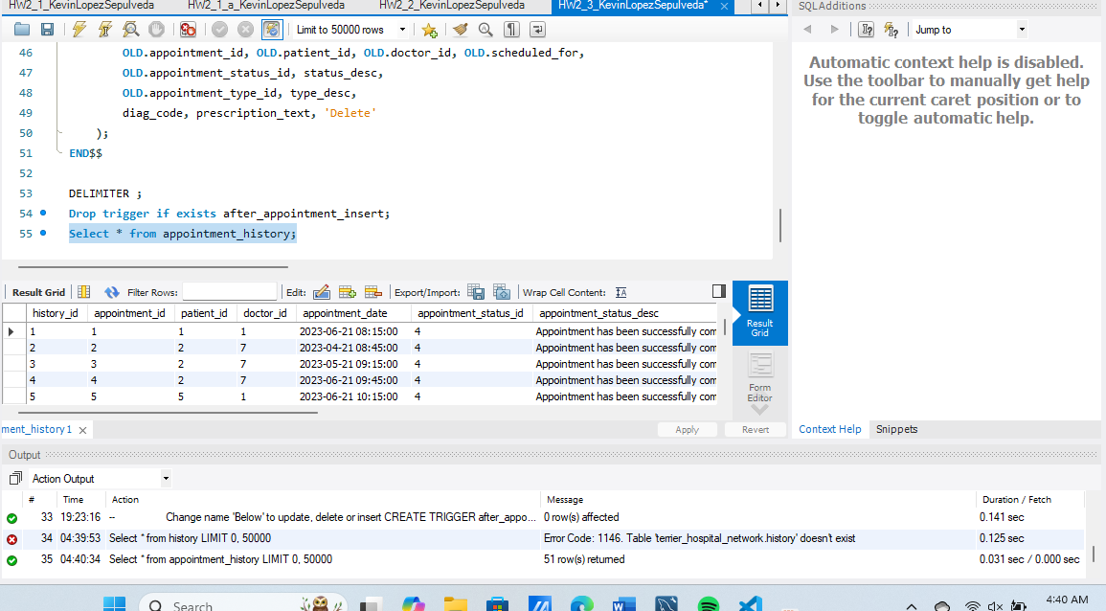

Your code and screenshots of the executed code

  - Test cases:

The test case must use your patient record (using your name) and current dates and times. In other words once you insert the record for the appointment, to show that it worked select records from the history table join appropriately to your person record to show that it was indeed your record inserted into the history table.

    - Demonstrate an insert
    - NOTE: I had to go back and remove prescription because it began to break everything.
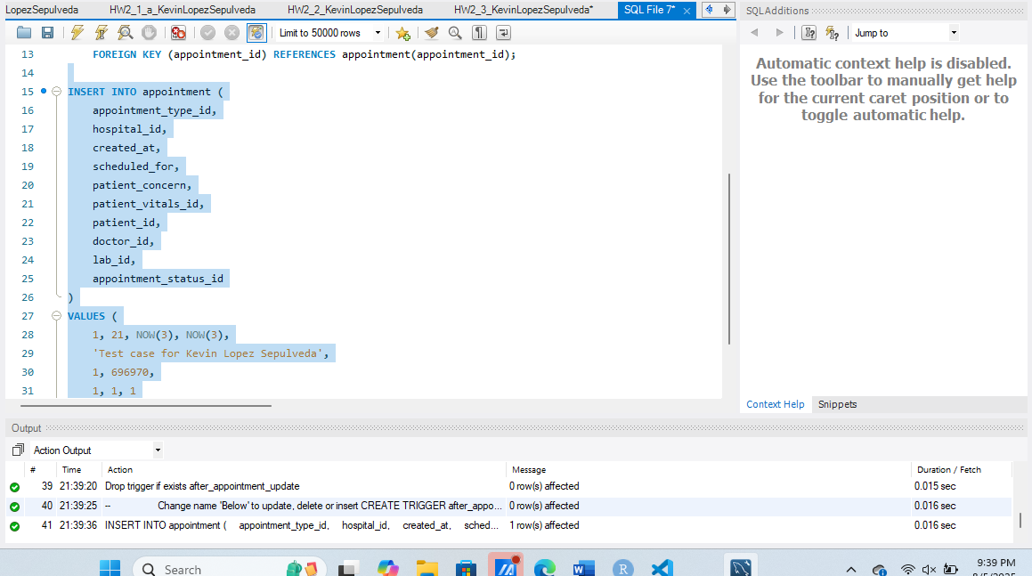
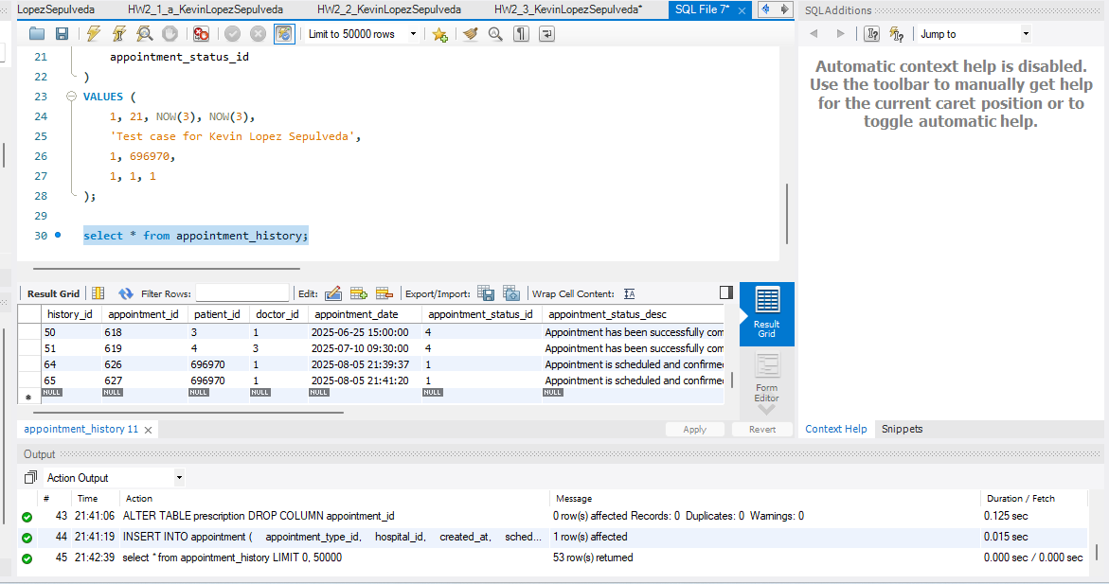

Your code and screenshots of test cases of the executed code

    - Demonstrate an update
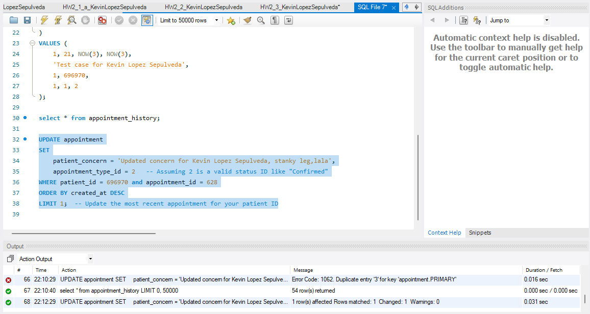
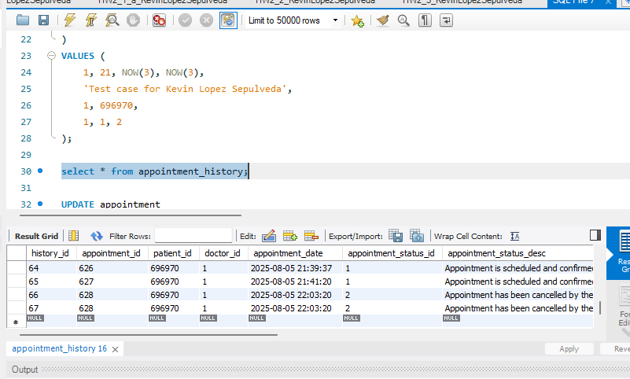

Your code and screenshots of test cases of the executed code

    - Demonstrate a delete

Your code and screenshots of test cases of the executed code
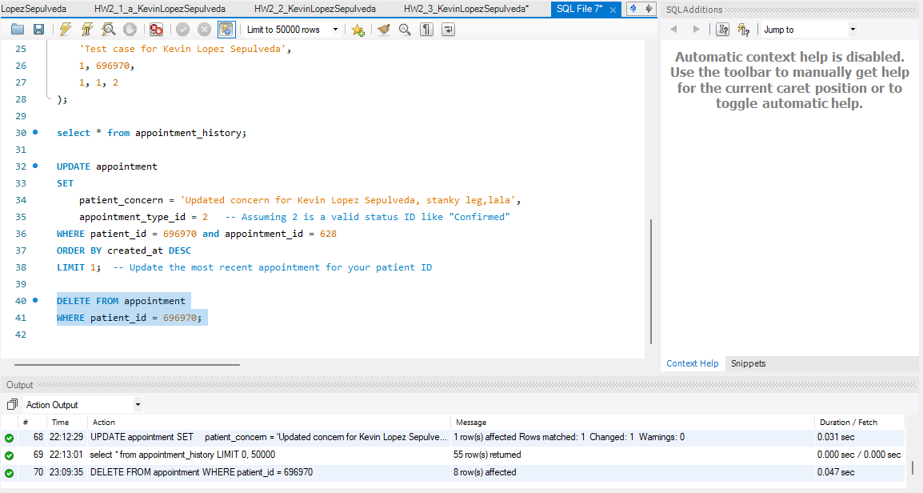
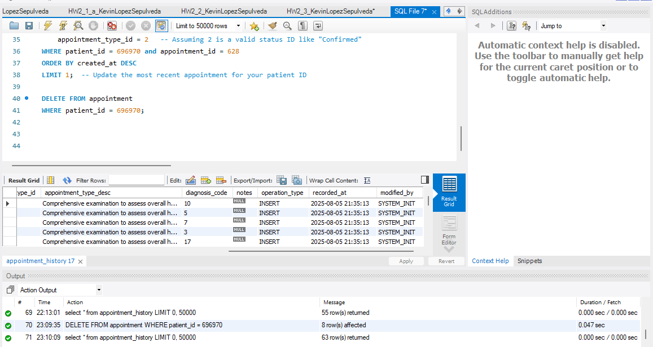

In the next set of questions, we will be implementing functionality to add appointments, questions 4 and 5 will have you create user defined functions, and question 6 will allow you to practice building a simple stored procedure, which will all be re-used and or expanded on in question 7.

- Implement a user defined function which checks if the doctor is working at a specific hospital. Question 7 will need to utilize this function.
The following are the business rules for the function
  - Input parameters should be doctor_id and hospital_id
  - Inspect the doctor, hospital, employee and department table. You will notice that there is a relationship that determines which hospitals are associated with which doctors. Begin by creating a query that identifies which hospital a doctor of your choice is associated with.
  - Modify the query above into a user defined function which checks if the doctor and hospital input parameters match what’s in the database, returning true (or 1) for a match and false (or 0) if there is no match.

  - Your code and screenshot of the executed code compiling of the user defined function.
  - Minimum test cases: (you are welcome to test beyond this).
    - Run a query (b) to show what the data looks like to show what we should expect as a return.
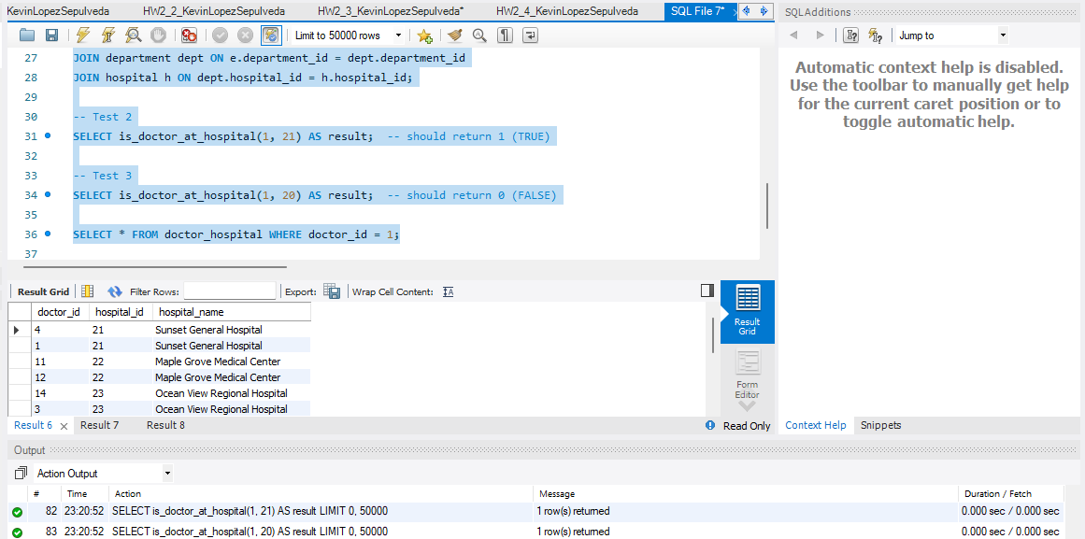
    - Test a doctor and hospital combo which matches.
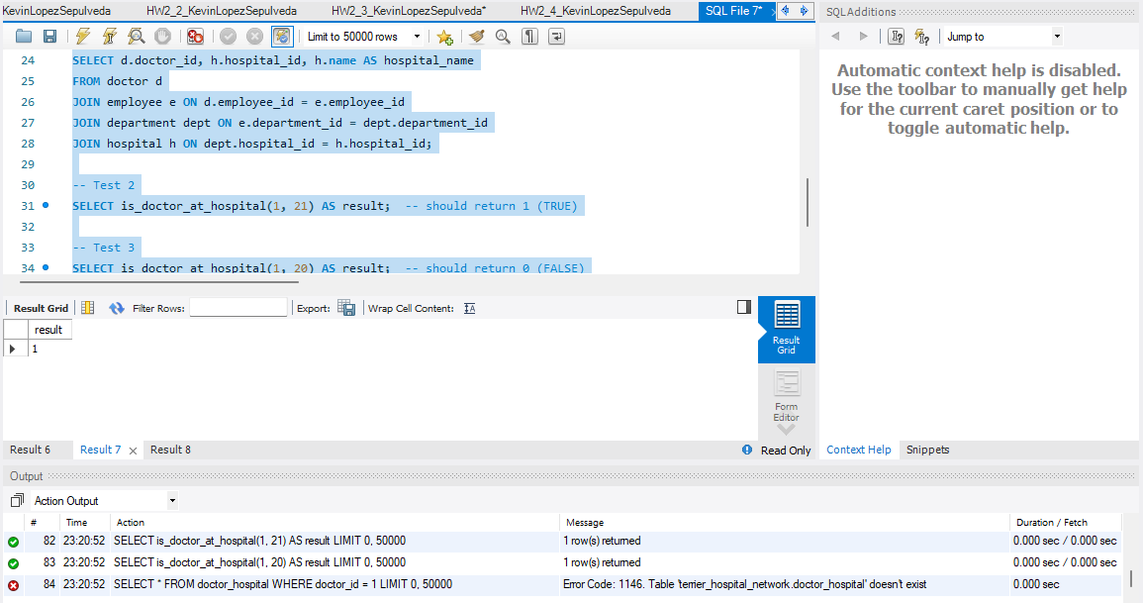
    - Test a doctor and hospital combo that does not match.
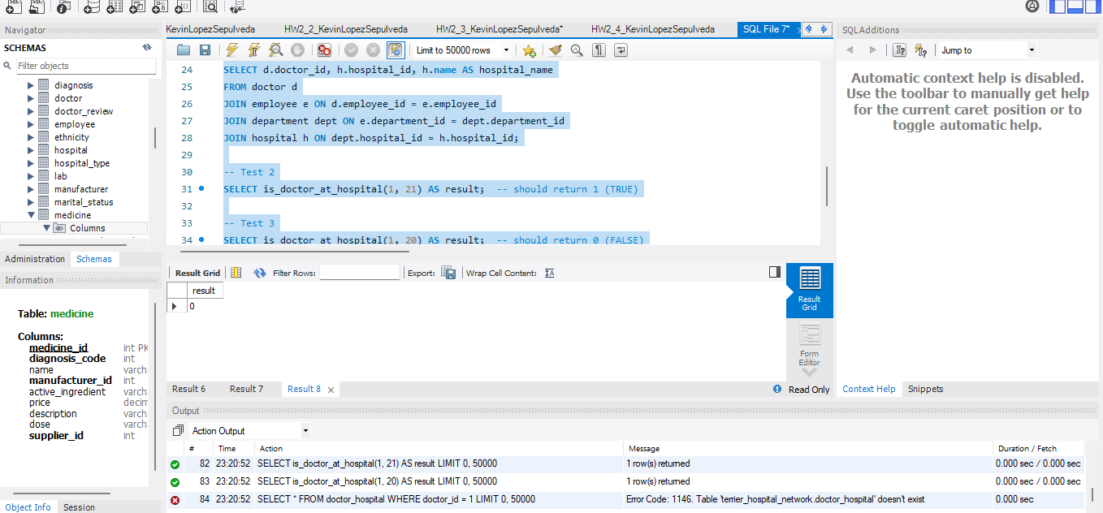

- Implement a user defined function which determines the next available time-slot for a doctor based on the data in the appointment table. Question 7 will need to utilize this function.
  - Your function should take a parameter of doctor_id, and a specified date and time, and check against the scheduled_for attribute.
  - You will be asked to explain and demonstrate the core functionality of the logic that you come up with.
  - Business rules to consider:
    - Appointments can be scheduled between the hours of 9 AM and 5 PM
    - Assume that each appointment runs an hour, for example if the appointment is scheduled for 9 AM, the next appointment slot can be offered at 10 AM.
    - Appointments are only offered Monday through Friday
    - If no time slot is available for this day for this doctor, or it’s the weekend, return NULL. You can also suggest the next day appointment if you would like to expand functionality.
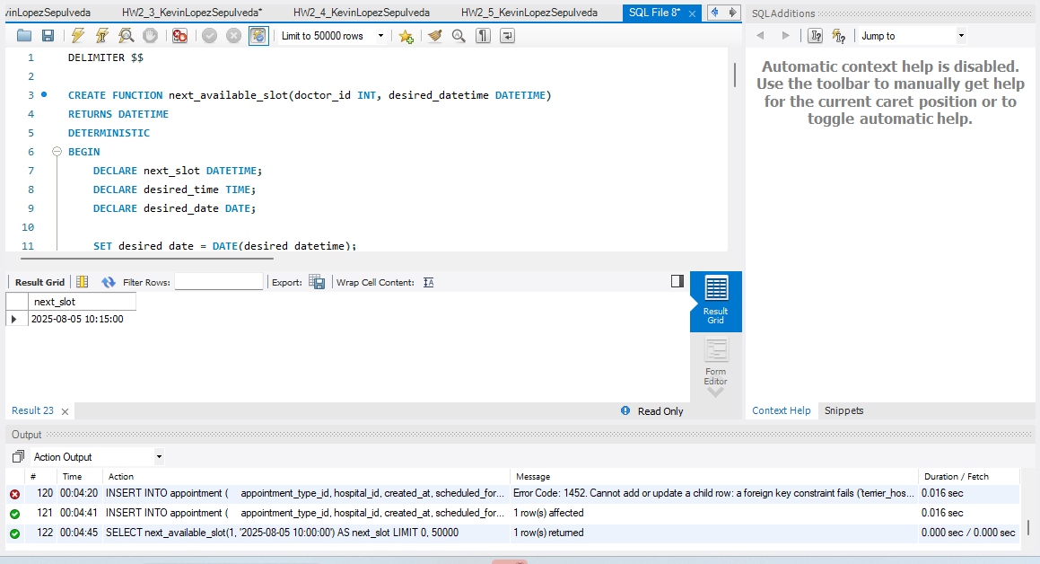

Hint: Write out your logic first as a select statement which might have sub-queries, for example think about building a data set of available time slots for the specified day for the specified doctor, and then compare that to the appointment table to find openings, return the one closest to the time given.

  - Write out/document the logic of your solution as clearly and concisely as possible. Provide a sample set within your logic that demonstrates how it works fundamentally. For example a query or a loop which is determining the time slots used and or available.
- To manage appointment scheduling within the Terrier Hospital Network, I developed a SQL-based solution that prevents overlapping appointment times for the same doctor. The logic starts with checking for existing appointments that conflict with a new one by comparing the scheduled_for and ends_at timestamps. When a new appointment is about to be inserted, a before_insert trigger checks whether the intended time range overlaps with any existing appointments assigned to the same doctor. The logic uses a condition that compares the new appointment’s start and end times against those already in the system. If any overlap exists, the trigger raises a signal to block the insertion. This query looks for any existing appointment where the new appointment’s start time is before the end of an existing appointment, and the new end time is after the start of an existing one. This ensures that appointments only get scheduled in time slots that are fully available. The trigger’s purpose is to make sure that the same doctor isn’t double-booked. For instance, suppose Dr. Smith has an appointment from 10:00 AM to 11:00 AM. If a patient tries to schedule a new appointment with Dr. Smith from 10:30 AM to 11:30 AM, the query would detect the overlap and block the scheduling. On the other hand, a request for 11:00 AM to 12:00 PM would be accepted since the earlier appointment ends right when the new one begins. This ensures efficient use of time slots while maintaining proper scheduling integrity across the system.

  - Your code and screenshot of the executed code compiling of the user defined function
  - Minimum test cases: (you are welcome to test beyond this).
Test case requirement:
- The test case must use your patient record (your name- please demonstrate this explicitly) and current dates and times.
Test cases:
    - Before the test cases show a select statement from the appointment table demonstrating current situation so that the test cases can be validated in context.
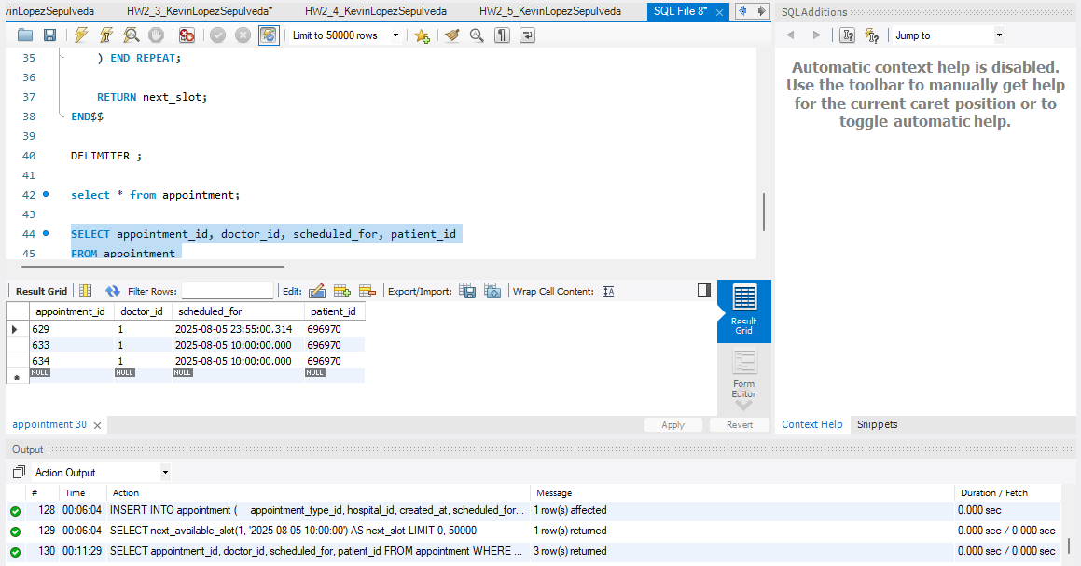
    - Test case where the time slot that’s requested is available
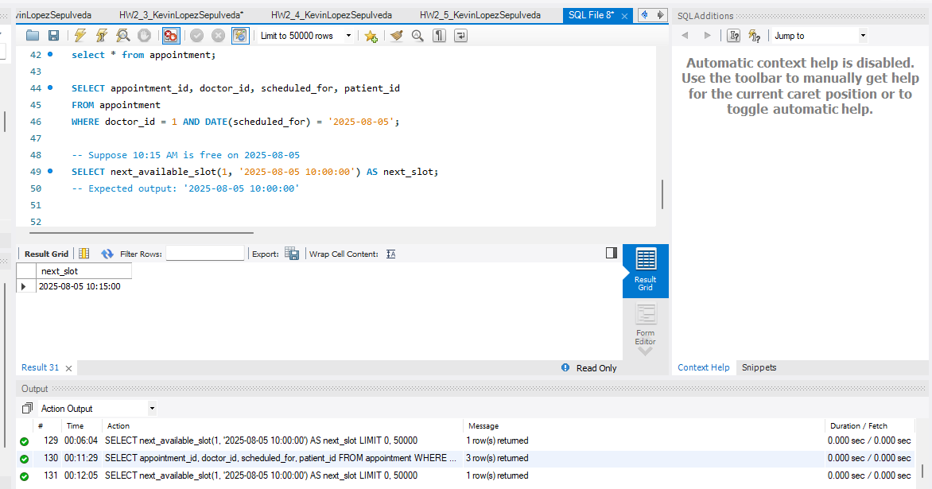
    - Test case where time slot requested is taken and the next time is offered
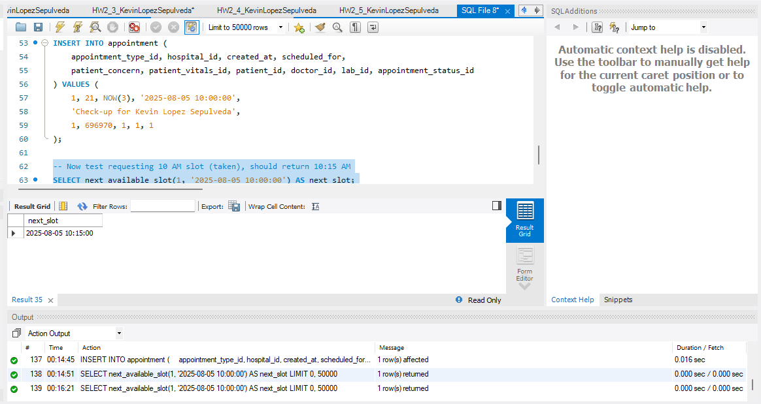
    - Test case if requested day is not available show null or suggest next day appointment.
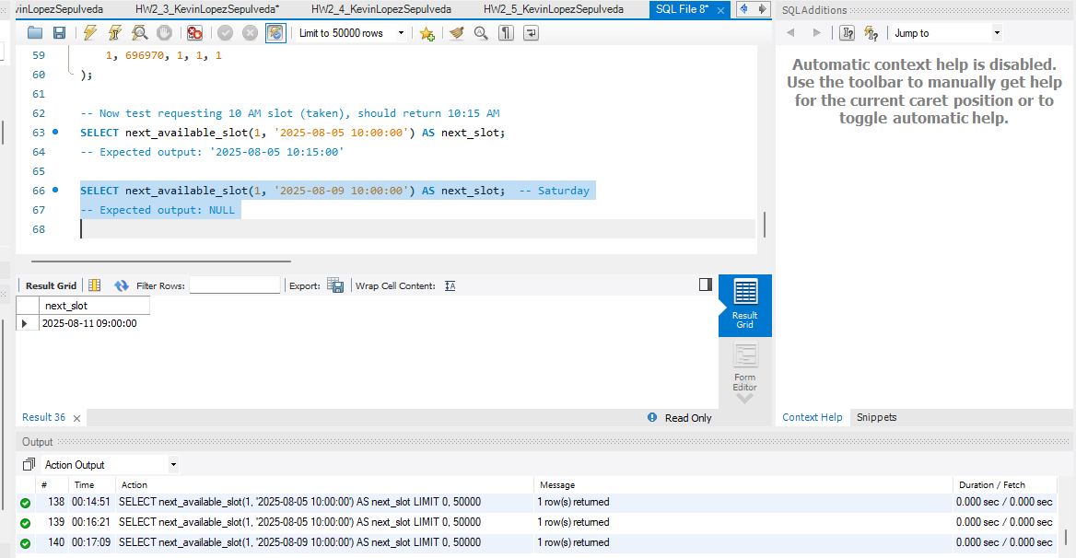
    - Any additional test cases you think are relevant.

  - Your code and screenshots of test cases of the executed code

- Review your solution in Programming Part 1 where you inserted records into the appointment table, and modify that solution into a stored procedure. You will need to have the procedure to maintain the appointment_id. You will build in much more logic in question 7, for now just keep it as simple as possible to get the procedure to insert a record into the appointment table so that you can gain experience writing and executing a stored procedure.

- Your code and screenshot of the executed code compiling of the stored procedure.
- Minimum test case: (you are welcome to test beyond this).
  - Insert the record via stored procedure, use your personal patient record (your name) and current dates and times.
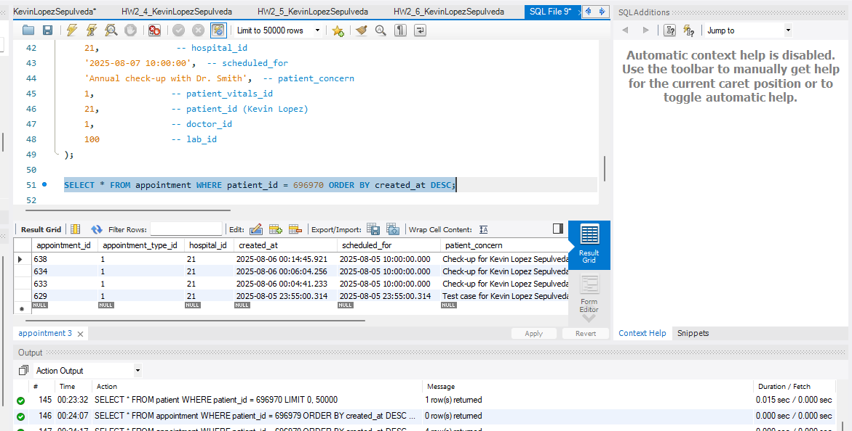
- Update your stored procedure from question 6 for appointment creation which will allow a patient to schedule a doctor’s visit by implementing the following requirements:.
  - Creates a new appointment for the desired time, hospital, and appointment type, as well as patient concern. Your procedure should take parameters of patient_id, requested appointment date and time, patient_concern, appointment_type_id, hospital_id, doctor_id.
  - Auto-fill the appointment ID (review what you implemented in programming part 1)
  - Auto-fill the created at date and time
  - Assign the appointment a relevant status.
  - Appointments cannot be made more than 3 months in advance and less than 1 hour in advance.
  - Newly created appointments should have NULL for patient_vitals_id, and lab_id.
  - Utilize user defined functions you created in questions 4 and 5 to check for available time slots and if the doctor and hospital records match.
  - Error handling you should implement:
    - If the patient does not exist in the system (not present in the patient table), display the message: “Please register with the hospital network before booking appointments.”
    - If the desired time is not available, display the message: “Time slot not available. Please select another time.”
    - The doctor you have selected should exist in the hospital you selected.
    - Validate appointment business rules such as - Appointments cannot be made more than 3 months in advance and less than 1 hour in advance.

Your code and screenshot of the executed code compiling of the stored procedure

Outline the 5-7 test cases you would like to test and confirm

A few test considerations that are required
- The appointment should be inserted for the patient record you created for yourself.
- A test case query needs to show that the appointment was created for you specifically (use joins to connect to patient and person table)
- We recommend being thorough - especially around error handling situations outlined in “h” above.
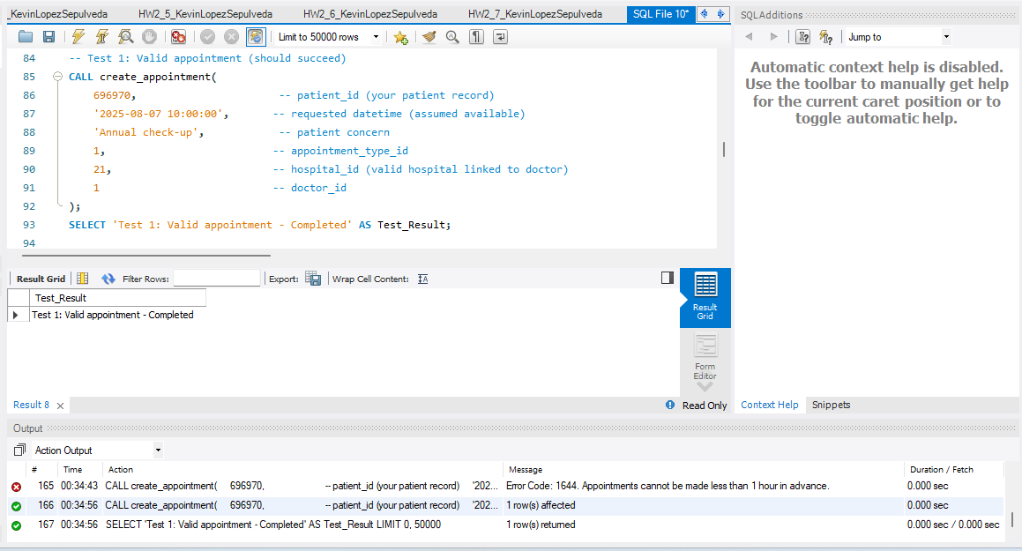
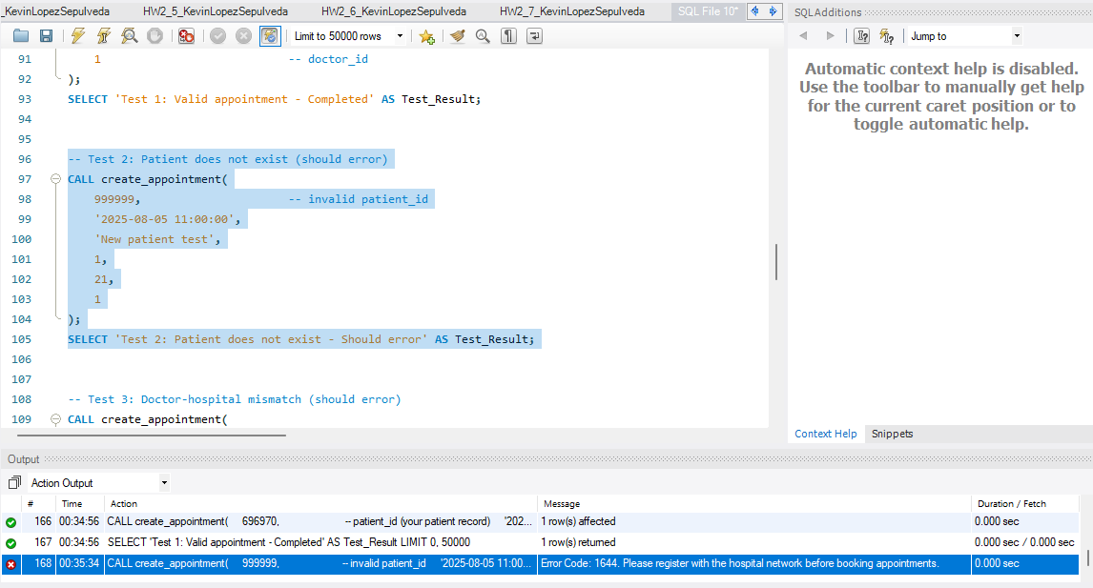
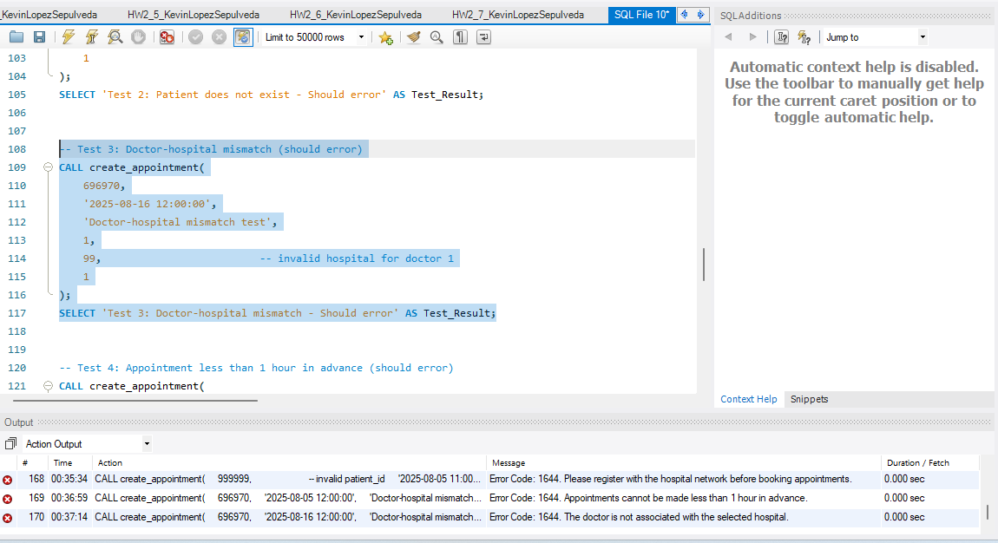
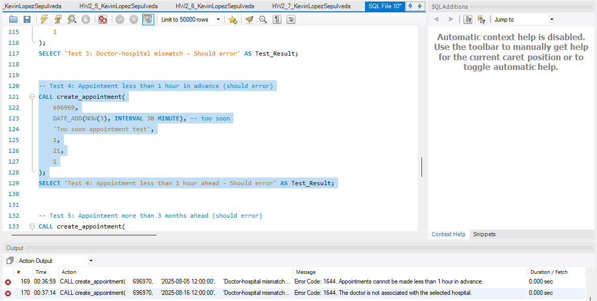
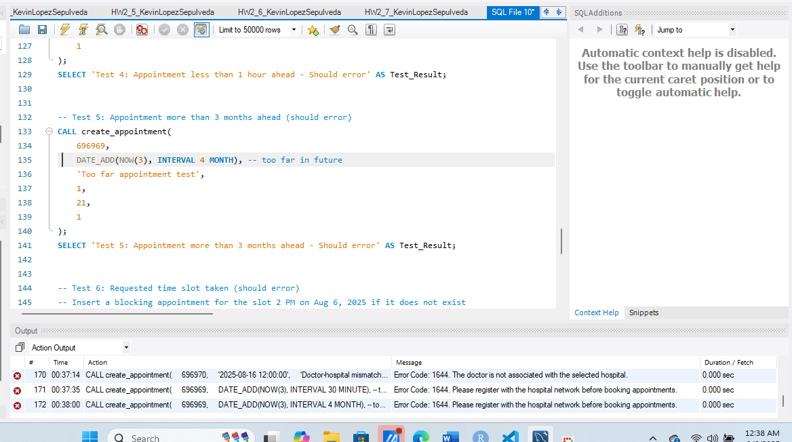
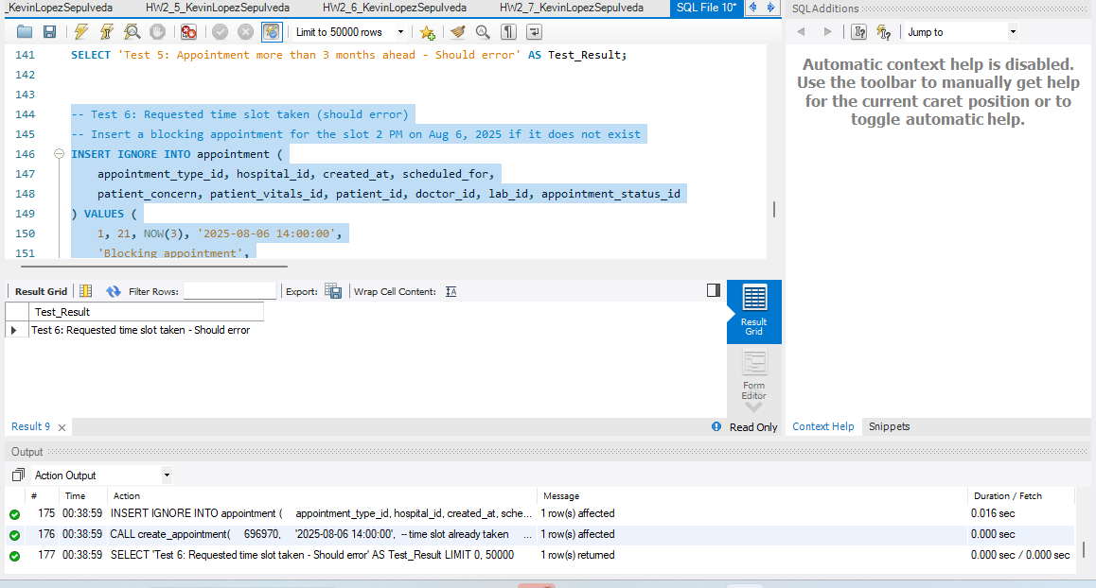
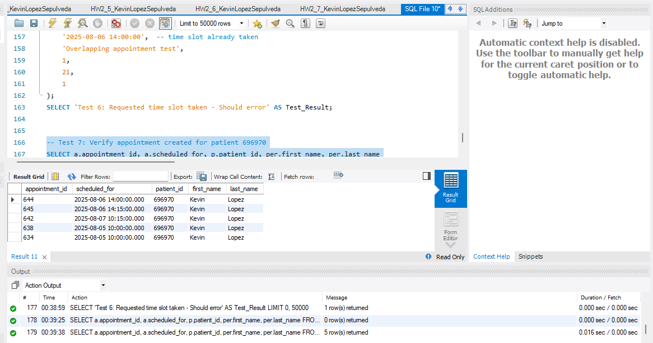

Your code and screenshots of test cases of the executed code

- Extra Credit (up to 3 points): Implement a stored procedure/user defined function combination to implement functionality of recommending and adding a prescription record based on the diagnosis of the appointment or similar complex functionality where recommendations are involved. Testing needs to be thorough, showing the data was recommended for your specific patient record. Up-to 3 points

Clarify and define requirements for the additional functionality

Your code and screenshots of test cases of the executed code

Outline the test cases you would like to test and confirm

Your code and screenshots of test cases of the executed code

Use the Ask the Teaching Team Discussion Forum if you have any questions regarding how to approach this assignment.
Save your assignment as lastnameFirstname_progPart2.docx and submit it in the Assignments section of the course.
For help uploading files please refer to the Technical Support page in the syllabus.

Grading Criteria

Criterion | F | D | C | B | A | Letter Grade
Correctness and Completeness of Results (65%) | Virtually none of the step's results are correct and complete | About ¼ of the steps' results are correct and complete | About half of the steps' results are correct and complete | About ¾ of the steps' results are correct and complete | All steps' results are entirely complete and correct
AI Integration, Explanations and constitution of SQL/Python (35%) | Work is mostly AI-generated with minimal or no student effort, original code, or explanation. | Heavy reliance on AI with little student reasoning. SQL/Python use is weak and explanations are unclear. | AI appears to drive major portions of the work. SQL/Python and explanations are present but show limited student insight. | AI supports problem-solving, with student voice still evident. SQL/Python use is solid and explanations are mostly clear. | AI is used thoughtfully to enhance or validate student work. SQL/Python is strong, and explanations show clear understanding and originality.
 |  |  |  |  | Assignment Grade:

