Overview of the Assignment:
In this exercise we will experiment with session management and simulate a deadlock.

Required Software
This assignment is designed to be completed in Oracle,Microsoft SQL Server, MySQL or PostreSQL. To create a deadlock we will need two or more sessions connected to the same database and each DBMS handles this a bit differently.

If you are using MySQL workbench, you will need to adjust two sets of preferences. Go to Edit-> Preferences - > SQL Editor
- Set DBMS MySQL session parameters to 6000 in seconds (100 minutes) for all three intervals.
- Uncheck Safe Updates
- You will need to reconnect after making the changes.

Directions:
- Create two sessions connected as the same user to a transactional DBMS. In Oracle SQL Developer and SQL Server Management Studio open two separate query windows, one for each session instead of two separate tabs. Within PostgreSQL PgAdmin you can create two sessions (separate tab). In MySQL workbench, on the home page open a new session, you will see two separate tabs at the top to the left of home. Work slowly through the steps thinking about what’s taking place, fill out the table in question 11 with the results of each step.

- Create two tables :
CREATE TABLE Deadlocker1 (firstName varchar(50), lastName varchar(50));
CREATE TABLE Deadlocker2 (firstName varchar(50), lastName varchar(50));

Your code and screenshot of the executed code
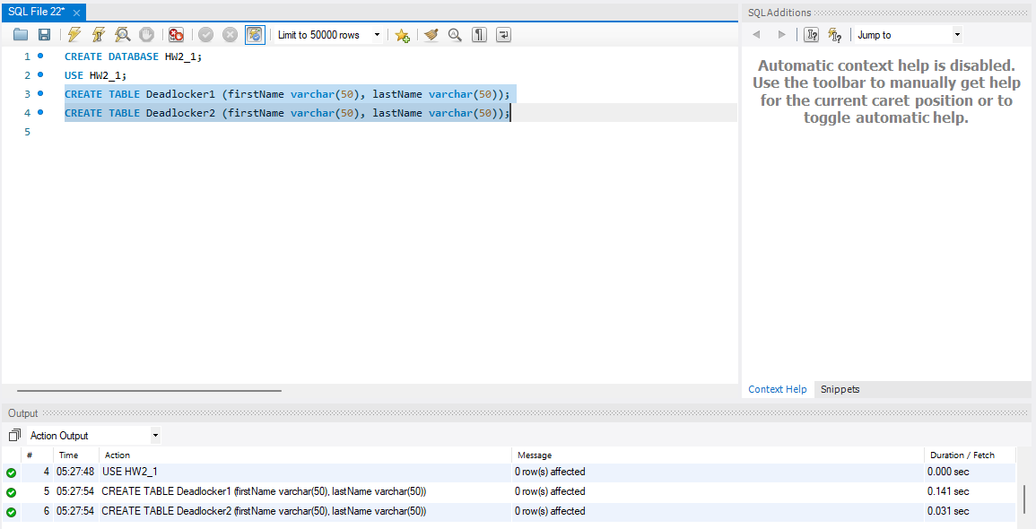

- Insert two rows in each of the tables with different data values, the first record should have your name, and the second record should be someone in your family. The two tables should have the same data.

INSERT INTO Deadlocker1 (firstName, lastName) VALUES([your first name, your last name]);
INSERT INTO Deadlocker1 (firstName, lastName) VALUES([first name, last name]); -- this is a record of someone in your family

INSERT INTO Deadlocker2 (firstName, lastName) VALUES([your first name, your last name]);
INSERT INTO Deadlocker2 (firstName, lastName) VALUES([first name, last name]); -- this is a record of someone in your family

- Note for Oracle autocommit is off by default, in PostreSQL or MySQL make sure to turn AutoCommit off: Commit your transaction.

Check the data in the two tables by doing a simple select.

Your code and screenshot of the executed code (both insert and select)

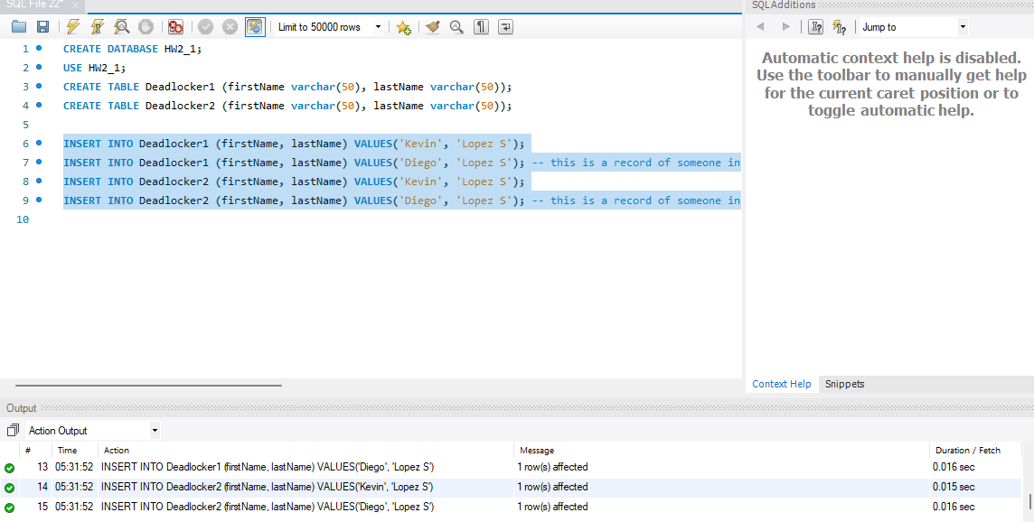
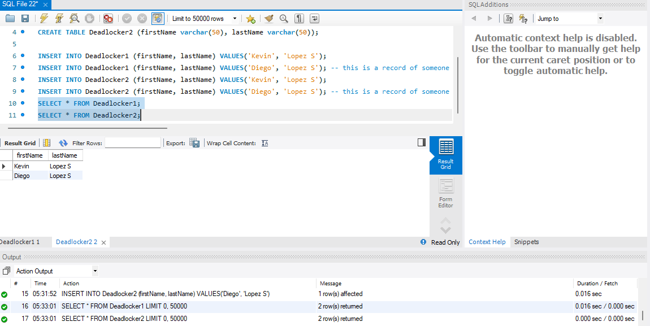

- In the first session start a transaction by updating the Deadlocker1 table by changing the first name of the first row to something else. This procures an exclusive lock on the Dedlocker1 table.

- SQL Server Note: you will need to use transactions to create a deadlock. To do this before the update add line BEGIN TRAN TRAN1

Your code and screenshot of the executed code
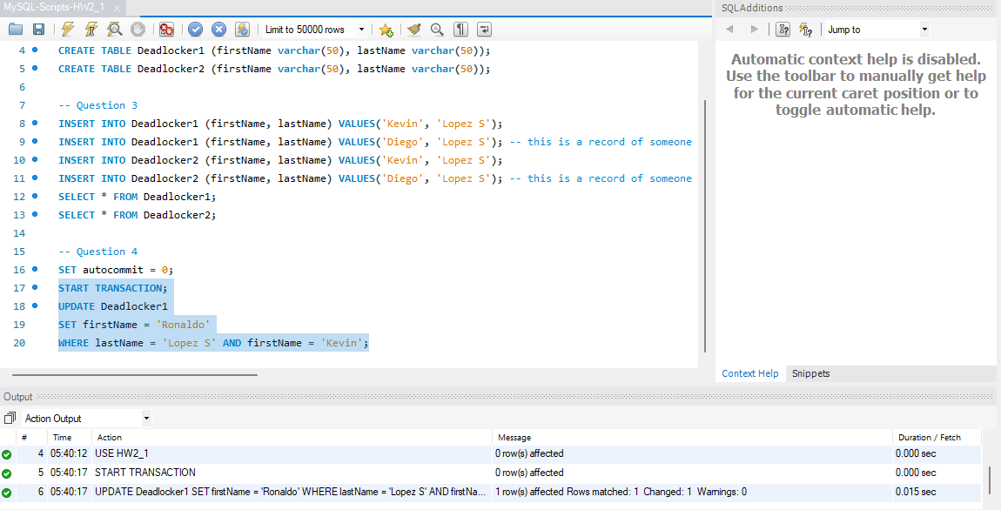

- In the second session start a new transaction by updating the Deadlocker2 table, updating the second row by changing the last name, placing a lock on the second row of the Deadlocker2 table. Note to be careful about your where clause so that only the second row is updated. Check your results by running a select statement from Deadlocker 2.

Your code and screenshot of the executed code
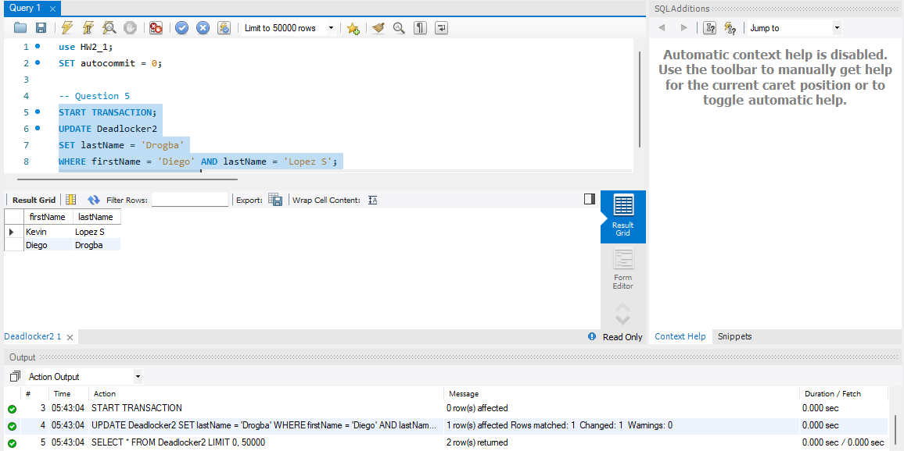

- SQL Server Note: you will need to use transactions to create a deadlock. To do this before the update add line BEGIN TRAN TRAN2

- Within the same second session update Deadlocker1 table, set the first record (either first or last name) to something else. (which is now locked by the other transaction) . Hint: it should be the same update statement as what you did in step #4. Your transaction here should now be executing, it is blocked.

Your code and screenshot of the executed code
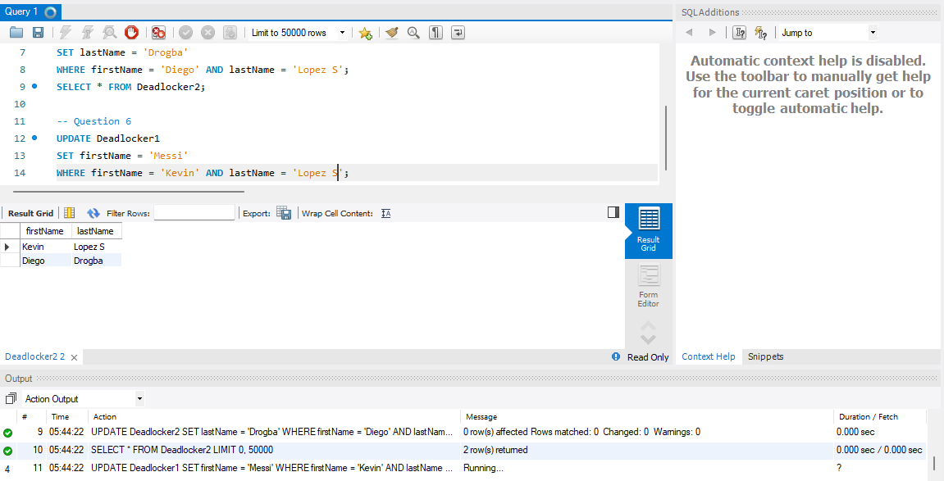

- At this point, the second session should be trying to execute the query and it is blocked. Let us take a look at the locks by monitoring the sessions.

- In Oracle SQL Developer: Under Tools select “Monitor Sessions” and connect as user SYSTEM. A Session window will open. Look for the User who you logged in as (you can filter by the column) and note the UPDATE command running (under the Command Column).

- In Microsoft SQL Server: Open the Activity Monitor (One way is to hold down CTRL-ALT-A)
It is also available as an icon in the toolbar at the top. Expand the processes window. You should see one of the tasks suspended. That is the one that has the lock (examine the wait type and wait response).

- In PostgreSQL: Open a new query tool window and run the following command, examine the sessions and filter the query below to the sessions that you are using.

select datname, usename, application_name,
query_start, state_change, wait_event, wait_event_type, state, query
from pg_stat_activity

- In MySql workbench: Within the Navigator panel on the left, select the Administration tab (to the left of Schemas) and then click on Client Connections under management.

Screenshot of your sessions window
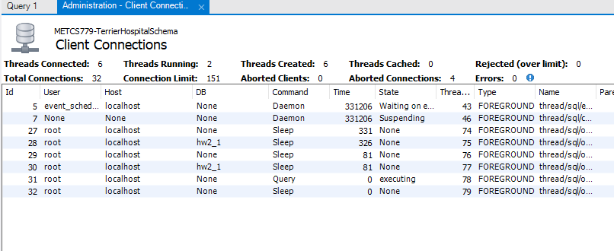

- Now go back to the first session window, which is running the first transaction, and update the second Deadlocker2 table with the same command you used in #5.

Your code and screenshot of the executed code

- In MySql workbench: You might need to reconnect the second session and do this step quickly skipping step 7 if your second session times out and disconnects, MySQl really tries to avoid blocked sessions
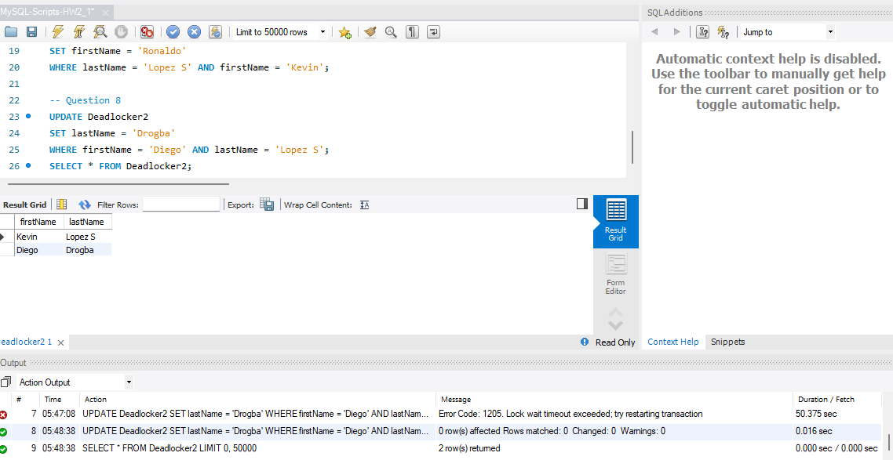

- You will see an error message, which should tell you that the transaction was deadlocked for one of your transactions. Take a screenshot of this and attach it here.

Your screenshot of the deadlock
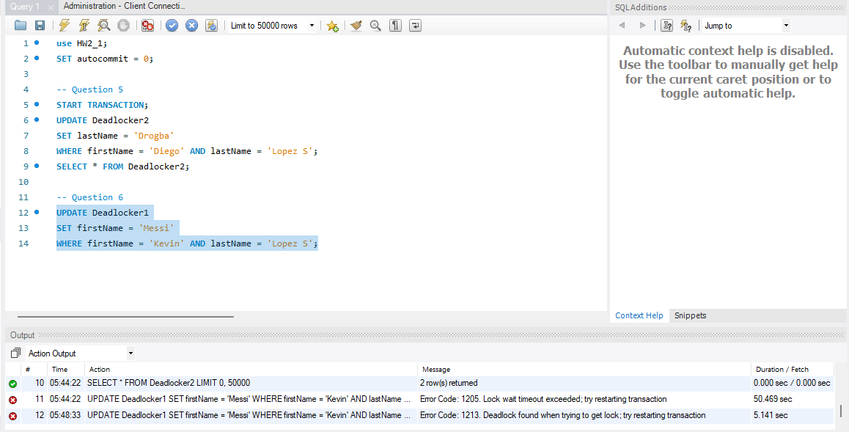

- You can unlock the second session window by committing the transaction. Select data from both tables in both sessions to review what changed and what did not.

Your code and screenshot of the executed code
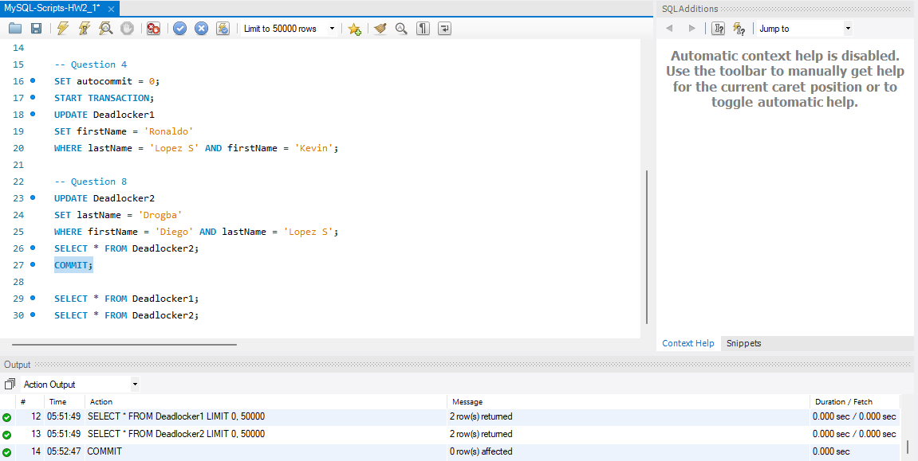
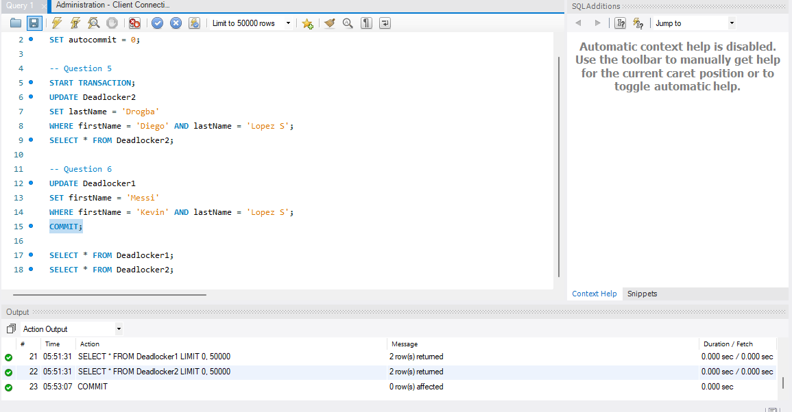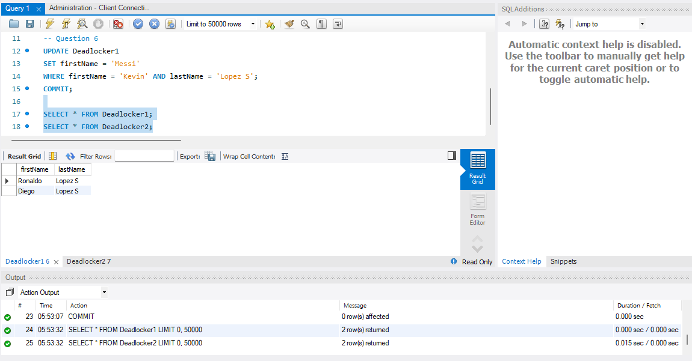
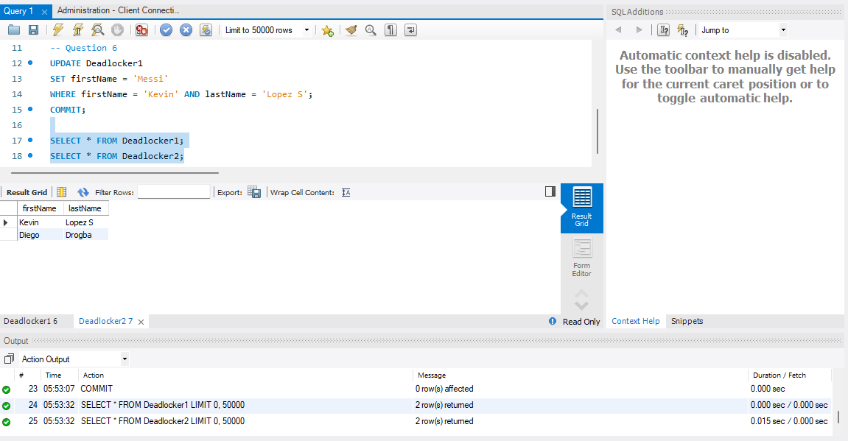
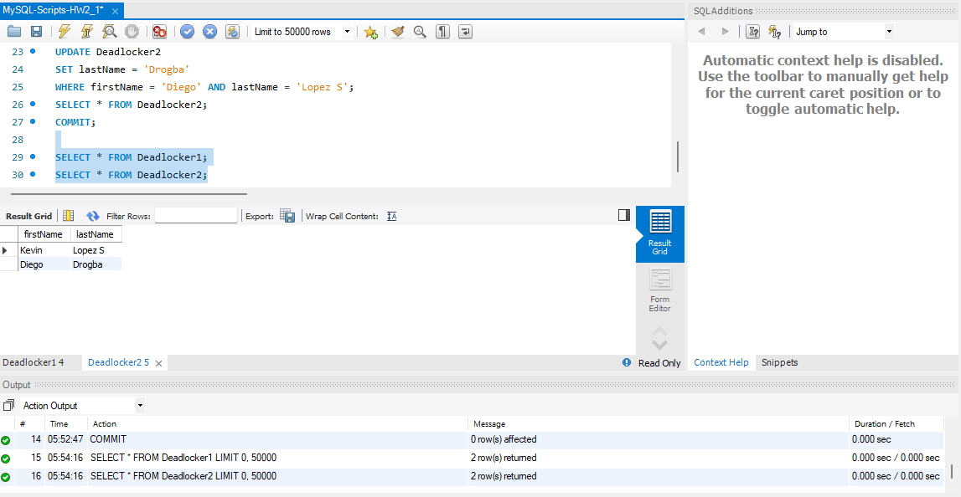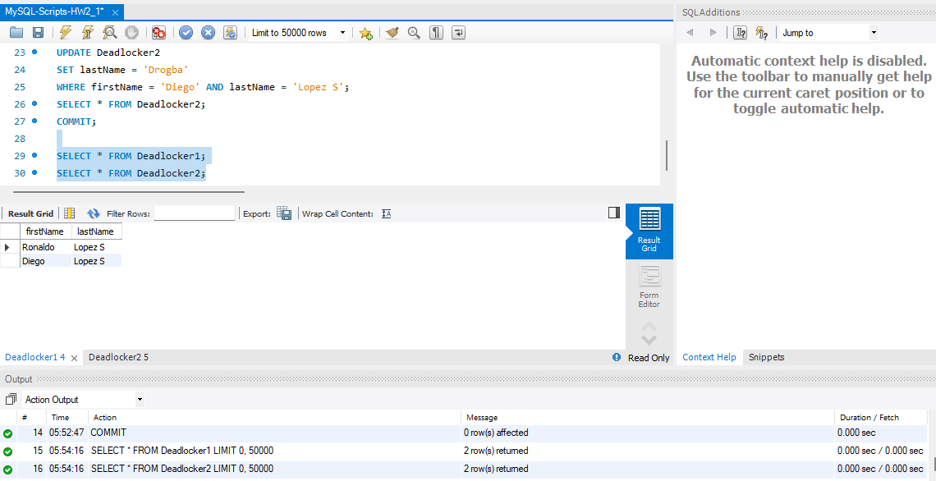

- Complete the table with the data you updated, what is happening at each step, identifying when the deadlock occurs and visibility of data between the two sessions. Below is a sample of the table, make sure to adjust and complete it with the names that you used.

Step | Session 1 | Session 2 | What is happening
3 | Added two records to deadlocker 1 and 2 tables with Bob Sonar and Mary Soling (data is identical) | nothing yet | setting up the data
4 | In deadlocker1 table changed Bob’s first name to Tom, deadlocker2 contains original data | nothing yet | Exclusive lock on the Dedlocker1 table, the first record is updated in Deadlocker1, but it’s not committed so the changes are not yet visible in the second session.
5 | Nothing yet | Updated Diego’s name | Lock on each other
6 | Nothing yet | Tried updating my name | Waiting on lock
8 | Tried Updating Diego’s name with same step as 5 and deadlock error | Blocked | Deadlock
9 | Error in deadlock | Query failed | Nothing, need a commit plus it timed out
10 | Final Tables stabilized | Final Tables Stabilized | Commited

- [Optional] For a more advanced variation you can create a three-session deadlock. Hint: This requires three rows in Deadlocker and multiple Deadlocker tables. (1 point)

Your code and screenshot of the executed code

Use the Ask the Teaching Team Discussion Forum if you have any questions regarding how to approach this assignment.
Save your assignment as lastnameFirstname_assign3_1.docx and submit it in the Assignments section of the course.
For help uploading files please refer to the Technical Support page in the syllabus.

Grading Criteria

Criterion | F | D | C | B | A | Letter Grade
Correctness and Completeness of Results (65%) | Virtually none of the step's results are correct and complete | About ¼ of the steps' results are correct and complete | About half of the steps' results are correct and complete | About ¾ of the steps' results are correct and complete | All steps' results are entirely complete and correct
AI Integration, Explanations and constitution of SQL/Python (35%) | Work is mostly AI-generated with minimal or no student effort, original code, or explanation. | Heavy reliance on AI with little student reasoning. SQL/Python use is weak and explanations are unclear. | AI appears to drive major portions of the work. SQL/Python and explanations are present but show limited student insight. | AI supports problem-solving, with student voice still evident. SQL/Python use is solid and explanations are mostly clear. | AI is used thoughtfully to enhance or validate student work. SQL/Python is strong, and explanations show clear understanding and originality.

