Kevin Lopez Sepulveda
klopezs@bu.edu
METCS779 Assignment 3
NYC QueryQuest Database Design

MET CS 779 Assignment 3

Table of Contents
1. Introduction 2
2. Distributed Database Allocation Strategy 2
1) Fragmentation Design 2
2) Fragmentation Analysis 3
3. Replication and Distribution Architecture 3
1) Distribution Design 3
2) Replication Analysis 3
4. Technology Recommendation 4
5. Conclusion 4
Appendices 5
Appendix A 5
Appendix B 6
Bibliography 7

Introduction
This proposal outlines a distributed database design for QueryQuest, an educational technology platform that connects students and tutors. As the platform expands globally across North America, Europe, and Asia, its current centralized database structure is struggling to meet performance and scalability demands. The increase in users and geographically dispersed data requests has introduced latency, availability, and maintenance issues. Therefore, a distributed database model is necessary to accommodate the growing user base while maintaining data availability, integrity, and performance. This document presents a solution that incorporates fragmentation and replication, both of which are foundational concepts in distributed database systems. The aim is to ensure high performance, fault tolerance, and scalability.
Our design reflects strategic tradeoffs discussed in Coronel and Morris (2024), including the balance between data locality and data redundancy. We also address consistency models, replication latency, and fragmentation overheads. The proposal will include both logical and physical design elements and will end with a recommendation for the most appropriate distributed DBMS technology for QueryQuest.

Distributed Database Allocation Strategy

Fragmentation Design
Fragmentation is an essential technique for distributing data across multiple locations. For QueryQuest, we apply both horizontal and vertical fragmentation. Horizontal fragmentation is used for the Users table, where user records are divided by region. Each geographic server stores only the users relevant to its area. For example, North American servers contain only North American users. This reduces access time and network load because most user requests originate locally. The Courses table is also horizontally fragmented based on course region relevance. Region-specific courses such as “American Literature” or “European Political Theory” are housed on their respective servers.
The Tutors table is vertically fragmented. Core identifying information like Tutor_ID, Name, and Subject_Specialty is replicated across regions since this data is needed globally. However, availability schedules and contact preferences are stored only on the regional node where the tutor operates. This vertical fragmentation reduces the size of transmitted data during searches and supports our design goal of reducing unnecessary cross-regional queries.
The Bookings table is fragmented using derived horizontal fragmentation. Since bookings are tied to both users and tutors, we fragment it based on foreign key relationships. Bookings made by North American users or with North American tutors are stored on that region’s node. This maintains data integrity and query efficiency, as most booking-related operations are regional.
This approach follows best practices from distributed database design, as described by Coronel and Morris (2024), which state that fragmenting tables based on usage patterns enhances local access and improves system performance.

Fragmentation Analysis
A key benefit of this fragmentation strategy is that it allows regional users to access their data with minimal delay, supporting our goal of improved data locality. Since users interact primarily with their local server, network load is minimized and query performance increases.
However, a major tradeoff is that global operations, such as a student in North America searching for a tutor in Europe, now require distributed transactions. These are harder to coordinate and can be slower. According to Coronel and Morris (2024), this complexity is common in fragmented environments and must be managed with distributed query optimization strategies.

Replication and Distribution Architecture

Distribution Design
Replication ensures that copies of critical data exist across multiple locations to support fault tolerance and high availability. In the QueryQuest architecture, each region has its own primary node. These nodes contain the fragmented tables discussed earlier, but they also participate in replication to support global operations.
We apply full replication for certain global metadata tables such as Login, Authentication, and Tutor_Profiles. This ensures that users can log in and search for tutors from any location, regardless of where they initially signed up. Full replication supports system availability and is critical for functions like user login, which need to be available globally.
Partial replication is used for data that is needed occasionally or can tolerate slight delays. For example, the Feedback and Tutor_Ratings tables are replicated using asynchronous methods. This means that user reviews are not updated in real-time across all servers but are eventually consistent.
The architecture follows a peer-to-peer model, which eliminates a single point of failure and provides distributed control. This is in line with Coronel and Morris’s (2024) recommendation that distributed systems should be designed with high fault tolerance and low reliance on centralized control.

Replication Analysis
One advantage of this replication strategy is that the system can continue operating even if a regional server goes offline. Users in Asia can still log in and search for tutors, thanks to replicated authentication and profile data. This supports our goal of system availability and fault tolerance.
A drawback of this approach is the potential for data inconsistency due to asynchronous replication. If a user in Europe posts a review about a tutor, it may take time before that review is visible to users in Asia. According to Coronel and Morris (2024), this is a common tradeoff in distributed environments. For non-critical data like reviews or likes, eventual consistency is acceptable. However, for bookings and payments, stronger consistency models are required.

Technology Recommendation
To implement the proposed distributed design, we recommend using Amazon Aurora Global Databases. Aurora provides strong support for multi-region databases, including automated backups, cross-region replication, and disaster recovery. It supports PostgreSQL and MySQL, making it compatible with most development environments. Aurora’s ability to replicate data asynchronously and provide fast read replicas aligns with our replication goals.
Alternatively, Google Cloud Spanner is an enterprise-grade solution that provides global consistency with horizontal scaling. It is ideal for systems requiring high transaction volumes and strict consistency guarantees. Spanner uses synchronized clocks (TrueTime API) to ensure that distributed transactions behave predictably across continents.
However, Spanner comes with a higher operational complexity and may be excessive for QueryQuest’s needs at this stage. Aurora strikes a balance between ease of use, cost, and advanced features, making it the recommended platform for our design.
As Coronel and Morris (2024) note, the choice of DBMS should be based on the application’s access patterns, consistency requirements, and anticipated growth. Aurora allows gradual scaling and has built-in support for hybrid replication, which is ideal for QueryQuest’s evolving system.

Conclusion
This proposal outlines a scalable and reliable distributed database design for QueryQuest, supporting its expansion across North America, Europe, and Asia. The use of horizontal and vertical fragmentation ensures that data is stored close to where it is needed, improving performance and reducing latency. Replication strategies improve availability and ensure that users can access critical services even during regional failures.
This project helped reinforce the concepts learned in Database Systems: Design, Implementation, & Management (Coronel & Morris, 2024), particularly around the challenges and tradeoffs involved in distributed systems. Designing a real-world application required careful balancing between consistency, availability, and performance. The proposed architecture is flexible enough to support future growth while remaining cost-efficient and technically feasible.

Appendices

Appendix A
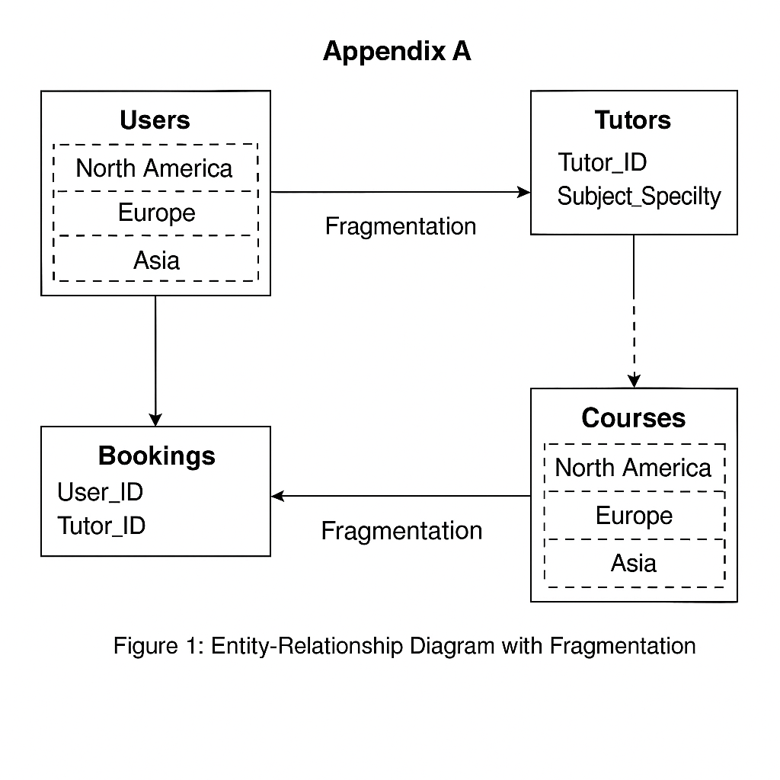

Appendix B
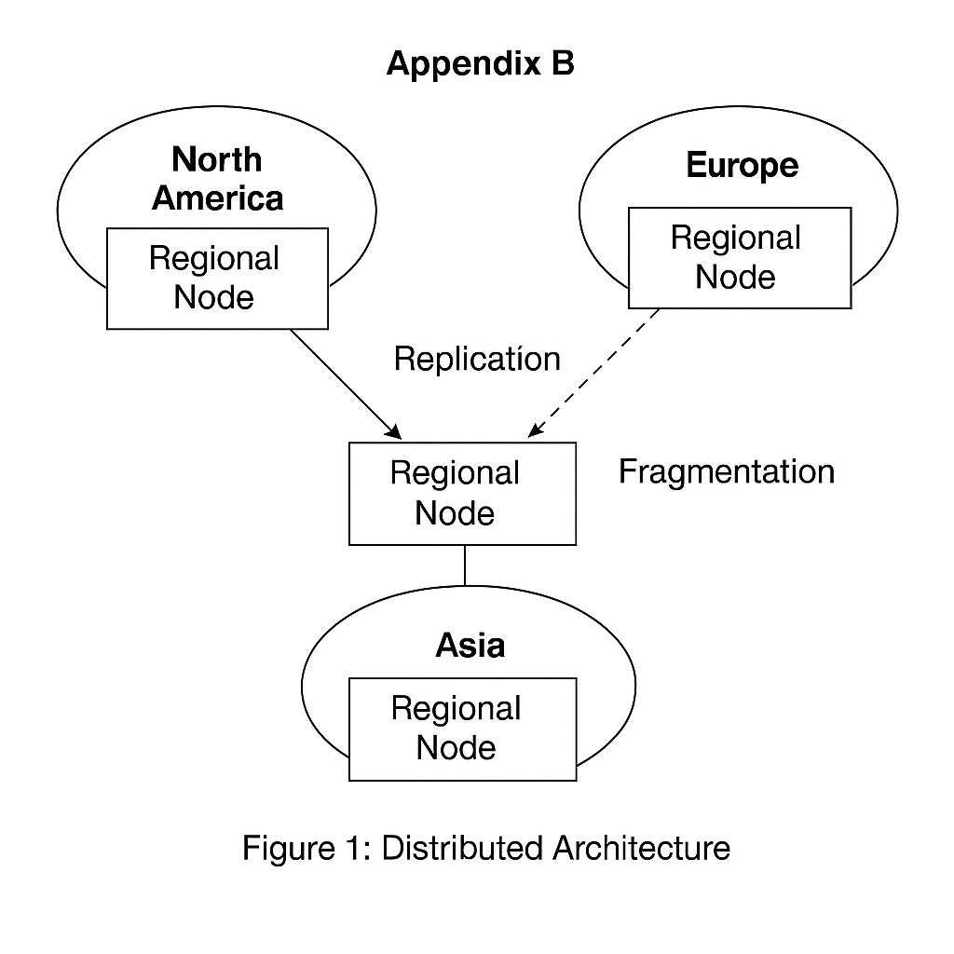

Bibliography
Ballve, M. (2014, January 18). Apps Rule The Phone, But The Mobile Web Is Still Alive And Well. Retrieved from http://www.businessinsider.com/html5-and-the-web-is-still-relevant-2014-1
Darlington, K. W. (2011). Designing for Explanation in Health Care Applications of Expert Systems. SAGE Open, 1-9.
Medlock, S. e. (2011). LERM (Logical Elements Rule Method): A method for assessing and formalizing clinical rules for decision support. International Journal of Medical Informatics, 286-295.
Whitten, J. L. (2007). Systems Analysis and Design Methods. New York: McGraw-Hill/Irwin.
Amazon Web Services. (n.d.). Amazon Aurora. https://aws.amazon.com/rds/aurora/
Google Cloud. (n.d.). Cloud Spanner. https://cloud.google.com/spanner

