Overview of the Assignment:
In this exercise we will review data warehouse concepts, specifically modeling the dimensional schema. We first outline the directions, and then provide guidance on which you will base your solution. You may complete this assignment in groups of two or on your own.

Generative AI directions
You are encouraged to leverage Generative AI for your writing. In blue font, make any adjustments to show differences in your work and from AI. Any text in black font will be considered AI generated.

Directions:
Create an initial design for a dimensional data warehouse for QueryQuest database which you designed in assignment 1.

Your Deliverable:

- Business Questions: Outline 4 key business questions your dimensional data warehouse will focus on.

Your response replaces this….
- Which NYC schools produced the highest-scoring teams across all hackathon challenges?
- How do participant skills correlate with average project scores and prize outcomes?
- What is the attendance and engagement rate for workshops, broken down by borough and school?
- Which sponsors’ prizes were most frequently awarded to winning teams in each challenge category?

- Dimensional ERD: Create an ERD of the data warehouse dimensional constellation schema that you envision. Your design will need to include dimension and fact tables. You need to show constellation schema of at least two fact tables. Fact tables will need to include measures. For dimension tables, show slowly changing dimensions. (Your design should be readable and appropriately labeled even when zoomed in.)

Your diagram replaces this….
Fact Tables:
- Fact_Project_Scores
  - Grain: One row per project per judge.
  - Measures: Score, Judge_Feedback_Length, Prize_Value.
- Fact_Workshop_Attendance
  - Grain: One row per participant per workshop session.
  - Measures: Attendance_Flag, Session_Duration_Minutes.
Dimension Tables:
- Dim_Date (SCD Type 1) — Standard date/time attributes.
- Dim_Team (SCD Type 2) — Tracks team membership changes over time.
- Dim_Participant (SCD Type 2) — Keeps historical skill and school changes.
- Dim_School (SCD Type 1) — School name, borough, district.
- Dim_Project (SCD Type 2) — Tech stack, theme, challenge type.
- Dim_Judge (SCD Type 1) — Name, expertise area.
- Dim_Workshop (SCD Type 1) — Title, topic, location.
- Dim_Sponsor (SCD Type 2) — Tracks changes in sponsorship tiers.
- Dim_Prize (SCD Type 1) — Prize type, category.
Shared dimensions like Dim_Date, Dim_Team, and Dim_Participant will join to both facts.
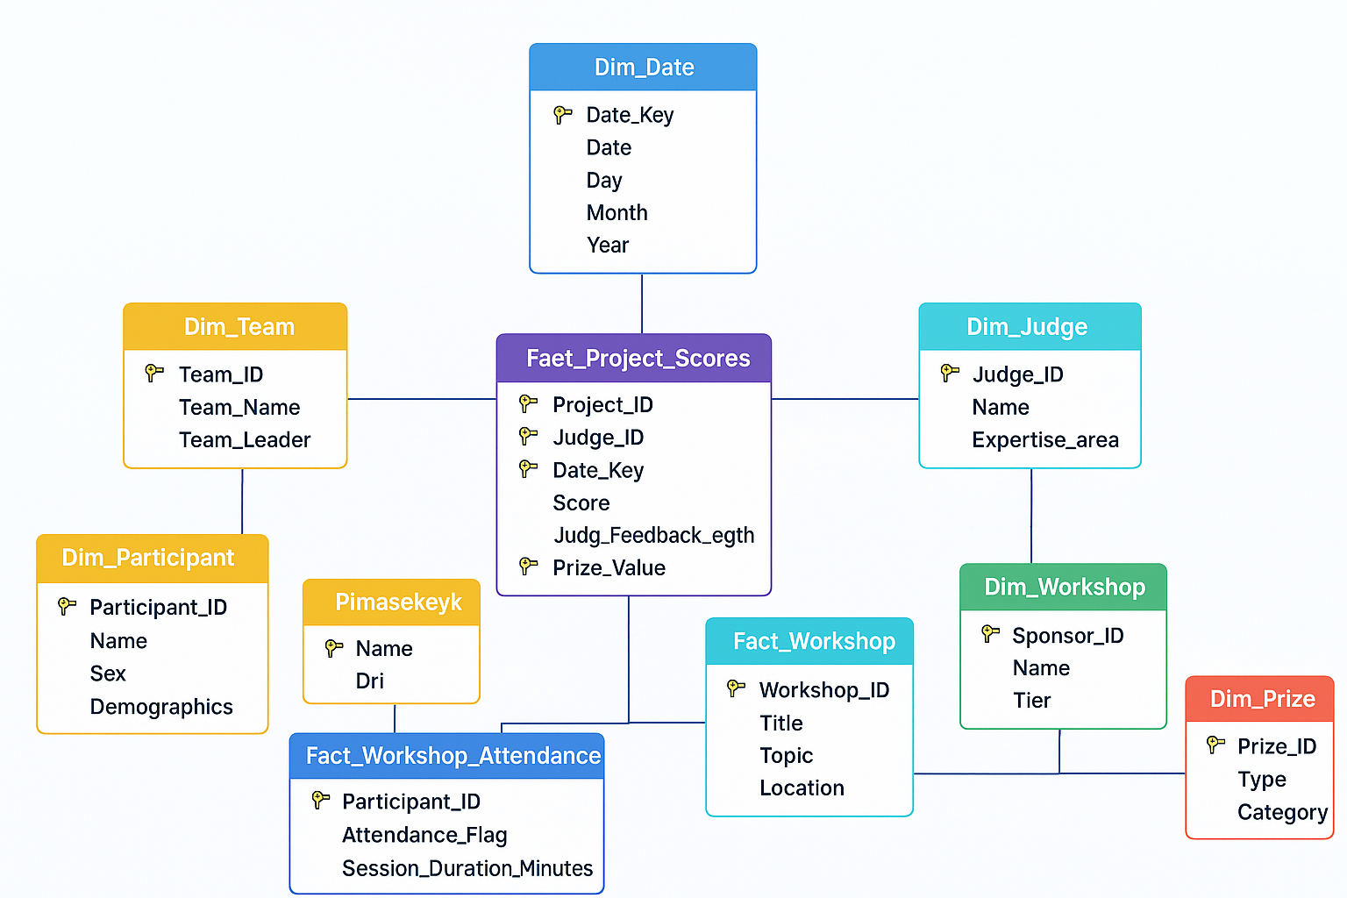

- SCD Explanation: Briefly explain your design choice for slowly changing dimensions. (one to two paragraphs)

Your response replaces this….
For the QueryQuest dimensional warehouse, I used Slowly Changing Dimensions Type 2 for tables that are likely to change over time, such as Dim_Participant, Dim_Team, and Dim_Sponsor. This method keeps a full history of changes by adding columns for StartDate, EndDate, and IsCurrent to each record. If a participant switches schools during the event, the warehouse will store both the old and new records so that reports from earlier periods still reflect the original data. This makes it possible to run accurate historical reports without losing important past information.
For dimensions that are mostly static, such as Dim_Skill or Dim_Prize, I used Slowly Changing Dimensions Type 1. In these cases, there is no need to keep historical versions, so updates simply overwrite old values. This mix of Type 1 and Type 2 gives the warehouse the ability to track trends over time while keeping it efficient and avoiding extra complexity for data that rarely changes.

- Fact Table Explanation: Briefly explain your design choice for the measures you have selected. Provide a diagram of which parts of the design is involved in answering each of your business questions. Your solution should be organized by your business questions.

Your response replaces this….
- Which teams achieved the highest average scores in each challenge?
  - Fact Table: Fact_Project_Submission (TotalScore)
  - Dimensions: Dim_Team, Dim_Event, Dim_Date, Dim_Challenge
- How many workshops did each participant attend, and what was the total time spent?
  - Fact Table: Fact_Event_Participation (WorkshopHours, AttendanceCount)
  - Dimensions: Dim_Participant, Dim_Workshop, Dim_Date
- What is the total value of prizes awarded per sponsor, and which teams received them?
  - Fact Table: Fact_Event_Participation (PrizeValue)
  - Dimensions: Dim_Sponsor, Dim_Team, Dim_Date, Dim_Prize
- How does project submission timing relate to final scores?
  - Fact Table: Fact_Project_Submission (SubmissionTime, TotalScore)
  - Dimensions: Dim_Team, Dim_Date, Dim_Event, Dim_Challenge

- Indexes: Outline three indexes which we discussed in class and a brief explanation of your choices as to why you want to index and what type of index you would use (one paragraph).

Your response replaces this….

- Clustered Index on Fact_Project_Scores (Project_ID, Judge_ID, Date_Key) — Improves scoring trend queries.
- Nonclustered Index on Dim_Participant (Skill_ID, School_ID) — Speeds up skill correlation reports.
- Bitmap Index on Dim_Prize (Prize_Category) — Useful for low-cardinality filtering in prize analysis.

Evaluation Rubric

