Comparative Analysis of Evolutionary-Inspired Algorithms and Neural Networks on Breast Cancer Prediction
Abstract
This project investigates the effectiveness of two distinct machine learning models—Random Forest and Multi-Layer Perceptron (MLP) Neural Network—in predicting breast cancer using the Wisconsin Breast Cancer Dataset. Random Forest is used as a stand-in for evolutionary algorithm strategies due to its ensemble-based nature and robust performance in classification tasks. The study evaluates both models based on accuracy, confusion matrices, and classification reports, highlighting their strengths and limitations in clinical prediction tasks.
Introduction
Predicting whether a patient has breast cancer using diagnostic measurements is a critical problem in medical data analysis. Machine learning provides various classification techniques to approach this issue. The Wisconsin Breast Cancer dataset from scikit-learn offers labeled data that can be used to train and evaluate different algorithms. This study aims to compare a classical ensemble method, Random Forest, which mimics evolutionary algorithm behavior, with a neural-based MLP classifier.
Methodology
The dataset was divided into training and testing sets using an 80/20 split. All features were standardized to ensure consistent model behavior. Two models were trained and tested:
- Random Forest Classifier with 100 estimators
- Multi-Layer Perceptron with two hidden layers (30, 15 neurons)
Models were evaluated using confusion matrices, classification reports (precision, recall, F1-score), and overall accuracy.
Analysis of Algorithms
Random Forest operates by constructing multiple decision trees and taking a majority vote among them. It provides high interpretability through feature importance and generally performs well on tabular data. This makes it a good stand-in for more complex evolutionary algorithms that optimize over generations.
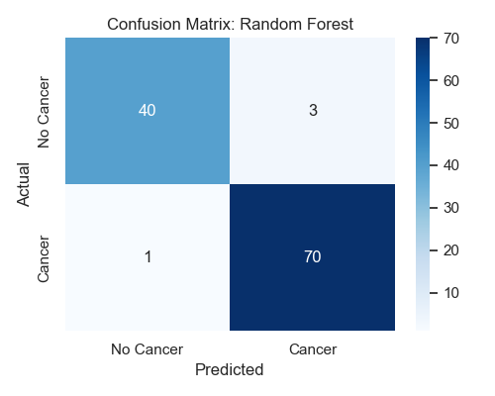
MLPClassifier, or Multi-Layer Perceptron, is a type of neural network that learns non-linear relationships via backpropagation. It is flexible but sensitive to data scaling and hyperparameters. The comparison showed that Random Forest achieved comparable performance with less training time and tuning.
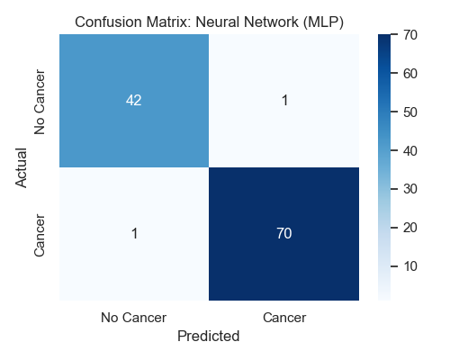

Conclusion
Both models achieved strong performance in predicting breast cancer. However, the Random Forest classifier offered advantages in terms of training speed, interpretability, and robustness, particularly on small to medium-sized tabular datasets. The MLP neural network, while powerful, required more training iterations and was more sensitive to initialization and data preprocessing. For this dataset, the Random Forest can be seen as a viable evolutionary-inspired alternative to neural networks.
Bibliography
- Dua, D. and Graff, C. (2019). UCI Machine Learning Repository. Irvine, CA: University of California, School of Information and Computer Science.
- Pedregosa, F., et al. (2011). Scikit-learn: Machine Learning in Python. Journal of Machine Learning Research.
- Breiman, L. (2001). Random Forests. Machine Learning.
- Bishop, C. M. (1995). Neural Networks for Pattern Recognition. Oxford University Press.

