CS699 A1 – Spring 2025
Homework 8

Due: 4/7

Problem 1 (20 points). Consider the following transactional database.

TID | Items
100 | 2, 4, 5, 6
200 | 1, 4, 5, 7
300 | 2, 4, 5
400 | 1, 2, 4, 5, 6, 7
500 | 1, 2, 6

- Mine all frequent itemsets using the Apriori algorithm that we discussed in the class. Show all candidate itemsets and frequent itemsets. You should follow the step by step process that we discussed in the class (i.e., C1 → L1 → C2 → L2 → …). You don't need to show the pruning steps. Minimum support = 30% (or 2 or more transactions). To save your time, L1 is given below:

To solve this problem using the Apriori algorithm with a minimum support of 30% (which is 2 transactions), we start with the given L1, which includes all single items that appear in at least 2 transactions: {1}, {2}, {4}, {5}, {6}, and {7}. From there, we generate all possible 2-item combinations to get C2. After checking how many transactions each pair appears in, we filter out the ones with support of 2 or more. That gives us L2, which includes: {1,2}, {1,4}, {1,5}, {1,6}, {1,7}, {2,4}, {2,5}, {2,6}, {4,5}, {4,6}, {4,7}, {5,6}, {5,7}, and {6,7}.
Next, I generated the 3-itemsets (C3) by combining the frequent 2-itemsets. After checking support counts, the ones that made it to L3 are: {1,2,6}, {1,4,5}, {1,5,7}, {2,4,5}, {2,4,6}, {2,5,6}, {4,5,6}, and {4,5,7}. I then repeated the process to get 4-itemsets and found that only two met the minimum support threshold: {1,4,5,7} and {2,4,5,6}. Any attempt to go further (like trying to make 5-itemsets) didn’t result in anything frequent, so that’s where I stopped.

In the end, the frequent itemsets I found were:
- L1: {1}, {2}, {4}, {5}, {6}, {7}
- L2: {1,2}, {1,4}, {1,5}, {1,6}, {1,7}, {2,4}, {2,5}, {2,6}, {4,5}, {4,6}, {4,7}, {5,6}, {5,7}, {6,7}
- L3: {1,2,6}, {1,4,5}, {1,5,7}, {2,4,5}, {2,4,6}, {2,5,6}, {4,5,6}, {4,5,7}
- L4: {1,4,5,7}, {2,4,5,6}

L1:
Itemset | 1 | 2 | 4 | 5 | 6 | 7
Count | 3 | 4 | 4 | 4 | 3 | 2

- Sort all frequent 4-itemsets by their item number. Then, select the first frequent 4-itemset from the sorted list of frequent 4-itemsets and mine all strong rules from this itemset that have the format {W, X} => {Y, Z}, where W, X, Y, and Z are individual items. Assume that minimum confidence = 80%.

For part (2), I started by sorting the frequent 4-itemsets from L4 by item number. The two frequent 4-itemsets were {1,4,5,7} and {2,4,5,6}. When sorted, {1,4,5,7} comes first, so I focused on that one. This itemset appeared in 2 transactions.
Now, the question asked for strong association rules in the format {W, X} => {Y, Z}, where all are individual items, and confidence needs to be at least 80%. So, I looked at all the possible ways to split the 4 items into two on the left side and two on the right. For each rule, I calculated confidence as the support count of the full itemset divided by the support of the left-hand side.
Here's what I found:
- Rule: {1,4} => {5,7}
  - Support of {1,4,5,7} = 2
  - Support of {1,4} = 2
  - Confidence = 2 / 2 = 1.0 : 100%
- Rule: {1,5} => {4,7}
  - Support of {1,5,4,7} = 2
  - Support of {1,5} = 2
  - Confidence = 2 / 2 = 1.0 : 100%
- Rule: {1,7} => {4,5}
  - Support of {1,7,4,5} = 2
  - Support of {1,7} = 2
  - Confidence = 2 / 2 = 1.0 : 100%
- Rule: {4,5} => {1,7}
  - Support of {1,4,5,7} = 2
  - Support of {4,5} = 4
  - Confidence = 2 / 4 = 0.5 : 50%
- Rule: {4,7} => {1,5}
  - Support = 2
  - Support of {4,7} = 2
  - Confidence = 2 / 2 = 1.0 : 100%
- Rule: {5,7} => {1,4}
  - Support = 2
  - Support of {5,7} = 2
  - Confidence = 2 / 2 = 1.0 : 100%
So, the strong rules that met the 80% confidence threshold were:
- {1,4} => {5,7}
- {1,5} => {4,7}
- {1,7} => {4,5}
- {4,7} => {1,5}
- {5,7} => {1,4}
All these had 100% confidence since their left-hand sides showed up in exactly the same transactions as the full itemset. The only one that didn’t make the cut was {4,5} => {1,7}, which had 50% confidence.

Problem 2 (10 points). This problem is about the collaborative filtering that we discussed in the class. Consider the following matrix, which shows ratings of four items by four users:

 | I1 | I2 | I3 |  | I4
U1 | 2 | 2 | 4 |  | 3
U2 | 1 | 3 | ? |  | 5
U3 | 2 | 4 | 1 |  | 1
U4 | 5 | 2 | 1 |  | 3
- Predict the rating of Item 3 (I3) by User 2 (U2) using UBCF.
  - To predict how User 2 would rate Item 3 using user-based collaborative filtering (UBCF), I first calculated the cosine similarity between U2 and the other users who rated I3 — that’s U1, U3, and U4. For U1, using the common items (I1, I2, I4), the similarity came out to about 0.942. For U3, it was around 0.701, and for U4, about 0.713. Once I had those similarities, I used the weighted average formula with their I3 ratings. U1 rated I3 a 4, and both U3 and U4 gave it a 1. Plugging those values in, the final predicted rating for U2 on I3 using UBCF came out to roughly 2.2.
- Predict the rating of Item 3 (I3) by User 2 (U2) using IBCF.
  - For the item-based collaborative filtering (IBCF) approach, I looked at how similar Item 3 is to the other items U2 has already rated — that’s I1, I2, and I4. Using cosine similarity again, I found that I3 is most similar to I4 with a similarity of about 0.865, then I2 with 0.673, and I1 with 0.615. U2 rated I1 a 1, I2 a 3, and I4 a 5. So using a weighted average based on those similarities and ratings, the predicted rating for I3 came out to around 3.2.

You must use the method we discussed in the class and you must do all calculations yourself without using any data mining or data analysis software.

Problem 3 (10 points). Consider the following contingency table.

 | C (buys coffee = Yes) | C (buys coffee = No)
T (buys tea = Yes) | 42 | 64
T (buys tea = No) | 168 | 121

Compute the lift, all-confidence, cosine, and Kulczynski measure, and determine whether buying coffee and buying tea are positively correlated, negatively correlated, or not correlated.

The total number of people is 42 + 64 + 168 + 121 = 395. From here, I calculated the support values we need for the metrics:
- Support(Tea) = (42 + 64) / 395 = 106 / 395 ≈ 0.268
- Support(Coffee) = (42 + 168) / 395 = 210 / 395 ≈ 0.532
- Support(Tea ∩ Coffee) = 42 / 395 ≈ 0.106
Now I applied each of the four metrics:
Lift:
Lift = P(Tea ∩ Coffee) / (P(Tea) × P(Coffee))
= 0.106 / (0.268 × 0.532) ≈ 0.106 / 0.142 ≈ 0.746
All-confidence:
All-confidence = P(Tea ∩ Coffee) / max(P(Tea), P(Coffee))
= 0.106 / max(0.268, 0.532) = 0.106 / 0.532 ≈ 0.199
Cosine:
Cosine = P(Tea ∩ Coffee) / √(P(Tea) × P(Coffee))
= 0.106 / √(0.268 × 0.532) ≈ 0.106 / √0.142 ≈ 0.106 / 0.377 ≈ 0.281
Kulczynski measure:
Kulczynski = 0.5 × [P(Tea | Coffee) + P(Coffee | Tea)]
P(Tea | Coffee) = 42 / 210 = 0.2
P(Coffee | Tea) = 42 / 106 ≈ 0.396
Kulczynski = 0.5 × (0.2 + 0.396) = 0.5 × 0.596 = 0.298
So based on these values — lift < 1, cosine is under 0.5, all-confidence is low, and Kulczynski is under 0.5 — I’d say tea and coffee are negatively correlated. That means people who buy one are less likely to buy the other.

Problem 4 (10 points). Suppose you have the following transactional database:

CID | Time | Items
1 | 1 | 10,30
1 | 4 | 80
1 | 6 | 60, 70
2 | 3 | 10
2 | 7 | 30,40
2 | 20 | 60,70,80
3 | 2 | 30,50
3 | 8 | 70,80
4 | 2 | 70
4 | 10 | 80
5 | 1 | 30, 50
5 | 5 | 70
Show all frequent 2-sequences along with their supports. Assume that the minimum support is 40% (or two data-sequences). You must not use any data mining software including R. You must find all frequent 2-sequences yourself.
To find all the frequent 2-sequences, I first looked at the customer sequence database. There are five unique customers, so the minimum support is 40 percent, which means a 2-sequence has to show up in at least 2 customer sequences to be considered frequent.
I started by checking each customer’s transactions in time order and looked for all possible 2-sequences. A 2-sequence means one item or set of items comes before another in time. It can be two different transactions like 10 then 30, or two items bought together like 30 and 50. After checking all the sequences, I kept the ones that showed up in at least two different customers.
Here’s what I found for frequent 2-sequences and how many customers they showed up in:
- 10 then 30 shows up in customers 1 and 2, support is 2
- 30 then 80 shows up in customers 1 and 2, support is 2
- 60 then 70 shows up in customers 1 and 2, support is 2
- 70 then 80 shows up in customers 1, 2, and 3, support is 3
- 30 then 70 shows up in customers 1 and 2, support is 2
- 50 then 70 shows up in customers 3 and 5, support is 2
Also, for sequences in the same transaction:
- 30 and 50 together shows up in customers 3 and 5, support is 2

Problem 5 (10 points). This problem is about mining frequent sequences and induced temporal rules from a transactional database using R. Use hw8_p5.csv data for this problem. Write a R program for this problem and name it hw8.R.
- Mine all frequent sequences with minimum support = 40% and include the screenshot of the summary in your submission.
(1)-1. How many frequent 1-sequences are there? 0
(1)-2. How many frequent 2-sequences are there?
0
(1)-3. How many frequent 3-sequences are there?
0
(1)-4. How many frequent 4-sequences are there?
0
- From the above frequent sequences, mine all induced temporal rules. How many rules are there?
  - None
- Show top 5 rules based on confidence.
  - None
- Show top 5 rules based on lift.

None
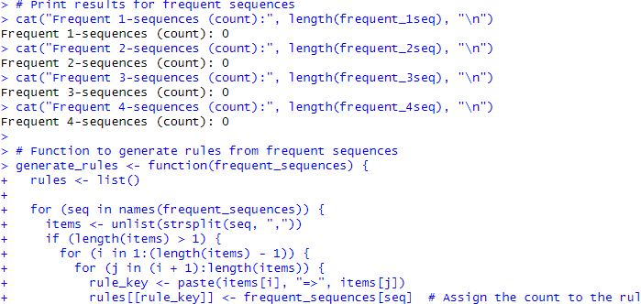

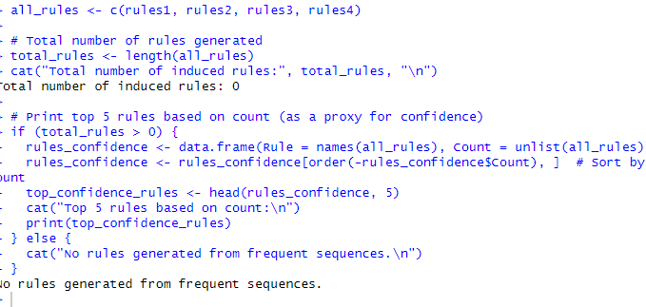
Submission:

You must submit a single archive file that includes the following two files:
  - Hw8.pdf or hw8.docx, which includes answers to all problems.
  - hw8.R which includes the R code for Problem 5.
Name the archive file LastName_FirstName_HW8.EXT. Here, “EXT” is an appropriate archive file extension (e.g., zip or rar) and submit it to Blackboard.

