Due: 4/23
CS699 A1 – Spring 2025
Homework 10

Problem 1 (10 points). This problem is about forecasting time series using a regression model with exponential trend, which we discussed in the class.
The following table shows Yt and predicted logYt:

Xt | Yt | Predicted log Yt
1 | 302.9 | 5.68
2 | 271.4 | 5.69
3 | 298.6 | 5.67
4 | 292.4 | 5.68
5 | 310.4 | 5.68
6 | 306.8 | 5.70
7 | 296 | 5.70
8 | 284.5 | 5.70
9 | 279.6 | 5.69
10 | 298.8 | 5.67

Calculate the RMSE for the initial Yt.
We were given actual Yt values and predicted log Yt values, and the goal was to calculate the RMSE. Since the predictions were in log form, I first converted each predicted log Yt back into regular Yt values by taking the exponential of each one. For example, when the predicted log Yt was 5.68, I did exp(5.68), which gave me around 293.6. I did that for all 10 values to get the predicted Yt values.
Once I had those, I calculated the squared error for each one by taking the actual Yt, subtracting the predicted Yt, and squaring the result. So for the first one, the actual Yt was 302.9, and the predicted was 293.6, so the squared error was about 86.5. I repeated that for all ten values and then added up all the squared errors, which came out to around 1703.37.
To finish, I divided that total by 10 to get the mean squared error, which was about 170.34. Then I took the square root of that to get the RMSE, which came out to roughly 13.05. So yeah, the RMSE for this data is about 13.05.

Problem 2 (10 points). Suppose that you are forecasting the following time series using the single exponential smoothing method that we discussed in the class.

Time | X
1 | 322.3
2 | 292.2
3 | 331.5
4 | 327.6
5 | 332.5
6 | 321.4
7 | 313.9
8 | 309.9
9 | 299.7
10 | 309.7
11 | 314.5

- Calculate the RMSE for α = 0.3
  - I started by setting the initial forecast to the first actual value, which is 322.3. From there, I used the smoothing formula Ft = alpha * Xt-1 + (1 - alpha) * Ft-1 to calculate forecasts for each time point starting from time 2. So for example, the forecast for time 3 was based on the actual value at time 2 and the forecast from time 2. I repeated this process all the way through time 11. Once I had all the forecasts, I compared them to the actual X values and calculated the squared errors for each one. After summing up all those squared errors and dividing by 10 (since we're forecasting 10 points), I took the square root of the mean squared error. That gave me an RMSE of approximately 10.65 for alpha = 0.3.
- Calculate the RMSE for α = 0.8
  - I started by using 322.3 as the initial forecast. Then I applied the same exponential smoothing formula, but now alpha was giving more weight to the most recent actual value. So the forecasts changed more quickly in response to changes in the data. I calculated all the forecasts up to time 11 and then measured the squared error between each forecast and the actual value. After adding up those squared errors and dividing by 10, I took the square root to get the RMSE. For alpha = 0.8, the RMSE came out to about 9.54.
- Which one is better?
  - Since RMSE tells us how far off our forecasts are from the actual values on average, the smaller the RMSE, the better the model is performing. Comparing the two results, the RMSE for alpha = 0.8 was lower than the RMSE for alpha = 0.3. That means the forecasts made with alpha = 0.8 were closer to the actual values overall. So based on this, alpha = 0.8 gives better performance for this particular time series.

For Problem 1 and Problem 2, you must do all calculations yourself and you must not use any data mining or data analysis software. However, you may use spreadsheet software, such as Excel, for calculations.
Problem 3 (10 points). For this problem, use hw10_p3.csv dataset. Use 12 as the frquency.
- Plot the time plot.
  - 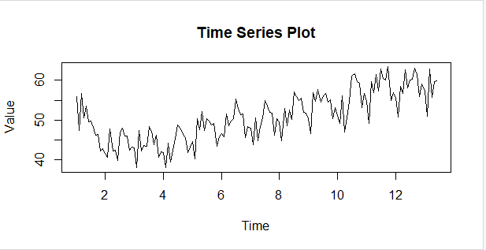
- Split the time series into a training set and a validation set with the validation set size = 16.
- Build a linear trend model from the training set and test it on the validation set. Plot the actual vs. predicted graph and calculate the RMSE.
  - 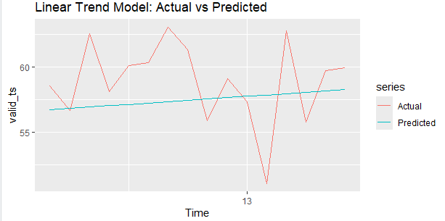
- Build an exponential trend model from the training set and test it on the validation set. Plot the actual vs. predicted graph and calculate the RMSE.
  - 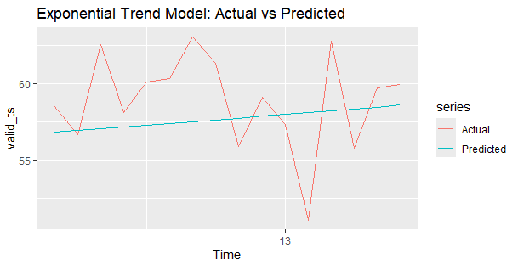
- Build a quadratic trend model from the training set and test it on the validation set. Plot the actual vs. predicted graph and calculate the RMSE.
  - 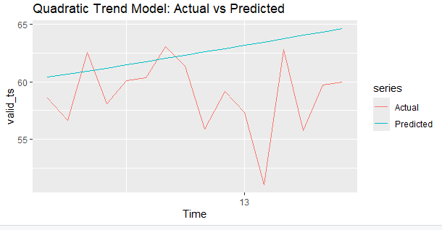
- Which model is the best?
  - Best Model is Exponential

Problem 4 (10 points). For this problem, use hw10_p4.csv dataset. Use 12 as the frquency.
- Plot the time plot.
  - 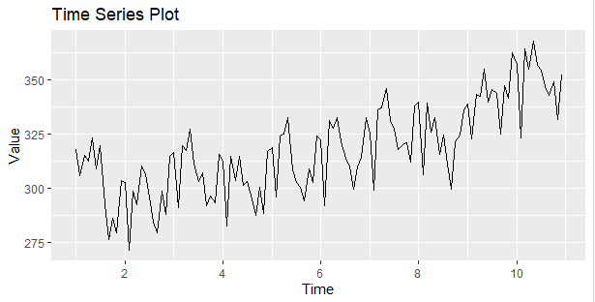
- Decompose the time series and plot the components.
  - 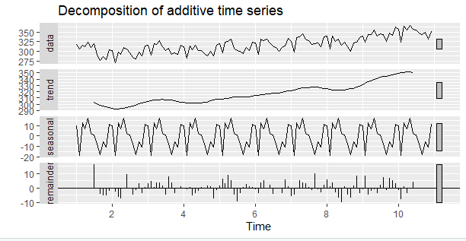
- Split the time series into a training set and a validation set with the validation set size = 16.
- Build a model with quadratic trend and seasonality (refer to Slide 43) from the training set and test it on the validation set. Plot the actual vs. predicted graph and calculate the RMSE.
  - 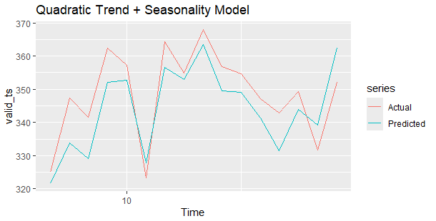
- Build a Holt-Winter's triple exponential smoothing model (refer to Slide 57) from the training set and test it on the validation set. Plot the actual vs. predicted graph and calculate the RMSE.
  - 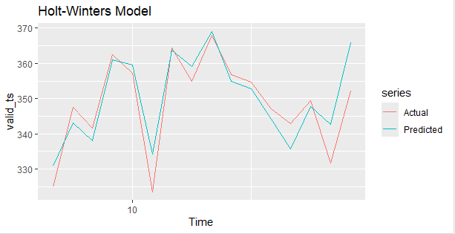
- Run the auto.arima function to find "best" parameters. Show the parameters in your answer.
  - 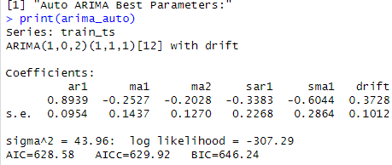
- Build an arima model using the above "best" parameters. Plot the actual vs. predicted graph and calculate the RMSE.
  - 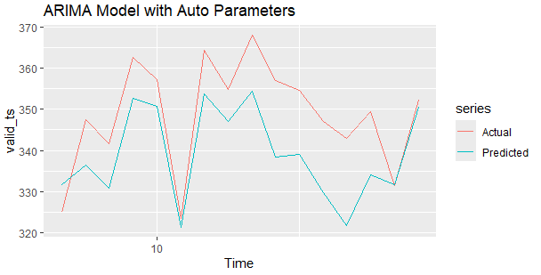
Submission:

Include all answers in a single file and name it LastName_FirstName_HW10.EXT. Here, “EXT” is an appropriate file extension (e.g., docx or pdf). You also need to submit an R code file, hw10.R. Combine all files into a single archive file. Name it LastName_FirstName_HW10.EXT. Here, “EXT” is an appropriate archive file extension (e.g., zip or rar). Upload the file to Blackboard.

