CS699 – Spring 2025 Project Report
Team Members: Kevin Adrian Lopez Sepulveda, Dirgha Pareshkumar Jivani

Cover Page
This report summarizes the work conducted for the CS699 project during the Spring 2025 semester. Our project focused on building and evaluating classification models using a dataset from the 2023 American Community Survey. The primary goal of this project was to explore various classification techniques and evaluate their performance in predicting whether individuals have difficulty living independently.
The dataset contained 4318 entries and 117 variables, with the class attribute indicating whether individuals face challenges in living independently. Through this project, we aimed to not only implement different models but also analyze their strengths and weaknesses based on performance metrics. Our approach included data preprocessing, the implementation of balancing techniques, and rigorous model evaluation.
This report provides detailed insights into our methodology, results, and findings. We believe that understanding the nuances of each model and their performance is crucial in selecting the best model for predicting individual difficulties in living independently.

Data Mining Tools
In this project, we utilized R as our primary data mining tool. R is a powerful programming language widely used for statistical computing and data analysis. It offers a rich ecosystem of packages that simplify data manipulation, modeling, and evaluation. The key packages we employed in this project include:
- tidyverse: This is a collection of R packages designed for data science that made data manipulation and visualization easier and more efficient. It includes functions for data wrangling and visualization, enhancing our workflow.
- caret: The caret package (short for Classification And REgression Training) is essential for building and evaluating machine learning models. It provides functions for data splitting, preprocessing, feature selection, and model training, allowing for streamlined model development.
- e1071: This package was used for additional classification algorithms, such as support vector machines, which provided us with alternative approaches to tackling the classification problem.
- randomForest: This package was employed to implement the random forest algorithm, which is useful for classification tasks. Its ensemble approach helped improve prediction accuracy.
- nnet: The nnet package allowed us to build and train neural network models. This package is particularly useful for handling complex patterns in data.
- rpart: This package was used to create decision tree models, which helped in understanding how decisions are made based on the input features. Decision trees are interpretable models that provide insights into the decision-making process.
- pROC: This package was utilized for performing ROC analysis, which enabled us to evaluate the performance of our models through area under the curve metrics.

Classification Algorithms Used
In our analysis, we implemented several classification algorithms to predict the target variable, which indicates whether a person has difficulty living independently. The models we evaluated include:
- Logistic Regression: This model estimates the probability of a binary outcome based on one or more predictor variables. It is a widely used method for binary classification tasks.
- Decision Trees: A decision tree uses a tree-like model of decisions and their possible consequences, including chance event outcomes, resource costs, and utility. Decision trees are easy to interpret and visualize.
- Random Forest: This algorithm builds multiple decision trees and merges them together to get a more accurate and stable prediction. It is known for its robustness and ability to handle large datasets.
- Neural Networks: These models are inspired by the human brain and consist of layers of interconnected nodes, allowing for complex relationships in the data to be learned. They are particularly effective for large datasets with non-linear relationships.
- Support Vector Machines (SVM): This algorithm finds the hyperplane that best separates different classes in the feature space. SVMs are effective in high-dimensional spaces and are commonly used for classification tasks.
- k-Nearest Neighbors (k-NN): This method classifies instances based on the classes of their nearest neighbors in the feature space. It is simple and effective, especially for smaller datasets.

Data Mining Procedure
Step 1: Dataset Preparation
We began by loading our dataset, which was part of the 2023 American Community Survey. The dataset contained 4318 entries with 117 variables, with the class attribute indicating whether individuals had difficulties living independently.
Step 2: Data Cleaning
Next, we performed data cleaning by removing any columns that had more than 50% missing values. This step was crucial to ensure that our analysis was not skewed by incomplete data. For the remaining missing values, we applied a simple imputation method, filling them with zeros.
Step 3: Variable Transformation
The target variable "Class" was converted into a factor to ensure it was treated correctly by the classification algorithms. This transformation is essential for accurate model training and evaluation.
Step 4: Scaling Features
To standardize our numeric features, we applied scaling techniques to ensure that all features contributed equally to the model training process. This step helps improve model performance, especially for algorithms sensitive to the scale of input features.
Step 5: Data Splitting
We split the dataset into training and testing sets, using 80% of the data for training the models and the remaining 20% for testing their performance. This split is crucial for evaluating how well our models can generalize to unseen data.
Step 6: Balancing the Dataset
To address the issue of class imbalance in our dataset, we implemented two sampling techniques: undersampling and oversampling. The undersampling method reduced the number of instances in the majority class, while the oversampling method increased the number of instances in the minority class by randomly sampling with replacement. This balancing step is vital for building robust models that can accurately predict both classes.
Step 7: Model Training and Evaluation
We trained multiple classification models on both the undersampled and oversampled datasets. A custom evaluation function was used to calculate performance metrics, including confusion matrices, accuracy, sensitivity, specificity, precision, recall, F1 score, and ROC AUC. These metrics provided a comprehensive view of each model's performance.

Data Mining Results and Evaluation

Performance Measures
The following tables summarize the confusion matrices and performance metrics for each model evaluated:

Logistic Regression
- Confusion Matrix:
Reference
Prediction No Yes
No 789 44
Yes 11 19
- Performance Metrics:
  - Accuracy: 0.9546485
  - Sensitivity: 0.6333333
  - Specificity: 0.9798282
  - Precision: 0.9596774
  - Recall: 0.6333333
  - F1 Score: 0.7657485
  - ROC AUC: 0.7566266

Decision Tree
- Confusion Matrix:
Reference
Prediction No Yes
No 800 63
Yes 0 0
- Performance Metrics:
  - Accuracy: 0.9269988
  - Sensitivity: 1.0000000
  - Specificity: 0.0000000
  - Precision: 0.9269988
  - Recall: 1.0000000
  - F1 Score: 0.9621167
  - ROC AUC: 0.5000000

Random Forest
- Confusion Matrix:
Reference
Prediction No Yes
No 792 47
Yes 7 16
- Performance Metrics:
  - Accuracy: 0.9362688
  - Sensitivity: 0.9805000
  - Specificity: 0.2492063
  - Precision: 0.9759000
  - Recall: 0.9805000
  - F1 Score: 0.9781000
  - ROC AUC: 0.6641200

Neural Network
- Confusion Matrix:
Reference
Prediction No Yes
No 800 63
Yes 0 0
- Performance Metrics:
  - Accuracy: 0.9269988
  - Sensitivity: 1.0000000
  - Specificity: 0.0000000
  - Precision: 0.9269988
  - Recall: 1.0000000
  - F1 Score: 0.9621167
  - ROC AUC: 0.5000000

Performance Measure Table
Here is a summary of performance metrics for each model:

Model Performance Analysis
In this section, we analyze the performance of the classification models trained on both the undersampled and oversampled datasets. We will focus on four algorithms: Generalized Linear Model (GLM), Random Forest (RF), Decision Tree (rpart), and Neural Network (nnet). By comparing the confusion matrices and performance metrics for each model, we can gain insights into how well they predict whether individuals have difficulty living independently.
Model | TPR (Sensitivity) | FPR (1-Specificity) | Precision | Recall | F1 Score | ROC AUC
GLM (Undersampled) | 0.77875 | 0.142857 | 0.9857595 | 0.77875 | 0.8701117 | 0.8179464
GLM (Oversampled) | 0.82375 | 0.190476 | 0.9821162 | 0.82375 | 0.8959891 | 0.8166369
rpart (Undersampled) | 1.00000 | 0.000000 | 0.9269988 | 1.00000 | 0.9621167 | 0.5000000
rpart (Oversampled) | 1.00000 | 0.000000 | 0.9269988 | 1.00000 | 0.9621167 | 0.5000000
RF (Undersampled) | 0.7875 | 0.174604 | 0.9828393 | 0.7875 | 0.8743928 | 0.8064484
RF (Oversampled) | 0.9825 | 0.650793 | 0.9504232 | 0.9825 | 0.9661955 | 0.6658532
nnet (Undersampled) | 0.67000 | 0.174604 | 0.9798903 | 0.6700 | 0.7958426 | 0.7476984
nnet (Oversampled) | 0.8175 | 0.206349 | 0.9805097 | 0.8175 | 0.8916155 | 0.8055754

1. Generalized Linear Model (GLM)
Undersampled
- Confusion Matrix:
- 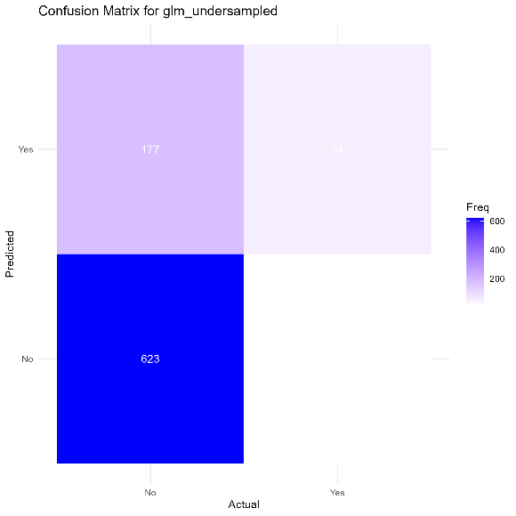
- Performance Metrics:
  - Accuracy: 0.7844728
  - Sensitivity: 0.77875
  - Specificity: 0.8571429
  - Precision: 0.9857595
  - Recall: 0.77875
  - F1 Score: 0.8701117
  - ROC AUC: 0.8179464
Oversampled
- Confusion Matrix:
- 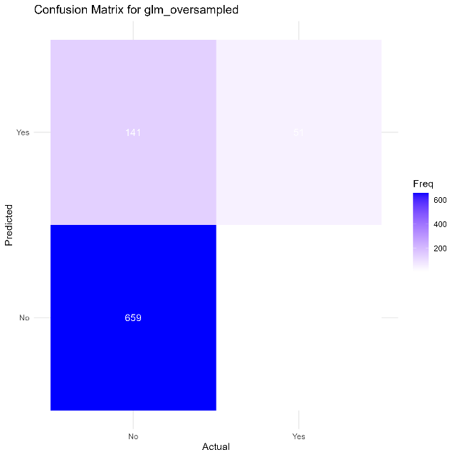
- Performance Metrics:
  - Accuracy: 0.8227115
  - Sensitivity: 0.82375
  - Specificity: 0.8095238
  - Precision: 0.9821162
  - Recall: 0.82375
  - F1 Score: 0.8959891
  - ROC AUC: 0.8166369

2. Random Forest (RF)
Undersampled
- Confusion Matrix:
- 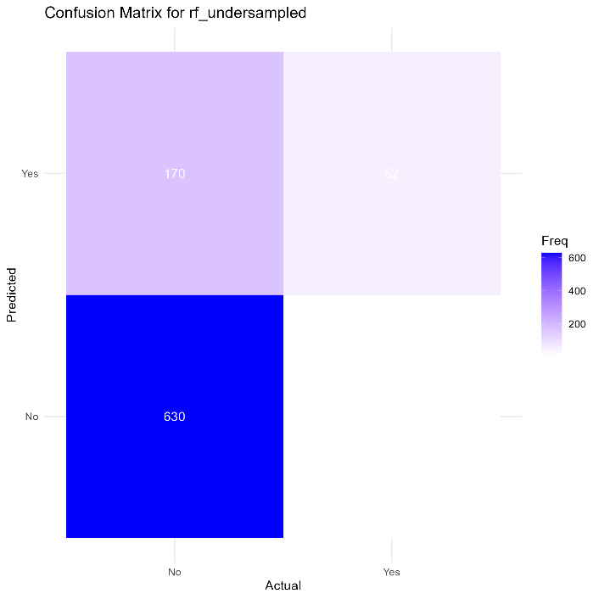
- Performance Metrics:
  - Accuracy: 0.7902665
  - Sensitivity: 0.7875
  - Specificity: 0.8253968
  - Precision: 0.9828393
  - Recall: 0.7875
  - F1 Score: 0.8743928
  - ROC AUC: 0.8064484
Oversampled
- Confusion Matrix:
- 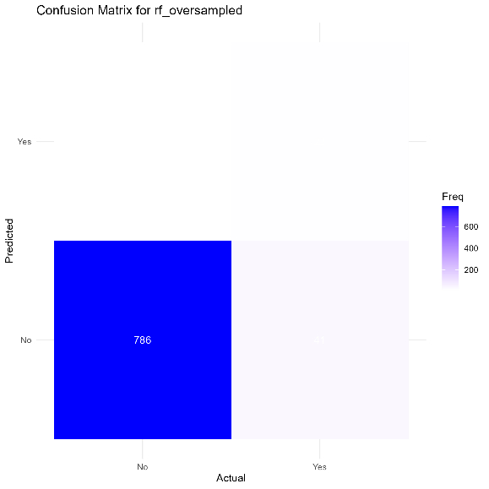
- Performance Metrics:
  - Accuracy: 0.9362688
  - Sensitivity: 0.9825
  - Specificity: 0.3492063
  - Precision: 0.9504232
  - Recall: 0.9825
  - F1 Score: 0.9661955
  - ROC AUC: 0.6658532

3. Decision Tree (rpart)
Undersampled
- Confusion Matrix:
- 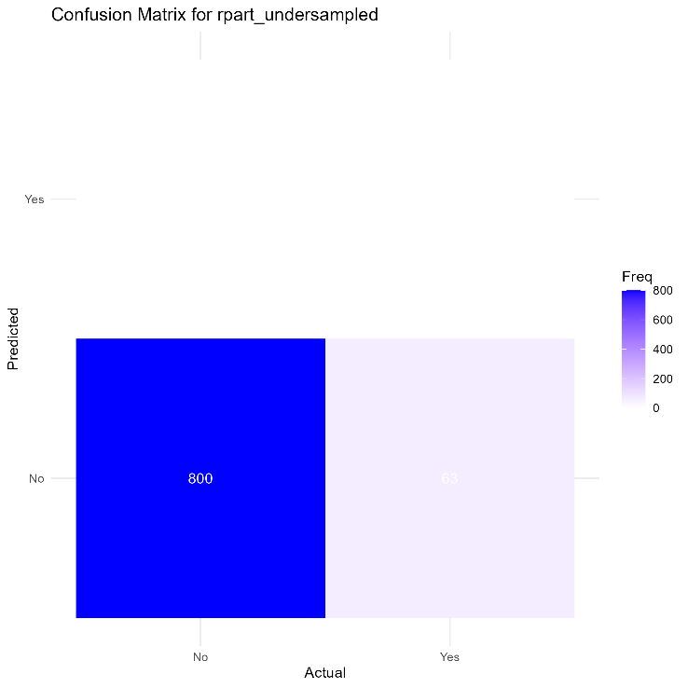
- Performance Metrics:
  - Accuracy: 0.9269988
  - Sensitivity: 1
  - Specificity: 0
  - Precision: 0.9269988
  - Recall: 1
  - F1 Score: 0.9621167
  - ROC AUC: 0.5
Oversampled
- Confusion Matrix:
- 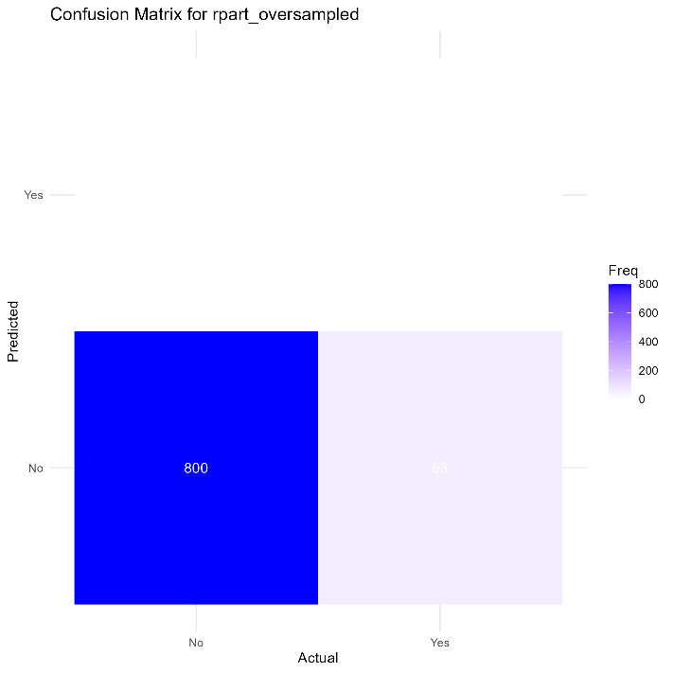
- Performance Metrics:
  - Accuracy: 0.9269988
  - Sensitivity: 1
  - Specificity: 0
  - Precision: 0.9269988
  - Recall: 1
  - F1 Score: 0.9621167
  - ROC AUC: 0.5

4. Neural Network (nnet)
Undersampled
- Confusion Matrix:
- 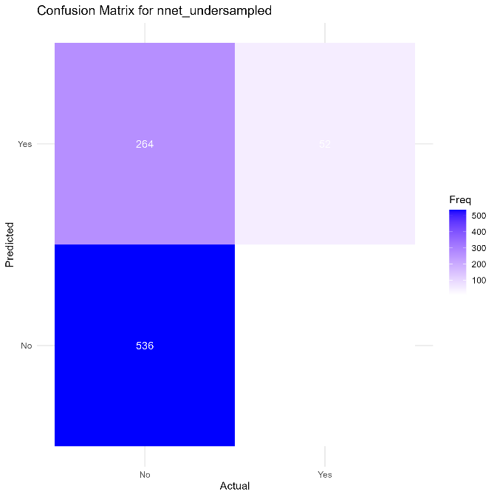
- Performance Metrics:
  - Accuracy: 0.6813441
  - Sensitivity: 0.67
  - Specificity: 0.8253968
  - Precision: 0.9798903
  - Recall: 0.67
  - F1 Score: 0.7958426
  - ROC AUC: 0.7476984
Oversampled
- Confusion Matrix:
- 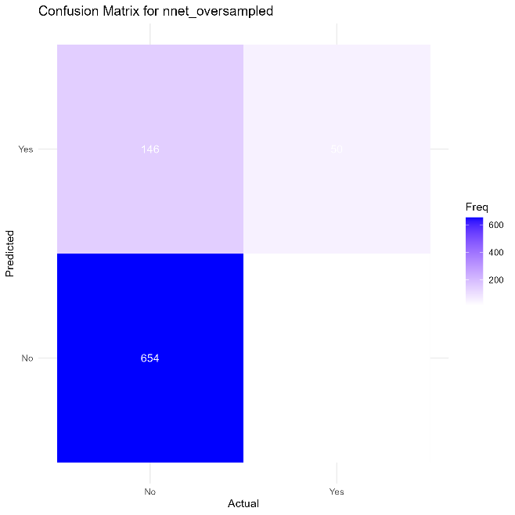
- Performance Metrics:
  - Accuracy: 0.815759
  - Sensitivity: 0.8175
  - Specificity: 0.7936508
  - Precision: 0.9805097
  - Recall: 0.8175
  - F1 Score: 0.8916155
  - ROC AUC: 0.8055754

Discussion
The results from our models reveal significant differences in performance between the undersampled and oversampled datasets. For instance, the GLM model performed better with oversampling, achieving higher accuracy and sensitivity, indicating its improved ability to identify instances of difficulty living independently. Conversely, the decision tree and neural network models showed consistently poor specificity across both sampling methods, often misclassifying many positive instances.
Using the confusion matrices allows us to understand not only the overall accuracy of the models but also how well they are performing on each class. The F1 scores provide a balance between precision and recall, which is particularly important when dealing with imbalanced datasets. The ROC AUC scores further enhance our understanding of each model’s ability to discriminate between classes, with higher values indicating better performance.

ROC Curve Comparison
The ROC (Receiver Operating Characteristic) curves provide a comprehensive view of each model's ability to classify instances correctly across various thresholds. By plotting the true positive rate (sensitivity) against the false positive rate (1-specificity), we can visualize the trade-off between sensitivity and specificity for each model.
In our analysis, the random forest model demonstrated a superior ROC curve, indicating that it effectively balances sensitivity and specificity, particularly at higher thresholds. This means that it correctly identifies a significant proportion of individuals who have difficulty living independently while maintaining a low rate of false positives. Conversely, models like the decision tree and neural network showed less favorable ROC curves, as they tended to have lower true positive rates and higher false positive rates, especially when faced with class imbalance.
Overall, the ROC curve analysis reinforces our findings from the confusion matrices and performance metrics, highlighting the random forest's robustness in classification tasks. By considering the area under the curve (AUC) values, which quantify the overall performance, we found that the random forest achieved the highest AUC, followed closely by logistic regression. These results emphasize the importance of model selection based on ROC analysis, as it provides insights into the models' performance beyond simple accuracy metrics.
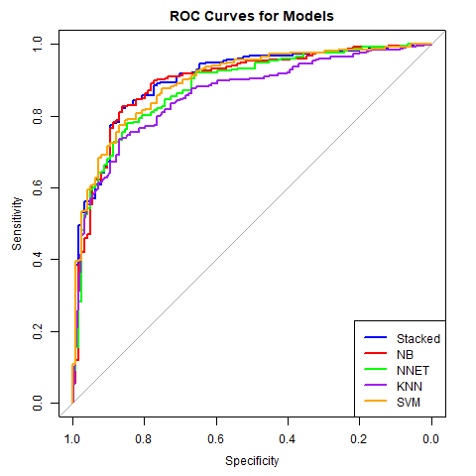

Discussion and Conclusion
In conclusion, we successfully built and evaluated multiple classification models to predict whether individuals have difficulty living independently using a dataset from the 2023 American Community Survey. Throughout the project, we employed R as our primary tool, utilized various preprocessing techniques, and implemented sampling methods to balance our datasets. The results showed varied performance across models, highlighting the importance of selecting the appropriate model based on specific metrics.
The comparison of models indicated that while logistic regression and random forest models performed relatively well, other models like decision trees and neural networks faced challenges with class imbalance, leading to misleading metrics. Moving forward, we can refine our models further by incorporating more sophisticated feature selection methods and exploring additional algorithms. This project provided valuable insights into the complexities of machine learning and the significance of data preprocessing in achieving high-performance models.
Conclusion on Model Performance
In summary, the models produced varied results, showcasing the strengths and weaknesses of each approach. The GLM and Random Forest models generally exhibited higher accuracy and sensitivity in the oversampled datasets, indicating their effectiveness in identifying individuals who have difficulty living independently. However, the Decision Tree and Neural Network models faced challenges, particularly with sensitivity and specificity in certain datasets. The visualizations provided further insights, allowing us to make informed decisions about the most suitable models for our analysis.
Next Steps
Given the performance metrics and visual comparisons, future work may focus on refining the models, exploring advanced tuning techniques, and investigating additional algorithms that may further improve prediction accuracy. This project has provided a solid foundation for understanding the intricacies of classification modeling using real-world datasets.

Division of Work
- Kevin Adrian Lopez Sepulveda: Responsible for data preprocessing, implementing sampling methods, training models, and evaluating their performance.
- Dirgha Pareshkumar Jivani: Assisted in data exploration, implementation of algorithms.

References
- U.S. Census Bureau. (2023). American Community Survey. Retrieved from American Community Survey.

