Kevin Lopez

CIS400

2/2/23

HW2

646315859

3ci) 26 distinct states

3cii) 3 states

3ciii) 8 states

3civ) This has two states from INS which are tau actions to pass or fail the student. The one action stemming from STU is used to do the homework itself. This means that the student is always going to do homework while the instructor is internally deciding whether or not to pass or fail the student.

3cv) This is node 18 and its seen by this picture:

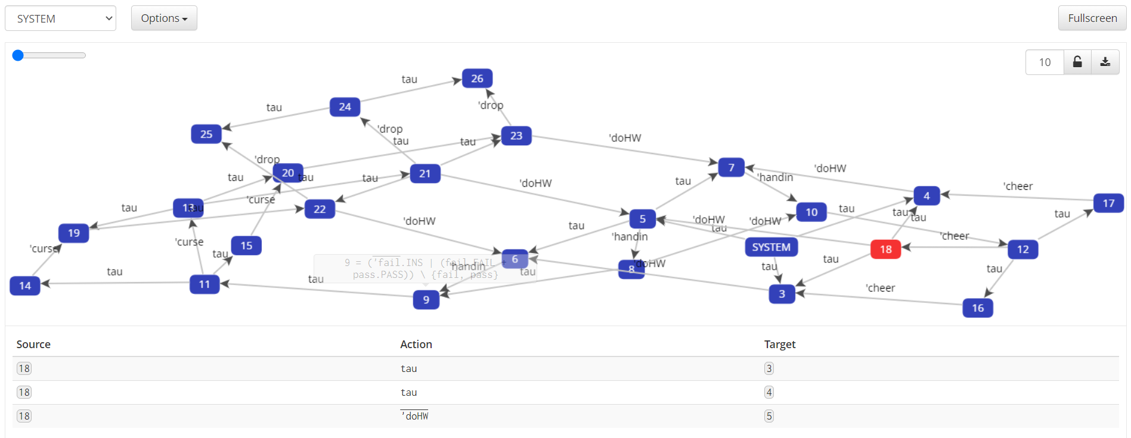

This is (INS|STU)\{pass,fail} and corresponds to a new instance of the beginning action