CIS 477 (Fall 2022) Disclosure Sheet

Name: Kevin Lopez

HW # 7

Yes No Did you consult with anyone on parts of this assignment, including other students, TAs, or the instructor?

Yes No Did you consult an outside source (such as an Internet forum or a book other than the course textbook) on parts of this assignment?

If you answered Yes to one or more questions, please give the details here:

By submitting this sheet through my Blackboard account, I assert that the information on this sheet is true.

Kevin Lopez

CIS477

12/7/22

HW7

1. Text, letter

   Description automatically generated
   1. The above argument is wrong because Hamiltonian path does not completely reduce to HP-Tree. A tree can have nodes that end such as the binary tree. It can have nodes that lead no where. It automatically assumes the nodes are all connected or not, as they all stem from an original node and do not return back to the same one.
   2. 1
   3. 2 3
   4. 4 5
   5. Here we can see 4 and 5 are connected by 3 but can never connect to each other, even though a regular graph can connect these by a single path, a tree will not.
2. Text, letter

   Description automatically generated
   1. Idea: Double Hamiltonian path is a double Hamiltonian cycle.
   2. Graph change: None
   3. Algorithm change: Run Hamiltonian path on any one of the nodes in the graph. It will return a path. Then on the unexplored nodes, run the Hamiltonian path again. If it returns a path then there is a separate cycle. Keep doing this until there are no more unexplored nodes. If there are only two separate Hamiltonian paths then it is a double Hamiltonian cycle.
   4. This can be solved in polynomial time by iterating through each cycle and checking if they visit every node in the graph
3. Text

   Description automatically generated with medium confidence
   1. Idea: Reduce Max Degree Spanning Tree to Hamiltonian path and since Hamiltonian path is NP-Complete, MDST is also NP complete
   2. Change in graph: You do not change the graph
   3. Change in algorithim: Run Hamiltonian path in a while loop until all paths can be explored. Take the number of paths and check it against k. If it is less than or equal to k then it is a max degree spanning tree
   4. This is NP complete because by definition, Hamiltonian path is NP and reduces to max degree spanning tree
4. 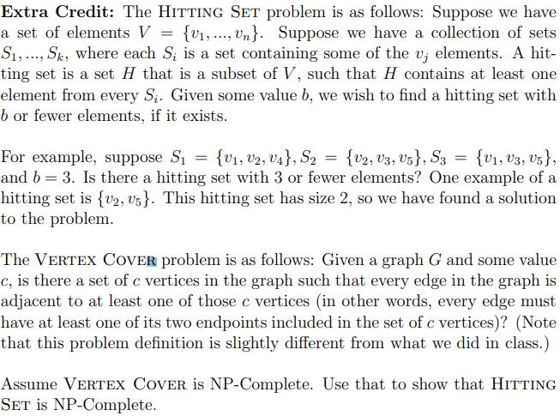
   1. Idea: