ITLDO801 Assignment 3: Test Logging
Student: Kevin ABIJURU
Ref No: BTI-20250306
Module: Development Operations (ITLDO801)
GitHub repository: https://github.com/KevinAbijuru/kevinabijuru.github.com
Portfolio: https://kevinabijuru.github.io/

Test Plan
Test ID | What is tested | Steps | Expected result
TC-01 | Home navigation link | Open portfolio, locate Home, click, inspect URL. | URL path is /index.html; PASS.
TC-02 | About navigation link | Open portfolio, locate About, click, inspect URL. | URL path is /about.html; PASS.
TC-03 | Services navigation link | Open portfolio, locate Services, click, inspect URL. | URL path is /services.html; PASS.
TC-04 | Portfolio navigation link | Open portfolio, locate Portfolio, click, inspect URL. | URL path is /portfolio.html; PASS.
TC-05 | Contact navigation link | Open portfolio, locate Contact, click, inspect URL. | URL path is /contact.html; PASS.
TC-06 | Portfolio Details in Pages menu | Open portfolio, open Pages, click Portfolio Details, inspect URL. | URL path is /portfolio-details.html; PASS.
TC-07 | Missing-link negative test | Search for absent missing-assignment-link.html. | Failure is handled, logged, and captured with screenshot.

Implementation
The Selenium runner uses Python logging and creates a unique timestamped log for every run. The complete text from all three generated log files is included below. Each failed-test screenshot is embedded directly below its corresponding log evidence, as requested.

selenium_run_20261025_145153_692154.log
2026-10-25 14:51:56 | INFO | RUN START | website=https://kevinabijuru.github.io/ | browser=chrome 156.0.8078.47 | operating_system=Linux-6.18.54.1-microsoft-standard-WSL2-x86_64-with-glibc2.41 (Basically a windows subsystem for linux, but my actual OS is Windows 11) | run_id=20261025_145153_692154
2026-10-25 14:52:02 | INFO | TC-01 | what_tested=Click Home from the portfolio navigation | expected=URL path is /index.html | actual=https://kevinabijuru.github.io/index.html | status=PASS | duration=5.831s | title=My Portfolio
2026-10-25 14:52:05 | INFO | TC-02 | what_tested=Click About from the portfolio navigation | expected=URL path is /about.html | actual=https://kevinabijuru.github.io/about.html | status=PASS | duration=2.802s | title=About Me
2026-10-25 14:52:13 | INFO | TC-03 | what_tested=Click Services from the portfolio navigation | expected=URL path is /services.html | actual=https://kevinabijuru.github.io/services.html | status=PASS | duration=6.136s | title=Services
2026-10-25 14:52:15 | INFO | TC-04 | what_tested=Click Portfolio from the portfolio navigation | expected=URL path is /portfolio.html | actual=https://kevinabijuru.github.io/portfolio.html | status=PASS | duration=1.537s | title=Portfolio
2026-10-25 14:52:18 | INFO | TC-05 | what_tested=Click Contact from the portfolio navigation | expected=URL path is /contact.html | actual=https://kevinabijuru.github.io/contact.html | status=PASS | duration=1.758s | title=Contact Us
2026-10-25 14:52:20 | INFO | TC-06 | what_tested=Click Portfolio Details from the Pages menu | expected=URL path is /portfolio-details.html | actual=https://kevinabijuru.github.io/portfolio-details.html | status=PASS | duration=1.741s | title=Portfolio Details
2026-10-25 14:52:25 | ERROR | TC-07 | what_tested=Locate a deliberately missing navigation link | expected=Missing locator is handled and recorded as FAIL | actual=https://kevinabijuru.github.io/ | status=FAIL | duration=4.011s | page_url=https://kevinabijuru.github.io/ | error=Message:
Stacktrace:
#0 0x570349274462 <unknown>
#1 0x570348b9b9d8 <unknown>
#2 0x570348bf064a <unknown>
#3 0x570348bf0a05 <unknown>
#4 0x570348c407e8 <unknown>
#5 0x570348c3e191 <unknown>
#6 0x570348be369c <unknown>
#7 0x570348be45f5 <unknown>
#8 0x570349235f0e <unknown>
#9 0x570349234a6d <unknown>
#10 0x57034923441e <unknown>
#11 0x570349223458 <unknown>
#12 0x570349235296 <unknown>
#13 0x57034920cee9 <unknown>
#14 0x57034925e1f9 <unknown>
#15 0x57034925e3e3 <unknown>
#16 0x570349272e23 <unknown>
#17 0x731ba0c6d8bb <unknown>
| screenshot=logs/screenshots/20261025_145153_692154_TC-07_fail.png
2026-10-25 14:52:25 | INFO | RUN END | total_tests=7 | passed=6 | failed=1 | duration=31.706s | log_file=selenium_run_20261025_145153_692154.log
Run summary: 2026-10-25 14:52:25 | INFO | RUN END | total_tests=7 | passed=6 | failed=1 | duration=31.706s | log_file=selenium_run_20261025_145153_692154.log
TC-07 failure screenshot:
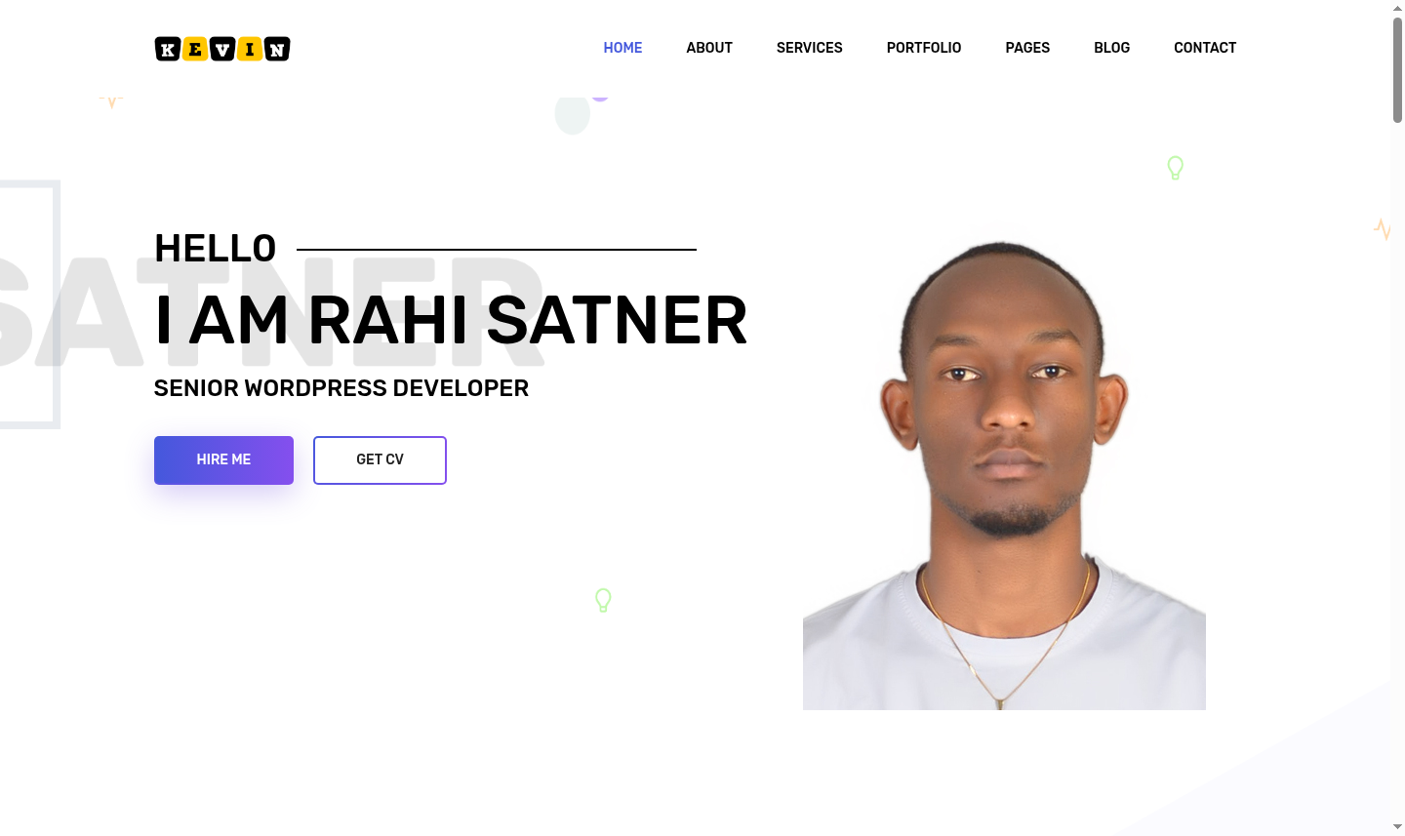

Repository Evidence
selenium_tests.py; TEST_PLAN.md; requirements.txt; Dockerfile; docker-compose.yml; logs/; logs/screenshots/

