**Table of Contents**

Introduction…………………………………………………………………1

Project Organization………………………………………………………...1

Risk Analysis………………………………………………………………..2

Hardware & Software Requirements………………………………………..4

Work Breakdown…………………………………………………………….4

Project Schedule……………………………………………………………..6

Monitoring and Reporting Mechanisms……………………………………..7

Appendix…………………………………………………………………….7

**Introduction**

Our project aims to innovate the board Stratego. We aim to breathe new life into this game by creating an innovative virtual version that not only preserves the core gameplay experience but also introduces exciting new features and enhancements. Our Python-based implementation will show an innovative way Stratego is played, offering an immersive digital experience that the traditional board game could never offer. Our version of Stratego will push the boundaries of what the game has to offer, while still upholding the tactical decision making of Stratego. With our implementation of Python, we will bring a new light into the Stratego experience.

**Project Organization**

| **POSITION** | **NAME** | **DESCRIPTION** |
| --- | --- | --- |
| Programmer | Kevin Ambler | As the Programmer, Kevin works to ensure our python code is progressing and running smoothly. |
| Designer | Joshua Stumpf | As the Designer, Josh will work on all documentation and the game itself to ensure an easy and fun experience for all users |
| GUI/ Document Writer | Ilyas Khamliche | Ensured all the course work was completed on time and gave considerable contributions to assignments. Created a functioning GUI |
| Tester | Dallas Lawson | As a Tester, Dallas will work with Ilyas to continually test our program at all stages to seek out bugs and make sure our game is running without any hiccups. |

**Risk Analysis**

| **Risk** | **Description** | **Risk Priority** | **Risk Planning** |
| --- | --- | --- | --- |
| **Cybersecurity Threats** | Malware, phishing, hacking attempts that target systems and networks to gain unauthorized access or disrupt operations. | High Risk | The threats will have a high risk of exposure, so there will be a higher priority to worry about when they come in rather than wait and worry about them when the attempts of hacking happen. |
| **Data Breaches** | Unauthorized access, theft, or exposure of sensitive data due to cyberattacks, insider threats, or human errors. | High Risk | Data breaches happen all the time. When it happens, we will make sure to get rid of any sensitive data to make sure none of it gets out. |
| **System Failures and Downtime** | Hardware or software issues, power outages, natural disasters, or human errors that cause technology systems to fail and disrupt operations. | Moderate Risk | Hardware and software issues happen all the time. When someone’s computer or internet goes down, the said person must tell their other group mates so they wouldn’t have to be behind long if at all. |
| **Obsolescence and Legacy Systems** | Outdated or legacy systems that are difficult to maintain, posing security vulnerabilities, compatibility issues, and performance degradation. | Moderate Risk | Outdated and legacy systems can cause a big concern when making programs. People can make viruses to make the outdated and legacy systems get out of whack and get all of the data from the computer that has the data. |
| **Third-Party Vendor Risks** | Risks introduced by third-party vendors, such as data breaches, supply chain disruptions, or non-compliance with regulations. | Moderate Risk | Third party vendors have data breaches all the time. If any of the vendors we use have a data breach, we need to make sure that none of our data gets out so our project doesn’t get tampered with. |
| **Compliance and Regulatory Risks** | Failure to comply with industry-specific regulations and data protection laws, leading to fines, legal consequences, and reputational damage. | Low Risk | As long as everything is up to date and following the laws, there wouldn’t need to worry about failing. |
| **Human Errors and Insider Threats** | Accidental data deletion, misconfiguration, or mishandling of sensitive information by employees, as well as malicious insider threats. | Moderate Risk | In order to make sure that no progress gets lost, everything will get backed up into multiple drives on multiple computers, as well as on Google Drive and GitHub. |

**Hardware Requirements**

* Windows OS compatible computer
* One or more monitors
* Keyboard and mouse

**Software Requirement**

* Windows 10/11 operating system
* Python IDE
  + Tkinter
  + Pillow (PIL) library

**Work Breakdown**

**Planning**

* Functions
* Classes
* Variables

**Main Menu/Settings**

* Options menu
* Gameplay options
* Exit function
* Testing

**Board Generation**

* Display empty board
* Determine first player
* Testing

**Deployment**

* Show unplaced pieces
* Determine legal deployment cells
* Alternate players placing
* End deployment
* Testing

**Player Movement**

* Determine legal moves
* Update piece position
* End turn function
* Alternate player turns
* Testing

**Player Attacks**

* Determine legal attacks
* Resolve combat
* Remove losing piece(s)
* Testing

**Endgame**

* Check for draw conditions
* Check for win conditions
* End game
* Declare winner or draw
* Show pieces lost by player
* Testing

**Project Schedule**

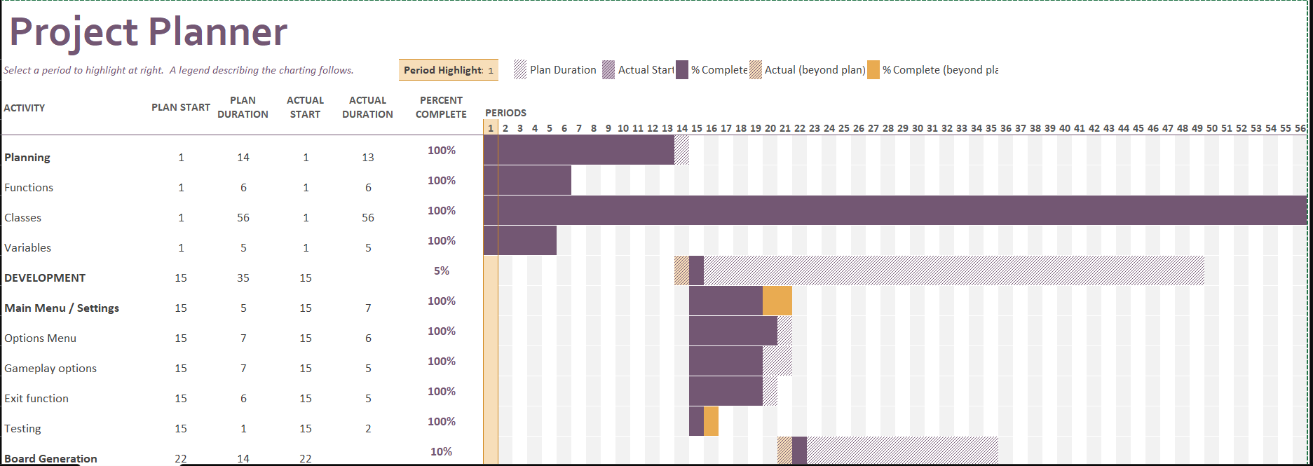

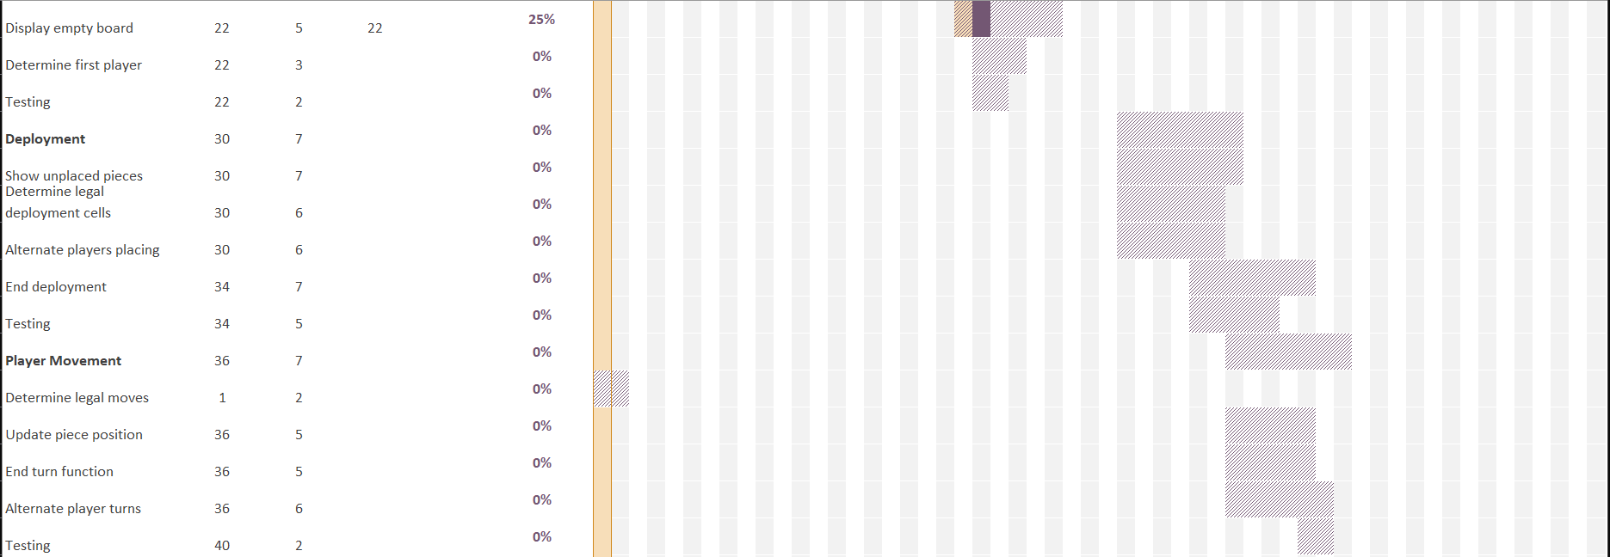

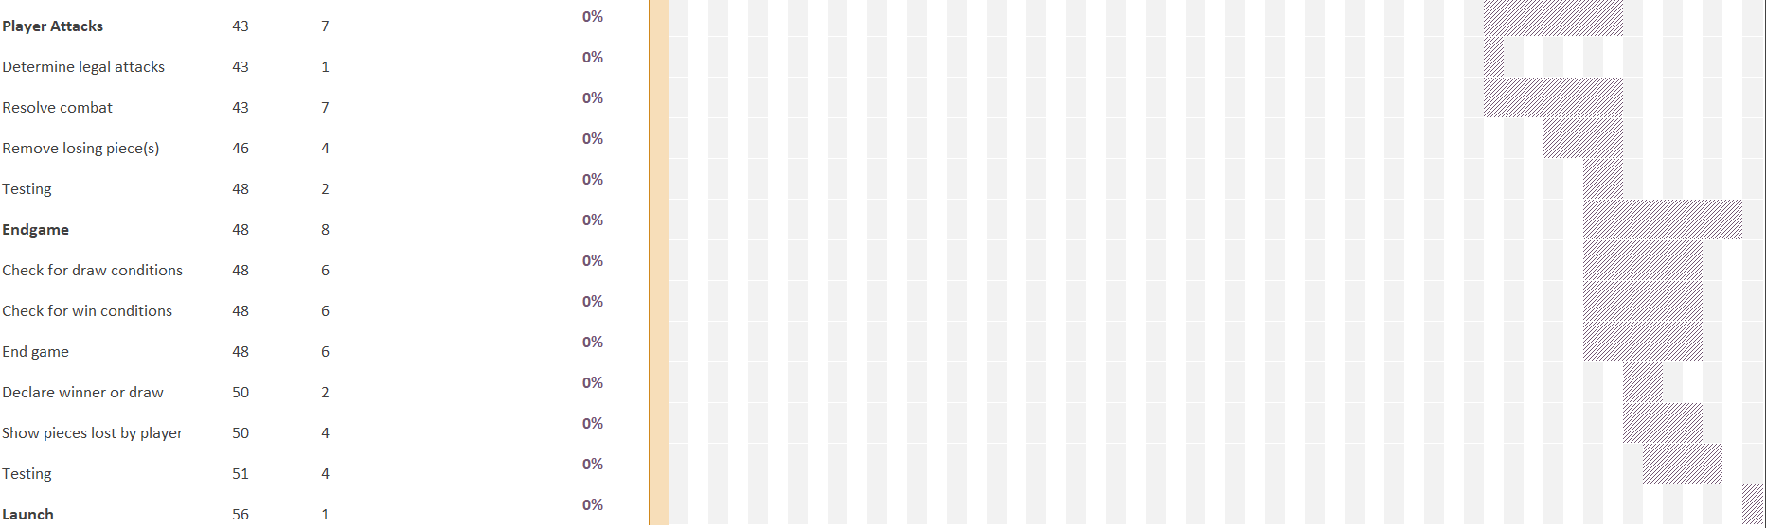

**Monitoring and Reporting Mechanisms**

All the official documentation for this project is stored in our shared Google Drive folder to ensure a consistent workflow amongst the team. Our team is also utilizing GitHub to share and store the Python code used to create our version of Stratego. We regularly keep up to date with each other via Discord as well as in person every Tuesday and Thursday to provide one another with updates and ideas for this project.

**Appendix**

| Task Number | Task | Assigned to | Dependencies | Status |
| --- | --- | --- | --- | --- |
| T1 | Planning | Ilyas/Kevin/Josh/Dallas | T1 | completed |
| T2 | Main Menu/Settings | Kevin/Josh | T1 | completed |
| T3 | Board Generation | Ilyas | T1 | completed |
| T4 | Deployment | Josh/Kevin | T1-T3 | completed |
| T5 | Player Movement | Kevin | T1-T4 | completed |
| T6 | Player Attacks | Kevin | T5 | completed |
| T7 | End Game | Kevin | T2-T6 | completed |
| T8 | Document assignments | Ilyas | T8 | completed |
| T9 | GUI | Ilyas | T9 | completed |