City Of Virginia Beach
Department Of Emergency Medical Services

Mt Trashmore July 4th
Incident Action Plan

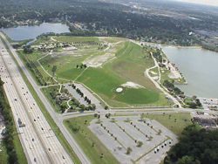

http://www.virginia.org/site/description.asp?attrID=30634

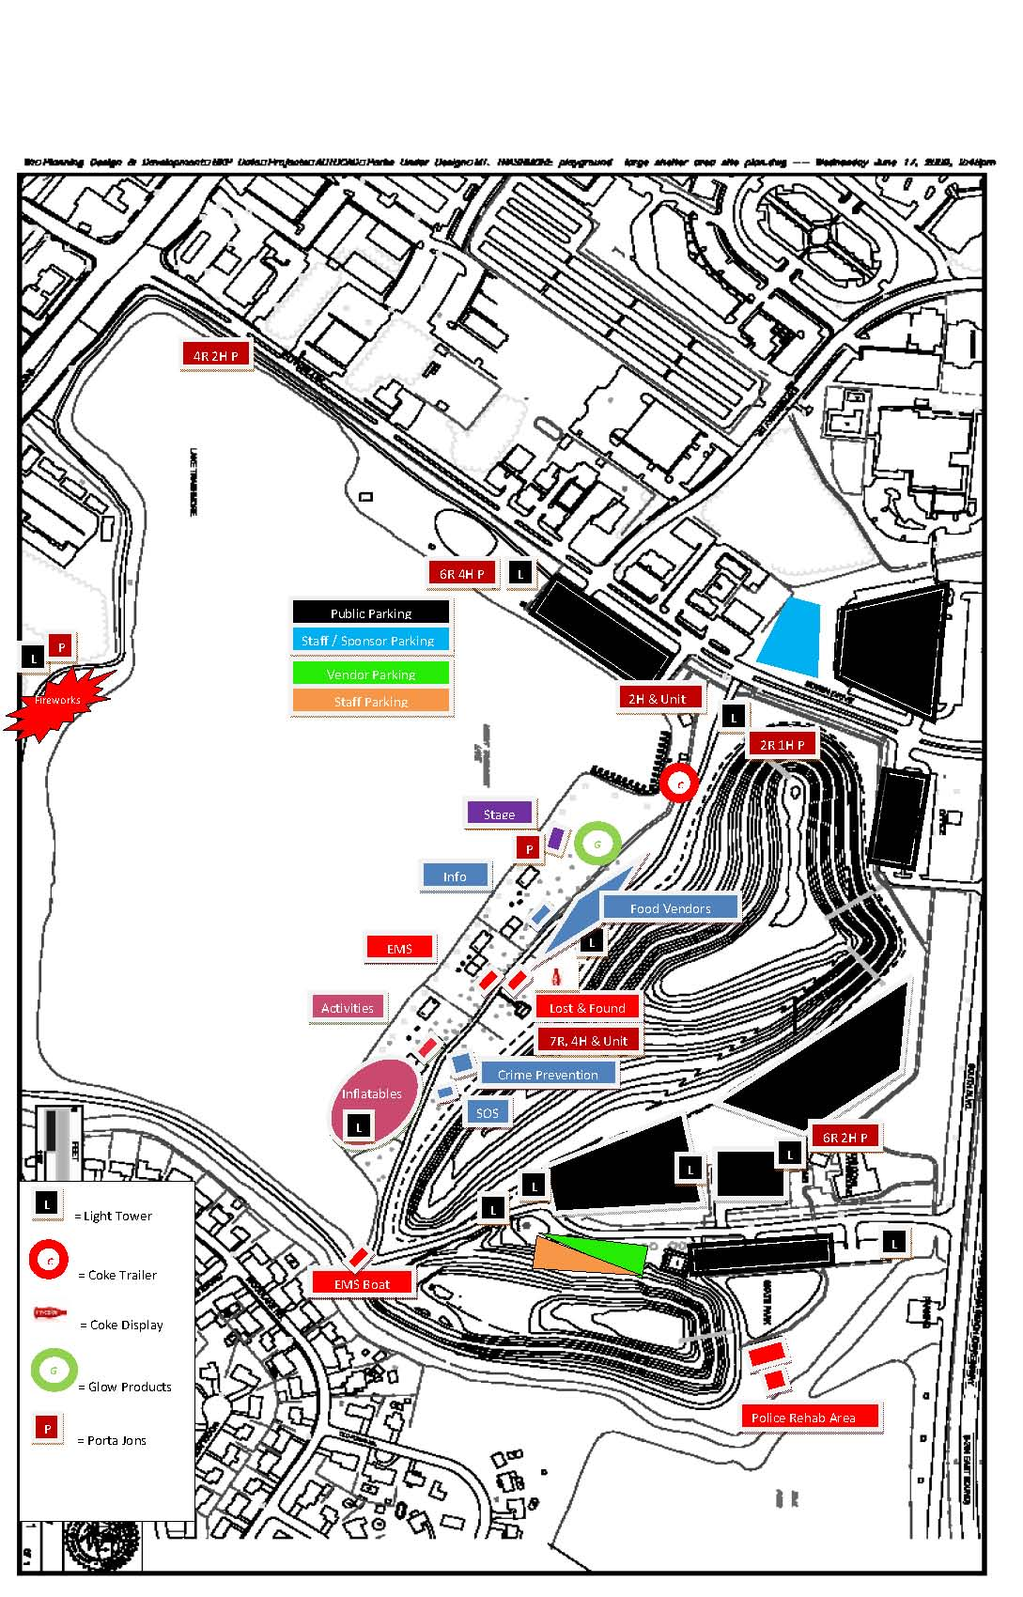
Attachment for IAP (Site Map)

