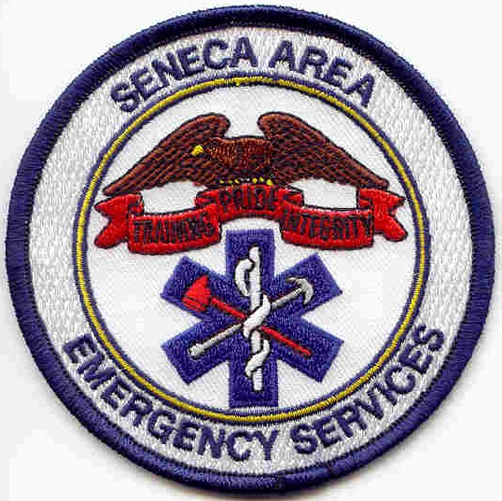
HAZMAT?
RESCUE?
PARAMEDIC

Kevin Lipscomb

supervisor

Seneca Area

Emergency

Services

507
Medical Command
Presby: 412-647-5858
St Margaret: 412-784-1616

Comm Centers
NEWCOM: 412-486-9377
NORCOM: 412-367-6979

EMS units on NEWCOM UHF
140-144 Foxwall
145-149 Hampton
150-154 Lower Valley
155-159 Shaler
160-169 Seneca
180-184 Parkview
240-244 West Deer
260-264 Richland
265-269 St Margaret

www.emsi04.org: 412-242-7322
EMS CERT
FIREFIGHTER?

Name

rank/cert

Seneca Area

Emergency

Services

5###
Medical Command
Presby: 412-647-5858
St Margaret: 412-784-1616

Comm Centers
NEWCOM: 412-486-9377
NORCOM: 412-367-6979

EMS units on NEWCOM UHF
140-144 Foxwall
145-149 Hampton
150-154 Lower Valley
155-159 Shaler
160-169 Seneca
180-184 Parkview
240-244 West Deer
260-264 Richland
265-269 St Margaret

www.emsi04.org: 412-242-7322



