Project Iteration 1
Activity 3
User-Centric Computing II
COMP4600
Spring 2025

Project Name: Healthcare Services in Carrollton
Team Name: Wolves
Trello board URL: https://trello.com/b/l3h0oAN5/team-wolves-healthcare-services-in-carrollton
Github repo URL: https://github.com/KevinBennett00/Team-Wolves---Healthcare-Services-in-Carrollton-GA-Website

Member information
# | Name
1 | Kevin Bennett
2 | Noah Barcomb
3 | Bernard Bawak

All the project iteration 1, activity 2 items from all members
Kevin Bennett
Survey Monkey Survey
THE PROMPT:

Our team has discussed making a website based on accessible healthcare resources for the city of Carrollton, Georgia. The website will be a directory of local healthcare services, including hospitals, urgent care centers, dental offices, eye doctors, therapists, and other medical providers. Each listing will provide essential information such as the type of services offered, physical location, phone number, and an image of the facility. The primary target users are Carrollton residents of all ages and backgrounds, including individuals with visual, auditory, cognitive, or mobility impairments, as well as those who may have limited access to reliable healthcare information online.

Possible benefits of the project

Improves access to healthcare information for users with disabilities through strong accessibility features

Helps new residents, students, and elderly people in the city quickly find nearby medical services

Provides a single, centralized location for trusted healthcare information specific to Carrollton

Current/similar Solutions

List of similar sites.

Google and Apple Maps give similar results to what our project aims to do; sometimes irrelevant information is shown like places that are far away, and those map services are not suitable for many people who are looking for only information on the available healthcare services in the city of Carrollton.

This project differs by:

Being location-specific to Carrollton, Georgia

Prioritizing accessibility and inclusive design from the start

Presenting concise, standardized information without unnecessary distractions

Focusing on usability for users with disabilities
UI/UX and User-Centric aspects of the project

List the things you will do to make the site user-centric and UX compliant.

High-contrast color schemes to support users with visual impairments

Descriptive alt text for all images

Text-to-speech support for written content

Large, readable fonts with adjustable text sizing

Simple, intuitive navigation with minimal cognitive load

Keyboard-only navigation support

Clear headings and consistent layout across pages

Mobile-friendly and responsive design
https://www.surveymonkey.com/r/2TBLFCP
Interview users
Age of the individual | 50
Gender of the individual | Female
Interview questions and answers
What device do you usually use when searching for healthcare services (phone, laptop, etc.)? | I usually use my phone because it’s quicker, especially if I’m trying to look something up while I’m at work or at home in the evening.
What information is most important for you to see right away when you visit a healthcare website? | I want to see the location, phone number, and what services they offer right away. I don’t want to dig through multiple pages to find basic information.
Have you ever had trouble finding healthcare providers in Carrollton online? If so, what made it difficult? | Yes, sometimes the search results show places outside of Carrollton or providers that don’t list what they specialize in. It can take a long time to figure out if they actually offer what I need.
How comfortable are you with scheduling appointments online instead of calling? | I’m comfortable scheduling online as long as it’s simple and clear. If the website is confusing, I usually just call instead.
What would make a healthcare website feel trustworthy to you? | Seeing reviews, clear provider credentials, and updated information would make it feel more trustworthy. If it looks outdated, I don’t trust it as much.
User Need Statements (list 5 statements)
Users need a way to quickly find nearby healthcare providers and their contact information so that they can get help immediately when they are sick or need urgent care.
Users need clear information about provider specializations and services offered so that they can choose the correct doctor or facility for their specific medical needs.
Users need access to trustworthy reviews and reputation information for healthcare providers so that they can feel confident about which provider to choose.
Users need an easy-to-navigate website with simple scheduling access so that they can quickly book appointments without confusion or frustration.
Users need a centralized directory of Carrollton-specific healthcare services so that they do not have to search multiple websites or filter through irrelevant locations.

Noah Barcomb
Survey Monkey Survey
Create a survey for me to understand users of a website that I have to build to provide healthcare information in carrolton GA only to people of ages 18-70
so that I can create user persona and user need statements.
https://www.surveymonkey.com/r/82SZBHM
Interview users
Age of the individual | 25
Gender of the individual | female
Interview questions and answers
When you need healthcare information in Carrolton, GA, what do you usually do first? | Look up best providers in for whatever I need, nephrologist, for example.
What has been your biggest frustration when trying to find healthcare services or information locally? | Finding one that has good reviews and it available in a good timeframe.
What makes you trust a healthcare facility? | Good reviews, and common partners with hospitals.
What device do you usually use to look up healthcare information? | My phone is most of the time.
If a website existed specifically for healthcare in Carrolton, GA, what would you want to include? | Appointment Booking, Insurance Filtering, telehealth support/info, and most importantly, cost transparency.
User Need Statements (list 5 statements)
Carrolton residents need an easy way to find doctors and clinics because searching multiple websites is confusing and takes a long time.Insert statement 2 here
Carrolton residents need simple guidance on which facility they should be visiting based off what complications they are experiencing because they are unsure which is appropriate in life/non-life-threatening situations.
Carrolton residents need clear information about which providers accept their insurance and approximate costs.
Carrolton residents need information that is easy to access regardless of device type since they are often on the go and using smaller devices when looking up this information.
Carrolton residents need information that is credible and locally relevant because they are tired of searching through hundreds of irrelevant practices.

Bernard Bawak
Survey Monkey Survey
Insert the prompt you used to generate the survey at SurveyMonkey website
Insert the link to the survey here
Interview users
Age of the individual | 52
Gender of the individual | Female
Interview questions and answers
How do you typically search for healthcare services in Carrollton? | I usually use Google first, but many results include places outside Carrollton or information that is outdated.
Which types of healthcare providers do you search for most frequently? | Mostly urgent care centers and dental offices, but sometimes eye doctors or therapists depending on the situation.
What information is most important to you when choosing a healthcare provider? | Location, phone number, services offered, office hours, and whether the provider accepts my insurance.
What frustrates you the most about existing healthcare websites? | Many websites are cluttered, hard to read, and difficult to navigate, especially when I am already stressed.
Do accessibility features affect how you use healthcare websites? | Yes. Larger text, clear contrast, and simple layouts make it much easier for me to find information.
User Need Statements (list 5 statements)
Users need a centralized and location-specific healthcare directory so they can quickly find trusted medical services within Carrollton, Georgia.And clear information about whether providers accept walk-ins or require appointments so they can avoid unnecessary trips
Users need clear, readable, and accessible layouts so individuals with visual or cognitive limitations can comfortably use the website.
Users need simple navigation and clearly labeled healthcare categories to reduce confusion and stress when searching for medical services.
Users need accurate and up-to-date healthcare provider information so they can confidently contact offices without worrying about incorrect details. And printable information pages so that elderly residents or those without consistent internet access can keep physical copies
Users need quick access to essential details such as location and phone number, especially during urgent healthcare situations.

Final List of User Need Statements

User Need Statements – final list
Carrolton residents need an easy way to find doctors and clinics because searching multiple websites is confusing and takes a long time.
Carrolton residents need clear information about which providers accept their insurance and approximate costs.
Users need clear information about provider specializations and services offered so that they can choose the correct doctor or facility for their specific medical needs.
Users need a way to quickly find nearby healthcare providers and their contact information so that they can get help immediately when they are sick or need urgent care.
Users need an accessible website with large text, simple navigation, and keyboard support so that individuals with visual or mobility impairments can independently find healthcare information.
Users need clear information about whether providers accept walk-ins or require appointments so they can avoid unnecessary trips
Users need printable information pages so that elderly residents or those without consistent internet access can keep physical copies

Summary of discussion on the effectiveness of the survey and interview questions
Our team agreed that the survey and interview questions were helpful for understanding our users and their needs. The survey gave us general insights into how people search for healthcare and what they expect from a website, showing that users want quick access to provider information, clear service details, and an easy way to find local options in Carrollton.
We found the questions effective for identifying common themes like the need for clear information, accessibility, and simple navigation. We also realized some questions could be more specific about accessibility and how users compare providers. Overall, the responses gave us enough information to create our personas, user need statements, and user flows for the website design.

User Personas
Kevin Bennett - User Persona
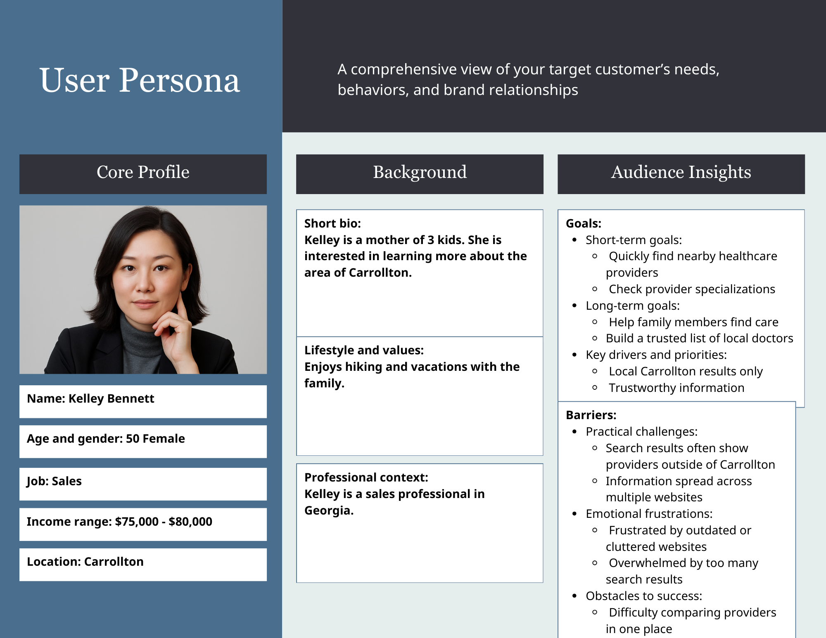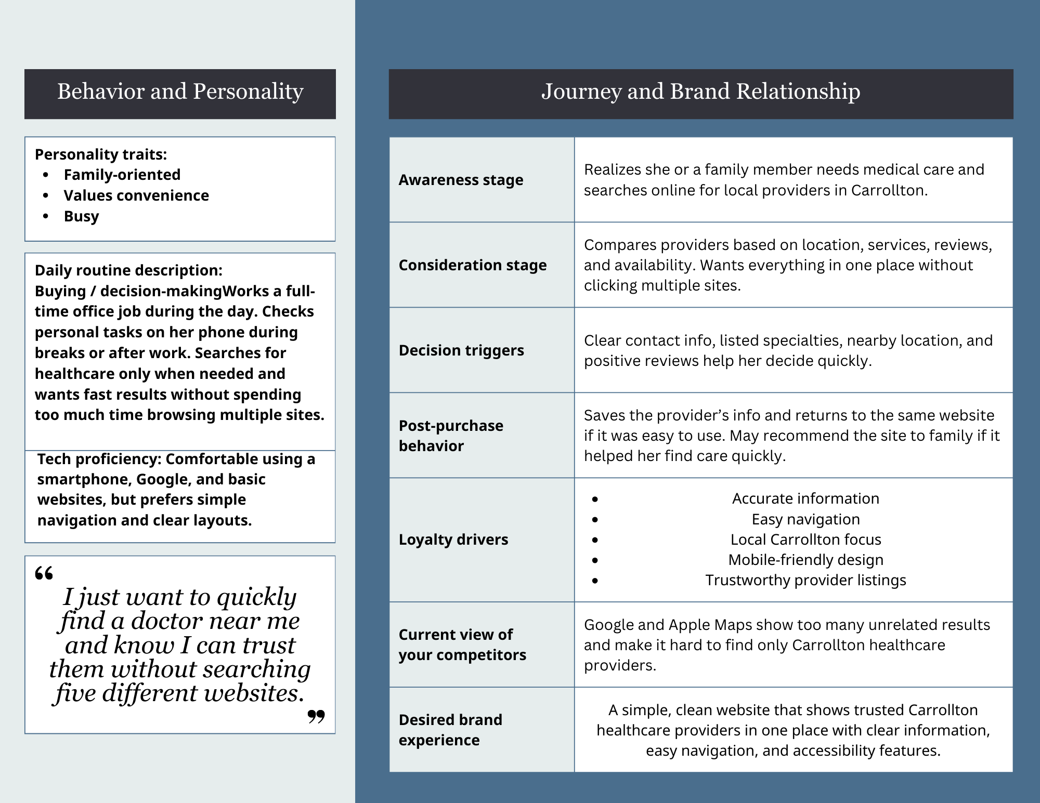
Noah Barcomb - User Persona
Insert user persona here
Bernard Bawak - User Persona
Insert user persona here
Combined User Persona
Insert the final user persona here

User Flows
Kevin Bennett - User Flow
Users need an accessible website with large text, simple navigation, and keyboard support so that individuals with visual or mobility impairments can independently find healthcare information.
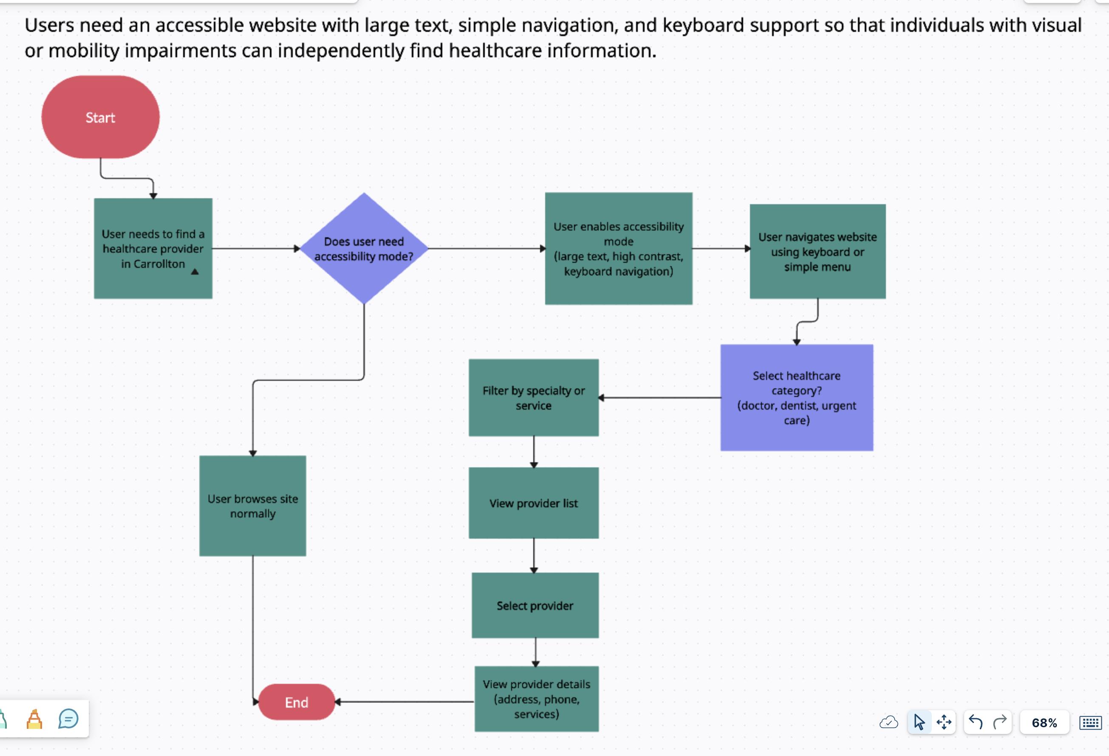
Noah Barcomb - User Flow
Mention the User Need statement the flow is for here
Insert the User flow diagram here
Bernard Bawak - User Flow
Users need clear information about whether providers accept walk-ins or require appointments so they can avoid unnecessary trips
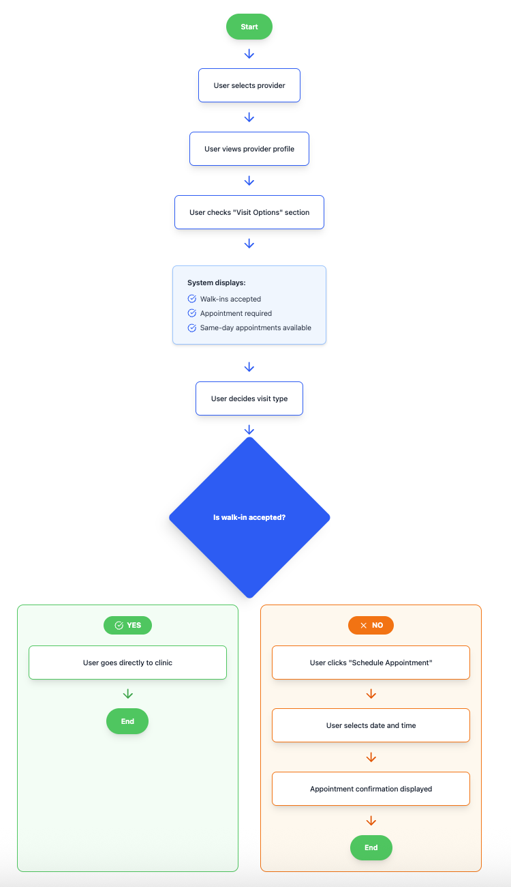
Carrolton residents need clear information about which providers accept their insurance and approximate costs.
