Customer Training Guide

Customer Cheat Sheet

Agency/Third Party Customers (anything other than Direct Advertiser & Advertiser)
- Bill To ONLY
- Add Site Profile History
- Has Parent
- Credit Information at Parent Level

Direct Advertiser Customers
- Bill To AND Ship To
  - 2 Sites:
    - Bill To = Address given to you from request form
    - Ship To = default address for advertisers
  - Each site must have both roles correctly assigned
  - Create 2 Sites for every Sub Revenue Stream
- Add Site Profile History
- Has Parent
- Credit Information at Parent Level

Advertiser Customers
- Ship To
- No Site Profile History
- Does not have Parent
- Credit Information at Account Level
- Addresses:
  - DOMESTIC: 1515 BROADWAY NEW YORK, NY 10036
  - ARGENTINA/TELEFE: PRILIDIANO PUEYRREDON 2989 MARTINEZ AR 1640

Internal Legal Entity vs. External Legal Entity
- EXTERNAL LEGAL ENTITY = ALL CUSTOMERS EXCEPT INTERCOMPANY
- INTERNAL LEGAL ENTITY = INTERCOMPANY CUSTOMERS ONLY

Revenue Stream/Sub Revenue Stream Mapping
Revenue Stream | Sub Revenue Stream | Classification Type
AD SALES | CABLE | AGENCY/ADVERTISER/DIRECT ADVERTISER
AD SALES | CMV | AGENCY/ADVERTISER/DIRECT ADVERTISER
AD SALES | DIGITAL | AGENCY/ADVERTISER/DIRECT ADVERTISER
AD SALES | NCAA | AGENCY/ADVERTISER/DIRECT ADVERTISER
AD SALES | NETWORK | AGENCY/ADVERTISER/DIRECT ADVERTISER
AD SALES | SPORTS NETWORK | AGENCY/ADVERTISER/DIRECT ADVERTISER
AD SALES | TV STATIONS | AGENCY/ADVERTISER/DIRECT ADVERTISER
AFFILIATE SALES | AFFILIATE SALES | 3RD PARTY
AFFILIATE SALES | RETRANS | 3RD PARTY
ANCILLARY/MISC | ANCILLARY/MISC | 3RD PARTY
CONTENT LICENSING | DIGITAL | 3RD PARTY
CONTENT LICENSING | HOME ENTERTAINMENT | 3RD PARTY
CONTENT LICENSING | NON-THEATRICAL | 3RD PARTY
CONTENT LICENSING | STUDIO | 3RD PARTY
CONTENT LICENSING | SVOD | 3RD PARTY
CONTENT LICENSING | SYNDICATION | 3RD PARTY
CONSUMER PRODUCTS | CONSUMER PRODUCTS | CP LICENSEE/CP AGENT
CONSUMER PRODUCTS | GAMING | CP LICENSEE/CP AGENT
CONSUMER PRODUCTS | LBE | CP LICENSEE/CP AGENT
CONSUMER PRODUCTS | LBE & TOURS | CP LICENSEE/CP AGENT
CONSUMER PRODUCTS | TOURS | CP LICENSEE/CP AGENT
FILMED ENTERTAINMENT | INTL THEATRICAL | CP LICENSEE/CP AGENT
FILMED ENTERTAINMENT | SUB-DISTRIBUTION | STUDIO
FILMED ENTERTAINMENT | THEATRICAL | STUDIO
INTERCOMPANY | INTERCOMPANY | INTERCOMPANY
LICENSING | NEWS | AGENCY/ADVERTISER/DIRECT ADVERTISER
PRODUCTION | PRODUCTION | AGENCY/ADVERTISER/DIRECT ADVERTISER
RELATED PARTY | RELATED PARTY | 3RD PARTY
STUDIO GROUP | STUDIO GROUP | 3RD PARTY
STREAMING | SUBSCRIPTIONS | AGENCY/ADVERTISER/DIRECT ADVERTISER

Credit Analyst Mapping
Revenue Stream | Credit Analyst
TV Station | Dyland Hazard
Europe/APAC/ (Australia) | Mariann Nagy
All Other NA Ad Sales, NEWS | Janet Roark
LATAM/TELEFE/CHILEVISION | Martina Fernandez
CP/CON | Leslie Murphy

C/O Setups
- TV Stations provides c/o as ADVERTISER C/O AGENCY
- Cable/Digital/Phoenix/Broadway provide c/o as AGENCY C/O ADVERTISER
  - Example: (AGENCY) HORIZON MEDIA C/O SLING TV (ADVERTISER)
  - Example: (ADVERTISER) SLIGHT TV C/O HORIZON MEDIA (AGENCY)
  - CREATE THE CUSTOMER UNDER HORIZON MEDIA
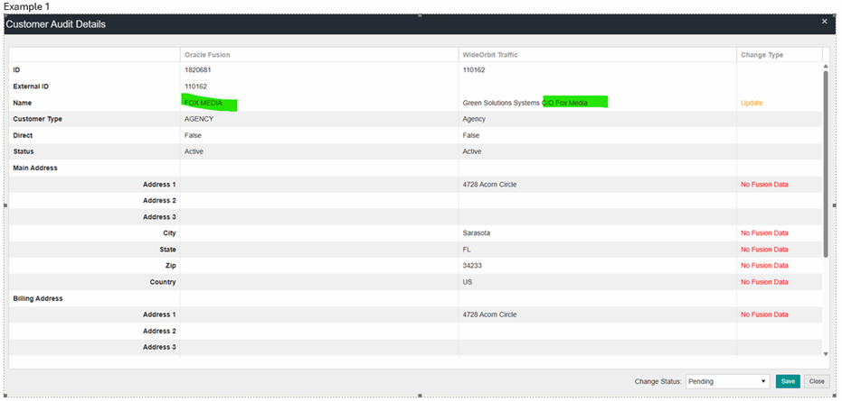

VAT Validation
https://ec.europa.eu/taxation_customs/vies/#/vat-validation

No Reply Requestors
- CP Customer Form Generator
- Data Management Request Forms
- NST@cbs.com

TV Stations Exceptions
- DO NOT create customers with (DIR, UNWIRED, ETC)), use customer name only.

Sames Client – Different Legal Entities
- When the same client operates through different legal entities (e.g., different countries, different addresses, different tax registrations):
  - Create one customer record per legal entity.
  - Use one parent customer to link all related entities.

Paramount Studio Customers
- Created under the below attributes unless a Paramount Skydance entity. Click Search to see all revenue stream options.

NOTE: If an Intercompany customer, the Classification is INTERCOMPANY and Account Type is INTERNAL
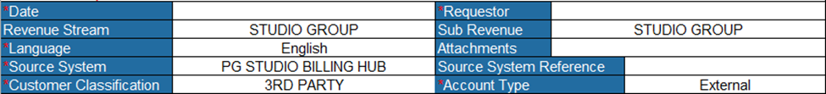
All details can be found on the 1st tab of the attachment provided in email.
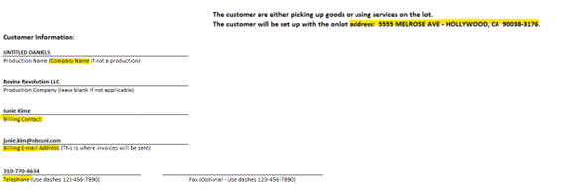
The Train Station, Express Station, and Corporate Group are found on the the 2nd tab of the spreadsheet.
Corporate Group is under Group Key – column X
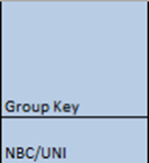

Train Station – column Z
Express Station – column AA
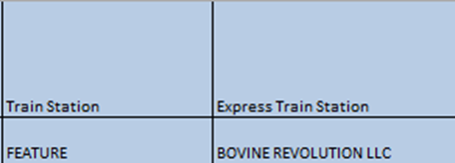

CBS AdSales Business Units
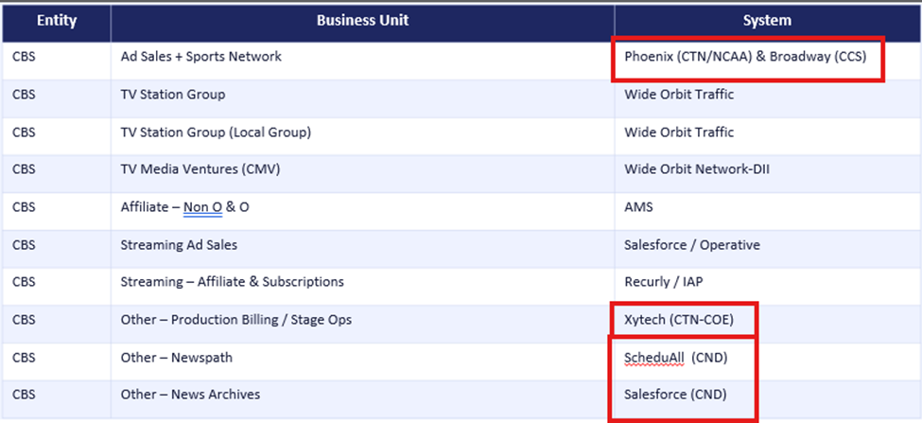

Create Customer (CDM → Organizations)
- Click + Create
- Enter:
  - Usage = External Legal Entity
  - Name, Country, Legal Address
- If Matching Organization popup has a 100% match, always check that first
- Add Source System Reference
  - Format: <SourceSystemCode>_<RegistryID> (if unknown)
  - Need to also add PG VIACOM SAP as a Boundary System if double asterisks below.
- Add Classification (e.g., Advertiser, Agency, Parent)
- Save & copy Registry ID (key identifier)

Create Account & Site (Receivables → Billing → Manage Customers)
- Search using Registry ID
- Click Create Account
  - Account Type = External
  - Account Number = Registry ID
  - Established Date = 1st day of the Month
  - Revenue Stream + Sub-stream (Boundary System mapping found here: P2_Customer_Attribute_List.xlsx)
- Set:
  - Address Set = ENTERPRISE
  - Site #: <RegistryID>_<Rev>_<SubRev>_1
  - Address Purpose: <Site #>_B for Bill To or <Site #>_S for Ship To
Address Purpose Rules:
- Advertiser (Direct) → Bill To + Ship To
- Agency/Third Party → Bill To only
- Advertiser → Ship To only

OSR Process (Required after Updates)
- Run report: CustomerOSRByLastUpdatedDate
- Export → clean → save as CSV
  - Filter on CANNOT DETERMINE
  - Replace CANNOT DETERMINE with Y for:
    - Any Sites with _1
    - VIACOM SAP Sites where Sub Revenue Stream is ANC/MISC
  - Remove all other CANNOT DETERMINE
- Import via Import Management → Object = Hub Source System Reference

Customer Updates
- Name, Legal Address, Source System, Classifications → Updated in CDM > Organizations
- Site Addresses, Contacts, Financials, Credit, Profiles → Updated in Receivables > Billing
- Whenever adding a new Source System, the OSR Import process needs to be run

Create & Define New Customer – Agency/Third Party/Direct Advertiser (with Parent) [Anything BUT Advertiser]

Creating Customer in CDM
- Logged in as a user with PG AR Customer Manager role, navigate to Navigation (Hamburger Menu) > Customer Data Management > Organizations.

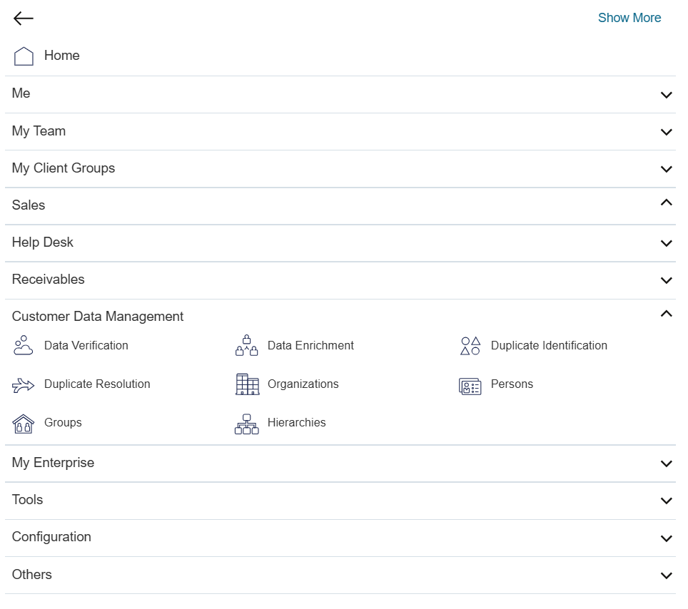

- Create Customer – click on the + icon

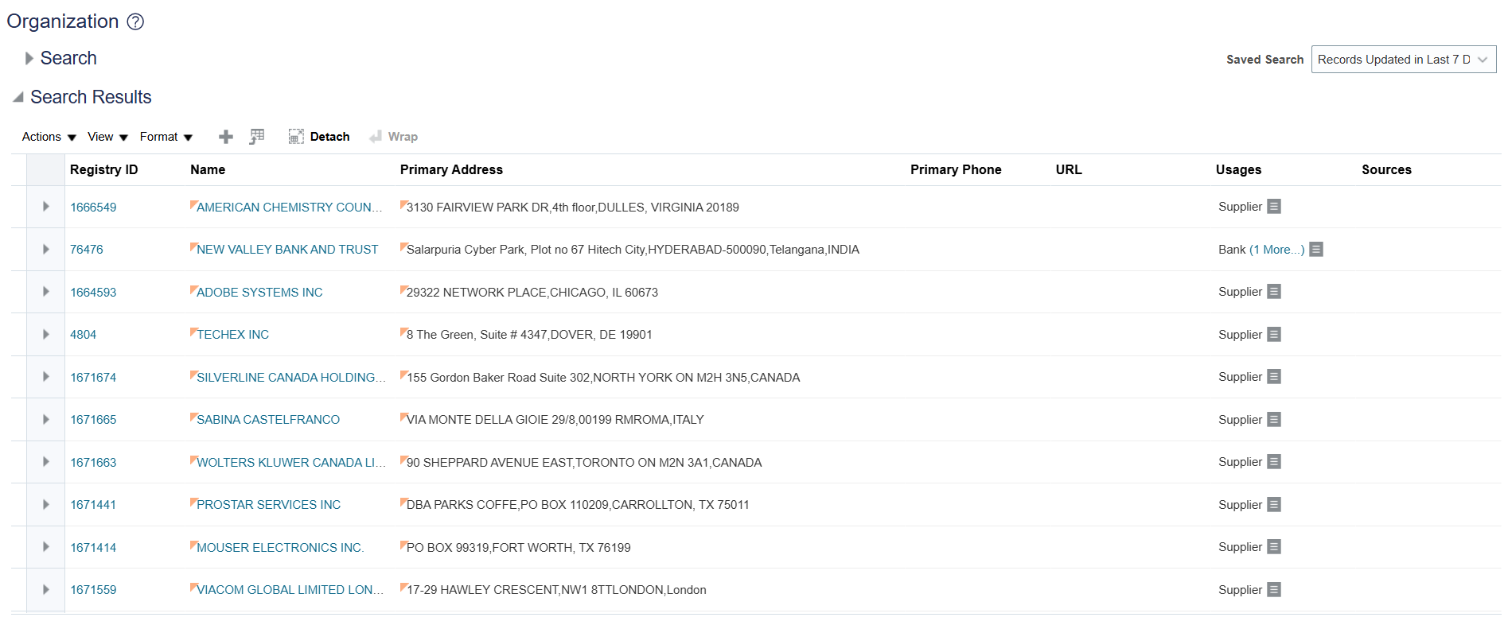
- Enter the account details needed:
  - Select Usage = External Legal Entity
  - Enter Name
  - Select the Country from the LOV
  - Enter the Legal Address
  - Click Save and Edit.
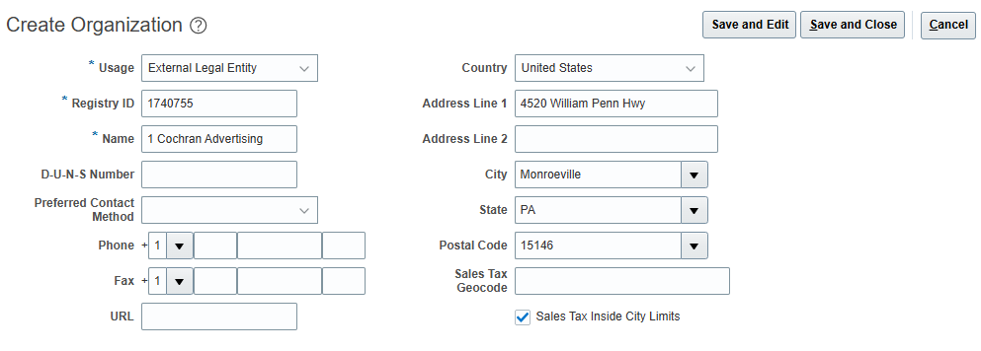
- Click Source System References tab and click Add (+ icon) source system references.

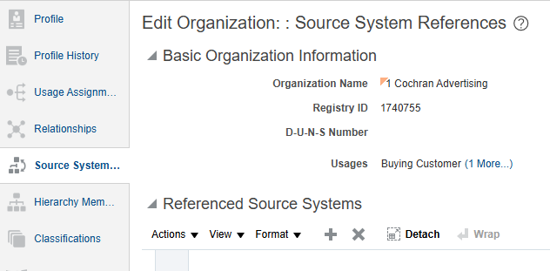

- Select Source System from Drop Down.

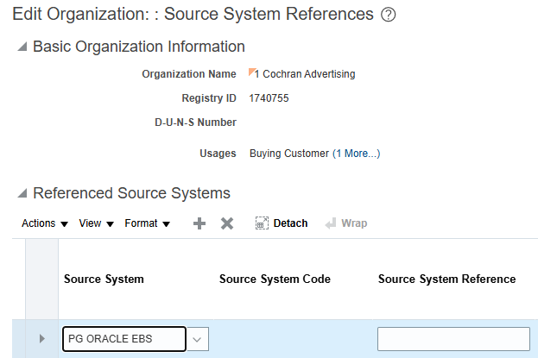

List of Source Systems:
Source System Name | Source System Code | Description
PG BROADWAY | PG_BROADWAY | BROADWAY Source System for EBS
PG BTS EUROPE ** | PG_BTS_EUROPE | BTS EUROPE Source System for Viacom
PG BTS INTERNATIONAL** | PG_BTS_INTERNATIONAL | BTS INTERNATIONAL Source System for Viacom
PG BTS LATAM** | PG_BTS_LATAM | BTS LATAM Source System for Viacom
PG CBS | PG_CBS_1 | Paramount CBS Legacy System
PG CBS PRISM | PG_CBS_PRISM | CBS PRISM Source System for Paramount
PG CP LICENSEMAESTRO (VIACOM)** | PG_CP_LICENSEMAESTRO | CP LICENSEMAESTRO Source System for Viacom
PG ELEVATION CINR | PG_ELEVATION_CINR | ELEVATION CINR Source System for Paramount
PG ELEVATION TECH | PG_ELEVATION_TECH | ELEVATION TECH Source System for Paramount
PG ESCD | PG_ESCD | ESCD Source System for Paramount
PG GPS ** | PG_GPS | GPS Source System for Viacom
PG IAP PARTNERS | PG_IAP_PARTNERS | IAP PARTNERS Source System
PG IBMS** | PG_IBMS | IBMS Source System for Viacom
PG INTESA SANPAOLO | PG_INTESA_SANPAOLO | INTESA SANPAOLO Source System for Paramount
PG LICENSE MAESTRO(PARMAOUNT) | PG_LICENSE_MAESTRO | LICENSE MAESTRO Source System for Paramount
PG MACCS AUSTRALIA | PG_MACCS_AUSTRALIA | MACCS AUSTRALIA Source System for Paramount
PG MACCS BRAZIL | PG_MACCS_BRAZIL | MACCS BRAZIL Source System for Paramount
PG MACCS FRANCE | PG_MACCS_FRANCE | MACCS FRANCE Source System for Paramount
PG MACCS GERMANY | PG_MACCS_GERMANY | MACCS GERMANY Source System for Paramount
PG MACCS IRELAND | PG_MACCS_IRELAND | MACCS IRELAND Source System for Paramount
PG MACCS MEXICO | PG_MACCS_MEXICO | MACCS MEXICO Source System for Paramount
PG MACCS NEW ZEALAND | PG_MACCS_NEWZEALAND | MACCS NEWZEALAND Source System for Paramount
PG MACCS SPAIN | PG_MACCS_SPAIN | MACCS SPAIN Source System for Paramount
PG MACCS UK | PG_MACCS_UK | MACCS UK Source System for Paramount
PG MANUAL | PG_MANUAL | MANUAL Source System for EBS
PG MEDIAMAESTRO DIGITAL | PG_MEDIAMAESTRO_DIGITAL | MediaMaestro Digital Source System
PG MEDIAMAESTRO LICENSING | PG_MEDIAMAESTRO_LICENSING | MediaMaestro Licensing Source System
PG MEDIA PULSE | PG_MEDIA_PULSE | MEDIA PULSE Source System for EBS
PG MSP DOMESTIC** | PG_MSP_DOMESTIC | MSP DOMESTIC Source System for Viacom and EBS
PG MSP INTERNATIONAL** | PG_MSP_INTERNATIONAL | MSP INTERNATIONAL System for Viacom
PG NEWSPATH | PG_NEWSPATH | NEWSPATH Source System for EBS
PG OPERATIVE (D2C) | PG_OPERATIVE | OPERATIVE Source System for EBS
PG OPERATIVE SAP (VIACOM)** | PG_OPERATIVE_SAP | OPERATIVE SAP Source System for Viacom
PG ORACLE EBS | PG_ORACLE_EBS | ORACLE EBS Source System
PG PARAMOUNT PRISM | PG_PARAMOUNT_PRISM | PARAMOUNT PRISM Source System for Paramount
PG PARAMOUNT SAP | PG_PARAMOUNT_SAP | PARAMOUNT SAP Source System
PG PHE AEC | PG_PHE_AEC | PHE AEC Source System
PG PHE ELC | PG_PHE_ELC | PHE ELC Source System
PG PHE ELE | PG_PHE_ELE | PHE ELE Source System
PG PHE ESC | PG_PHE_ESC | PHE ESC Source System
PG PHE SDS | PG_PHE_SDS | PHE SDS Source System
PG PHE UNI | PG_PHE_UNI | PHE UNI Source System
PG PHOENIX | PG_PHOENIX | PHOENIX Source System for EBS
PG PUBLIFE ** | PG_PUBLIFE | PUBLIFE Source System for Viacom
PG RECURLY | PG_RECURLY | RECURLY Source System
PG RMS** | PG_RMS | RMS Source System for Viacom
PG SCHEDULEALL | PG_SCHEDULEALL | SCHEDULEALL Spoke System for EBS
PG SF FILM LIBRARY | PG_SF_FILM_LIBRARY | SF FILM LIBRARY Source System for EBS
PG SISCOM ** | PG_SISCOM | SISCOM Source System for Viacom
PG SPOTS | PG_SPOTS | SPOTS Source System
PG STUDIO BILLING HUB | PG_STUDIO_BILLING_HUB | Studio Billing Hub Source System
PG STUDIO DIST SVCS | PG_STUDIO_DIST_SVCS | STUDIO DIST SVCS Source System for Paramount
PG TDS | PG_TDS | TDS Source System for Paramount
PG TREC | PG_TREC | TREC Source System
PG TVR | PG_TVR | TVR Source System
PG UIP | PG_UIP | UIP Source System
PG UPI | PG_UPI | UPI Source System
PG VIACOM SAP | PG_VIACOM_SAP | VIACOM SAP Source System for Viacom and Paramount
PG WHIP MEDIA | PG_WHIP_MEDIA | WHIP MEDIA Source System
PG WIDEORBIT DII | PG_WIDEORBIT_DII | WIDEORBIT DII Source System
PG WIDEORBIT NETWORK** | PG_WIDEORBIT_NETWORK | WIDEORBIT NETWORK Source System for Viacom
PG WIDEORBIT TRAFFIC | PG_WIDEORBIT_TRAFFIC | WIDEORBIT TRAFFIC Source System for EBS
**Need to also add PG VIACOM SAP as a Boundary System if any of these Boundary Systems are selected.

- Enter Source System Reference as <Source System Code>_<Registry ID> if Source System Reference is unknown. Otherwise, enter the known Source System Reference. Click Save.

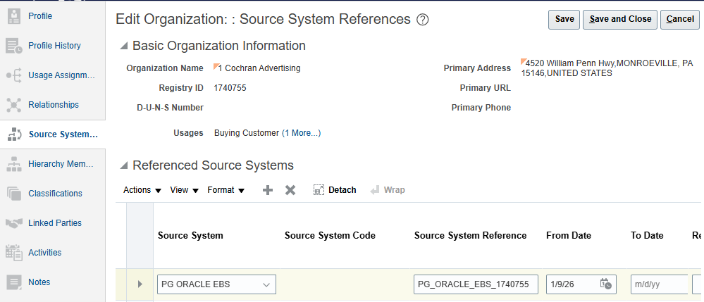
- If adding multiple source system References, repeat steps 4, 5 and 6

- Click the Classifications tab and click Add (+ icon).

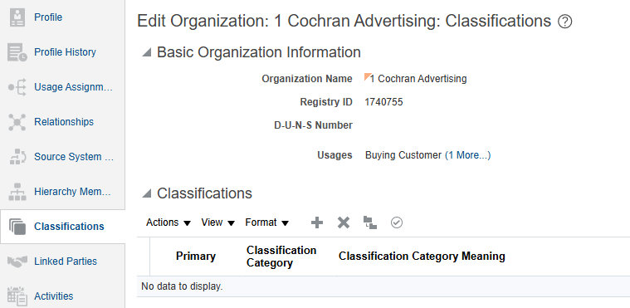

- Search for Classification Category = “PG_CUSTOMER_CLASSIFICATION”

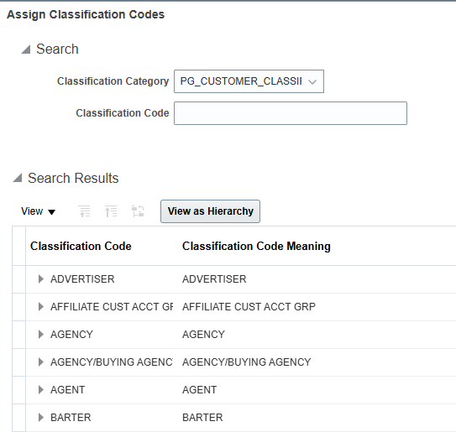

List of Classification Codes:
Classification Code
3RD PARTY
ADVERTISER
AGENCY
CP AGENT
CP LICENSEE
HOLDING COMPANY
INTERCOMPANY
N-TRADE
PARENT
STUDIO

- Select the correct Classification Code and click OK.

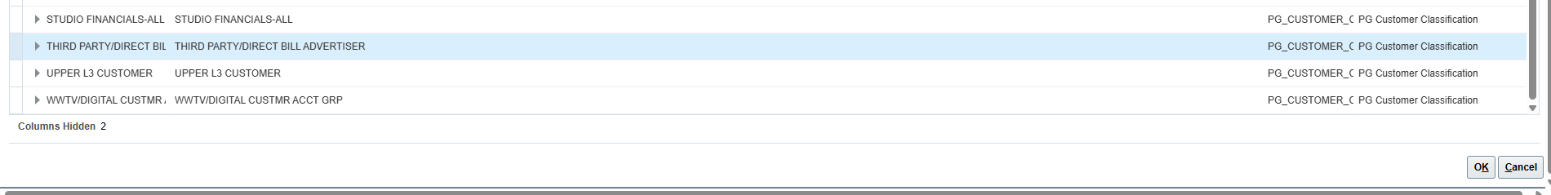
- If adding multiple classifications repeat steps 8, 9, and 10.

- Copy the Registry ID from the top of the page. Click Save and Close.

Creating Account & Site(s) in Manage Customers (AR)

- Navigate to Navigation (Hamburger Menu) > Receivables > Billing.

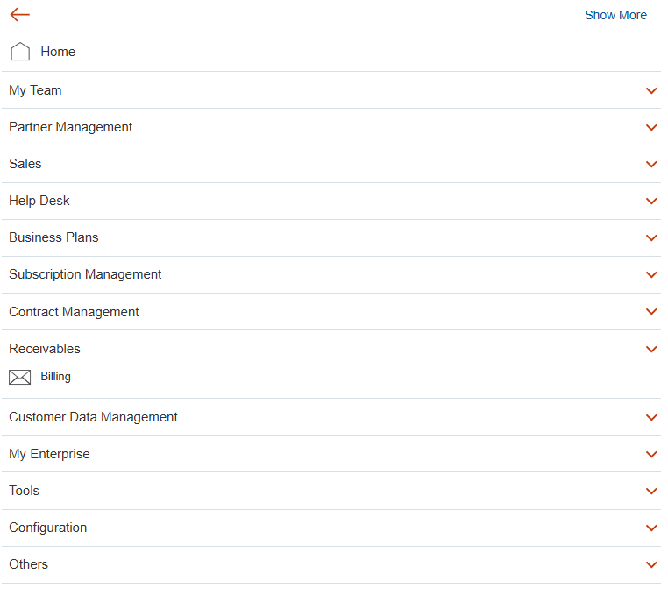

- Click the Task Panel on the right side of the page. Under Customers, click Manage Customers.

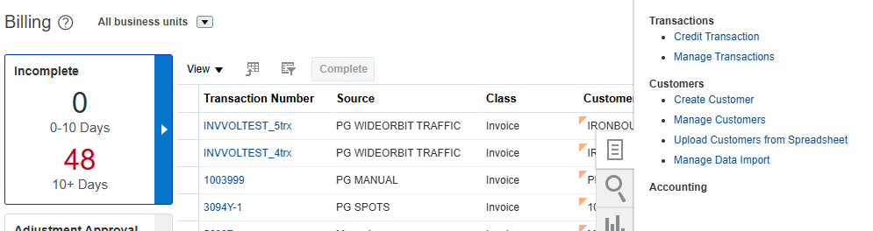

- Enter Customer Account Number previously copied in the Registry ID field then click the Search button

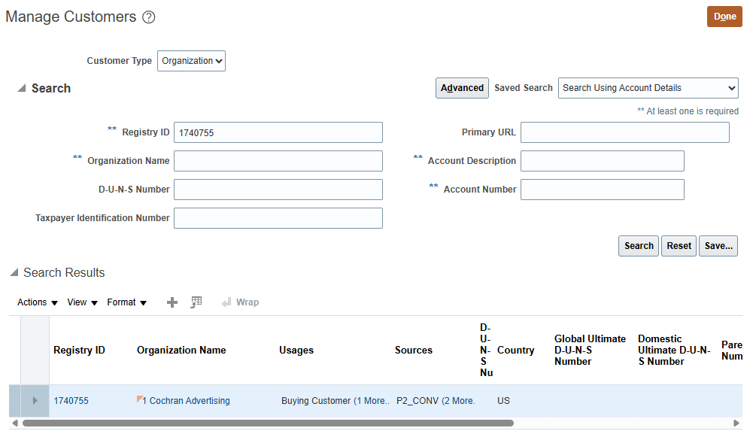
- In the Account information section of the window, click Create.

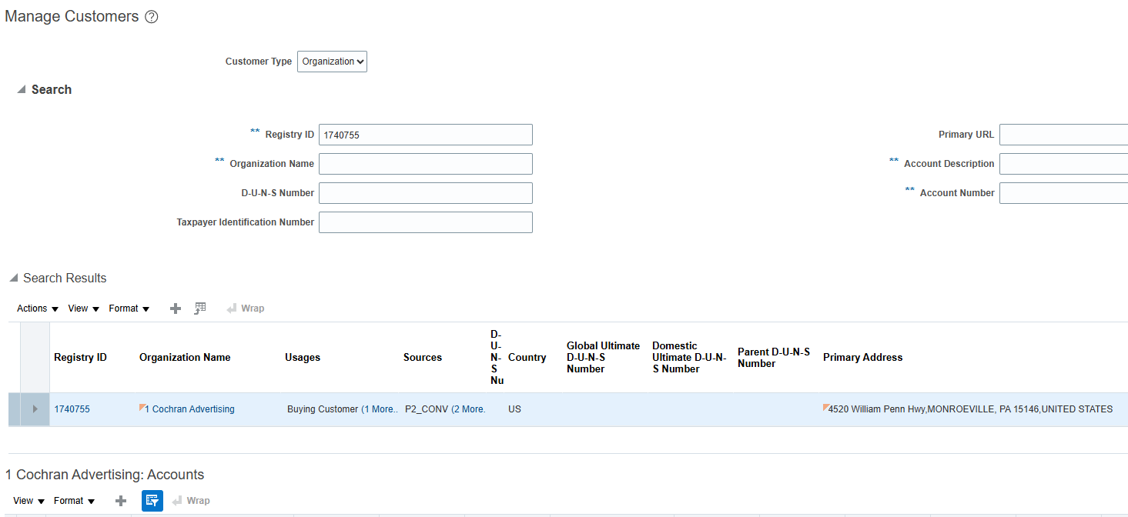
- Create Account:
  - Enter the Registry ID into the Account Number field
  - Select Account Type = “External” from the LOV (dropdown)*REQUIRED FIELD
  - Enter the Financial Rep (if applicable)
  - Back date Account Established Date if required, otherwise leave as-is (today’s date)

*If creating a Studio specific customer, enter *** Express Station, Train Station, and Corporate Group.

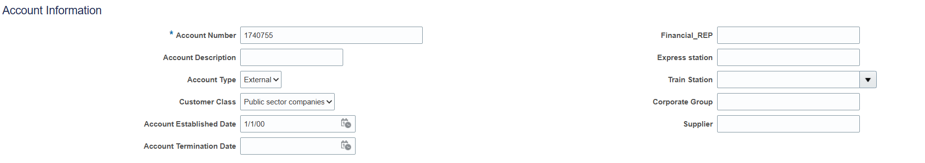
- In the Account Address area,
  - Select Account Address Set = “ENTERPRISE”
  - Select Revenue Stream and Sub Revenue Stream from the LOVs.
  - Enter From Date to be the same as the account establishment date.

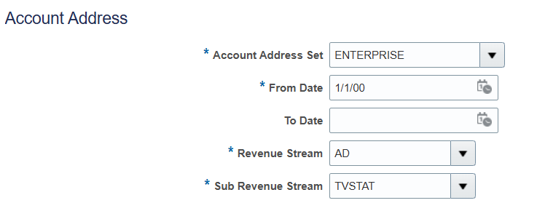
***When selecting the Revenue Stream and Sub Revenue Stream, please refer to this document P2_Customer_Attribute_List.xlsx (BS_Outbound_Enablement tab – Columns E & F) to determine the correct Sub Revenue Stream for the Boundary System requesting the Customer. If there are multiple Sub Revenue Streams listed, then a Site for each must be created. If multiple Sites are required, once you complete Step 21, click “+” under the Sites, and repeat steps 18-21 as needed.

- Update Site Number = <Registry ID>_<Revenue Stream>_<Sub Revenue Stream>_1.

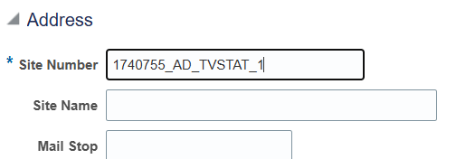

- Select Country and enter relevant site address information.

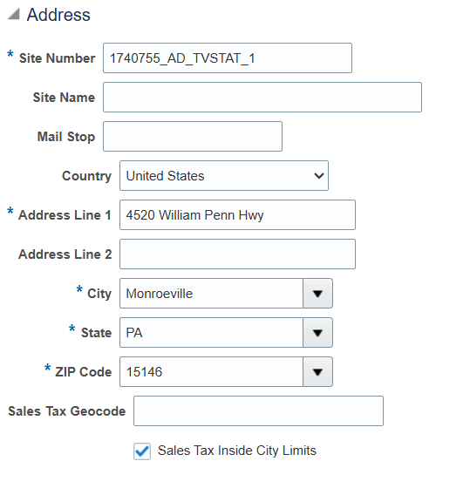

- In the Address Purposes section, click Add.
  - Enter Site = <Site Number>_ B for Bill to Address.
  - Select the From Date same as Account Establishment Date.
  - Select Purpose as Bill to.
  - Click Save.
  - Click Save and Close.

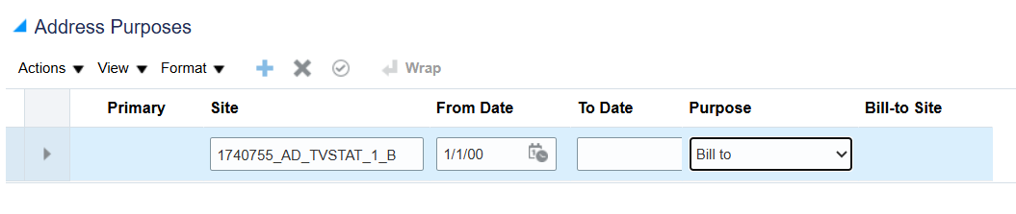
- If you are creating a Direct Advertiser, create an additional Site.
  - Select Account Address Set = “ENTERPRISE”
  - Select Revenue Stream and Sub Revenue Stream from the LOVs.
  - Enter From Date to be the same as the account establishment date.
  - Enter Site Number = <Registry ID>_<Revenue Stream>_<Sub Revenue Stream>_2.
  - Address = 1515 BROADWAY NEW YORK, NY 10036

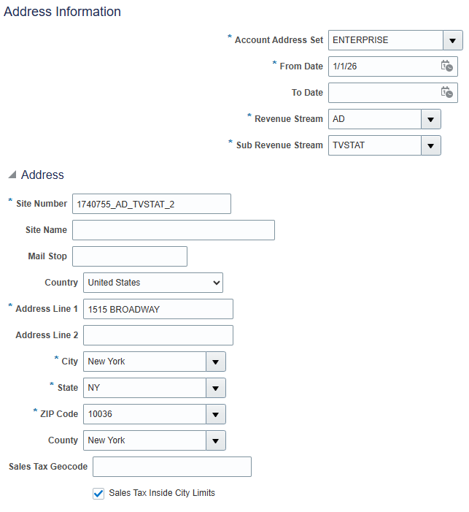

- In the Address Purposes section, click Add.
  - Enter Site = <Site Number>_S for Ship to Address.
  - Select the From Date same as the Account Establishment Date.
  - Select Purpose as Ship to.
  - Click Save.
  - Click Save and Close.

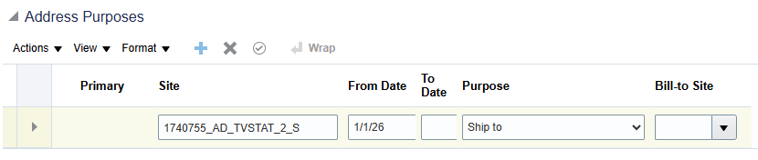

Adding Tax Information (if applicable)

- If Tax Information was provided, select the Party by clicking on the Registry ID in the first row. Otherwise, skip to Step 27.

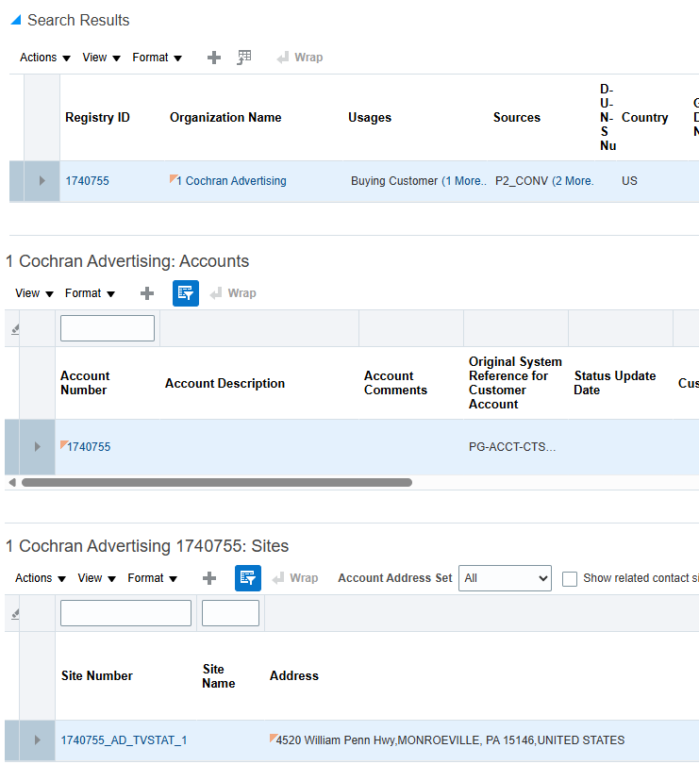

- Click on the “Tax Profile” tab, then click on the “Tax Registrations” tab to enter the Tax Registration number
  - Select Country
  - Enter Tax Registration Number
  - Select Tax Registration Type

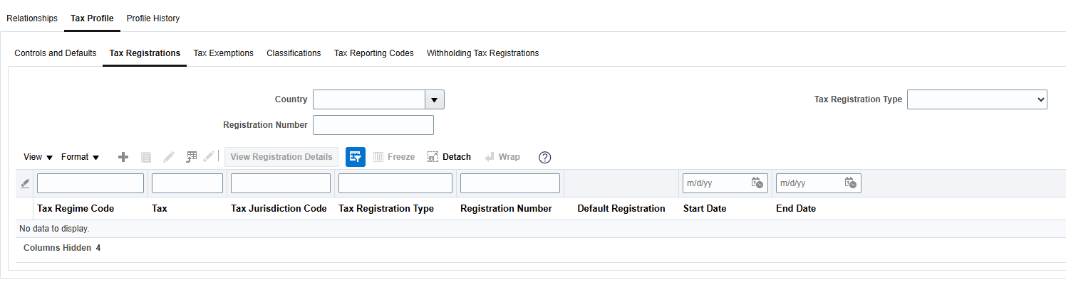
- Click on the “Classifications” tab under the Tax Profile.

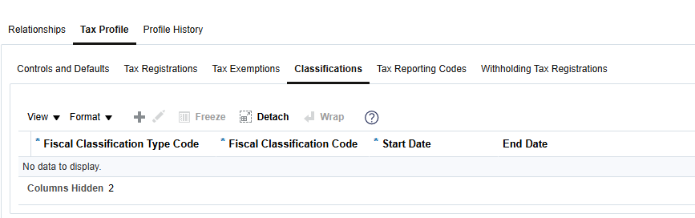
- Click Add Row.
  - Select Fiscal Classification Type Code from the LOVs
  - Select Fiscal Classification Code from the LOVs
  - Select Start Date same as Account Establishment Date

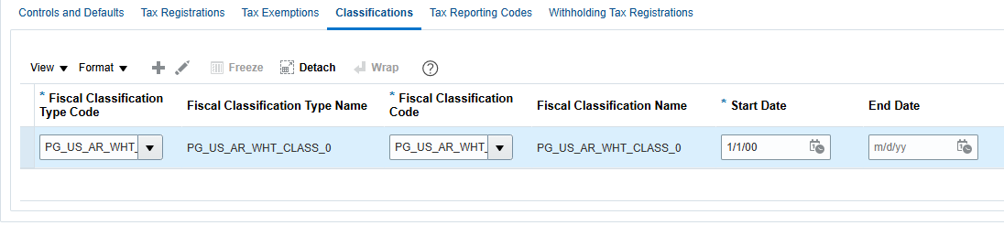
- Click Save and Close.

Create Site Profile (Collector/Payment Terms)

- Click on the Site Number link which is highlighted under Sites section.

- In the Profile History tab, click the “Create Site Profile” button.

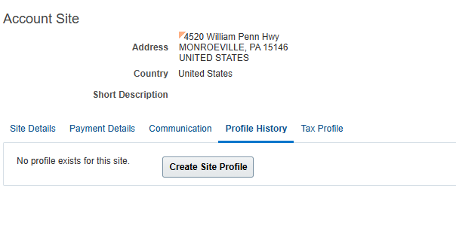

- Select the Collector for this customer. If there are different Payment Terms than Net 30, also select that here. Click Save and Close TWICE.

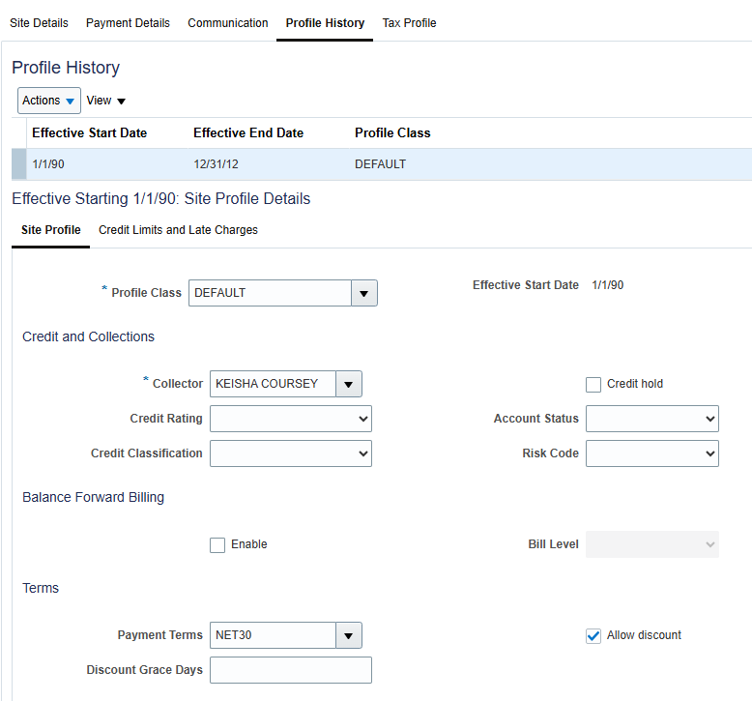
- If multiple Sites were created, repeat steps 27-29 for all Sites.

Creating Contacts

- To create Contacts:
  - Click on Communication tab within the Site (if multiple Sites were created, this only needs to be done within the first one)
  - Click on the “Edit Contacts” button

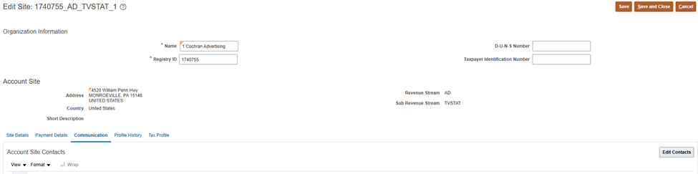

- Click Create Contact icon (the first + icon on the page).

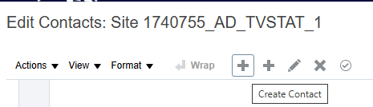

- Populate the necessary fields and click OK.

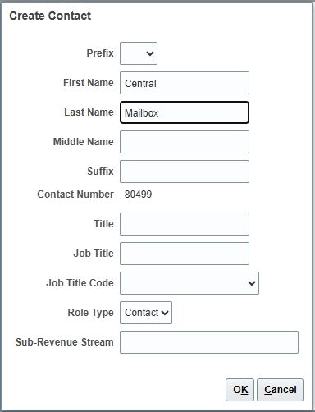

- If the Contact is Primary, click Actions > Set Primary Contact.

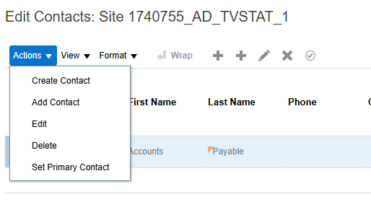

- Select the Contact that was just created and click on the Create icon (+ icon) under the Contact Points section.

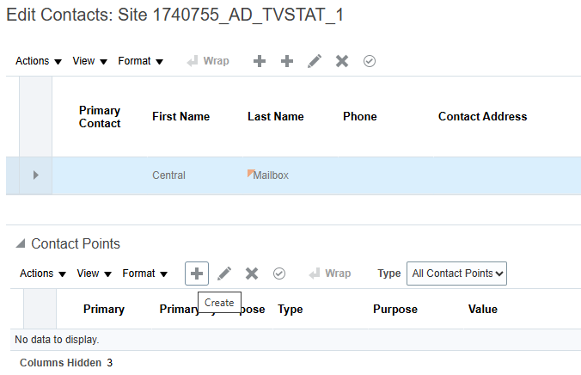

- Populate the necessary fields and click OK.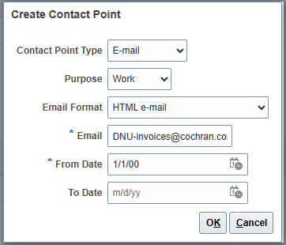

- To enter multiple Contact Points, repeat steps 35 and 36.

- Under Account Contact Responsibilities, click Create (+ icon) and select the Contact’s Responsibility.

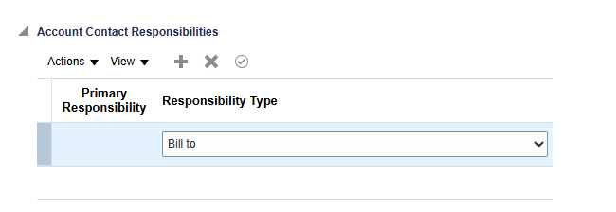

- Click Save and Close.

Create Parent

- To create the Parent, navigate back to Customer Data Management > Organizations.

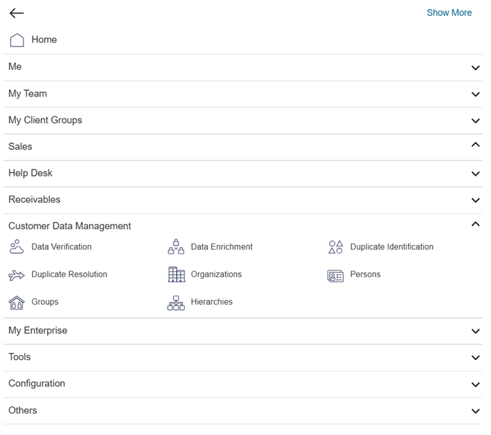

- Create Customer – click on the + icon.

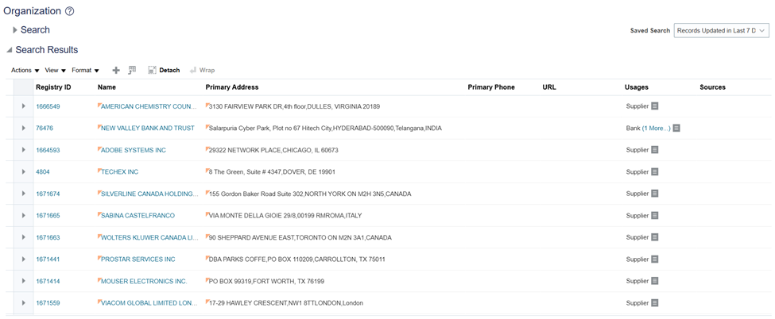
- Enter the account details needed:
  - Select Usage = External Legal Entity
  - Enter Name (this will be the same as the Customer just created).
  - Enter the Legal Address = 1515 BROADWAY NEW YORK, NY 10036
  - Click Save and Edit.
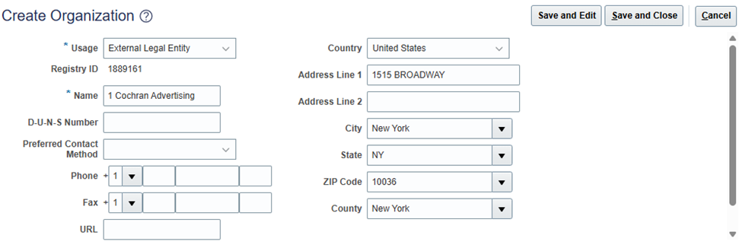

- In the Matching Organization window, select Option 2 (Create new organization based on what you provided). Click OK.

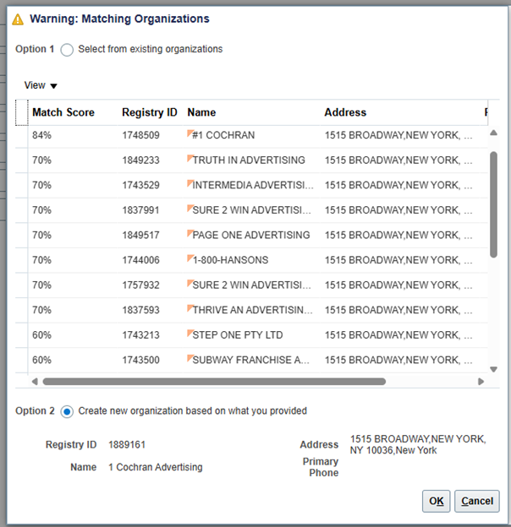

- Click the Classifications tab and click Add (+ icon).

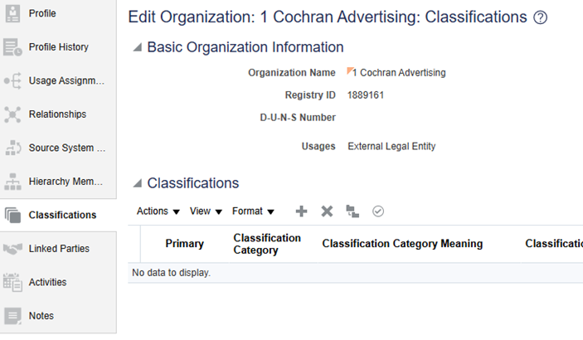

- Search for Classification Category = “PG_CUSTOMER_CLASSIFICATION”

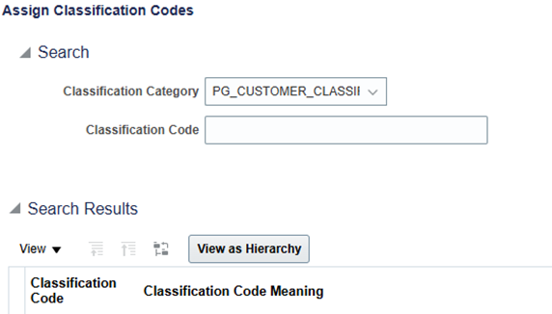

- Select the Classification Code PARENT and click OK.

- Copy and paste the Registry ID. Then click Save and Close.

Create Hierarchy

- Navigate to Navigation (Hamburger Menu) > Customer Data Management > Hierarchies.

- Click Create (+ icon).

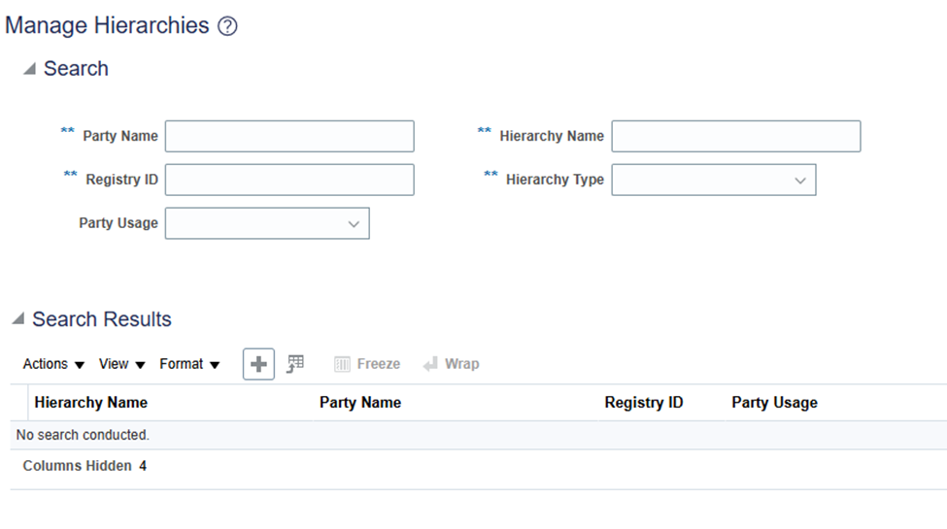

- Create the Hierarchy:
  - Enter Hierarchy Name: <CUSTOMER NAME> HIERARCHY
  - Select Hierarchy Type = Customer Hierarchy
  - Enter Effect Start Date = 1st of the month
  - Click Next

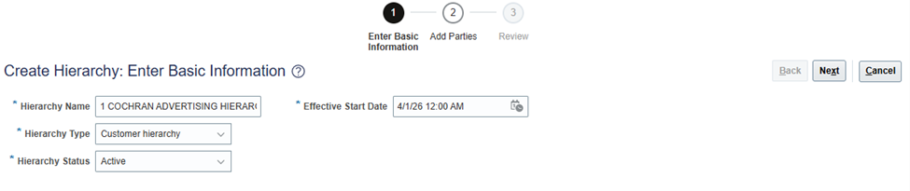
- Click Add (+ icon)

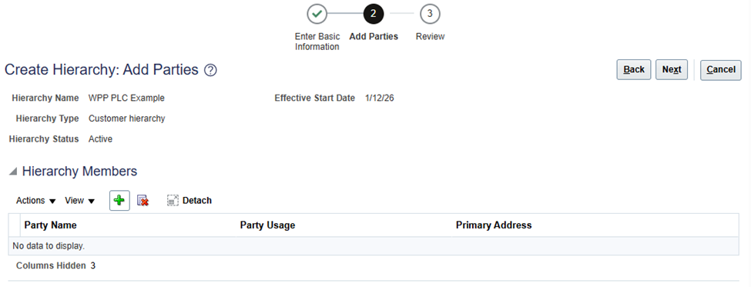
- Click Search.

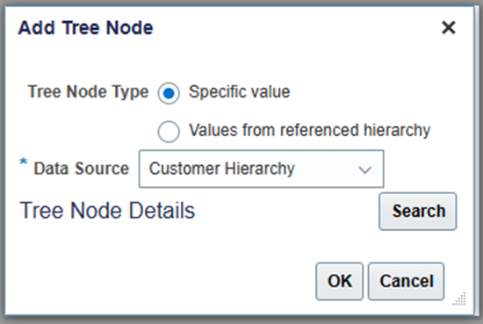

- Search for the Parent Company using either the Name or the Registry ID.

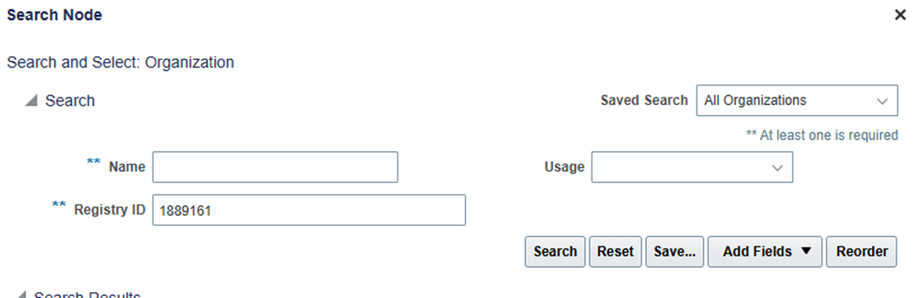
- Select the Parent Company (should be highlighted) and click OK.

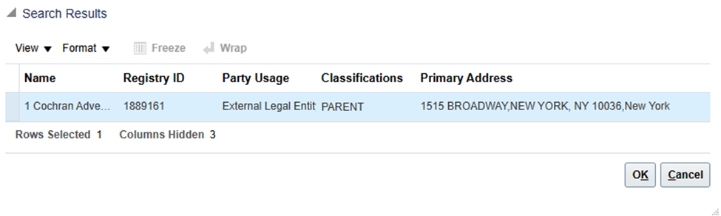
- With the Parent Company selected, click Add (+ icon).

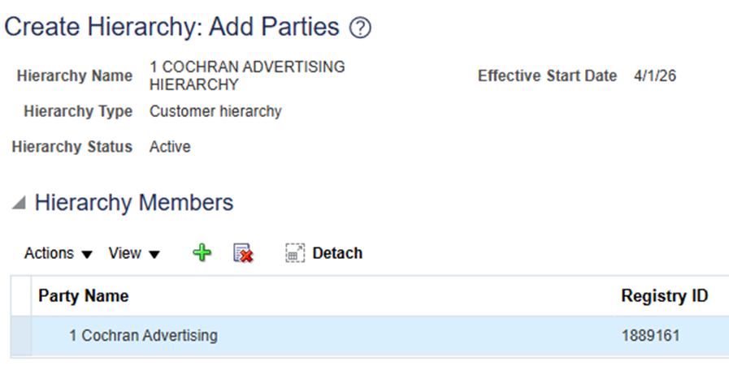
- Click Search.

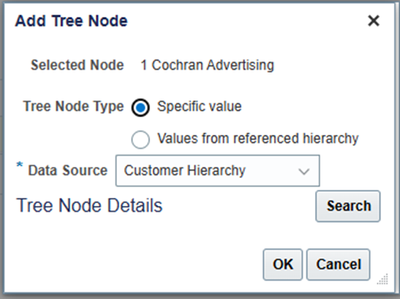

- Search for the Customer/child using either the Name or the Registry ID.

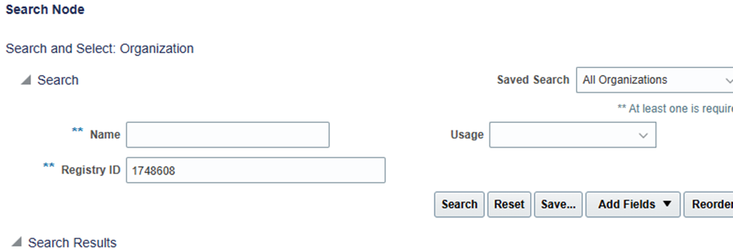
- Select the Parent Company (should be highlighted) and click OK.

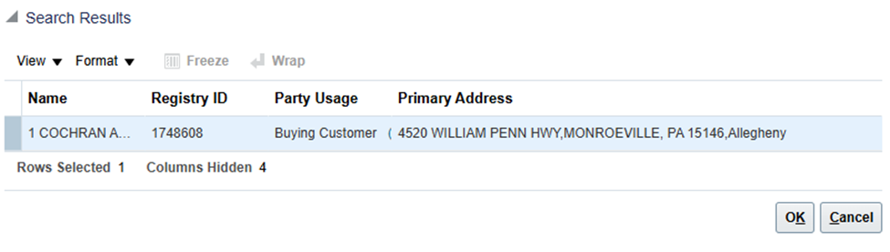
- Once the Hierarchy is complete, click Next.

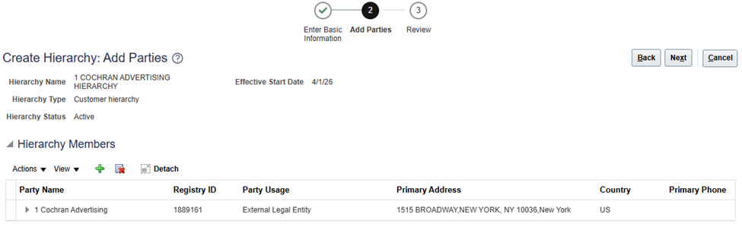
- Review the Hierarchy and click Finish to save the changes.

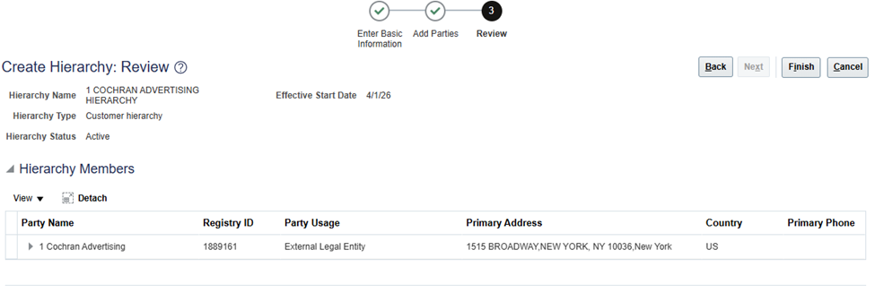

Add Credit Information to the Parent

- Navigate to Navigation (Hamburger Menu) > Receivables > Billing.

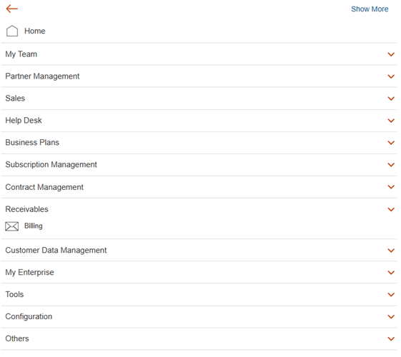

- Click the Task Panel on the right side of the page. Under Customers, click Manage Customers.

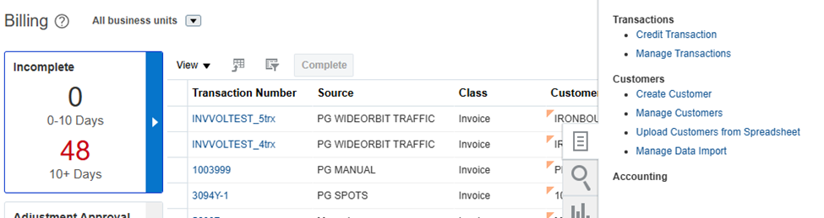
- Enter the Parent Registry ID number into the Registry ID field and click Search.

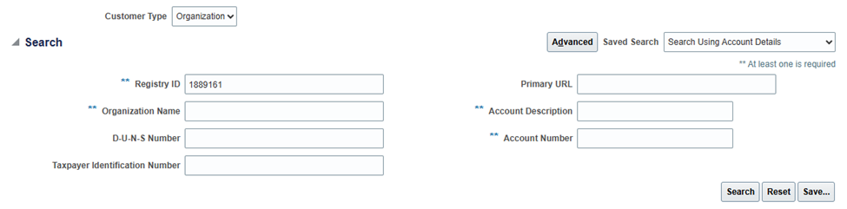
- Click into the Party Level by clicking on the Registry ID.

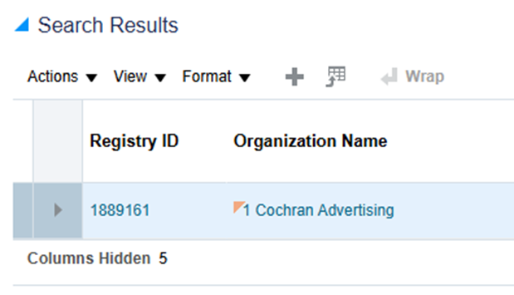

- Under Profile History, select “Create Customer Profile”.

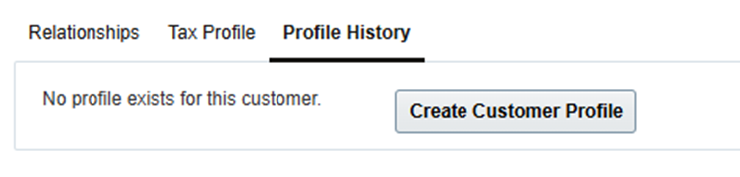

- Set the Credit Analyst, Credit Limit, and Credit Currency. If the Credit Limit and Credit Currency are unknown, set the default $10,000 USD. Click Save and Close.

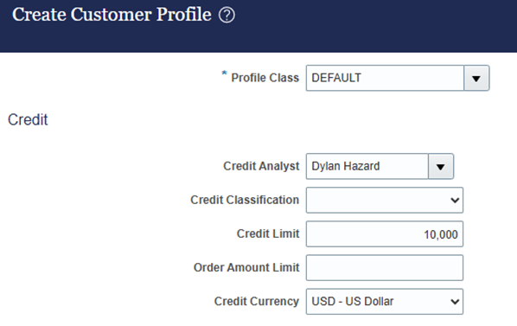

- Click Save and Close.

- Run the report to update the OSRs via Import Management to complete the Customer setup. Steps under “Running OSR Import File” section.

Create & Define New Customer – Advertiser (without Parent)

Creating Customer in CDM
- Logged in as a user with PG AR Customer Manager role, navigate to Navigation (Hamburger Menu) > Customer Data Management > Organizations.

- Create Customer – click on the + icon

- Enter the account details needed:
  - Select Usage = External Legal Entity
  - Enter Name
  - Enter the Legal Address = 1515 BROADWAY NEW YORK, NY 10036
  - Click Save and Edit.
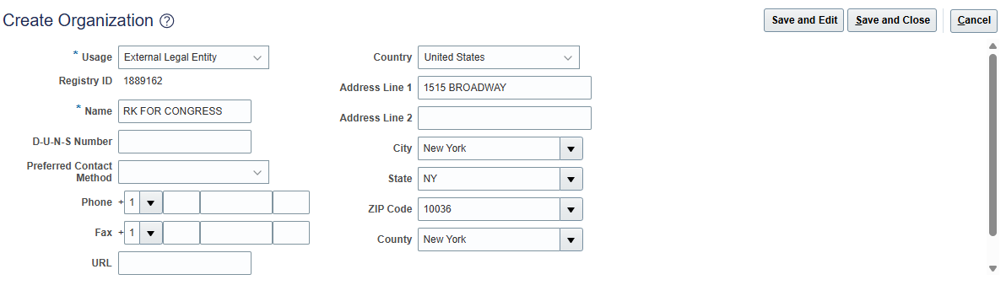
- In Matching Organizations popup, select Option 2 (Create new organization based on what you provided), unless there is a 100% match. Click OK.

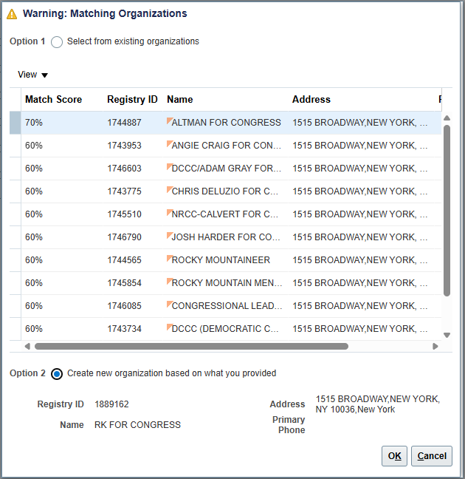

- Click Source System References tab and click Add (+ icon) source system references.

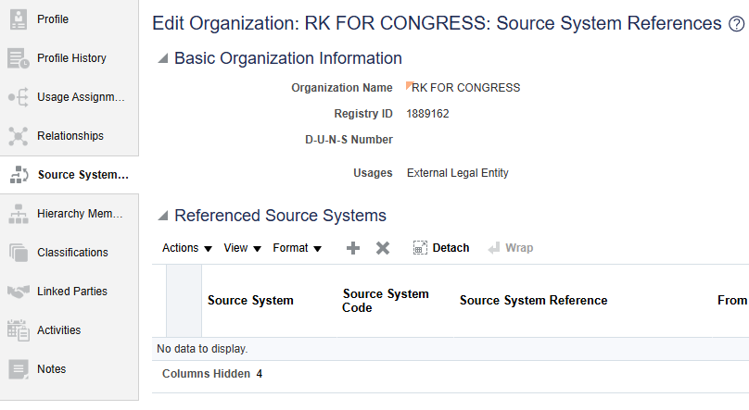

- Select Source System from Drop Down.

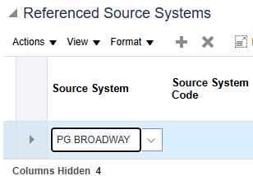

List of Source Systems:
Source System Name | Source System Code | Description
PG BROADWAY | PG_BROADWAY | BROADWAY Source System for EBS
PG BTS EUROPE ** | PG_BTS_EUROPE | BTS EUROPE Source System for Viacom
PG BTS INTERNATIONAL** | PG_BTS_INTERNATIONAL | BTS INTERNATIONAL Source System for Viacom
PG BTS LATAM** | PG_BTS_LATAM | BTS LATAM Source System for Viacom
PG CBS | PG_CBS_1 | Paramount CBS Legacy System
PG CBS PRISM | PG_CBS_PRISM | CBS PRISM Source System for Paramount
PG CP LICENSEMAESTRO (VIACOM)** | PG_CP_LICENSEMAESTRO | CP LICENSEMAESTRO Source System for Viacom
PG ELEVATION CINR | PG_ELEVATION_CINR | ELEVATION CINR Source System for Paramount
PG ELEVATION TECH | PG_ELEVATION_TECH | ELEVATION TECH Source System for Paramount
PG ESCD | PG_ESCD | ESCD Source System for Paramount
PG GPS ** | PG_GPS | GPS Source System for Viacom
PG IAP PARTNERS | PG_IAP_PARTNERS | IAP PARTNERS Source System
PG IBMS** | PG_IBMS | IBMS Source System for Viacom
PG INTESA SANPAOLO | PG_INTESA_SANPAOLO | INTESA SANPAOLO Source System for Paramount
PG LICENSE MAESTRO(PARMAOUNT) | PG_LICENSE_MAESTRO | LICENSE MAESTRO Source System for Paramount
PG MACCS AUSTRALIA | PG_MACCS_AUSTRALIA | MACCS AUSTRALIA Source System for Paramount
PG MACCS BRAZIL | PG_MACCS_BRAZIL | MACCS BRAZIL Source System for Paramount
PG MACCS FRANCE | PG_MACCS_FRANCE | MACCS FRANCE Source System for Paramount
PG MACCS GERMANY | PG_MACCS_GERMANY | MACCS GERMANY Source System for Paramount
PG MACCS IRELAND | PG_MACCS_IRELAND | MACCS IRELAND Source System for Paramount
PG MACCS MEXICO | PG_MACCS_MEXICO | MACCS MEXICO Source System for Paramount
PG MACCS NEW ZEALAND | PG_MACCS_NEWZEALAND | MACCS NEWZEALAND Source System for Paramount
PG MACCS SPAIN | PG_MACCS_SPAIN | MACCS SPAIN Source System for Paramount
PG MACCS UK | PG_MACCS_UK | MACCS UK Source System for Paramount
PG MANUAL | PG_MANUAL | MANUAL Source System for EBS
PG MEDIAMAESTRO DIGITAL | PG_MEDIAMAESTRO_DIGITAL | MediaMaestro Digital Source System
PG MEDIAMAESTRO LICENSING | PG_MEDIAMAESTRO_LICENSING | MediaMaestro Licensing Source System
PG MEDIA PULSE | PG_MEDIA_PULSE | MEDIA PULSE Source System for EBS
PG MSP DOMESTIC** | PG_MSP_DOMESTIC | MSP DOMESTIC Source System for Viacom and EBS
PG MSP INTERNATIONAL** | PG_MSP_INTERNATIONAL | MSP INTERNATIONAL System for Viacom
PG NEWSPATH | PG_NEWSPATH | NEWSPATH Source System for EBS
PG OPERATIVE (D2C) | PG_OPERATIVE | OPERATIVE Source System for EBS
PG OPERATIVE SAP (VIACOM)** | PG_OPERATIVE_SAP | OPERATIVE SAP Source System for Viacom
PG ORACLE EBS | PG_ORACLE_EBS | ORACLE EBS Source System
PG PARAMOUNT PRISM | PG_PARAMOUNT_PRISM | PARAMOUNT PRISM Source System for Paramount
PG PARAMOUNT SAP | PG_PARAMOUNT_SAP | PARAMOUNT SAP Source System
PG PHE AEC | PG_PHE_AEC | PHE AEC Source System
PG PHE ELC | PG_PHE_ELC | PHE ELC Source System
PG PHE ELE | PG_PHE_ELE | PHE ELE Source System
PG PHE ESC | PG_PHE_ESC | PHE ESC Source System
PG PHE SDS | PG_PHE_SDS | PHE SDS Source System
PG PHE UNI | PG_PHE_UNI | PHE UNI Source System
PG PHOENIX | PG_PHOENIX | PHOENIX Source System for EBS
PG PUBLIFE ** | PG_PUBLIFE | PUBLIFE Source System for Viacom
PG RECURLY | PG_RECURLY | RECURLY Source System
PG RMS** | PG_RMS | RMS Source System for Viacom
PG SCHEDULEALL | PG_SCHEDULEALL | SCHEDULEALL Spoke System for EBS
PG SF FILM LIBRARY | PG_SF_FILM_LIBRARY | SF FILM LIBRARY Source System for EBS
PG SISCOM ** | PG_SISCOM | SISCOM Source System for Viacom
PG SPOTS | PG_SPOTS | SPOTS Source System
PG STUDIO BILLING HUB | PG_STUDIO_BILLING_HUB | Studio Billing Hub Source System
PG STUDIO DIST SVCS | PG_STUDIO_DIST_SVCS | STUDIO DIST SVCS Source System for Paramount
PG TDS | PG_TDS | TDS Source System for Paramount
PG TREC | PG_TREC | TREC Source System
PG TVR | PG_TVR | TVR Source System
PG UIP | PG_UIP | UIP Source System
PG UPI | PG_UPI | UPI Source System
PG VIACOM SAP | PG_VIACOM_SAP | VIACOM SAP Source System for Viacom and Paramount
PG WHIP MEDIA | PG_WHIP_MEDIA | WHIP MEDIA Source System
PG WIDEORBIT DII | PG_WIDEORBIT_DII | WIDEORBIT DII Source System
PG WIDEORBIT NETWORK** | PG_WIDEORBIT_NETWORK | WIDEORBIT NETWORK Source System for Viacom
PG WIDEORBIT TRAFFIC | PG_WIDEORBIT_TRAFFIC | WIDEORBIT TRAFFIC Source System for EBS
**Need to also add PG VIACOM SAP as a Boundary System if any of these Boundary Systems are selected.

- Enter Source System Reference as <Source System Code>_<Registry ID> if Source System Reference is unknown. Otherwise, enter the known Source System Reference.
Set From Date = 1st of the Month.
Click Save.

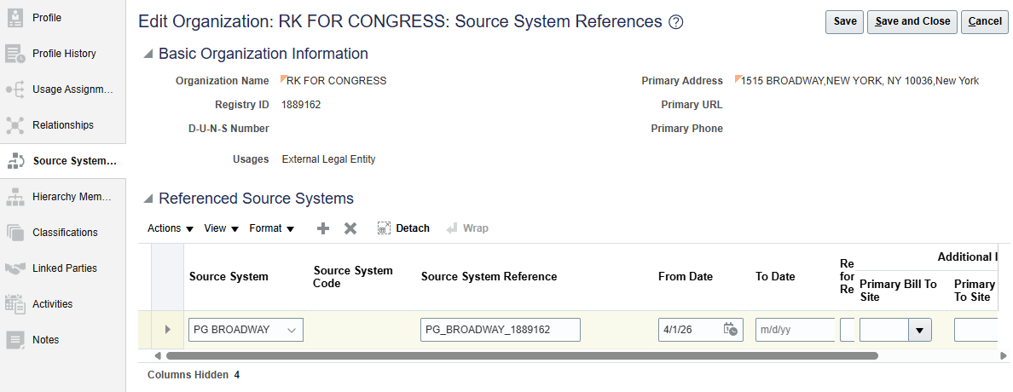
- If adding multiple source system References, repeat steps 4, 5 and 6

- Click the Classifications tab and click Add (+ icon).

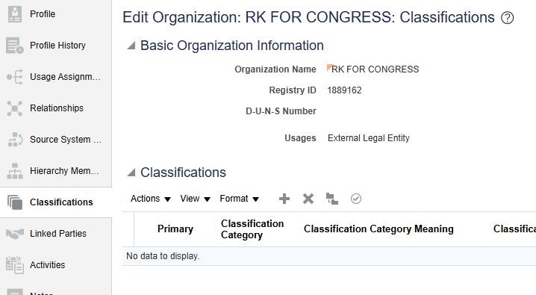

- Search for Classification Category = “PG_CUSTOMER_CLASSIFICATION”

- Select the ADVERTISER Classification Code and click OK.

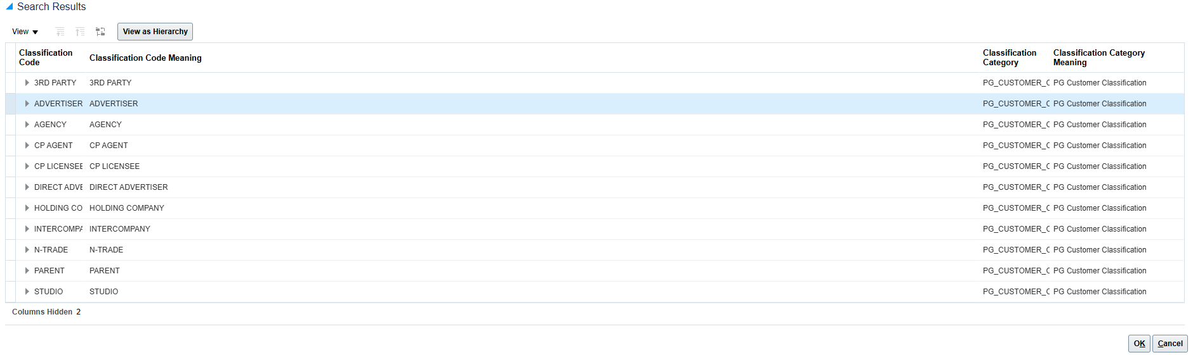
- Copy the Registry ID from the top of the page. Click Save and Close.

Creating Account & Site(s) in Manage Customers (AR)

- Navigate to Navigation (Hamburger Menu) > Receivables > Billing.

- Click the Task Panel on the right side of the page. Under Customers, click Manage Customers.

- Enter Customer Account Number previously copied in the Registry ID field then click the Search button

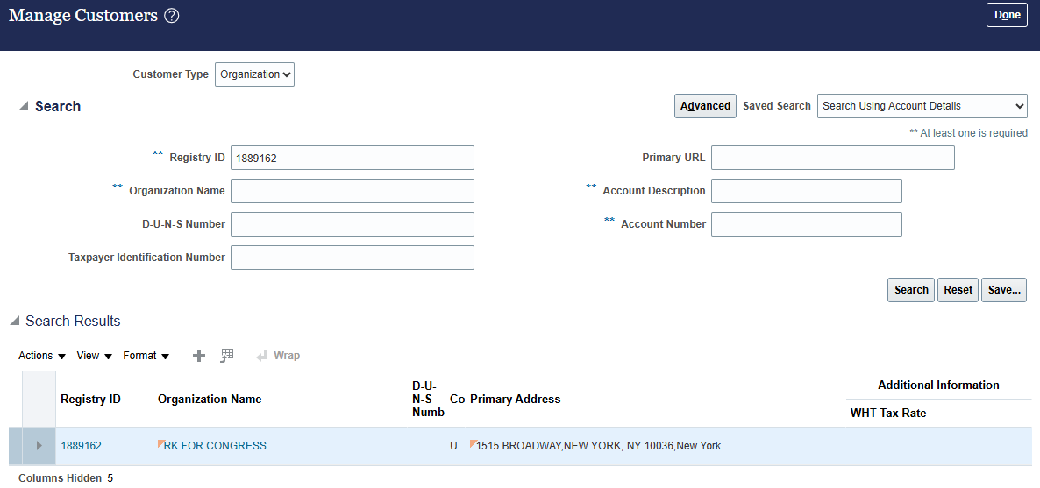
- In the “Account Level” information section of the window, click Create.
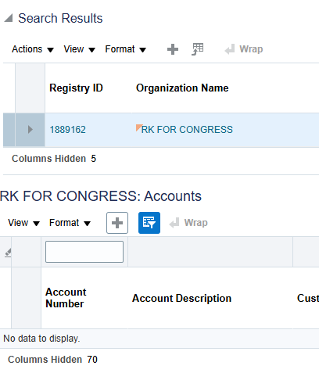

- Create Account:
  - Enter the Registry ID into the Account Number field
  - Select Account Type = “External” from the LOV (dropdown)*REQUIRED FIELD
  - Enter the Financial Rep (if applicable)
  - Back date Account Established Date to the 1st of the current month.

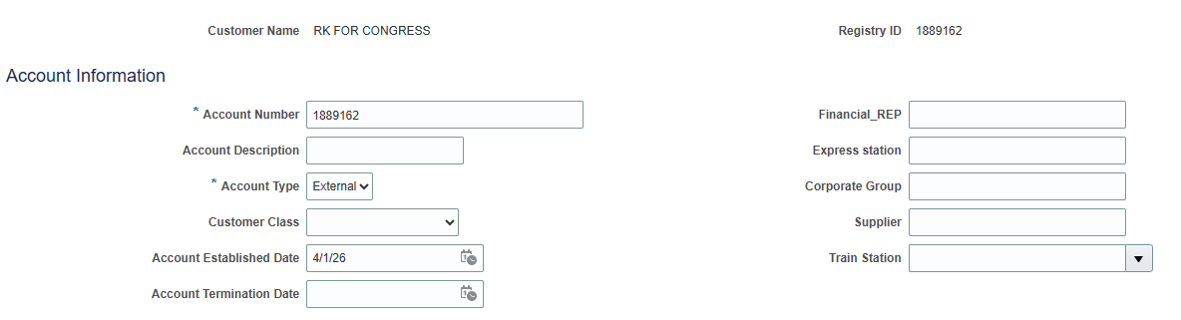
- In the Account Address area,
  - Select Account Address Set = “ENTERPRISE”
  - Select Revenue Stream and Sub Revenue Stream from the LOVs.
  - Enter From Date to be the same as the account establishment date.

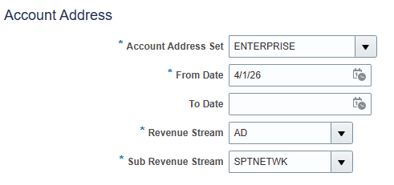
***When selecting the Revenue Stream and Sub Revenue Stream, please refer to this document P2_Customer_Attribute_List.xlsx (BS_Outbound_Enablement tab – Columns E & F) to determine the correct Sub Revenue Stream for the Boundary System requesting the Customer. If there are multiple Sub Revenue Streams listed, then a Site for each must be created. If multiple Sites are required, once you complete Step 21, click “+” under the Sites, and repeat steps 18-21 as needed.

- Update Site Number = <Registry ID>_<Revenue Stream>_<Sub Revenue Stream>_1.

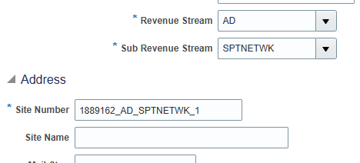

- Enter1515 BROADWAY NEW YORK, NY 10036 Address.

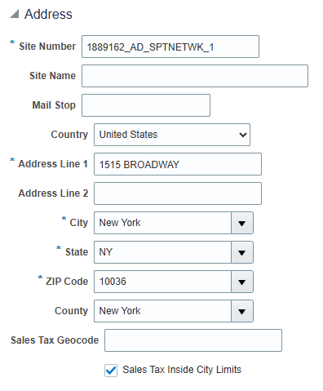

- In the Address Purposes section, click Add.
  - Enter Site = <Site Number>_S for Ship to Address.
  - Select the From Date same as Account Establishment Date.
  - Select Purpose as Ship to.
  - Click Save.
  - Click Save and Close.

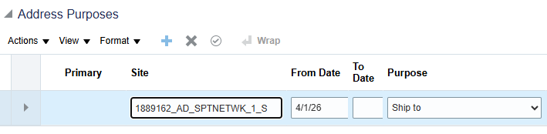

Adding Tax Information (if applicable)

- If Tax Information was provided, select the Party by click on the Registry ID in the first row. Otherwise skip to Step 27.

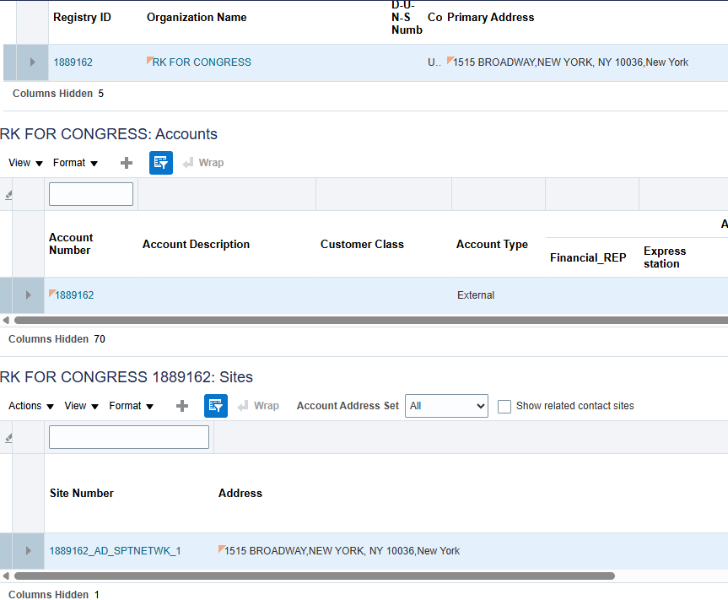
- Click on the “Tax Profile” tab, then click on the “Tax Registrations” tab to enter the Tax Registration number
  - Select Country
  - Enter Tax Registration Number
  - Select Tax Registration Type

- Click on the “Classifications” tab under the Tax Profile.

- Click Add Row.
  - Select Fiscal Classification Type Code from the LOVs
  - Select Fiscal Classification Code from the LOVs
  - Select Start Date same as Account Establishment Date

- Click Save and Close.

Add Credit Information to the Account

- Click on the Account Number link which is highlighted under “Accounts” section.

- Under the Profile History tab, click Actions > Correct Record.

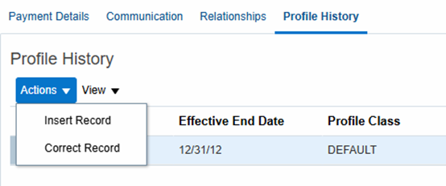

- Update the Collector (if known), Credit Limit, and Credit Currency. If the Credit Limit and Credit Currency are unknown, set it as the default $10,000 USD.

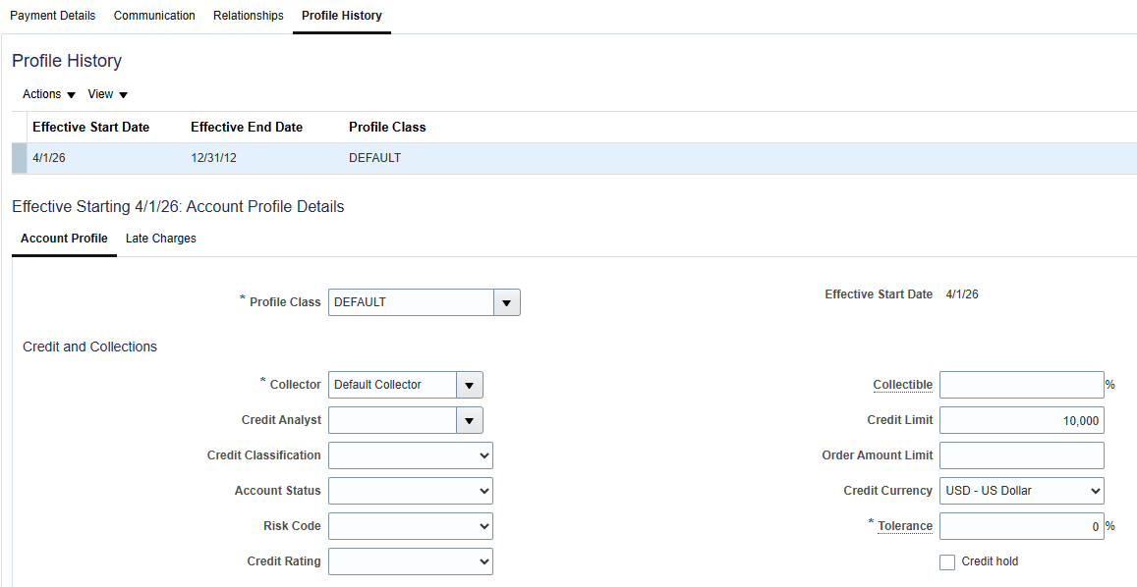

- Click Save and Close.

Creating Contacts

- Click on the Site Number link which is highlighted under Sites section.

- To create Contacts:
  - Click on Communication tab within the Site (if multiple Sites were created, this only needs to be done within the first one)
  - Click on the “Edit Contacts” button

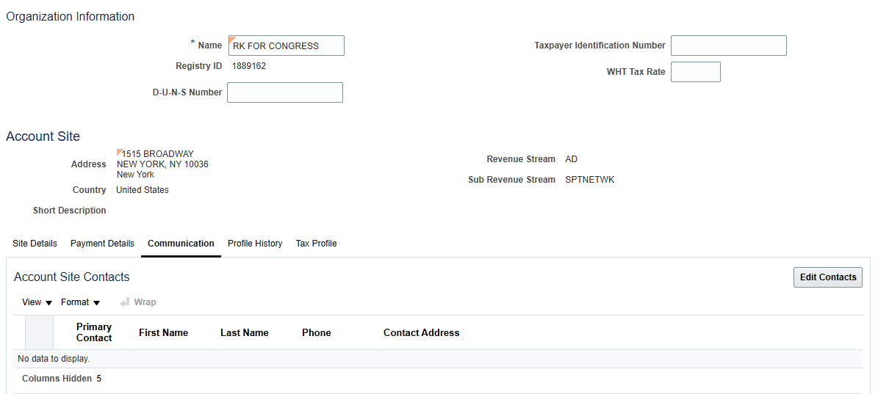

- Click Create Contact icon (the first + icon on the page).

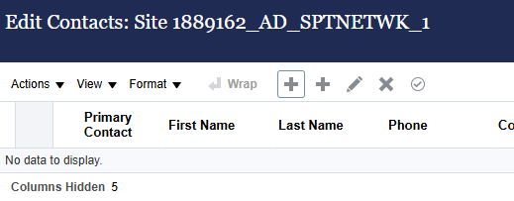

- Populate the necessary fields and click OK.

- If the Contact is Primary, click Actions > Set Primary Contact.

- Select the Contact that was just created and click on the Create icon (+ icon) under the Contact Points section.

- Populate the necessary fields and click OK.

- To enter multiple Contact Points, repeat steps 35 and 36.

- Under Account Contact Responsibilities, click Create (+ icon) and select the Contact’s Responsibility.

- Click Save and Close.

- Run the report to update the OSRs via Import Management to complete the Customer setup. Steps under “Running OSR Import File” section.

Running OSR Import File

Running OSR Report

- Navigate to Tools > Report and Analytics

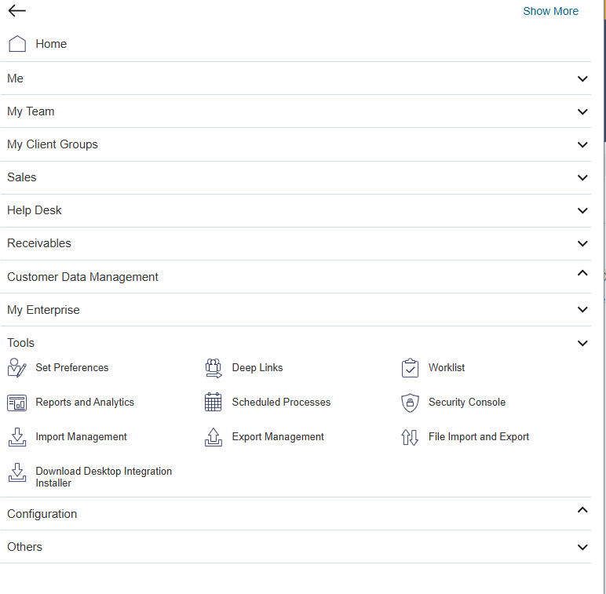
- Select ‘Browse Catalog’.



- In the Catalog, expand Shared Folders > Custom > OSR Update. Open the report titled ‘CustomerOSRByLastUpdatedDate Report’

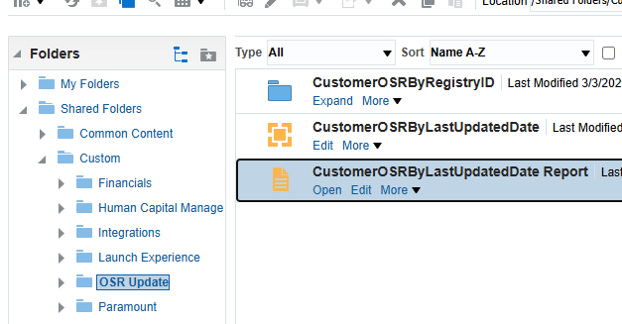

- Enter a Date into the Filter and click Apply. This report will generate any OSRs that have not been populated yet for all records created/updated on or after the date you select. For example, if “03-01-2026" is entered, the report will generate all customers that do not have OSRs that were created/updated on or after March 1, 2026.

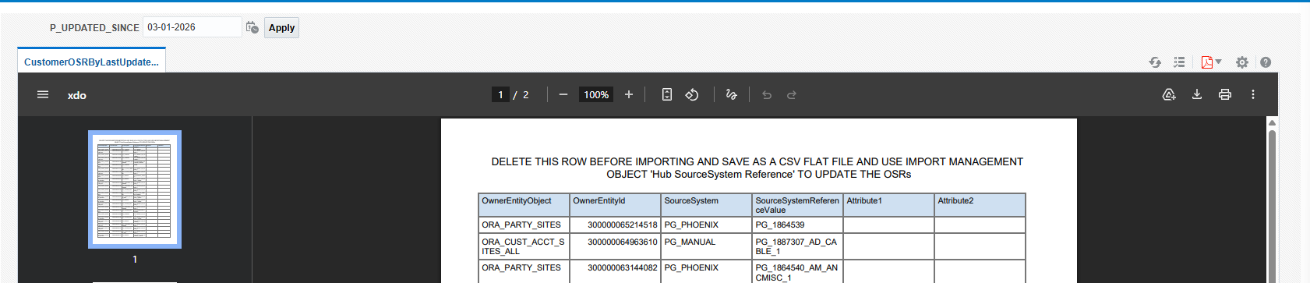

- Export the report as an Excel file.

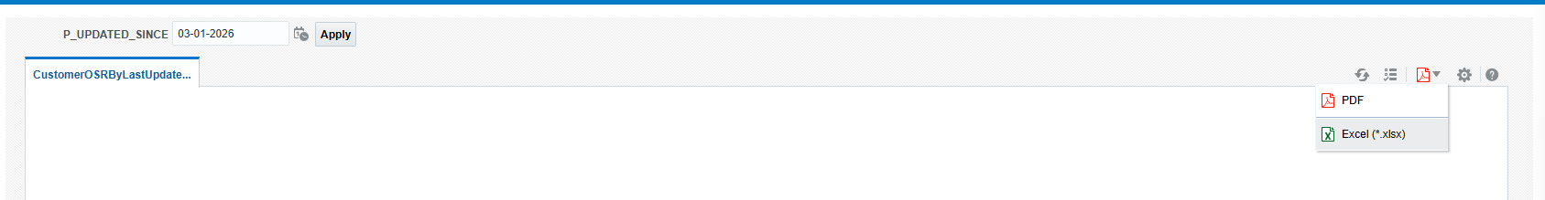

Clean Up File

- Open the excel and place a filter on the 3rd row of the file.

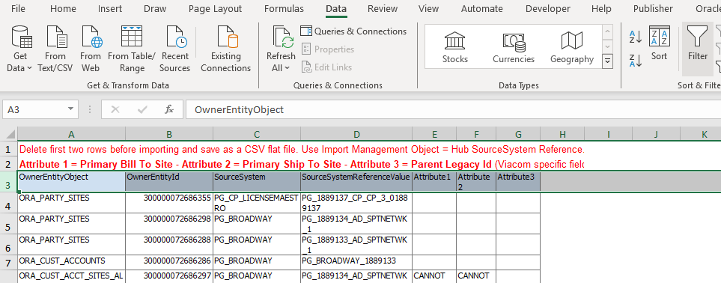
- Filter Column E (Attribute 1) to “CANNOT DETERMINE”.

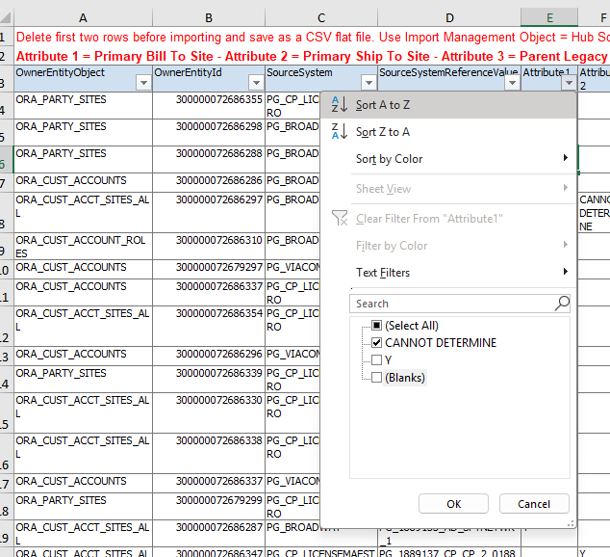

- Replace “CANNOT DETERMINE” with “Y” for the following:
  - Anything with Site Number that contain _1
  - Has Source System = PG_VIACOM_SAP AND Ancillary/Misc Sub Revenue Stream (ANCMISC) AND Site Number has _1

In the below screenshot:
- The rows highlighted in green should have the Y in Attribute 1 because they are all Sites with “_1”.
- The row highlighted in orange should be blank in Attribute 1 because it is a “_3” Site.
- The rows highlighted in red should be blank because they are PG_VIACOM_SAP rows and DO NOT have Ancillary/Misc. Sub Revenue Streams.

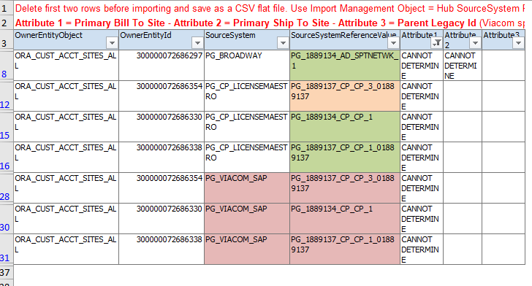
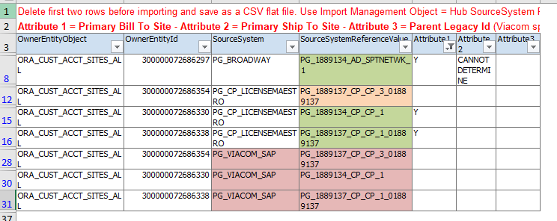
- Clear the filter in Column E.

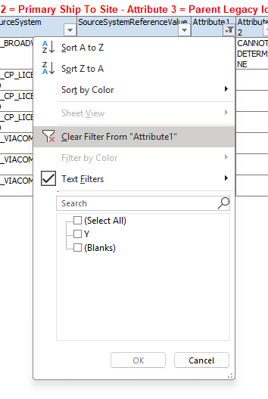

- Filter Column F (Attribute 2) to “CANNOT DETERMINE”.

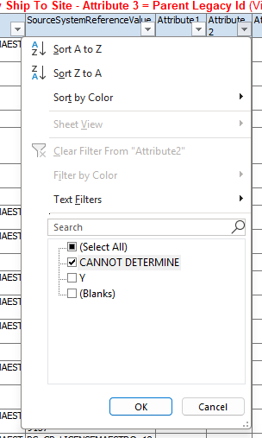

- Replace “CANNOT DETERMINE” with “Y” for the following:
  - Anything with Site Number that contain _1
  - Has Source System = PG_VIACOM_SAP AND Ancillary/Misc Sub Revenue Stream (ANCMISC) AND Site Number has _1

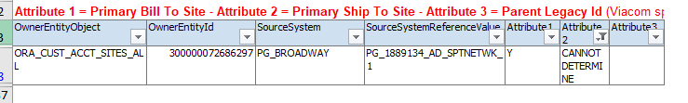

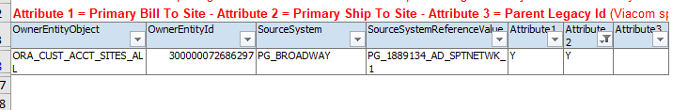
- Clear any remaining filter.

- Delete the first two rows of the file. Save the file as a CSV file with the name “CUSTOSR <Today’s Date> <Your Initials>”

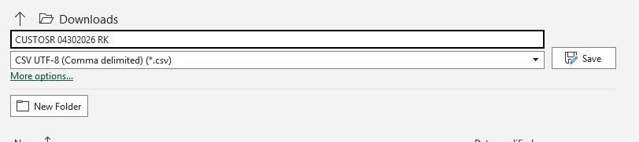

Loading Import File

- Back in the Fusion instance, navigate to Tools > Import Management.

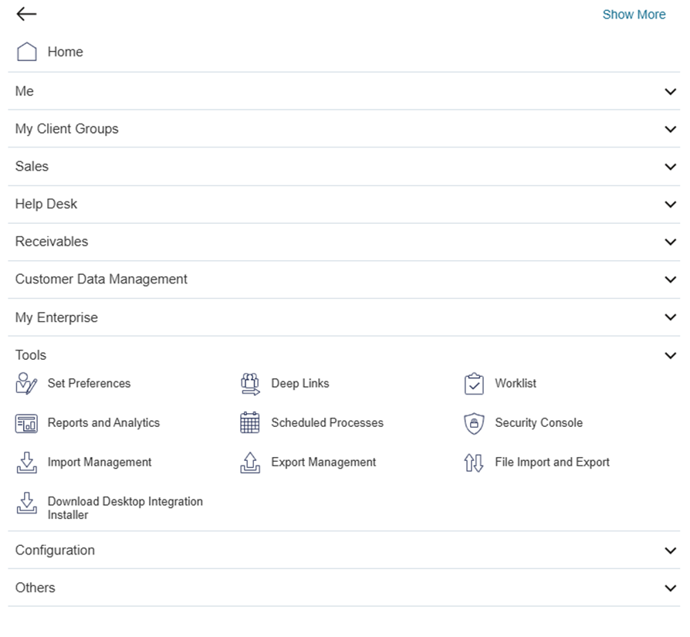

- Click “Create Import Activity”.

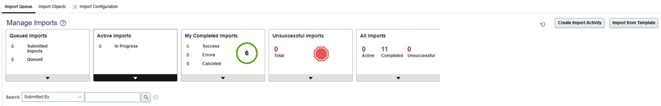

- Fill in the necessary information on the page:
  - Name = “CUSTOSR <Today’s Date> <Your Initials>”
  - Object = Hub Source System Reference
  - Add the saved csv file
  - Click Next

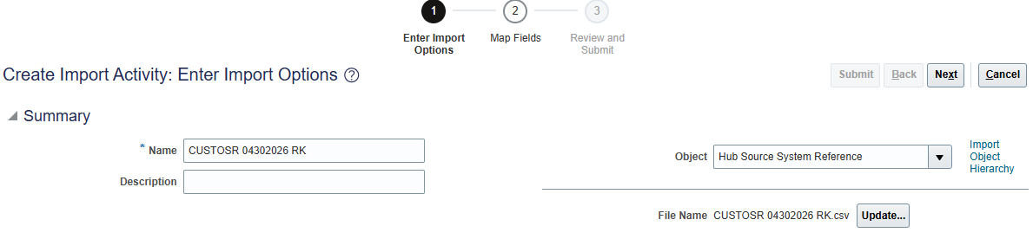
- The system will automatically map the data. Click Next.

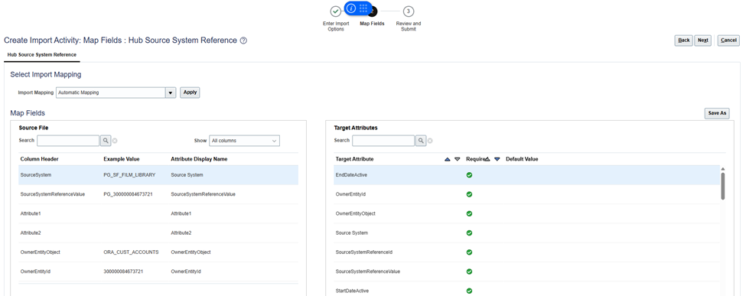

- Click Submit to run the Import.

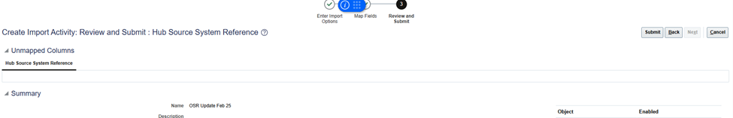

- The import will run (this will take a couple of minutes). When it is completed, it will appear under “My Completed Imports”.

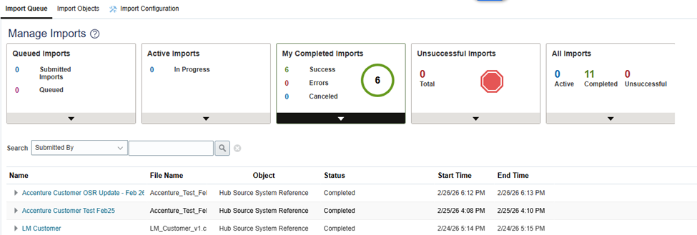

Create Parent Customer

- Logged in as a user with PG AR Customer Manager role, navigate to Navigation (Hamburger Menu) > Customer Data Management > Organizations.

- Create Customer – click on the + icon

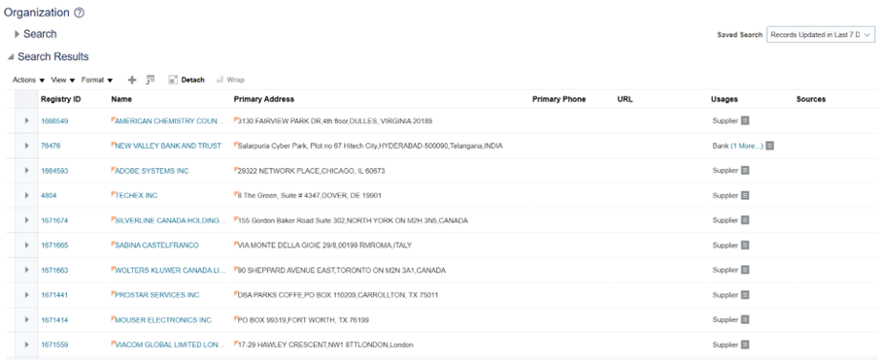
- Enter the account details needed:
  - Select Usage = External Legal Entity
  - Enter Name
  - Enter 1515 Broadway address
  - Click Save and Edit.

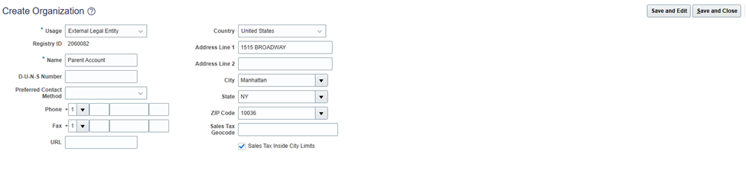
- In the Matching Organizations popup, select ‘Option 2: Create new organization based on what you provided’ to create a new customer. Click OK.

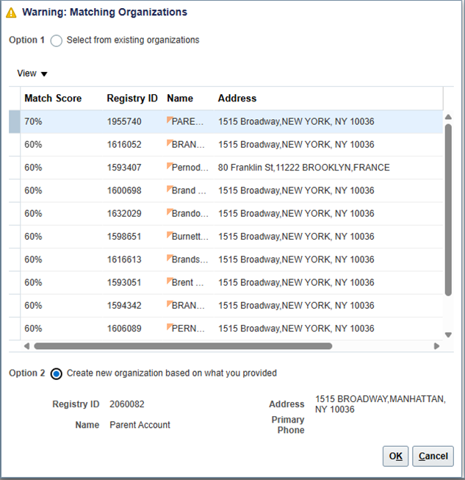

- Click the Classifications tab and click Add (+ icon).

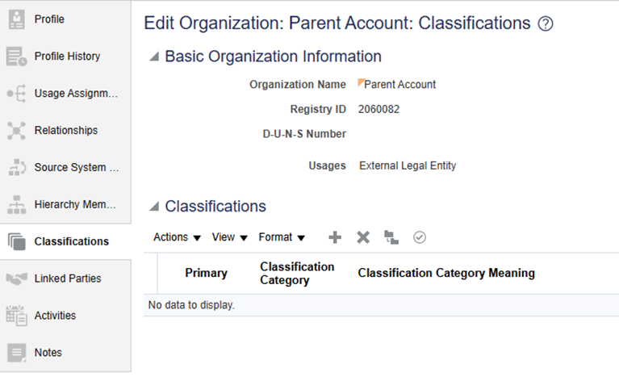

- Search for Classification Category = “PG_CUSTOMER_CLASSIFICATION”

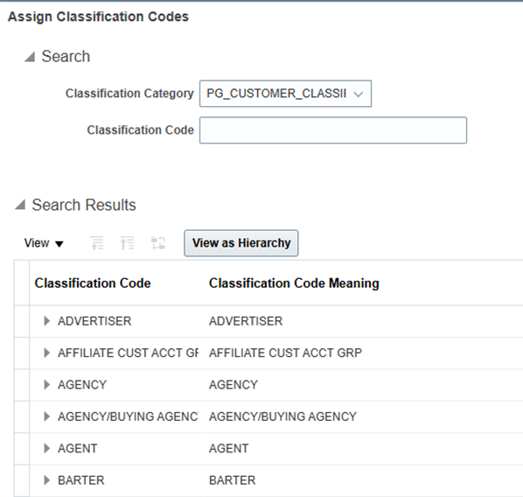

- Select the 'PARENT' Classification Code and click OK.

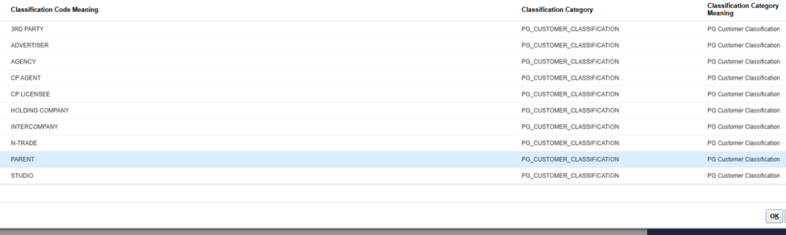
- Copy the Registry ID from the top of the page. Click Save and Close.

- Navigate to Navigation (Hamburger Menu) > Receivables > Billing.

- Click the Task Panel on the right side of the page. Under Customers, click Manage Customers.

- Enter Customer Account Number previously copied in the Registry ID field then click the Search button

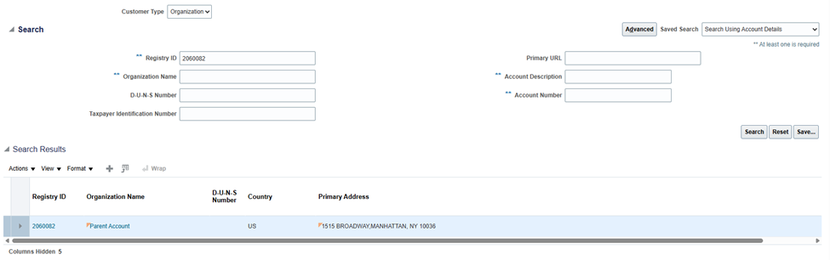
- Click on the Registry ID link that is highlighted under the Search Results.

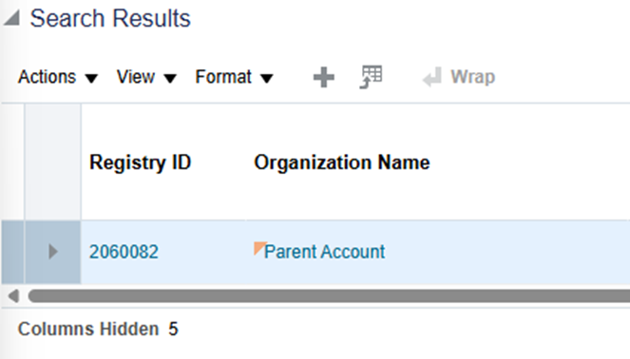

- Under the Profile History tab, click Create Customer Profile.

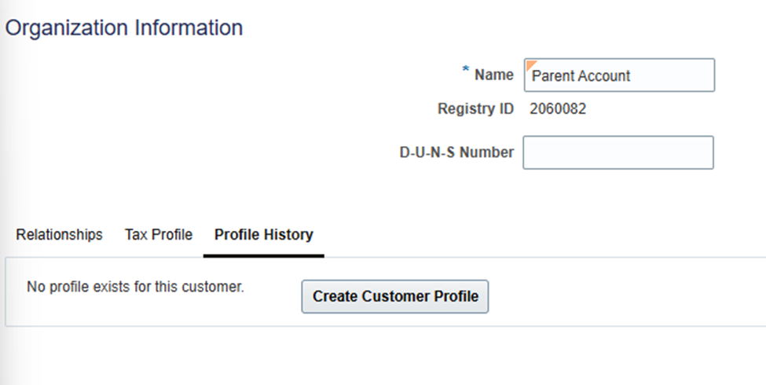

- Update the Profile Class, Credit Limit, and Credit Currency.
  - Potential use of Aging report to determine Credit Limit
  - Addition of Terms – addition modification of terms if needed

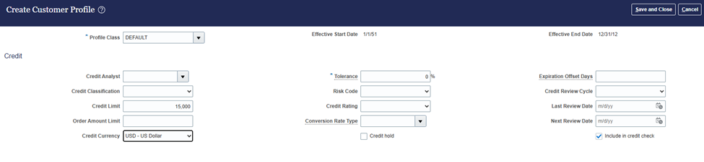

- Click Save and Close. The credit is now set up at the Parent level.

Create/Manage Customer Hierarchy

Prerequisite: Holding Company, Parent Company, and Customers already created and assigned the correct Classification values.

- Holding Company Classification value = HOLDING COMPANY
  - Address = 1515 Broadway
- Parent Company Classification value = PARENT
  - Address = 1515 Broadway
- Customer Classification value = can be anything except HOLDING COMPANY and PARENT

- Logged in as a user with PG AR Customer Manager role, navigate to Navigation (Hamburger Menu) > Customer Data Management > Hierarchies.

- Click Create (+ icon).
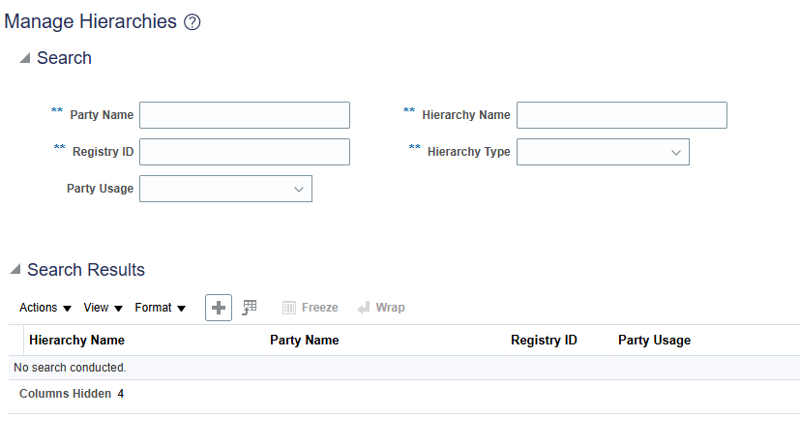
- Create the Hierarchy:
  - Enter Hierarchy Name
  - Select Hierarchy Type = Customer Hierarchy
  - Click Next

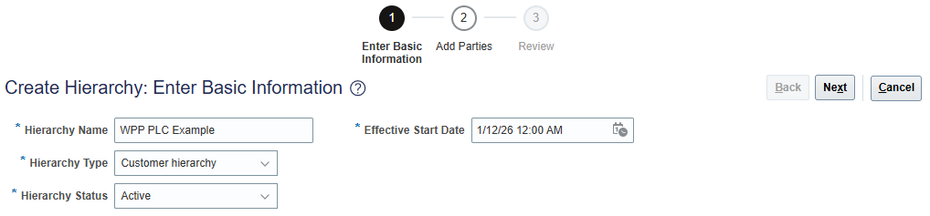

- Click Add (+ icon)

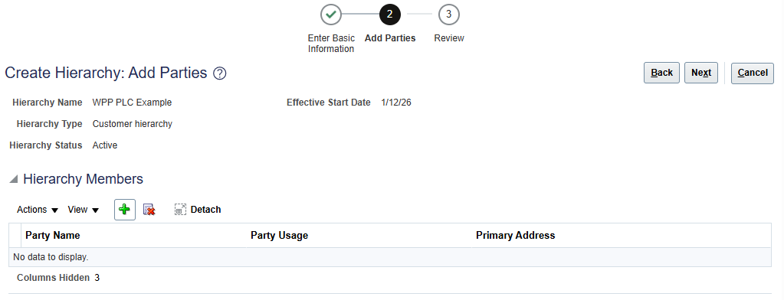
- Ensure Tree Node Type = Specific value and Data Source = Customer Hierarchy. Click Search.

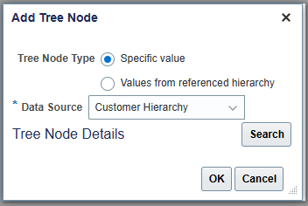

- Search for the Holding Company using either the Name or the Registry ID.

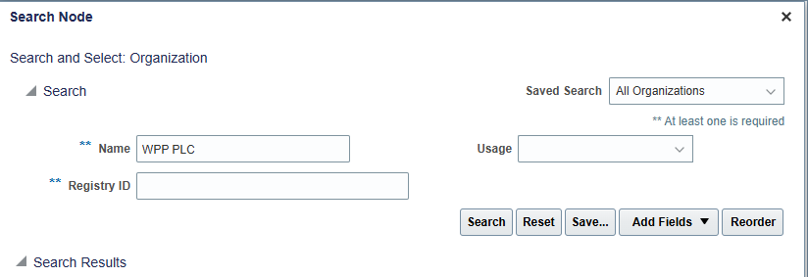
- Select the Holding Company (should be highlighted) and click OK.

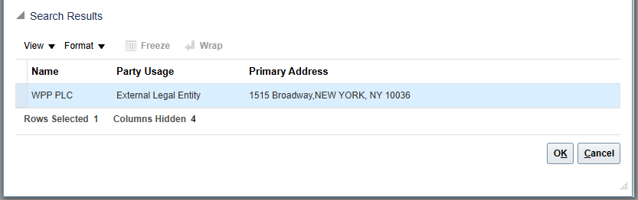
- With the Holding Company selected, click Add (+ icon).

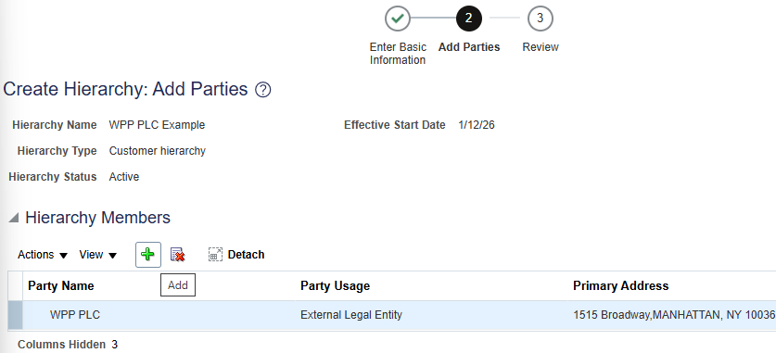
- Ensure Selected Node = Holding Company and Data Source = Customer Hierarchy. Click Search.

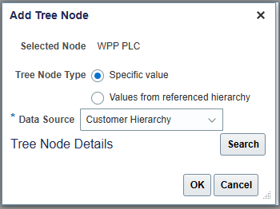

- Search for the Parent Company using either the Name or the Registry ID.

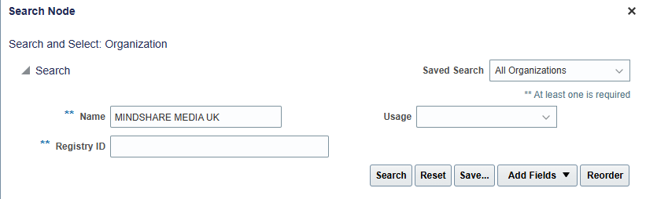
- Select the Parent Company (should be highlighted) and click OK.

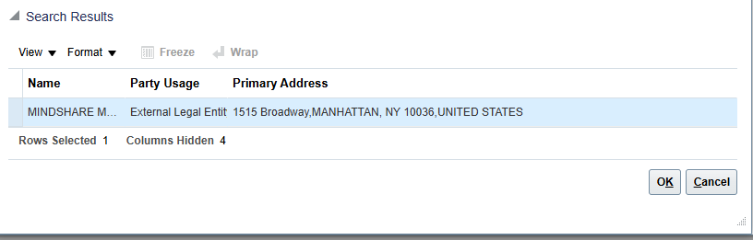
- With the Parent Company selected, click Add (+ icon).

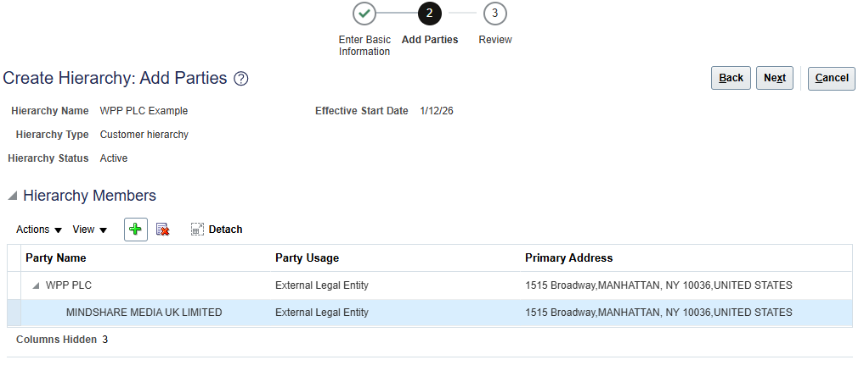
- Ensure Selected Node = Parent Company and Data Source = Customer Hierarchy. Click Search.

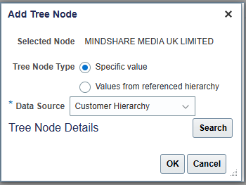

- Search for the Customer/child using either the Name or the Registry ID.

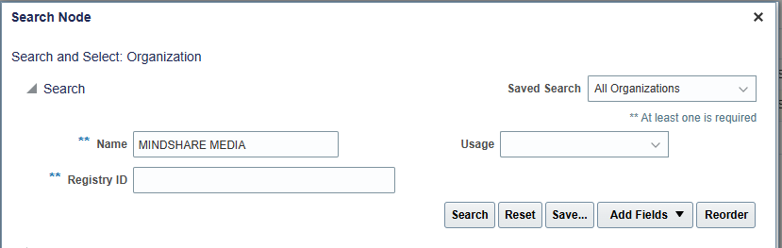

- Select the Parent Company (should be highlighted) and click OK.

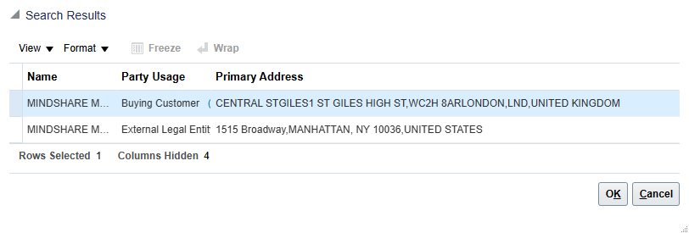
- Repeat steps as needed.

If adding additional Parent Companies under the Holding Company, start again at Step 8.
If adding additional Customers under the Parent Company, start again at Step 12.

- Once the Hierarchy is complete, click Next.

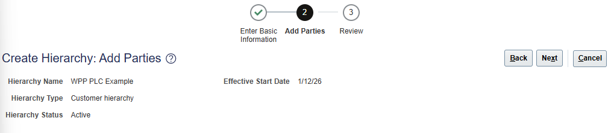
- Review the Hierarchy and click Finish to save the changes.

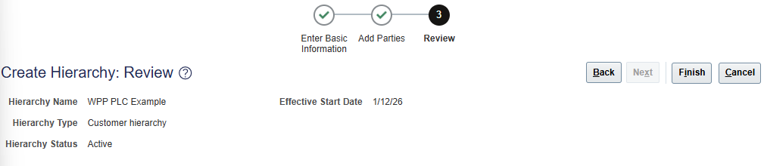

Updating/Managing Customers

The following is updated in the Customer Data Management Organizations screen (Organizations tile under Customer Data Management)
- Customer Name
- Legal Address
- Adding Source System References
Note: When adding a new Source System Reference, the report and Import need to be run again.
- Customer Classifications

All other field updates will be made on the AR screen (Manage Customers under Receivables).

OSR Formatting
The section below is to be used as a reference for how the OSRs are formatted.
Entity | ERP System | Original System | Reference ID [OSR]
Parties | CBS Non Digital - WideOrbit | PG WIDEORBIT TRAFFIC | Legacy Account Number – CTS  (i.e. CTS102459 → 102459)
Parties | CBS Non Digital - Manual | PG Manual | Party Number from Fusion
Parties | CBS Non Digital Advertisers - Phoenix | PG PHOENIX | Legacy Site Number – NET  (i.e. NET00098-001 → 00098-001)
Parties | CBS Non Digital - Phoenix | PG PHOENIX | Legacy Site Number – NET  (i.e. NET01198 → 01198)
Parties | CBS Non Digital – Media Pulse | PG MEDIA PULSE | Legacy Site Number – NET  (i.e. NET83010 → 83010)
Parties | CBS Non Digital Advertisers – Broadway | PG BROADWAY | Legacy Account Number
Parties | CBS Non Digital – Broadway | PG BROADWAY | Legacy Account Number
Parties | CBS Non Digital – Sales Force | PG SF FILM LIBRARY | Legacy Site Number – anything after ‘-’  (i.e. NET101721-00 → NET101721)
Parties | CBS Non Digital – ScheduleAll | PG SCHEDULEALL | Legacy Site Number – anything after ‘-’  (i.e. NET107475-00 → NET107475)
Parties | CBS Non Digital - REST | Boundary System Name | Party Number from Fusion
Parties | CBS Digital | Boundary System Name | CHILD_SFDC_ID
Parties | Paramount | Boundary System Name | Boundary System ID
Parties | Viacom | Boundary System Name | Boundary System ID
Accounts | CBS Non Digital - WideOrbit | PG WIDEORBIT TRAFFIC | Legacy Account Number – CTS  (i.e. CTS102459 → 102459)
Accounts | CBS Non Digital - Manual | PG Manual | Account Number from Fusion
Accounts | CBS Non Digital Advertisers - Phoenix | PG PHOENIX | Legacy Site Number – NET  (i.e. NET00098-001 → 00098-001)
Accounts | CBS Non Digital - Phoenix | PG PHOENIX | Legacy Site Number – NET  (i.e. NET01198 → 01198)
Accounts | CBS Non Digital – Media Pulse | PG MEDIA PULSE | Legacy Site Number – NET  (i.e. NET83010 → 83010)
Accounts | CBS Non Digital Advertisers – Broadway | PG BROADWAY | Legacy Account Number
Accounts | CBS Non Digital – Broadway | PG BROADWAY | Legacy Account Number
Accounts | CBS Non Digital – Sales Force | PG SF FILM LIBRARY | Legacy Site Number – anything after ‘-’  (i.e. NET101721-00 → NET101721)
Accounts | CBS Non Digital – ScheduleAll | PG SCHEDULEALL | Legacy Site Number – anything after ‘-’  (i.e. NET107475-00 → NET107475)
Accounts | CBS Non Digital - REST | Boundary System Name | Party Number from Fusion
Accounts | CBS Digital | Boundary System Name | CHILD_SFDC_ID
Accounts | Paramount | Boundary System Name | Boundary System ID
Accounts | Viacom | Boundary System Name | Boundary System ID
Party Sites | CBS Non Digital | Boundary System Name | <Fusion Site Number>
Party Sites | CBS Non Digital Advertisers | Boundary System Name | <Fusion Site Number>
Party Sites | CBS Digital | Boundary System Name | <Fusion Site Number>_<SFDC_CONTACT_ID>
Party Sites | Paramount | Boundary System Name | <Fusion Site Number>_<BoundarySystemID>
Party Sites | Viacom | Boundary System Name | <Fusion Site Number>_<BoundarySystemID>
Cust Account Sites | CBS Non Digital | Boundary System Name | <Fusion Site Number>
Cust Account Sites | CBS Non Digital Advertisers | Boundary System Name | <Fusion Site Number>
Cust Account Sites | CBS Digital | Boundary System Name | <Fusion Site Number>_<SFDC_CONTACT_ID>
Cust Account Sites | Paramount | Boundary System Name | <Fusion Site Number>_<BoundarySystemID>
Cust Account Sites | Viacom | Boundary System Name | <Fusion Site Number>_<BoundarySystemID>
Cust Account Roles | CBS Non Digital | Boundary System Name | <Fusion Site Number>_<Fusion Contact Number>
Cust Account Roles | CBS Non Digital Advertisers | Boundary System Name | <Fusion Site Number>_<Fusion Contact Number>
Cust Account Roles | CBS Digital | Boundary System Name | <Fusion Site Number>_<SFDC_CONTACT_ID>
Cust Account Roles | Paramount | Boundary System Name | <Fusion Site Number>_<Fusion Contact Number>
Cust Account Roles | Viacom | Boundary System Name | <Fusion Site Number>_<Fusion Contact Number>

