Oracle Fusion Cloud AR
Account Class and Account Type
Reference Guide — Paramount Skydance Oracle Fusion ERP Implementation
June 2026

1. Account Type in Oracle Fusion Cloud GL

1.1 Overview
In Oracle Fusion Cloud General Ledger, every natural account segment value is assigned an Account Type, which determines how the system handles balances, period-end processing, and financial reporting. The Account Type is set on the Chart of Accounts value set at the segment value level and drives core GL behavior: how balances roll forward, how retained earnings are calculated, and how translation and consolidation work.

1.2 The Five Account Types

Account Type | Classification | Normal Balance | Description
Asset | Balance Sheet | Debit | Resources owned or controlled by the entity
Liability | Balance Sheet | Credit | Obligations owed to external parties
Equity | Balance Sheet | Credit | Owner's interest; retained earnings roll here at year-end
Revenue | Income Statement | Credit | Earnings from business operations; zeroed at year-end
Expense | Income Statement | Debit | Costs incurred in operations; zeroed at year-end

1.3 Balance Sheet vs. Income Statement
The most operationally significant split is balance sheet (Asset/Liability/Equity) vs. income statement (Revenue/Expense). Balance sheet accounts carry forward their balances period over period indefinitely. Income statement accounts zero out at fiscal year-end, with the net rolling into the retained earnings account.

2. Account Class in Oracle Fusion AR

2.1 Account Type vs. Account Class — The Distinction
These terms are often used interchangeably but have distinct meanings in Oracle Fusion:

Attribute | Account Type | Account Class
Where it lives | COA natural account segment value | AR subledger — transaction distributions
Set by | GL setup administrator | AutoAccounting rules or explicit FBDI population
Used by | GL posting engine | AR AutoAccounting, FBDI interface, financial reporting
Purpose | Controls balance behavior and year-end processing | Classifies what a distribution line represents
Scope | System-wide across all modules | AR-specific

2.2 AR Account Class Values
In Oracle Fusion AR, Account Class is used on AutoAccounting and on transaction line distributions to classify what a given accounting line represents:

Account Class | Code | Description
Receivable | REC | Standard billed receivable — the customer owes this amount now
Revenue | REV | Earned revenue recognized at invoicing
Tax | TAX | Sales tax or VAT collected on the transaction
Freight | FREIGHT | Freight charges billed to the customer
Unbilled Receivable | UNBILLED | Revenue earned but customer not yet invoiced
Unearned Revenue | UNEARN | Customer invoiced or paid before revenue is earned

3. Unbilled Receivable vs. Receivable

3.1 Functional Comparison

Attribute | Receivable (REC) | Unbilled Receivable (UNBILLED)
Trigger | Invoice sent to customer | Work performed; invoice not yet sent
Balance sheet treatment | Current asset — billed A/R | Current asset — unbilled A/R
Revenue recognized? | Yes, at invoicing | Yes, but billing lags recognition
ASC 606 classification | A/R or contract asset (conditional) | Contract asset
AutoAccounting default? | Yes — standard flow | Requires explicit configuration or FBDI override

3.2 Standard Accounting Flow for Unbilled Receivable
The accounting flow when Unbilled Receivable account class is in use:

At revenue recognition (pre-billing):
- DR Unbilled Receivable
- CR Revenue

At invoicing / billing event:
- DR Receivable
- CR Unbilled Receivable

4. Why Paramount Imports AR with Unbilled Receivable
Two primary scenarios explain when Unbilled Receivable account class appears on imported AR transactions.

4.1 Scenario 1 — System Integration Design (Most Likely)
This is the pattern where an upstream system — a billing engine, project system, subscription platform, or revenue subledger — has already made the accounting decision and is passing it to Oracle AR via FBDI. Oracle is a posting destination, not the decision-maker on account class. Confirmed for Paramount: MMS (the Media Management System) is the upstream system generating both the revenue recognition and billing interfaces to SAP/Oracle AR.

How It Works
The upstream system generates a billing event and pre-determines the distribution lines, including account class. When it sends to Oracle via FBDI it explicitly populates ACCOUNT_CLASS = UNBILLED on the receivable line and the specific GL account for unbilled receivables. This bypasses AutoAccounting entirely for that line — when account class and GL account are provided explicitly on the interface record, Oracle honors them and does not invoke AutoAccounting rules.
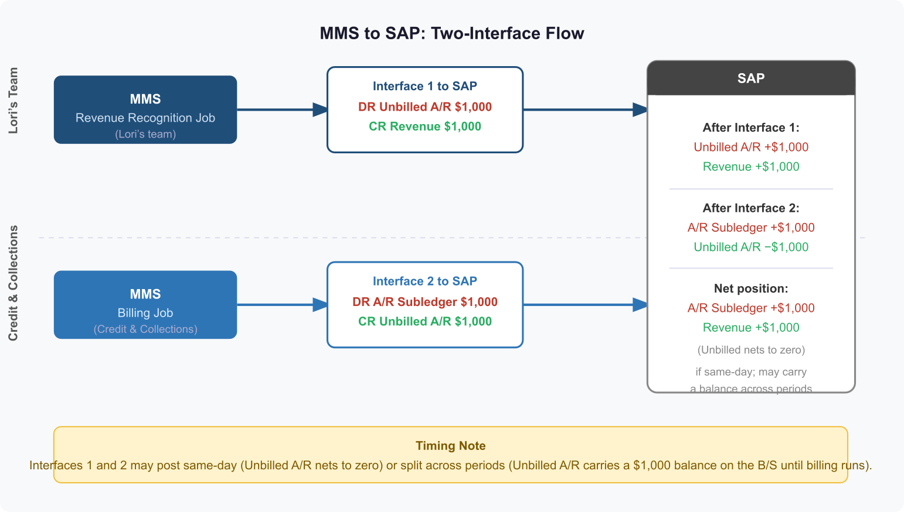

Why Paramount Would Use This Pattern
- Project-driven billing: a project system tracks work-in-progress and recognizes revenue at milestones or percent-complete, but the formal customer invoice is generated at a later trigger
- MMS (Media Management System) — Paramount’s confirmed upstream system: MMS runs the revenue recognition job (DR Unbilled A/R / CR Revenue) and a separate billing job (DR A/R subledger / CR Unbilled A/R), generating two sequential interfaces to Oracle AR rather than Oracle managing the reclassification natively
- Multi-system revenue close: the corporate close process requires unbilled A/R visible on the Oracle balance sheet to reconcile to a revenue subledger or consolidation tool

FBDI Interface Structure
The RA_INTERFACE_DISTRIBUTIONS_ALL interface table for a single invoice would look like:

LINE_TYPE | ACCOUNT_CLASS | AMOUNT | GL_ACCOUNT
LINE | REVENUE | 100,000 | 4000-Revenue
LINE | UNBILLED | 100,000 | 1300-Unbilled A/R

Instead of the standard REC flow:

LINE_TYPE | ACCOUNT_CLASS | AMOUNT | GL_ACCOUNT
LINE | REVENUE | 100,000 | 4000-Revenue
LINE | REC | 100,000 | 1200-Receivable

Key Setup Requirements — Scenario 1
- Unbilled Receivable GL account defined in the COA and active
- Transaction Type must allow AutoAccounting override — verify 'Allow AutoAccounting Override' is enabled
- Interface records must balance — AR will reject distributions that do not net to zero per invoice line
- Revenue Scheduling Rule: only required if Oracle AR is also expected to manage the reclassification from Unbilled to Receivable on a future event

The Reclassification Step — Critical Design Decision
Who owns the flip from Unbilled Receivable to Receivable?

Option | Owner | Mechanism | Recommended For
A | Oracle AR | Bill in Arrears invoicing rule; Oracle auto-generates reclassification at billing date | Oracle-native revenue scheduling scenarios
B | Upstream system | Integration sends a second FBDI record (credit memo or adjustment) that credits Unbilled and debits Receivable | Integration-heavy designs; confirmed for Paramount 10/1 — MMS sends two interfaces: revenue recognition (DR Unbilled A/R / CR Revenue) then billing (DR A/R subledger / CR Unbilled A/R)
C | Manual / journal | Finance team manually journals reclassification at period end | Early go-live workaround; not recommended long-term

4.2 Scenario 2 — Revenue Recognition Timing
This is the pattern where Oracle AR is the system of record for revenue recognition, and the Unbilled Receivable account class is used because the revenue recognition event and the billing event are intentionally decoupled within Oracle's own processing.

The Core Concept
In standard AR, invoice creation, revenue recognition, and receivable booking all happen simultaneously. When revenue recognition timing differs from billing timing, Oracle breaks that apart using Invoicing Rules and Revenue Scheduling Rules:

Rule Type | Controls | Location
Invoicing Rule | When the receivable is recorded | Transaction Type or Transaction header
Revenue Scheduling Rule | When and how revenue is recognized across periods | Setup > Revenue Scheduling Rules

Pattern A — Bill in Arrears (Generates Unbilled Receivable)
Work is performed and revenue is recognized before the customer is invoiced.

Period 1 — Revenue recognized:
- DR Unbilled Receivable
- CR Revenue

Period 2 — Invoice sent:
- DR Receivable
- CR Unbilled Receivable

Pattern B — Bill in Advance (Generates Unearned Revenue)
Customer is invoiced before the revenue is earned. This is the mirror image of Pattern A and is noted here for completeness. For Paramount's Unbilled Receivable requirement, Pattern A is the relevant scenario.

Period 1 — Invoice sent / cash collected:
- DR Receivable
- CR Unearned Revenue

Period 2 — Service delivered:
- DR Unearned Revenue
- CR Revenue

Full Example — Bill in Arrears
$120,000 annual contract, billed in arrears, revenue recognized monthly ($10,000/month):

Period | Event | DR | CR
Jan | Revenue recognized | Unbilled Receivable $10,000 | Revenue $10,000
Feb | Revenue recognized | Unbilled Receivable $10,000 | Revenue $10,000
Mar–Nov | Revenue recognized each month | Unbilled Receivable $10,000/mo | Revenue $10,000/mo
Dec | Invoice raised for full year | Receivable $120,000 | Unbilled Receivable $120,000

Key Setup Requirements — Scenario 2
- Unbilled Receivable GL account mapped in AutoAccounting under the UNBILLED account class rule
- Invoicing Rule = Bill in Arrears set on the transaction type
- Revenue Scheduling Rule defined and attached to the transaction or transaction type
- Recognize Revenue ESS program scheduled as part of period-end close
- Transaction Type must have both invoicing rule and revenue scheduling rule attached — cannot mix invoicing-rule transactions with non-invoicing-rule transactions in the same batch

5. Scenario Comparison and Decision Framework

5.1 Scenario 1 vs. Scenario 2 — The Deciding Factor

Decision Question | Points to Scenario 1 (Integration Design) | Points to Scenario 2 (Revenue Recognition Timing)
Who determines account class? | Upstream system — explicitly passed in FBDI | Oracle AR rules — AutoAccounting resolves it
Is AutoAccounting bypassed? | Yes — interface provides GL account directly | No — AutoAccounting resolves from rules
Is an invoicing rule required? | Not required | Required (Bill in Arrears)
Who manages the reclassification? | Upstream system or manual journal | Oracle Recognize Revenue ESS program
Is FBDI the entry point? | Yes — primary integration mechanism | Sometimes; may also be manual or AutoInvoice
Is a revenue scheduling rule required? | Not required | Required
Complexity of Oracle setup? | Lower — mostly interface mapping | Higher — requires invoicing and scheduling rule config

5.2 Recommendation for Paramount 10/1
Given the October 1 go-live timeline and the integration-heavy O2C workstream design, Scenario 1 (System Integration Design) is the more likely fit. The critical actions before go-live:

- Confirm whether the upstream billing system is passing ACCOUNT_CLASS and GL_ACCOUNT explicitly on every RA_INTERFACE_DISTRIBUTIONS_ALL record
- Verify the Unbilled Receivable GL account exists in the Paramount COA and is correctly mapped
- Confirm Transaction Type configuration allows AutoAccounting override
- Document and sign off on who owns the reclassification step (upstream system, Oracle, or manual) — this must be resolved before UAT
- If Scenario 2 applies to any transaction types, invoicing rules and revenue scheduling rules must be in scope now — they cannot easily be retrofitted after go-live without impacting existing transactions
- Get Paramount's revenue recognition policy documented and signed off — misalignment here is a P1 defect risk in UAT

6. Oracle Fusion 26B — Account Balance Optimization Feature

6.1 Overview
Oracle Fusion Cloud Financials 26B introduces an opt-in feature called Optimized Maintenance for Account Balances that affects how the GL engine maintains balance records for income statement accounts.

6.2 What the Feature Does
The feature changes balance row maintenance for income statement accounts in a new fiscal year. Instead of maintaining rows for every period regardless of activity, Oracle only maintains balances from the first accounting period with posted activity. The business benefit is performance: it reduces unnecessary record growth in GL balances tables and balances cubes, improving posting, open period, and translation operations.

6.3 Critical Considerations Before Enabling

Consideration | Detail
Irreversible | Once enabled, this is a permanent setting and cannot be reverted. It applies to all users of the General Ledger module.
Scope | Applies to all ledgers: primary, reporting currency, and secondary. Covers both standard and average balances.
PJTD Balances | Project-to-date balances for income statement accounts may no longer be accurate after enabling. If there is a lapse in periodic activity after the start of a new fiscal year, the PJTD balance will effectively reset to zero.
Account Type Misclassification | If any account has been misclassified (income statement account that should be balance sheet, or vice versa), this feature makes the correction significantly more complex. Such corrections must be addressed before enabling.
Reclassification Risk | Flipping a previously income statement account to balance sheet type after enabling is problematic: balance sheet accounts require contiguously maintained periodic balances. Any correction should be done once, carefully, before enabling.

6.4 Relevance to Paramount
If Paramount's Oracle Fusion instance is on or moving to 26B, this opt-in warrants a deliberate conversation before anyone enables it — especially if there are known account type misclassifications in the COA, or if project-to-date reporting is used anywhere in the financial close process. This is not a feature to enable without a formal impact assessment.

Paramount Skydance Oracle Fusion ERP — O2C/AR Integrations Workstream — June 2026

