Oracle Fusion Cloud AR
Account Class and Account Type

Account Type is a fundamental GL chart of accounts attribute assigned directly to each natural account segment value. It's part of the account value setup itself (Setup > Financial Reporting Structures > Chart of Accounts > Manage Values).

Account Class is an AR/Revenue-specific classification used in the context of Receivables transactions — it lives on transaction line distributions, not on the COA segment values themselves.

1. Account Type in Oracle Fusion Cloud GL

1.1 Overview
In Oracle Fusion Cloud General Ledger, every natural account segment value is assigned an Account Type, which determines how the system handles balances, period-end processing, and financial reporting. The Account Type is set on the Chart of Accounts value set at the segment value level and drives core GL behavior: how balances roll forward, how retained earnings are calculated, and how translation and consolidation work.

1.2 The Five Account Types

Account Type | Classification | Normal Balance | Description
Asset | Balance Sheet | Debit | Resources owned or controlled by the entity
Liability | Balance Sheet | Credit | Obligations owed to external parties
Equity | Balance Sheet | Credit | Owner's interest; retained earnings roll here at year-end
Revenue | Income Statement | Credit | Earnings from business operations; zeroed at year-end
Expense | Income Statement | Debit | Costs incurred in operations; zeroed at year-end

1.3 Balance Sheet vs. Income Statement
The most operationally significant split is balance sheet (Asset/Liability/Equity) vs. income statement (Revenue/Expense). Balance sheet accounts carry forward their balances period over period indefinitely. Income statement accounts zero out at fiscal year-end, with the net rolling into the retained earnings account.

2. Account Class in Oracle Fusion AR

2.1 Account Type vs. Account Class — The Distinction
These terms are often used interchangeably but have distinct meanings in Oracle Fusion:

Attribute | Account Type | Account Class
Where it lives | COA natural account segment value | AR subledger — transaction distributions
Set by | GL setup administrator | AutoAccounting rules or explicit FBDI population
Used by | GL posting engine | AR AutoAccounting, FBDI interface, financial reporting
Purpose | Controls balance behavior and year-end processing | Classifies what a distribution line represents
Scope | System-wide across all modules | AR-specific

2.2 AR Account Class Values
In Oracle Fusion AR, Account Class is used on AutoAccounting and on transaction line distributions to classify what a given accounting line represents:

Account Class | Code | Description
Receivable | REC | Standard billed receivable — the customer owes this amount now
Revenue | REV | Earned revenue recognized at invoicing
Tax | TAX | Sales tax or VAT collected on the transaction
Freight | FREIGHT | Freight charges billed to the customer
Unbilled Receivable | UNBILLED | Revenue earned but customer not yet invoiced
Unearned Revenue | UNEARN | Customer invoiced or paid before revenue is earned

3. Unbilled Receivable vs. Receivable

3.1 Functional Comparison

Attribute | Receivable (REC) | Unbilled Receivable (UNBILLED)
Trigger | Invoice sent to customer | Work performed; invoice not yet sent
Balance sheet treatment | Current asset — billed A/R | Current asset — unbilled A/R
Revenue recognized? | Yes, at invoicing | Yes, but billing lags recognition
ASC 606 classification | A/R or contract asset (conditional) | Contract asset
AutoAccounting default? | Yes — standard flow | Requires explicit configuration or FBDI override

3.2 Standard Accounting Flow for Unbilled Receivable
The accounting flow when Unbilled Receivable account class is in use:

At revenue recognition (pre-billing):
- DR Unbilled Receivable
- CR Revenue

At invoicing / billing event:
- DR Receivable
- CR Unbilled Receivable

4. Why Paramount Imports AR with Unbilled Receivable

System Integration Design

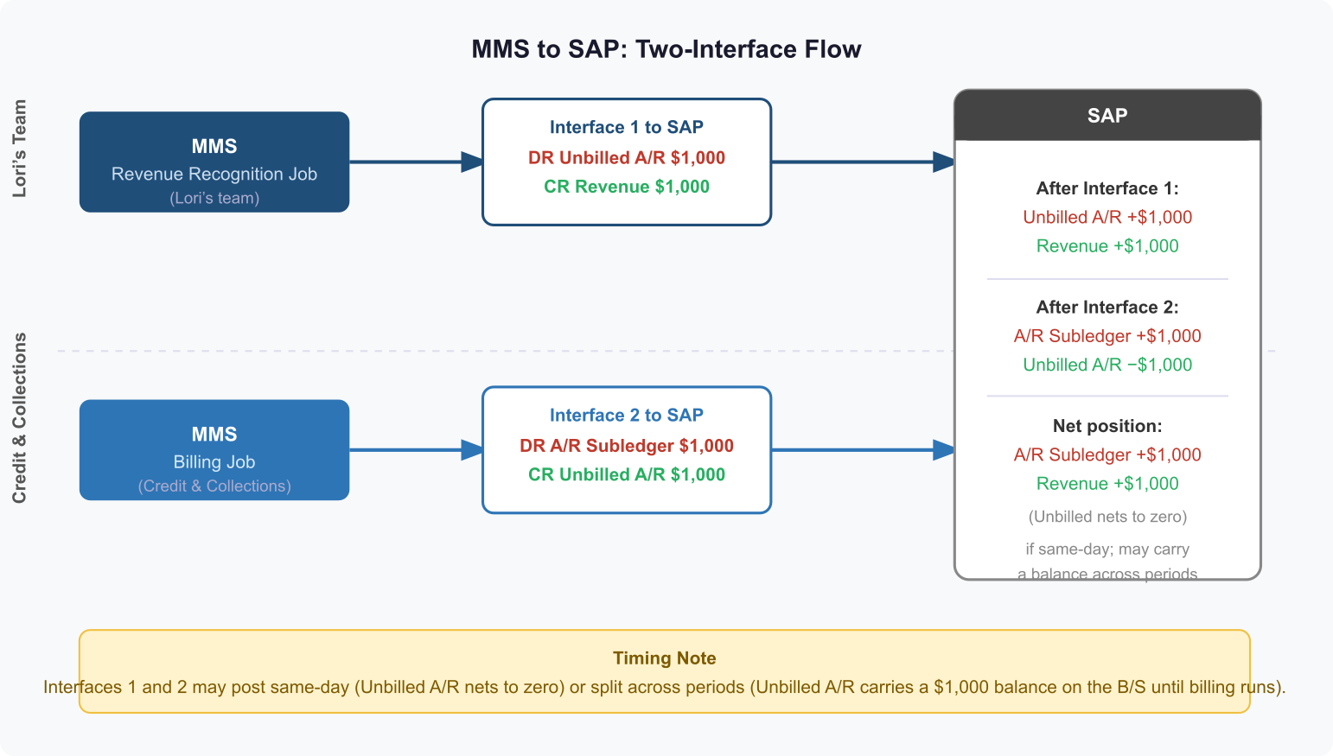

This is the pattern where an upstream system — a billing engine, project system, subscription platform, or revenue subledger — has already made the accounting decision and is passing it to Oracle AR via FBDI. Oracle is a posting destination, not the decision-maker on account class. Confirmed for Paramount: MMS (the Media Management System) is the upstream system generating both the revenue recognition and billing interfaces to SAP/Oracle AR.

How It Works
The upstream system generates a billing event and pre-determines the distribution lines, including account class. When it sends to Oracle via FBDI it explicitly populates ACCOUNT_CLASS = UNBILLED on the receivable line and the specific GL account for unbilled receivables. This bypasses AutoAccounting entirely for that line — when account class and GL account are provided explicitly on the interface record, Oracle honors them and does not invoke AutoAccounting rules.

FBDI Interface Structure
The RA_INTERFACE_DISTRIBUTIONS_ALL interface table for a single invoice would look like:

LINE_TYPE | ACCOUNT_CLASS | AMOUNT | GL_ACCOUNT
LINE | REVENUE | 100,000 | 4000-Revenue
LINE | UNBILLED | 100,000 | 1300-Unbilled A/R

Instead of the standard REC flow:

LINE_TYPE | ACCOUNT_CLASS | AMOUNT | GL_ACCOUNT
LINE | REVENUE | 100,000 | 4000-Revenue
LINE | REC | 100,000 | 1200-Receivable

Key Setup Requirements
- Unbilled Receivable GL account defined in the COA and active
- Transaction Type must allow AutoAccounting override — verify 'Allow AutoAccounting Override' is enabled
- Interface records must balance — AR will reject distributions that do not net to zero per invoice line
- Revenue Scheduling Rule: only required if Oracle AR is also expected to manage the reclassification from Unbilled to Receivable on a future event

The Reclassification Step — Critical Design Decision
Who owns the flip from Unbilled Receivable to Receivable?

Option | Owner | Mechanism | Recommended For
A | Oracle AR | Bill in Arrears invoicing rule; Oracle auto-generates reclassification at billing date | Oracle-native revenue scheduling scenarios
B | Upstream system | Integration sends a second FBDI record (credit memo or adjustment) that credits Unbilled and debits Receivable | Integration-heavy designs; confirmed for Paramount 10/1 — MMS sends two interfaces: revenue recognition (DR Unbilled A/R / CR Revenue) then billing (DR A/R subledger / CR Unbilled A/R)
C | Manual / journal | Finance team manually journals reclassification at period end | Early go-live workaround; not recommended long-term

5.2 Recommendation for Paramount 10/1
The critical actions before go-live:

- Confirm whether the upstream billing system is passing ACCOUNT_CLASS and GL_ACCOUNT explicitly on every RA_INTERFACE_DISTRIBUTIONS_ALL record
- Verify the Unbilled Receivable GL account exists in the Paramount COA and is correctly mapped
- Confirm Transaction Type configuration allows AutoAccounting override
- Document and sign off on who owns the reclassification step (upstream system, Oracle, or manual) — this must be resolved before UAT
- If Scenario 2 applies to any transaction types, invoicing rules and revenue scheduling rules must be in scope now — they cannot easily be retrofitted after go-live without impacting existing transactions
- Get Paramount's revenue recognition policy documented and signed off — misalignment here is a P1 defect risk in UAT

