

**The King**

**William Hotel**

By:

Mathew Migliore, Tyler Segovia, and Kevin Romero

Presented to:

Basil J. Cleese and Development Team

of:

The King William Hotel

Date:

2020-11-27

Table of Contents

**Title Page1**

Table of Contents2

Table of Contents3

**Introduction 4**

**Mission Statement 5**

**Mission Objectives 6**

**User View Preface7**

**User View Design8**

**System Boundary Preface8**

System Boundaries8

External Boundaries9

Road Map Brief9

**System Boundary Diagram10**

**Use Case Diagram11**

**3NF Preface12**

**3NF List 13**

**3NF Diagram 14**

**Functional Dependencies Preface 15**

**Functional Dependencies 16**

Patient 16

Financial_Stat 16

PatientVisit 16

Bill 16

Diagnosis 16

Employee 17

Physician 17

tblUser 17

tblPhysicianUser 17

Patient_Room 17

Room 17

tblTransaction17

Item18

CostCenter 18

Payment 18

**Data Dictionary Preface 19**

**Data Dictionary Diagrams 20**

Patient 20-21

Financial_Stat 21

Patient-Vist 22-23

Bill 23

Diagnosis 24-25

Employee 25

Physician 26

tblPhysicianUser 26

User 28

Patient_Room 29

Room 30

tblTransaction31

Item32

CostCenter 33

Payment 34

**Final Word35**

**Dictionary 36**

**Disclaimer & Closing 37**

**Introduction**

The King William Hotel, a historic much-loved landmark built in 1923. It serves the community of Ontario and offers guests hospitality and services that makes the guest want to come back. Due to the hotel’s older age and transition to the modern world, the hotel has renovated it’s rooms to look part of an early 20th era, Although the rooms have changed, the hospitality and service remain the same. This transition to the modern world and its perpetual top of the line service has come at cost. Although the staff maintain a great system to book the hotel’s information, it is now time for their system to adopt a new modern take, not only to facilitate but to also improve their service. With this Report, our team will be doing our best to show case the many different approaches we have taken to meet the client’s requests with as much accuracy as possible and to present the application we have created. Without further delay, here is our solution to The King William case.

MISSION STATEMENT

The purpose of the King Williams Database Application is to store and manage information to improve efficiency and control of hotel processes.

OBJECTIVES

- To maintain (enter, update, delete) data on rooms

- To maintain (enter, update, delete) data on room reservations

- To maintain (enter, update, delete) data on customers

- To maintain (enter, update, delete) data on customer billing

- To maintain (enter, update, delete) data on chargeable items

- To maintain (enter, update, delete) data on transactions

- To maintain (enter, update, delete) data on employees

- To maintain (enter, update, delete) data on employment positions

- To perform searches on rooms

- To perform searches on room reservations

- To perform searches on customers

- To perform searches on customer billing

- To perform searches on chargeable items

- To perform searches on transactions

- To perform searches on employees

- To perform searches on employment positions

- To track the status of rooms

- To track the status of customer bills

- To track the status of customer requests

- To report on room reservations

- To report on customers

- To report on customer billing

- To report on chargeable items

- To report on transactions

- To report on employees

**User View**



SYSTEM DEFINITION

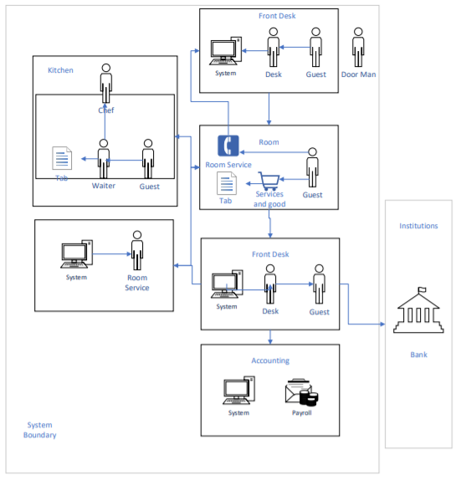

## 3NF

reservations(reservationID, roomNumber, customerID, billID, numberOfGuests, startDate, endDate, notes)

rooms(roomNumber, floorNumber, roomType, statusID, notes)

roomStatus(statusID, statusDescription)

roomTypes(roomType, pricePerNight)

customers(customerID, firstName, lastName, phoneNumber, addressID)

address(addressID, addressLine1, addressLine2, city, provinceCode, country, postalCode)

provinces(provinceCode, provinceName)

customerBilling(billID, billAmount, reservationID, paymentType, amountOwing)

chargeableItems(chargeableItem, itemDescription, itemPrice)

transactions(transactionID, billID, chargeableItem, amountOfItems, date)

staff(staffID, firstName, lastName, phoneNumber, addressID, positionID, salary, hiredDate, terminationDate, photo)

employmentPositions(positionID, positionTitle, positionDescription, startingSalary)

users(userName, password, roleID, staffID)

roles(roleID, roleTitle, roleDescription)

# Data Dictionary

|  |  |  |  |  |  |
| --- | --- | --- | --- | --- | --- |
| Table | Column | Data Type | References | Default | Not Null |
| <reservations> | reservationID | INT |  | Identity | Y |
| <reservations> | roomNumber | INT | <rooms>.roomNumber |  | Y |
| <reservations> | customerID | INT | <customers>.customerID |  | Y |
| <reservations> | billID | INT | <customerBilling>.billID |  | Y |
| <reservations> | numberOfGuests | INT |  |  | Y |
| <reservations> | startDate | DATETIME |  |  | Y |
| <reservations> | endDate | DATETIME |  |  | Y |
| <reservations> | notes | VARCHAR |  |  | Y |
| <rooms> | roomNumber | INT |  | Identity | Y |
| <rooms> | floorNumber | INT |  |  | Y |
| <rooms> | roomType | VARCHAR | <roomTypes>.roomType |  | Y |
| <rooms> | statusID | INT |  |  | Y |
| <rooms> | notes | VARCHAR |  |  | Y |
| <roomStatus> | statusID | INT |  | Identity | Y |
| <roomStatus> | statusDescription | VARCHAR |  |  | Y |
| <roomTypes> | roomType | VARCHAR |  | Identity | Y |
| <roomTypes> | pricePerNight | MONEY |  |  | Y |
| <customers> | customerID | INT |  | Identity | Y |
| <customers> | firstName | VARCHAR |  |  | Y |
| <customers> | lastName | VARCHAR |  |  | Y |
| <customers> | phoneNumber | VARCHAR |  |  | Y |
| <customers> | addressID | INT | <address>.addressID |  | Y |
| <address> | addressID | INT |  | Identity | Y |
| <address> | addressLine1 | VARCHAR |  |  | Y |
| <address> | addressLine2 | VARCHAR |  |  | Y |
| <address> | city | VARCHAR |  |  | Y |
| <address> | provinceCode | CHAR | <provinces>.provinceCode |  | Y |
| <address> | country | VARCHAR |  | ‘Canada’ | Y |
| <address> | postalCode | CHAR |  |  | Y |
| <provinces> | provinceCode | CHAR |  | Identity | Y |
| <provinces> | provinceName | VARCHAR |  |  | Y |
| <customerBilling> | billID | INT |  | Identity | Y |
| <customerBilling> | billAmount | MONEY |  |  | Y |
| <customerBilling> | reservationID | INT | <reservations>.reservationID |  | Y |
| <customerBilling> | paymentType | VARCHAR |  |  | Y |
| <customerBilling> | amountOwing | MONEY |  |  | Y |
| <chargeableItems> | chargeableItem | CHAR |  | Identity | Y |
| <chargeableItems> | itemDescription | VARCHAR |  |  | Y |
| <chargeableItems> | itemPrice | MONEY |  |  | Y |
| <transactions> | transactionID | INT |  | Identity | Y |
| <transactions> | billID | INT | <customerBilling>.billID |  | Y |
| <transactions> | chargeableItem | CHAR | <chargeableItems>.chargeableItem |  | Y |
| <transactions> | amountOfItems | INT |  |  | Y |
| <transactions> | date | DATETIME |  |  | Y |
| <staff> | staffID | INT |  | Identity | Y |
| <staff> | firstName | VARCHAR |  |  | Y |
| <staff> | lastName | VARCHAR |  |  | Y |
| <staff> | phoneNumber | VARCHAR |  |  | Y |
| <staff> | addressID | INT | <address>.addressID |  | Y |
| <staff> | positionID | INT | <employmentPositions>.positionID |  | Y |
| <staff> | salary | MONEY |  |  | Y |
| <staff> | hiredDate | DATETIME |  |  | Y |
| <staff> | terminationDate | DATETIME |  |  | Y |
| <staff> | photo | IMAGE |  |  | Y |
| <employmentPositions> | positionID | INT |  | Identity | Y |
| <employmentPositions> | positionTitle | VARCHAR |  |  | Y |
| <employmentPositions> | positionDescription | VARCHAR |  |  | Y |
| <employmentPositions> | startingSalary | MONEY |  |  | Y |
| <users> | userName | VARCHAR |  | Identity | Y |
| <users> | password | VARCHAR |  |  | Y |
| <users> | roleID | INT | <roles>.roleID |  | Y |
| <users> | staffID | INT | <staff>.staffID |  | Y |
| <roles> | roleID | INT |  | Identity | Y |
| <roles> | roleTitle | VARCHAR |  |  | Y |
| <roles> | roleDescription | VARCHAR |  |  | Y |