**一、線性方程組極大值問題解題 (共40%) R05454008 周哲宇**

請用單形法(Simplex)法一步一步來解下面的線性方程組極大值問題，並回答下

列問題:

1. 請用表格方式，並以*Z* = *f* (*x*1, *x*2 , *x*3 )， , *x s c c* 分別為原始變量和閒置變量

(slack variable，將限制式不等式變成等式所加入的變量)， *I* 為單位矩陣，*b*

為方程組等式右邊的常數向量，*A* 為限制式係數矩陣，來表示加入閒置變量

後的線性方程組問題。(5%)

|  |  |  |  |  |  |  |  |  |
| --- | --- | --- | --- | --- | --- | --- | --- | --- |
| X1 | X2 | X3 | X4 | X5 | X6 | X7 | X8 |  |
| 0 | 1 | -3 | 1 | 0 | 0 | 0 | 0 | 10 |
| 2 | 0 | 1 | 0 | 1 | 0 | 0 | 0 | 12 |
| 0 | 0.5 | 0 | 0 | 0 | 1 | 0 | 0 | 4 |
| 1 | 0 | 0 | 0 | 0 | 0 | 1 | 0 | 6 |
| -4 | -5 | -2 | 0 | 0 | 0 | 0 | 1 | 0 |

2. 請分別將下面的矩陣標明出來。(5%)

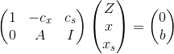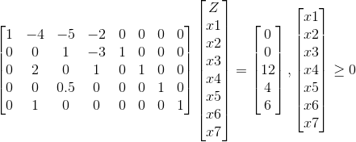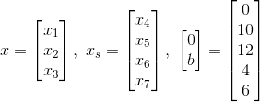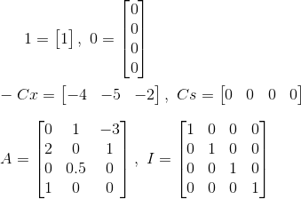

3. 請用疊代法方式，進行第一回求解，請從目標式挑選一單位能夠增加最多數

值的變量當作工作變量(辨識pivot column「軸行」)，然後尋找滿足其可行

域的可行邊界條件當作單位化約式pivot row「軸列」，請問「軸行」、「軸

列」分別為？(10%)

Pivot row

|  |  |  |  |  |  |  |  |  |
| --- | --- | --- | --- | --- | --- | --- | --- | --- |
| X1 | X2 | X3 | X4 | X5 | X6 | X7 | X8 |  |
| 0 | 1 | -3 | 1 | 0 | 0 | 0 | 0 | 10 |
| 2 | 0 | 1 | 0 | 1 | 0 | 0 | 0 | 12 |
| 0 | 0.5 | 0 | 0 | 0 | 1 | 0 | 0 | 4 |
| 1 | 0 | 0 | 0 | 0 | 0 | 1 | 0 | 6 |
| -4 | -5 | -2 | 0 | 0 | 0 | 0 | 1 | 0 |

Pivot column

第一回求解:

|  |  |  |  |  |  |  |  |  |
| --- | --- | --- | --- | --- | --- | --- | --- | --- |
| X1 | X2 | X3 | X4 | X5 | X6 | X7 | X8 |  |
| 0 | 0 | -3 | 1 | 0 | -2 | 0 | 0 | 2 |
| 2 | 0 | 1 | 0 | 1 | 0 | 0 | 0 | 12 |
| 0 | 0.5 | 0 | 0 | 0 | 1 | 0 | 0 | 4 |
| 1 | 0 | 0 | 0 | 0 | 0 | 1 | 0 | 6 |
| -4 | 0 | -2 | 0 | 0 | 10 | 0 | 1 | 40 |

4. 對於上面等式方程組進行通分約分的操作，直到求得可行解為止，請把過程

都列出來。(若可行條件相同，可任意選擇其一) (20%)

|  |  |  |  |  |  |  |  |  |
| --- | --- | --- | --- | --- | --- | --- | --- | --- |
| X1 | X2 | X3 | X4 | X5 | X6 | X7 | X8 |  |
| 0 | 0 | -3 | 1 | 0 | -2 | 0 | 0 | 2 |
| 0 | 0 | 1 | 0 | 1 | 0 | -2 | 0 | 0 |
| 0 | 0.5 | 0 | 0 | 0 | 1 | 0 | 0 | 4 |
| 1 | 0 | 0 | 0 | 0 | 0 | 1 | 0 | 6 |
| 0 | 0 | -2 | 0 | 0 | 10 | 4 | 1 | 64 |

第二回求解:

|  |  |  |  |  |  |  |  |  |
| --- | --- | --- | --- | --- | --- | --- | --- | --- |
| X1 | X2 | X3 | X4 | X5 | X6 | X7 | X8 |  |
| 0 | 0 | 0 | 1 | 3 | -2 | -6 | 0 | 2 |
| 0 | 0 | 1 | 0 | 1 | 0 | -2 | 0 | 0 |
| 0 | 0.5 | 0 | 0 | 0 | 1 | 0 | 0 | 4 |
| 1 | 0 | 0 | 0 | 0 | 0 | 1 | 0 | 6 |
| 0 | 0 | 0 | 0 | 2 | 10 | 0 | 1 | 64 |

第三回求解:



**二、等價對偶問題 (共35%)**

請利用11/15 日的上課講義有關原始問題(primal)和對偶(dual)問題的等價關係，來解第一題的極大值問題。

1. 請重新將第一題的極大值問題當作原始問題，用聯立方程組的方式表示其對

偶問題。(10%)

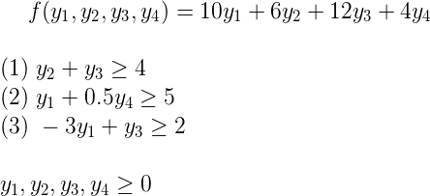

2. 請用表格方式，並以*y*0 = *f* ( *y*1, *y*2 , *y*3, *y*4 )， , *y sy c c* 分別為原始變量和閒置變量(slack variable，將限制式不等式變成等式所加入的變量)， *I* 為單位矩陣，*c* 為方程組等式右邊的常數向量，*A* 為限制式係數矩陣，來表示加入閒置變量後的線性方程組問題。(5%)

|  |  |  |  |  |  |  |  |  |
| --- | --- | --- | --- | --- | --- | --- | --- | --- |
| Y1 | Y2 | Y3 | Y4 | Y5 | Y6 | Y7 | Y8 |  |
| 0 | 1 | 2 | 0 | -1 | 0 | 0 | 0 | 4 |
| 1 | 0 | 0 | 0.5 | 0 | -1 | 0 | 0 | 5 |
| -3 | 0 | 1 | 0 | 0 | 0 | -1 | 0 | 2 |
| -10 | -6 | -12 | -4 | 0 | 0 | 0 | 1 | 0 |

請用疊代法方式，敘明解題過程，來解出上面*y* = *f (y1* , *y2* , *y3* , *y4)*的極小化問題(提示：解法相同於第一題所用的單形法，極小化問題目標式等於極大

化元目標式的相反數，不過當目標式已經化簡到最簡時仍看不出全部未知變

數的解時，則可以先將確定知道的其中一個未知變數解帶回原方程組，進一

步降階成比原來少一個未知變量的極大化問題，如此持續進行降階直到解出

所有未知變量的解，在解此對偶問題時，可以考慮依序對*y1* , *y4* 一一降階至

僅剩*y2* , *y3* 便可求出完整未知變數解) (20%)

|  |  |  |  |  |  |  |  |  |
| --- | --- | --- | --- | --- | --- | --- | --- | --- |
| Y1 | Y2 | Y3 | Y4 | Y5 | Y6 | Y7 | Y8 |  |
| 0 | 1/2 | 1 | 0 | -1/2 | 0 | 0 | 0 | 2 |
| 1 | 0 | 0 | 0.5 | 0 | -1 | 0 | 0 | 5 |
| -3 | -1/2 | 0 | 0 | 1/2 | 0 | -1 | 0 | 0 |
| -10 | 0 | 0 | -4 | -6 | 0 | 0 | 1 | 24 |

|  |  |  |  |  |  |  |  |  |
| --- | --- | --- | --- | --- | --- | --- | --- | --- |
| Y1 | Y2 | Y3 | Y4 | Y5 | Y6 | Y7 | Y8 |  |
| 0 | 1/2 | 1 | 0 | -1/2 | 0 | 0 | 0 | 2 |
| 0 | -1/6 | 0 | 0.5 | 1/6 | -1 | -1/3 | 0 | 5 |
| 1 | 1/6 | 0 | 0 | -1/6 | 0 | 1/3 | 0 | 0 |
| 0 | -5/3 | 0 | -4 | -(7+2/3) | 0 | 10/3 | 1 | 24 |

|  |  |  |  |  |  |  |  |  |
| --- | --- | --- | --- | --- | --- | --- | --- | --- |
| Y1 | Y2 | Y3 | Y4 | Y5 | Y6 | Y7 | Y8 |  |
| 0 | 0 | 1 | 1.5 | 0 | -3 | -1 | 0 | 17 |
| 0 | 1 | 0 | -3 | -1 | -1 | 2 | 0 | -30 |
| 1 | 0 | 0 | 0.5 | 0 | -1 | 0 | 0 | 5 |
| 0 | 0 | 0 | -9 | -28/3 | 10 | 0 | 1 | -26 |

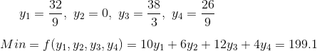

2. 請分別針對原始問題和對偶問題，說明在最終的參數解中，閒置變量數值與

限制式之間的關係及其意義。(10%)

閒置變量數值與限制式之間有係數轉換的關係。