流行病學與生物統計計算
求函數解與確切信賴區間
林菀俞

牛頓法：
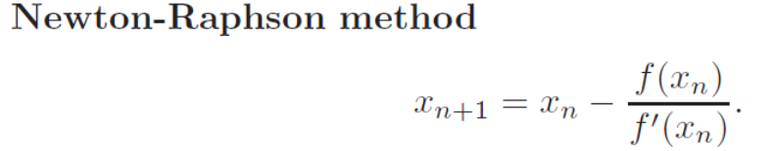
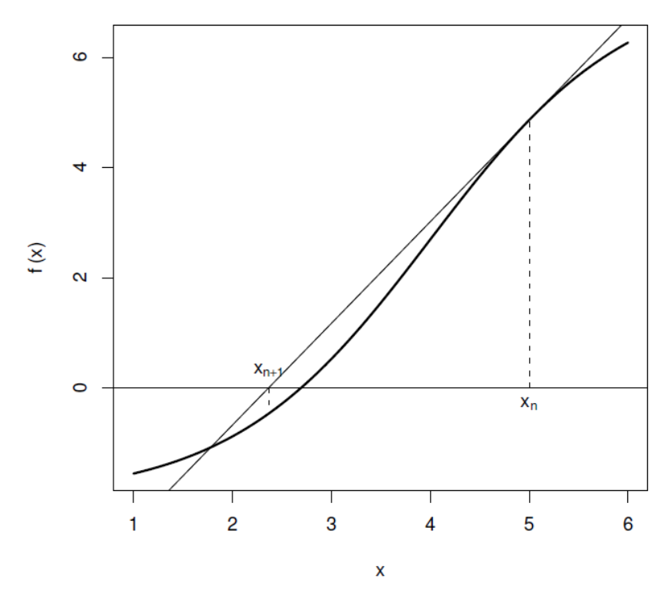

The code below implements the Newton-Raphson algorithm in a function newtonraphson. To use it, you first need to create a function, ftn(x) say, which returns the vector (f(x), f′(x)).

newtonraphson(ftn, x0, tol = 1e-9, max.iter = 100) has four inputs:

ftn is the name of a function that takes a single numeric input and returns a numeric vector of length two. If x is the input then the output must be (f(x), f′(x)).
x0 is the starting point for the algorithm. (牛頓法中，起始點要小心指定)
tol is such that the algorithm will stop if | f(x_{n}) | ≤ tol, with default 10⁻⁹.
max.iter is such that the algorithm will stop when n = max.iter, with default 100.
牛頓法的函數：

rm(list=ls())
newtonraphson <- function(ftn, x0, tol = 1e-9, max.iter = 100) {
x <- x0 # 先把 x assign 為起始值 x0
fx <- ftn(x)
iter <- 0
while ((abs(fx[1]) > tol) & (iter < max.iter)) {
x <- x - fx[1]/fx[2]
fx <- ftn(x)
iter <- iter + 1
cat("At iteration", iter, "value of x is:", x, "\n")
}
if (abs(fx[1]) > tol) {
cat("Algorithm failed to converge\n")
return(NULL)
} else {
cat("Algorithm converged\n")
return(x)
}
}

想求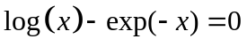的解，先畫圖看看：
x <- seq(0,10,0.01)
y <- log(x)-exp(-x)
plot(x,y)

再將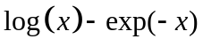及其一次微分寫成函數：
ftn4 <- function(x) {
fx <- log(x) - exp(-x)
dfx <- 1/x + exp(-x)
return(c(fx, dfx))
}
newtonraphson(ftn4, 2, 1e-06)

想求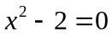的解，先畫圖看看：
x <- seq(-4,4,0.01)
y <- x^2-2
plot(x,y)

再將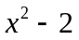及其微分寫成函數：
ftn5 <- function(x) {
fx <- x^2 - 2
dfx <- 2*x
return(c(fx, dfx))
}
newtonraphson(ftn5, 2, 1e-06)
newtonraphson(ftn5, -2, 1e-06)

練習16：請用牛頓法求出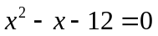的解。

練習17：二項分布中，若在20次試驗中成功3次，請求出成功機率(假設為p)的95% exact confidence interval。

提示：
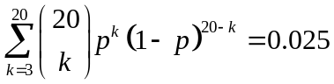 或 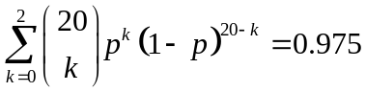
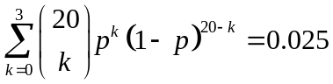
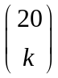在R中的指令為：choose(20,k)

練習17-1：二項分布中，若在100次試驗中成功20次：
- 請求出成功機率(假設為p)的95% exact confidence interval。
- 請以中央極限定理求本題的95% confidence interval，並比較其與(1)小題結果。
- 請以中央極限定理求練習17的95% confidence interval，並比較其與95% exact confidence interval，哪一方的結果較為可信？

