

**SRS Document**

*-*

By

Kelly Smith (s3898340)

Myat Theingi Nwe (Gigi) (s3963447)

Tanya Tran (s3843142)

Huy Do (s3894502)

Antoni Giannakopoulos (Toni) (s3895923)

Kevin Chen (s3780646)

Course: COSC2299 Software Engineering: Process and Tools

Date: 17/09/2023

1. Introduction 1

1.1 Purpose 1

1.2 Intended Audience 1

1.3 Product Scope 1

1.4 Stakeholders 1

2. Overall Description 2

2.1 Product Functions 2

2.2 Assumptions and Constraints 3

2.3 Dependencies 4

3. User story and Acceptance Criteria 4

4. User cases 20

5. System Features 21

5.1 Product Search and Categorization 21

5.1.1 Description and Priority 21

5.1.2 Stimulus/Response Sequences 21

5.1.3 Functional Requirements 21

5.2 Price Comparison 22

5.2.1 Description and Priority 22

5.2.2 Stimulus/Response Sequences 22

5.2.3 Functional Requirements 22

5.3 Delivery Organization 22

5.3.1 Description and Priority 22

5.3.2 Stimulus/Response Sequences 22

5.3.3 Functional Requirements 22

5.4 Notifications and Alerts 23

5.4.1 Description and Priority 23

5.4.2 Stimulus/Response Sequences 23

5.4.3 Functional Requirements 23

5.5 Purchasing Items 23

5.5.1 Description and Priority 23

5.5.2 Stimulus/Response Sequences 23

5.5.3 Functional Requirements 23

5.6 User Account Management 23

5.6.1 Description and Priority 23

5.6.2 Stimulus/Response Sequences 23

5.6.3 Functional Requirements 24

5.7 Review and Rating 24

5.7.1 Description and Priority 24

5.7.2 Stimulus/Response Sequences 24

5.7.3 Functional Requirements 24

6. Nonfunctional Requirements 24

7. Analysis Models: System Architecture and Data Model 26

7.1 System Architecture: 26

7.2 Class Diagram: 27

7.3 Use Case Diagram: 27

7.4 Data Model: 28

8. User Interface Design 29

9. Testing and Acceptance Criteria 30

10. Glossary 31

11. Product Backlog 31

12. Sprint 1 and 2 (estimated) backlog 31

13. Sprint 1 and 2 (estimated) Planning note 31

14. Sprint 0 retro 31

# 

# Introduction

## Purpose

This document presents the Software Requirements Specification (SRS) for the SuperPrice application. The SuperPrice application is envisioned as a price-matching and delivery application. The scope of this SRS encompasses the full system, detailing its functionalities, features, interfaces, and expected behavior, enabling users to efficiently compare grocery prices across multiple local retailers and organize deliveries to their preferred locations.

## Intended Audience

This SRS document is intended for multiple audiences, including:

* **Developers** - who will use this for implementing the system.
* **Project Managers** - to understand the project scope and features.
* **Marketing Staff** - to frame marketing strategies based on features.
* **Users** - to understand the application’s capabilities.
* **Testers** - for designing test cases and understanding expected system behaviour.
* **Documentation Writers** - to create user manuals and help guides.

## Product Scope

The SuperPrice application is initially launching in Melbourne. It empowers users to promptly compare prices from various local supermarkets, guaranteeing them the most optimal deals available. Alongside this price comparison utility, SuperPrice offers a steadfast delivery system, ensuring that groceries are delivered right to users' doorsteps at their chosen time. This application not only streamlines the shopping process but also enhances the overall user experience.

## Stakeholders

* **Supermarkets and Retailers**:
  + Local supermarkets and stores integrated into the platform. They benefit from increased visibility, potentially leading to higher sales.
* **Delivery Service Providers**:
  + Entities or individuals responsible for fulfilling the delivery requirements set by the application. This could be in-house or third-party delivery services.
* **Project Developers and Designers**:
  + Teams responsible for the design, development, testing, and maintenance of the SuperPrice application.

# Overall Description

## Product Functions

The SuperPrice application is designed to provide a holistic and enhanced grocery shopping experience. Here is a summarized list of the major functions the product offers:

**Product Search and Categorization**:

* **Search Capability**: Allows users to input specific keywords to find grocery products.
* **Product Categorization**: Organizes products into easily identifiable categories.
* **Product Filtering**: Provides users the ability to filter products based on personal preferences.

**Price Comparison**:

* **Real-time Price Display**: Fetches and displays up-to-date product prices from various local supermarkets.

**Delivery Organization**:

* **Home Delivery Option**: Facilitates grocery delivery to users' homes.
* **Estimated Delivery Time**: Provides users with an estimated date range for their grocery delivery.
* **Express Delivery**: Offers a faster delivery option for users.
* **Delivery Time Slot Selection**: Enables users to choose from a range of delivery time slots.
* **Delivery Instructions**: Allows users to give specific directions for the delivery service.

**Notifications and Alerts**:

* **Price Alerts**: Sends users notifications regarding price reductions and special promotions.
* **Notification Preferences**: Lets users toggle notifications on or off based on their preferences.

**Purchasing Items**:

* **Shopping Cart Functionality**: Enables users to add, review, and purchase items from their cart.
* **Shopping List Creation and Management**: Allows users to create and manage their shopping lists.

**Account Management**:

* **Account Creation**: Offers an unregistered user the ability to create an account.
* **Login/Logout Mechanism**: Facilitates user access to their personal accounts and the ability to log out.
* **Account Detail Modification**: Allows users to update personal details in their accounts.

**Review and Rating**: Extra

* **Product Review Submission**: Lets users post reviews on products they have purchased.
* **Supermarket Experience Feedback**: Allows users to rate and review their shopping experiences with different supermarkets.
* **Review Access**: Enables users to read reviews and ratings on products and supermarkets to make informed decisions.

## Assumptions and Constraints

**Assumptions:**

* We assume that local supermarkets and grocery stores will be open to integrating their system with our application for real-time price updates.
* We assume that most of our user base will access the SuperPrice application through mobile devices with stable internet connection.
* We assume our data will be accurate and timely.
* We assume that the product has the necessary permissions and licenses to integrate with third-party systems and handle user data will be obtained.

**Constraints:**

**Time** (6 weeks to final build):

* The project must be completed within a period of 6 weeks from start to final build.
* Development, testing, and documentation phases must adhere to this timeline.

**Cost** ($0 Budget):

* The project will be run on local devices, as hosting is outside the scope and cost constraints.
* Cost considerations will impact the selection of tools, technologies, and third-party services.

**Technology and Licensing**:

* The project is constrained to using only free and open-licensed tools.
* Due to project constraints, we are limited in our choice of backend architectures.

**Team Experience**:

* The development team's size and expertise are limited, impacting the scope and complexity of features that can be implemented.

**Third-Party Integration**:

* The successful integration of the SuperPrice application with local supermarkets' systems for real-time price updates relies on the cooperation of external parties.
* In this project we will simply simulate external APIs and databases in a controlled environment.

**Feedback and Iteration**:

* Due to the project's time constraints, there are limited opportunities for extensive user testing and iterative development.
* The project will need to prioritize functionality over form and adjust within the given period.

**Scalability**:

* The original scope is designed for a few users, and considerations for scalability and future expansion are limited given the project timeline.

## Dependencies

Below is a list of the external dependencies we will be using to construct the SuperPrice application.

**Back-End Framework**

* **SpringBoot:** Java-based framework for rapid web application development.

**Front-End Framework**

* **React.js:** JavaScript library for dynamic user interfaces.

**Database System**

* **MySQL Hosted:** Cloud-based MySQL relational database service.

**Build Tool**

* **Maven:** Java build automation and dependency management.

**Testing**

* **JUnit:** Widely used Java testing framework for unit tests.
* **Mockito/Mocking Framework:** Java library for creating mock objects in tests (useful for integration testing).

**Deployment**

* **GitHub Pages or AWS (Amazon Web Services):** Client to confirm later.

# User story and Acceptance Criteria

|  |  |  |  |
| --- | --- | --- | --- |
| **Story #1:** | Search Products | **Priority** | 2 |
| **Effort** | 30 |
| As a | User | | |
| I want | To search for specific grocery products | | |
| So that | I can efficiently find what I need. | | |
| Acceptance criteria | **Criterion 1:**  **Given** that the specific grocery products are already on the website.  **When** the user tries to search for the product  **Then** the website will display all available items for what the user have searched    **Criterion 2:**  **Given** that the specific grocery products are not on the website.  **When** the user tries to search for the product  **Then** the website will display that there is no product the user is searching for and show the recommended products instead. | | |

|  |  |  |  |
| --- | --- | --- | --- |
| **Story #2:** | Product Categorization | **Priority** | 2 |
| **Effort** | 30 |
| As a | User | | |
| I want | to view products in categories | | |
| So that | I can browse new items | | |
| Acceptance criteria | **Criterion 1:**  **Given** that the specific grocery products are already on the website,  And the products are categorized properly under specific categories.  **When** the user tries to search for the product through the categories  **Then** the website will display all items under the specific category    **Criterion 2:**  **Given** that the specific category does not exist,  **When** the user tries to search for that category  **Then** the category will not be shown under the list of all available categories. | | |

|  |  |  |  |
| --- | --- | --- | --- |
| **Story #3:** | Filter product list | **Priority** | 2 |
| **Effort** | 60 |
| As a | User | | |
| I want | To filter products by specific preferences | | |
| So that | I can save time searching for the items that I want | | |
| Acceptance criteria | **Criterion 1:**  **Given** that there is already a list of products,  **When** the user wants a new list of products based on certain criteria,  **Then** the website should display filtered items.    **Criterion 2:**  **Given** that there is already a list of products,  **When** the user wants a new list of products based on certain criteria,  **And** there are no available items based on the filter,  **Then** the website will display that there are no products the customer is searching for that meets the criteria. | | |

|  |  |  |  |
| --- | --- | --- | --- |
| **Story #4:** | Price Comparison | **Priority** | 2 |
| **Effort** | 30 |
| As a | User | | |
| I want | to be shown in real-time, accurate product prices from various supermarkets | | |
| So that | I can make informed decisions about where to shop | | |
| Acceptance criteria | **Criterion 1:**  **Given** that the specific grocery products are already on the website.  **And** there is more than one product of the same kind from different supermarkets,  **When** the user tries to search for the product  **Then** the website will display all available items for what the user has searched, with different prices from different stores so that the user can choose the best deal.    **Criterion 2:**  **Given** that the specific grocery products are not on the website.  **When** the user tries to search for the product  **Then** the website will display that there is no product the user is searching for and show the recommended products instead. | | |

|  |  |  |  |
| --- | --- | --- | --- |
| **Story #5:** | Delivery | **Priority** | 2 |
| **Effort** | 60 |
| As a | User | | |
| I want | the option to have groceries delivered to my house | | |
| So that | I do not need to go directly to the store | | |
| Acceptance criteria | **Criterion 1:**  **Given** that the user has at least one item in the shopping cart,  **And** the user has decided to proceed with the selected cart.  **When** the user selects delivery mode  **Then** the website will take the user to the delivery section to further proceed with specific delivery options. | | |

|  |  |  |  |
| --- | --- | --- | --- |
| **Story #6:** | Delivery Date Range | **Priority** | 3 |
| **Effort** | 30 |
| As a | User | | |
| I want | to see an estimated date range of when my groceries will be delivered | | |
| So that | I know when to expect it to come | | |
| Acceptance criteria | **Criterion 1:**  **Given** that the user has already chosen delivery mode,  **And** there are available time slots,  **When** the user clicked on the specific available time slot,  **Then** the website will display an estimated date range of when to expect the groceries. | | |

|  |  |  |  |
| --- | --- | --- | --- |
| **Story #7:** | Express delivery | **Priority** | 2 |
| **Effort** | 15 |
| As a | User | | |
| I want | to select an express delivery option | | |
| So that | I receive my groceries as soon as possible. | | |
| Acceptance criteria | **Criterion 1:**  **Given** that the user has at least one item in the shopping cart,  **And** the user has decided to proceed with the selected cart.  **And** the express delivery option is currently available,  **When** the user selects express delivery mode  **Then** the website will take the user to the express delivery section to further proceed with specific delivery options.    **Criterion 2:**  **Given** that the user has at least one item in the shopping cart,  **And** the user has decided to proceed with the selected cart.  **And** the express delivery option is not currently available,  **When** the user selects express delivery mode  **Then** the website will display the that the express mode is not available and redirect the user to the delivery mode section. | | |

|  |  |  |  |
| --- | --- | --- | --- |
| **Story #8:** | Delivery Time options | **Priority** | 3 |
| **Effort** | 30 |
| As a | User | | |
| I want | to see a list of delivery time options | | |
| So that | I can select the most convenient time slot | | |
| Acceptance criteria | **Criterion 1:**  **Given** that the user has chosen the delivery mode,  **When** the user decides to proceed with the chosen delivery option,  **Then** the website will display all available time slots so that the user can choose the most convenient time slot for them. | | |

|  |  |  |  |
| --- | --- | --- | --- |
| **Story #9:** | Delivery instructions | **Priority** | 3 |
| **Effort** | 15 |
| As a | User | | |
| I want | To provide specific instructions for the delivery services | | |
| So that | I receive my groceries in an orderly manner | | |
| Acceptance criteria | **Criterion 1:**  **Given** that the user has chosen the delivery mode,  **And** the user has chosen the time slot,  **When** the user decides to proceed with the chosen delivery option,  **Then** the user can write specific delivery instructions for the delivery service in the given space for a smoother delivery process. | | |

|  |  |  |  |
| --- | --- | --- | --- |
| **Story #10:** | Notifications and alerts | **Priority** | 2 |
| **Effort** | 30 |
| As a | User | | |
| I want | to receive notifications and alerts for price drops and special offers | | |
| So that | I am aware of the current money-saving deals | | |
| Acceptance criteria | **Criterion 1:**  **Given** that the user is subscribed to specific notifications and alerts.  **When** there are any changes to the subscribed items,  **Then** the user will receive notifications and alerts to keep up to date with the money-saving deals. | | |

|  |  |  |  |
| --- | --- | --- | --- |
| **Story #11:** | Notifications subscription | **Priority** | 3 |
| **Effort** | 30 |
| As a | User | | |
| I want | to opt in and opt out of notifications | | |
| So that | I can choose if I want to be notified | | |
| Acceptance criteria | **Criterion 1:**  **Given** that the user is subscribed to the specific notifications and alerts,  **And** the user is already logged in,  **When** the users wished to either opt in or opt out,  **Then** the user will have the option to select items to either opt in or opt out.    **Criterion 2:**  **Given** that the user is not subscribed to any notifications and alerts,  And the user is already logged in,  **When** the users wished to either opt in  **Then** the user can select items to subscribe to notifications of their choice. | | |

|  |  |  |  |
| --- | --- | --- | --- |
| **Story #12:** | User interface | **Priority** | 1 |
| **Effort** | 60 |
| As a | User | | |
| I want | to use a user-friendly and intuitive interface | | |
| So that | I can enjoy a seamless shopping experience | | |
| Acceptance criteria | **Criterion 1:**  **Given** that the user has the intention of using the website,  **And** the website exists,  **When** the user enters the website  **Then** the website will display with a very user-friendly interface so that the user can enjoy a seamless shopping experience. | | |

|  |  |  |  |
| --- | --- | --- | --- |
| **Story #13:** | Shopping cart | **Priority** | 1 |
| **Effort** | 30 |
| As a | User | | |
| I want | to add items to the shopping cart | | |
| So that | I can purchase them after I finish browsing. | | |
| Acceptance criteria | **Criterion 1:**  **Given** that the user has already logged in.  **When** the user clicks the button to add item to cart,  **Then** the website will ensure that the selected item with the chosen quantity is added correctly to the shopping cart of the user, with the total amount shown below.    **Criterion 2:**  **Given** that the user is not logged in.  **When** the user clicks the button to add item to cart,  **Then** the website will display the user to log in first, then redirect the user to the login page. | | |

|  |  |  |  |
| --- | --- | --- | --- |
| **Story #14:** | Payment | **Priority** | 1 |
| **Effort** | 60 |
| As a | User | | |
| I want | to purchase the items inside my shopping cart | | |
| So that | I can proceed to payment. | | |
| Acceptance criteria | **Criterion 1:**  **Given** that the user has already logged in,  **And** the user has at least one item inside the shopping cart,  **And** the user has chosen delivery options and filled out all necessary information for delivery process,  **And** the user has already added a valid payment card or a different valid payment option,  **And** the user has required total amount in the bank,  **When** the user proceeds with the payment  **Then** the total amount will be deduced from the user’s account  **And** the user will receive confirmation on the successful payment.    **Criterion 2:**  **Given** that the does not have valid amount in the bank account,  **When** the user proceeds with the payment  **Then** the error message will be shown of the unsuccessful payment.  **And** the user will return to the payment section again.  **Criterion 3:**  **Given** that the user has filled in the incorrect credentials,  **When** the user proceeds with the payment  **Then** the error message will be shown of the unsuccessful payment.  **And** the user will return to the payment section again.  **Criterion 4:**  **Given** that the user is not logged in,  **When** the user proceeds with the payment  **Then** the error message to log in will be shown to the user  **And** the user will be directed to the login page. | | |

|  |  |  |  |
| --- | --- | --- | --- |
| **Story #15:** | Create account | **Priority** | 1 |
| **Effort** | 30 |
| As a | Unregistered User | | |
| I want | to create an account | | |
| So that | I can use all of SuperPrice’s features. | | |
| Acceptance criteria | **Criterion 1:**  **Given** that the user does not have an account,  **And** the user has filled in all valid credentials,  **When** the user clicks create account  **Then** the website will create a unique account so that all features can be used by the user    **Criterion 2:**  **Given** that the user already has an account,  **When** the user clicks create account  **Then** the website will display that the account already exists and direct the user to the login page.    **Criterion 3:**  **Given** that the user does not have an account,  **And** the user has filled in invalid credentials,  **When** the user clicks create account  **Then** the website will display errors on incorrect credentials and reload the page for the user to try again. | | |

|  |  |  |  |
| --- | --- | --- | --- |
| **Story #16:** | Login error | **Priority** | 1 |
| **Effort** | 30 |
| As a | User | | |
| I want | to have an error message displayed when I log in with the incorrect credentials | | |
| So that | I can try to login again with the correct credentials | | |
| Acceptance criteria | **Criterion 1:**  **Given** that the user does not have an existing account**,**  **When** the user clicks the log in button  **Then** the user will be displayed the error that the account does not exist, and the user will be directed to the page for creating account.    **Criterion 2:**  **Given** that the user already has an account,  **And** the user entered incorrect login information,  **When** the user clicks the log in button  **Then** the user will get error information on incorrect login credentials and the page will be reloaded for the user to try again. | | |

|  |  |  |  |
| --- | --- | --- | --- |
| **Story #17:** | Login | **Priority** | 1 |
| **Effort** | 15 |
| As a | User | | |
| I want | to login to the application | | |
| So that | I can access my personal account | | |
| Acceptance criteria | **Criterion 1:**  **Given** that the user already has an account,  **And** the user has entered correct login information,  **When** the user clicks the log in button  **Then** the user will get logged in and be directed to their personal user page. | | |

|  |  |  |  |
| --- | --- | --- | --- |
| **Story #18:** | Logout | **Priority** | 1 |
| **Effort** | 15 |
| As a | User | | |
| I want | to logout of the application | | |
| So that | I can exit out of my account | | |
| Acceptance criteria | **Criterion 1:**  **Given** that user is signed in into their account,  **When** the user clicked log out button in the menu,  **Then** all information will be stored  **And** the user will be logged out successfully.    **Criterion 2:**  **Given** that user is signed in into their account,  **When** the website connection has timed out,  **Then** all information will be stored  **And** the user will be logged out successfully. | | |

|  |  |  |  |
| --- | --- | --- | --- |
| **Story #19:** | Edit Account | **Priority** | 2 |
| **Effort** | 30 |
| As a | User | | |
| I want | to edit my account details | | |
| So that | my provided information is up to date | | |
| Acceptance criteria | **Criterion 1:**  **Given** that the user is already signed in,  **When** the user clicked the button to edit account details  **Then** the user will be able to edit their information | | |

|  |  |  |  |
| --- | --- | --- | --- |
| **Story #20:** | Reading Supermarket feedbacks | **Priority** | 4 |
| **Effort** | 30 |
| As a | User | | |
| I want | to read customer feedback about different supermarkets | | |
| So that | I can decide where to shop for a positive and user-friendly experience | | |
| Acceptance criteria | **Criterion 1:**  **Given** that the user is signed in,  **When** the user clicks on the specific supermarket  **Then** the user will be able to view the supermarket’s ratings given by other users.    **Criterion 2:**  **Given** that the user is not signed in,  **When** the user clicks on the specific supermarket  **Then** the user will be displayed to sign-in to further access the features. | | |

|  |  |  |  |
| --- | --- | --- | --- |
| **Story #21:** | Reading Product feedbacks | **Priority** | 4 |
| **Effort** | 30 |
| As a | User | | |
| I want | to read product reviews | | |
| So that | I can buy trustworthy products | | |
| Acceptance criteria | **Criterion 1:**  **Given** that the user is signed in,  **When** the user clicks on the specific item  **Then** the user will be able to view the item ratings given by other users.    **Criterion 2:**  **Given** that the user is not signed in,  **When** the user clicks on the specific item  **Then** the user will be displayed to sign-in to further access the features. | | |

|  |  |  |  |
| --- | --- | --- | --- |
| **Story #22:** | Rating supermarkets | **Priority** | 4 |
| **Effort** | 30 |
| As a | User | | |
| I want | to be able to provide feedback and rate my shopping experience with different supermarkets | | |
| So that | I can help others make better-informed purchase decisions | | |
| Acceptance criteria | **Criterion 1:**  **Given** that the user is signed in,  **And** the user has purchased from the supermarket before,  **When** the user clicks on that supermarket  **Then** the user will be able to view the supermarket ratings given by other users.  **And** the user will be able to give ratings in the given space.    **Criterion 2:**  **Given** that the user is not signed in,  **When** the user clicks on the specific supermarket  **Then** the user will be displayed to sign-in to further access the features.    **Criterion 3:**  **Given** that the user is signed in,  **And** the user has never purchased from the supermarket before,  **When** the user clicks on that supermarket  **Then** the user will be able to view the supermarket ratings given by other users.  **And** the user will not be able to give ratings in the given space. | | |

|  |  |  |  |
| --- | --- | --- | --- |
| **Story #23:** | Rating products | **Priority** | 4 |
| **Effort** | 30 |
| As a | User | | |
| I want | to write reviews about the products I have bought | | |
| So that | other people can make better informed purchases | | |
| Acceptance criteria | **Criterion 1:**  **Given** that the user is signed in,  **And** the user has purchased the specific item before,  **When** the user clicks on that item  **Then** the user will be able to view the item ratings given by other users.  **And** the user will be able to give ratings in the given space.    **Criterion 2:**  **Given** that the user is not signed in,  **When** the user clicks on the specific item  **Then** the user will be displayed to sign-in to further access the features.      **Criterion 3:**  **Given** that the user is signed in,  **And** the user has never purchased the specific item before,  **When** the user clicks on that item  **Then** the user will be able to view the item ratings given by other users.  **And** the user will not be able to give ratings in the given space. | | |

# User cases

**User Registration and Login:**  
**Use Case:** New users can register an account on the SuperPrice app. Registered users can log in with their credentials.  
**Description:** This use case describes the process of creating a new user account and logging into the application. It covers account creation, password recovery, and secure user authentication.

**Product Search and Browsing:**  
**Use Case:** Users can search for products using keywords or browse through product categories to find items of interest.  
**Description:** This use case outlines how users can search for products using the application's search functionality and navigate through various product categories. It ensures efficient and accurate product discovery.

**Price Comparison and Selection:**  
**Use Case:** Users can select a specific product and view a list of prices from different supermarkets to make an informed purchasing decision.  
**Description:** This use case explains how users can compare prices for a chosen product across different retailers, helping them identify the store with the lowest price and enabling them to make cost-effective choices.

**Delivery Scheduling:**  
**Use Case:** Users can select delivery options for their groceries, including choosing delivery time slots that suit their preferences.  
**Description:** This use case details the process of scheduling deliveries, allowing users to choose delivery dates and time slots according to their convenience. It ensures a seamless and flexible delivery experience.

**Price Drop Notifications:**  
**Use Case:** Users receive notifications and alerts about price drops or special offers for products they have shown interest in.  
**Description:** This use case describes how the application sends notifications to users when there are price reductions or special promotions for products, they have added to their watchlist or previously viewed.

**Integration with Supermarkets:**  
**Use Case:** Supermarkets can integrate their product catalogs with the SuperPrice application to provide real-time product data.  
**Description:** This use case outlines how the application integrates with supermarkets' databases to fetch and display accurate and up-to-date product information, ensuring a reliable price comparison service.

# System Features

## Product Search and Categorization

### Description and Priority

* **Description**: Enable user to search for specific grocery products, view products in categories, and filter them based on specific preferences.
* **Priority**: High.

### Stimulus/Response Sequences

1. User enters a search term into the search bar.
2. System responds by displaying relevant product results or appropriate messages.
3. User selects a category.
4. System displays products under that category.
5. User applies specific filters.
6. The system displays products that match the filters.

### Functional Requirements

REQ-1: System must have a search bar that allows users to enter product names or keywords.

REQ-2: System should display relevant product results based on user’s input.

REQ-3: System must categorize products into specific categories.

REQ-4: System should display a message if no products match the user's search criteria and suggest relevant products or categories.

REQ-5: System must allow users to filter products based on specific criteria (e.g., brand, price range, dietary preferences).

REQ-6: System should provide feedback if no products match the applied filters.

## Price Comparison

### Description and Priority

* **Description**: Displays real-time product prices from various local supermarkets.
* **Priority**: High

### Stimulus/Response Sequences

1. User selects a product.
2. System displays price comparisons from different supermarkets.

### Functional Requirements

REQ-7: System must fetch real-time prices from different supermarkets.

REQ-8: System must display a comparison of these prices for a given product.

REQ-9: If a product is unavailable, system should notify the user and suggest related products.

## Delivery Organization

### Description and Priority

* **Description**: Manages and provides delivery options for users.
* **Priority**: Medium.

### Stimulus/Response Sequences

1. User selects delivery option during checkout.
2. The system provides available time slots, express delivery options, and a space for delivery instructions.

### Functional Requirements

REQ-10: System should offer home delivery options.

REQ-11: System must provide an estimated delivery period.

REQ-12: System should offer express delivery options and display associated fees.

REQ-13: System must allow users to select from available delivery time slots.

REQ-14: System must allow users to provide delivery instructions.

## Notifications and Alerts

### Description and Priority

* **Description**: Sends relevant alerts and notifications about price drops, special offers to users.
* **Priority**: Medium.

### Stimulus/Response Sequences

1. Price of watched product drops.
2. System sends a notification to the user.

### Functional Requirements

REQ-15: System should notify users of price reductions for watched products.

REQ-16: System must allow users to opt-in and opt-out of notifications.

## Purchasing Items

### Description and Priority

* **Description**: Facilitates the process of selecting, adding, and purchasing products.
* **Priority**: High.

### Stimulus/Response Sequences

1. User adds items to cart and proceeds to checkout.
2. System handles the transaction and provides feedback.

### Functional Requirements

REQ-17: System must allow users to add products to a shopping cart.

REQ-18: System must allow users to create and manage shopping cart.

REQ-19: System must securely handle transactions.

REQ-20: System should provide feedback on successful or failed transactions.

## User Account Management

### Description and Priority

* **Description**: Manages and creates user accounts, login, logout, and personal details.
* **Priority**: High.

### Stimulus/Response Sequences

1. User attempts to log in, create an account, or modify account details.
2. System verifies credentials and grants/denies access.
3. System responds with appropriate feedback and actions.

### Functional Requirements

REQ-21: System must securely store user data.

REQ-22: System should facilitate account creation for new users.

REQ-23: System must securely verify login credentials.

REQ-24: System should allow users to log out.

REQ-25: System must enable users to modify their account details.

## Review and Rating

### Description and Priority

* **Description**: Allows users to provide feedback on products and supermarket.
* **Priority**: Medium.

### Stimulus/Response Sequences

1. User views or provides feedback on a product or supermarket.
2. System displays or stores the feedback, respectively.

### Functional Requirements

REQ-26: System must allow logged-in users to provide feedback on products they have purchased.

REQ-27: System should display user review and rating for products and supermarkets on product pages.

REQ-28: System must ensure the authenticity of reviews by allowing only users who have purchased a product to review it.

# Nonfunctional Requirements

* **Performance**
  + The website should load within 3 seconds on a standard broadband connection.
  + The search and comparison process should be completed within 5 seconds.
  + The website should be able to handle concurrent user requests without significant slowdowns.
* **Scalability**
  + The website should be designed to handle a significant increase in user traffic, especially during peak shopping hours.
  + The system should be able to scale horizontally to accommodate a growing number of supermarkets, products, and users.
* **Availability**
  + Scheduled maintenance should be communicated to users in advance, and a maintenance page should be displayed during downtime.
  + The website should be available and operational 24/7, with a maximum downtime of 30 minutes per month for maintenance.
* **Maintainability**
  + The mean time to restore the system (MTTRS) should not exceed 10 minutes.
  + Technical documents such as system architecture designs, APIs and other major components should be documented for easier maintainability and use, by any developers or maintainers.
* **Security**
  + User data, especially personal information, must be securely stored and encrypted.
  + The website should use HTTPS to ensure secure communication between the user's browser and the server.
* **Date accuracy**
  + The website should provide accurate and up-to-date data and prices from different supermarkets.
  + Data synchronization should be done regularly to ensure that data and prices remain synchronized on all devices.
* **Privacy**
  + User information should not be shared with any third-party services unless necessary.
  + Rules and policy should be notified to users on data collections, data storage, cookies and on usage of user data.
* **Usability**
  + The website should have a user-friendly interface for easy accessibility.
  + Features should be distinct and clear to avoid confusion for users.
  + The website should have an attractive yet easy-to-use interface.
* **Compatibility**
  + The website should be able to run effortlessly on different software platforms.
  + Updates and changes should be backward compatible with older versions of databases/website.
* **Error Handling**
  + Clear instructions on error messages should be displayed to the user in case of any error or faults, failures, and other issues.
  + The system should be robust enough to handle errors and prevent crashes.
  + In case of unexpected errors or crashes, the website should be able to automatically recover and restore normal functionality within 5 minutes.

# Analysis Models: System Architecture and Data Model

## System Architecture:

The system architecture is a demonstration of how components of the system will interact with each other and their environment. This allows all stakeholders and developers to have a shared understanding of the system and emphasizes what elements are the most important to the system.

A microservices architecture pattern was chosen to allow for an autonomous and independent system design. The microservices allow for a robust overall system design that is not too sensitive to change in each service, allowing for the system to handle more services without risk of error or failure.

This design has five element types and twelve unique components. The browser is how the users will directly interact with the application. The browser will draw from the storefront web application, which also allows for potential future scalability to mobile and tablet applications.

The web application will access the REST API for both the account service and product service. As both APIs will be under REST architecture, this means that methods to pull from such interfaces can be uniform in nature. These REST APIs will pull data from the account database and product database, respectively. In addition to this internal structure, the product service will interact with each supermarket chain’s own external inventory service.

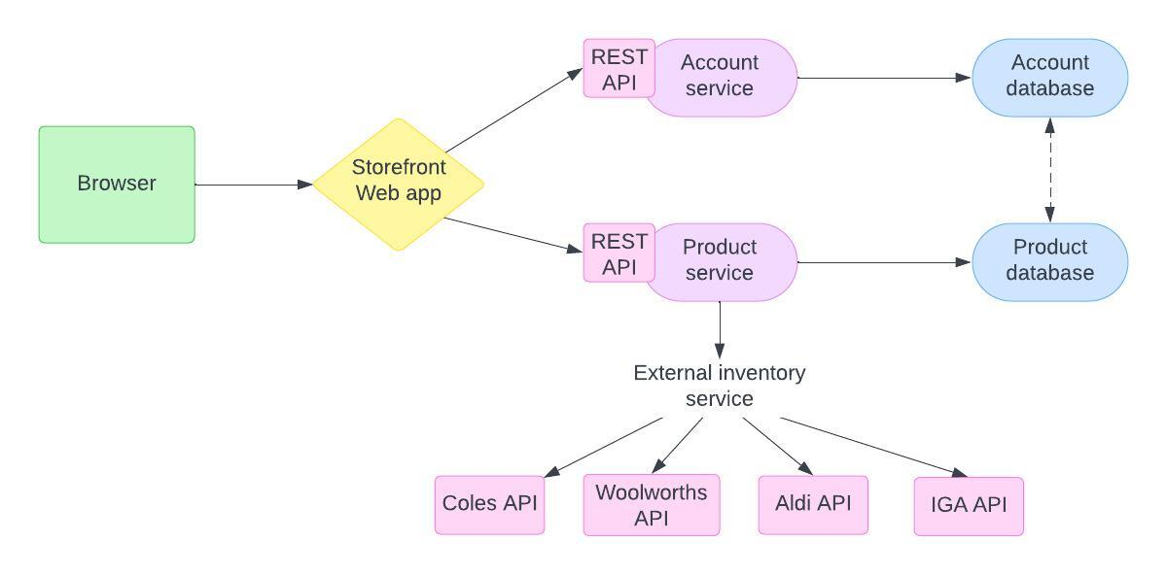

## Class Diagram:

The class diagram below shows the general class system to be used in the backend, which will be a mirror of the database table system. This is split into the main classes of Customer, Order, Product, Chain, Store, OpeningTime and finally as an extra class Review.

This architecture will allow for complex requests from the database, as well as easy backend access to all important data. The backend should request mainly the list of Chain objects (which contains lists of products within) and the current Customer object. This allows access to all other classes by proxy.

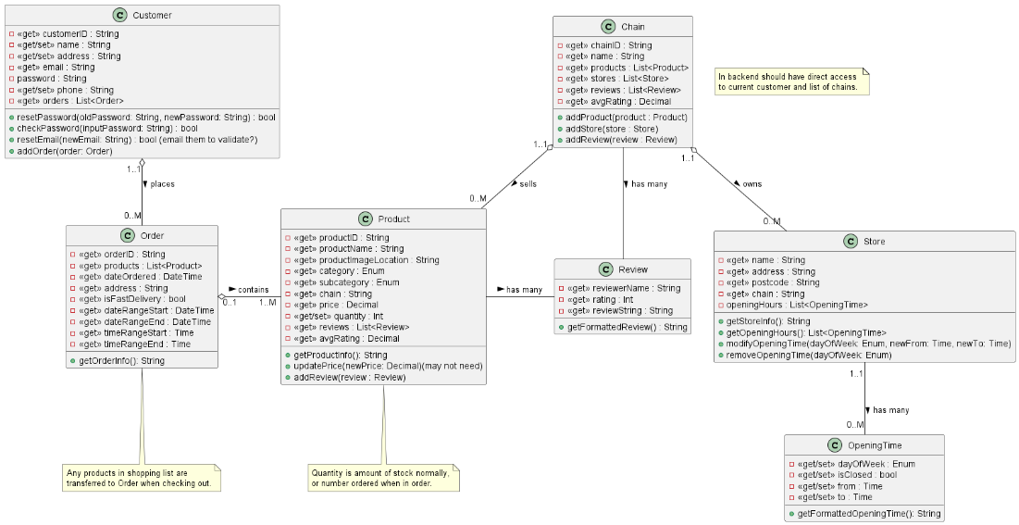

## Use Case Diagram:

The use case diagram is an example of how actors interact with use cases within the system. This visualization is beneficial for stakeholders and developers to understand the relationship and progression of different use cases. As this is a very automated system, most of the action comes from the customer, only one use-case involves the supermarket chain.

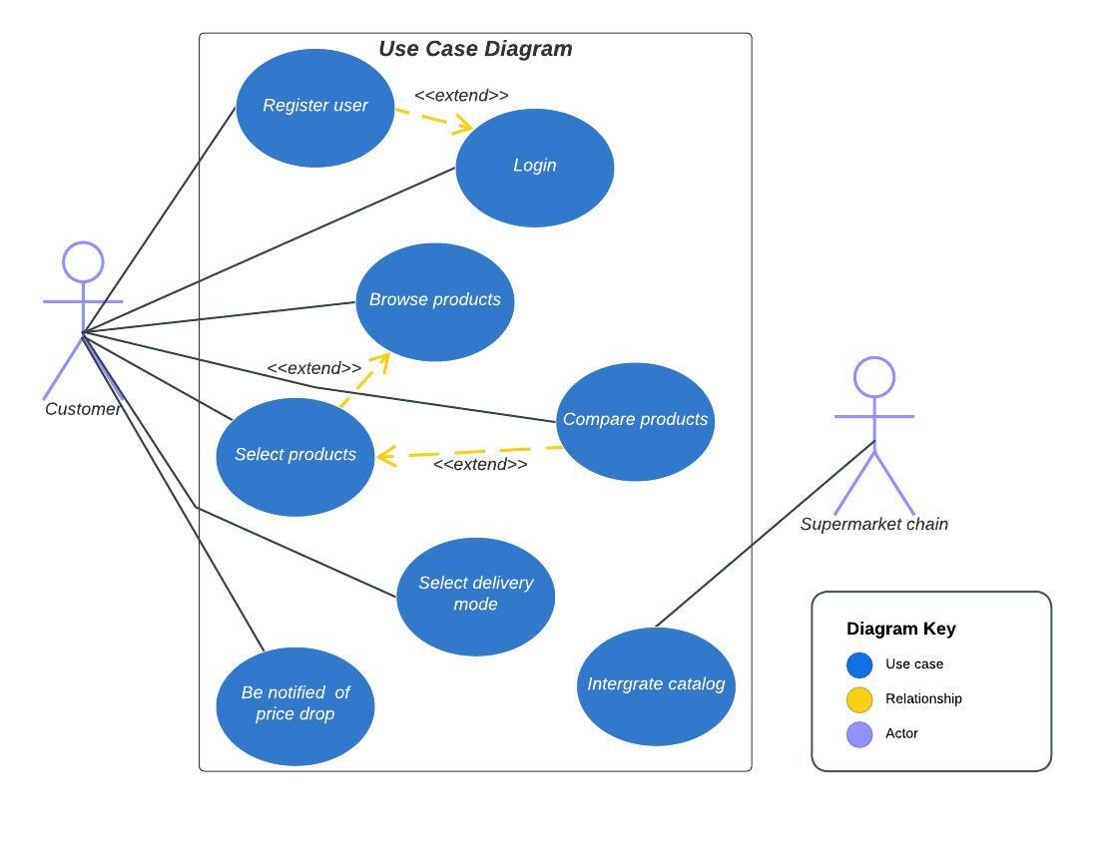

## Data Model:

The data model defines the logical structure of the database and the relationships between each entity. This data model pictures two databases that match up with the architectural diagram pictured in 7.1. The data model has seven entities overall and seven relationships between them.

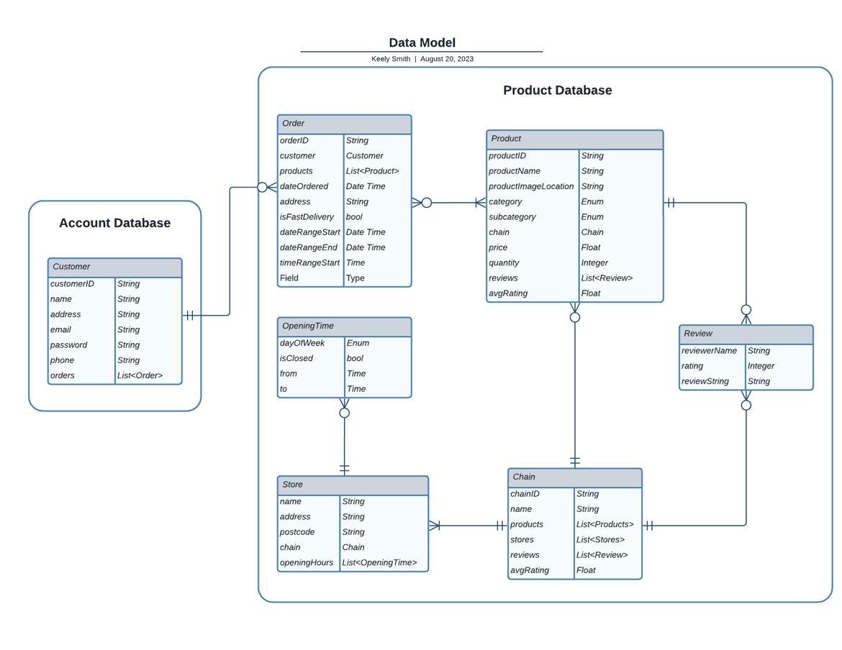

# User Interface Design

SuperPrice’s UI design will focus on both the visual elements and functional considerations that contribute to a user-friendly and engaging experience. By making SuperPrice accessible, this will extend the reach of the application to a greater range of shoppers.

**Visual Elements**

The visual elements for the UI design includes the use of colour palettes and typography, which are essential for defining brand identity and the overall tone of the application. As SuperPrice is used to compare grocery prices across multiple local retailers, it is important that the colours chosen for the application do not similarly reflect another brand. Colour contrast is also crucial for readability, hence it is also necessary that the colour palette chosen will have high visibility and complement the website all together.

The typography for this application will consist of modern sans-serif fonts, as it produces a cleaner and simpler look. Sans-serif fonts are better for a responsive design that can adapt to different screen sizes while maintaining readability. The font sizes for all headings and text will be chosen appropriately to ensure that the content on the application is legible for all users to easily consume information.

**Layout and Navigation**

SuperPrice will adopt a vertical page layout and employ a grid-based design strategy to follow a minimalistic approach. The header and navigation bar will be positioned at the top of the page, while the center will hold the main content. The footer will be towards the bottom of the page. This design choice will help users to seamlessly move through different sections of the application as they follow the visual hierarchy.

**Interactive Elements**

The SuperPrice website will have numerous interactive elements such as buttons, hyperlinks and forms which will encourage user engagement and productivity. Buttons will feature a subtle shadow upon hover, providing a tactile feel that encourages users to further explore the application whilst forms will require users to focus, as they will be asked to input personal information. By providing clear visual cues and interactive elements, these micro-interactions can offer informative feedback that guides users to intuitively navigate the website.

# Testing and Acceptance Criteria

**User Registration and Login:**  
**Test:** Verify that users can successfully register and log in to the application using valid credentials.  
**Acceptance Criteria:**  
A new user can register using a valid email and password.  
A registered user can log in using their credentials.  
Incorrect login attempts result in appropriate error messages.

**Product Search and Browsing:**  
**Test:** Ensure that users can search for products using keywords and navigate through different product categories.  
**Acceptance Criteria:**  
Users can enter a search query and view relevant product results.  
Users can browse through categories and view a list of products in each category.  
Products in search results and categories are accurate and appropriate.

**Price Comparison and Selection:**  
**Test:** Confirm that users can compare prices for a specific product across different supermarkets.  
**Acceptance Criteria:**  
Users can select a product and see a list of prices from various supermarkets.  
The prices displayed are accurate and reflect real-time data from integrated supermarkets.  
The lowest price is clearly highlighted for easy identification.

**Price Drop Notifications:**  
**Test:** Ensure that users receive timely notifications of price drops and special offers.  
**Acceptance Criteria:**  
Users receive notifications for products.  
Notifications are sent when there are price reductions or promotional offers.  
Users have the option to enable/disable notifications in their settings.

By designing these testing scenarios and acceptance criteria, the development team and stakeholders can establish a clear understanding of the expected behavior of the SuperPrice application and ensure its functionality aligns with the project's goals.

# Glossary

**Scope** – The deliverables of the project, specifying what is within the capabilities of budget, time, and ability.

**Stakeholders** – Members who are involved in the project and will be affected depending on the outcome of the project.

**Function Requirements** – Defines what the product or feature does, must be implemented to complete the product.

**Non-functional Requirements** – Defines the operation and properties of a system based on certain metrics.

**Constraints** – Elements that restrict the development of the product.

**Architecture** – The organization of a given system.

# Product Backlog

Prefer to Document folder.

# Sprint 1 and 2 (estimated) Backlogs

Prefer to Document folder.

# Sprint 1 and 2 (estimated) Planning note

Prefer to Document folder.

# Sprint 0 Retro

Prefer to Document folder

# Appendix : Milestone 2

CI_workflow.docx  
ContributionStatement.docx  
Dropped User Stories.docx  
GROUP-P5-01 COSC2299-23s2 Milestone 2.txt  
SprintPlanningNotes.docx  
SprintRetroNotes.docx  
TestsDetails.docx