KCatch-the-Rain

Jiji, Yoyo, and Momo are very close friends, one of their favorite activity is collecting rain water. Unfortunately, rainy season is about to end, so they asked you to make a simple console game about collecting rain water. Here are the requirements:

Main menu

* This menu contains 2 menus, which are Play, and Exit.
* 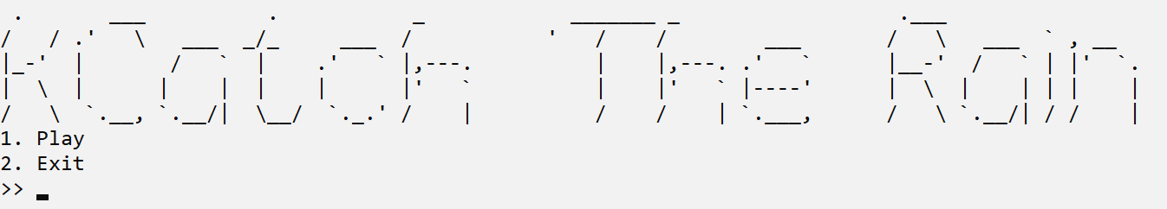Prompt the user to input the chosen menu. Validate that the input must be between 1 and 2 inclusively.

Figure 1. Main Menu

1. If the user chooses Play (Menu 1), start the gameplay, which consists of:

* Display the gameplay map.
* Randomly generate new raindrops at the top of the map, the raindrops should be raining from top to bottom.
* Display a bar at the bottom of the map, the bar can be controlled by the user:

|  |  |
| --- | --- |
| Key | Movement |
| ‘A’ | Left |
| ‘D’ | Right |

* Display the amont of raindrops collected, and the amount of raindrops passed
* If the raindrop hits the bottom of the map, increment the amount of raindrops passed.
* If the raindrop hits the bar, increment the amount of raindrops collected.

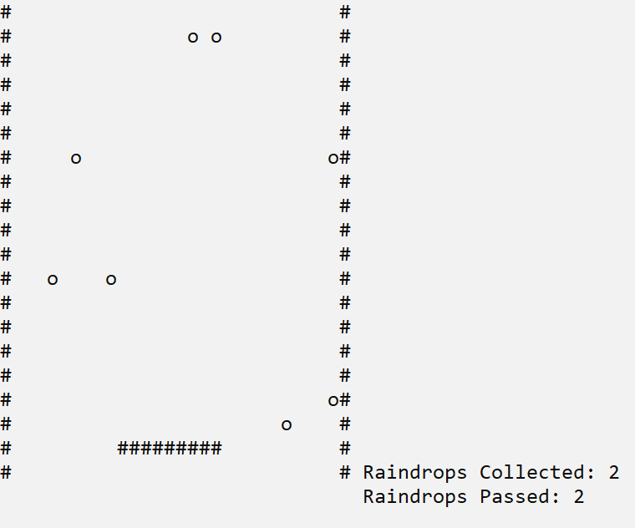

Figure 2. Play Menu

* If the amount of raindrops passed is more than or equal to 50, end the game and display the amount of raindrops collected.

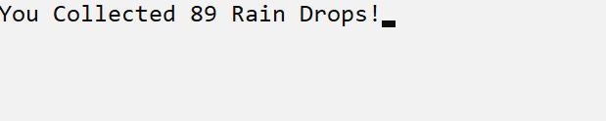

Figure 3. End Game Screen

1. If the user chooses Exit (Menu 2), display exit screen and exit the app.

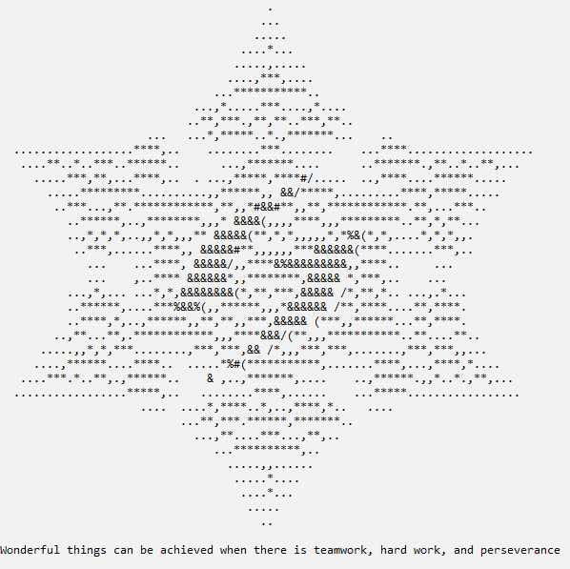

Figure 4. Exit Screen