1.

Generate table (candidate set) of support count for each item

|  |  |
| --- | --- |
| a | 6 |
| b | 8 |
| c | 6 |
| d | 4 |
| e | 2 |
| I | 1 |
| J | 1 |
| k | 1 |

Get rid of those less than min_support (2) for l1

|  |  |
| --- | --- |
| a | 6 |
| b | 8 |
| c | 6 |
| d | 4 |
| e | 2 |

Join step for l2:

|  |  |
| --- | --- |
| A, b | 4 |
| A, c | 4 |
| A, d | 2 |
| A,e | 2 |
| B, c | 4 |
| B,d | 3 |
| B,e | 2 |
| C,d | 1 |
| C, e | 1 |
| D, e | 0 |

Remove those with less than 2:

|  |  |
| --- | --- |
| A, b | 4 |
| A, c | 4 |
| A, d | 2 |
| A,e | 2 |
| B, c | 4 |
| B,d | 3 |
| B,e | 2 |

Join step for l3:

|  |  |
| --- | --- |
| A, b,c | 2 |
| A, b,d | 2 |
| A,b,e | 2 |
| A, c,d | 1 |
| A, C ,E | 1 |
| A, D, E | 0 |
| B C D | 1 |
| B C E | 1 |
| B D E | 0 |

Remove those with less than 2

|  |  |
| --- | --- |
| A, b,c | 2 |
| A, b,d | 2 |
| A,b,e | 2 |

FP-tree: Frequency over min-support

|  |  |
| --- | --- |
| b | 8 |
| a | 6 |
| c | 6 |
| d | 4 |
| e | 2 |

|  |
| --- |
| Ordered List |
| B,c |
| B,a,d |
| A,c |
| B,d |
| B,a,c,e |
| B,c |
| A,c |
| b,a,e |
| B,d |
| B,a,c,d |

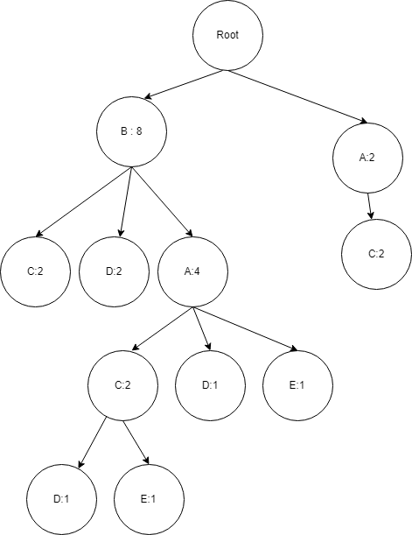

Conditional data base : (B:2) (B:1 A:1 D:1) (B:1 A:1 C:1 D:1)

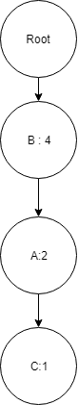

2. Output:

================================================== toy.txt

min_support: 0.6 min_conf: 0.8

Running ...

------------------------ FREQUENT PATTERNS

Itemset: "xxx", "zzz" , 60.00%

Itemset: "yyy", "zzz" , 60.00%

Itemset: "xxx", "yyy", "zzz" , 60.00%

Itemset: "xxx", "yyy" , 80.00%

----> 4 printed

------------------------ RULES:

Rule: "xxx" ==> "yyy" , 0.800

Rule: "yyy" ==> "xxx" , 1.000

Rule: "zzz" ==> "xxx" , 1.000

Rule: "zzz" ==> "yyy" , 1.000

Rule: "zzz" ==> "xxx", "yyy" , 1.000

Rule: "xxx", "zzz" ==> "yyy" , 1.000

Rule: "yyy", "zzz" ==> "xxx" , 1.000

----> 7 printed

0.00699996948242 sec

================================================== user_movies.txt

min_support: 0.26 min_conf: 0.68

Running ...

------------------------ FREQUENT PATTERNS

Itemset: "Forrest Gump (1994)", "Braveheart (1995)" , 27.33%

Itemset: "Forrest Gump (1994)", "Shawshank Redemption, The (1994)" , 28.35%

Itemset: "Pulp Fiction (1994)", "Braveheart (1995)" , 28.57%

Itemset: "Star Wars: Episode IV - A New Hope (1977)", "Star Wars: Episode V - The Empire Strikes Back (1980)" , 28.57%

Itemset: "Pulp Fiction (1994)", "Forrest Gump (1994)" , 30.10%

Itemset: "Pulp Fiction (1994)", "Shawshank Redemption, The (1994)" , 31.63%

----> 6 printed

------------------------ RULES:

Rule: "Braveheart (1995)" ==> "Forrest Gump (1994)" , 0.686

Rule: "Forrest Gump (1994)" ==> "Pulp Fiction (1994)" , 0.686

Rule: "Braveheart (1995)" ==> "Pulp Fiction (1994)" , 0.717

Rule: "Shawshank Redemption, The (1994)" ==> "Pulp Fiction (1994)" , 0.725

Rule: "Star Wars: Episode V - The Empire Strikes Back (1980)" ==> "Star Wars: Episode IV - A New Hope (1977)" , 0.897

----> 5 printed

1.53900003433 sec

================================================== movie_tags.txt

min_support: 0.0028 min_conf: 0.6

Running ...

------------------------ FREQUENT PATTERNS

Itemset: "dark comedy", "black comedy" , 0.28%

Itemset: "funny", "quirky" , 0.28%

Itemset: "future", "sci-fi" , 0.28%

Itemset: "fantasy", "adventure" , 0.29%

Itemset: "comic book", "superhero" , 0.30%

Itemset: "atmospheric", "based on a book" , 0.31%

Itemset: "Nudity (Topless)", "nudity (topless)" , 0.33%

Itemset: "sci-fi", "space" , 0.34%

Itemset: "dystopia", "sci-fi" , 0.37%

Itemset: "imdb top 250", "atmospheric" , 0.37%

Itemset: "aliens", "sci-fi" , 0.38%

Itemset: "imdb top 250", "classic" , 0.39%

Itemset: "action", "sci-fi" , 0.39%

Itemset: "stylized", "atmospheric" , 0.47%

Itemset: "funny", "comedy" , 0.57%

Itemset: "based on a book", "adapted from:book" , 0.60%

----> 16 printed

------------------------ RULES:

Rule: "future" ==> "sci-fi" , 0.729

----> 1 printed

50.9389998913 sec

2.1. Because every global frequent pattern is mined from local frequent pattern, its guaranteed that it is at least a local frequent pattern

2.2. Because there are times where we delete local frequent patterns, such as if it does not have more than the minimum support, it is not guaranteed a local frequent pattern is a global frequent pattern.

3.

Confidence: Beers -> nuts = P(nuts | beer) = support (beer and nuts) / support(nuts)

Confidence: 150/850 = 0.1764

Lift: P(Beers or Nuts) / P(beer) / P(nuts) = (150/10000)/ (500/10000) / (850/10000) = 3.5294

Chi-square:

Expected values: 850*500/10000, 9500*850/10000, 500*9150/10000, 9150*9500/10000

42.5, 807.5, 475, 8692.5

(150-42.5)^2/10000 + (807.5-700)^2/10000 + (475-350)^2/10000 + (8800-8692.5)^2/10000

=5.029

All_confidence:

Min(p(nuts|beer) and p(beer|nuts)) = 150/500 = .3

From these statistics we can tell that beers and nuts are not closely correlated.

4. Contains 4 events/ elements, but has a length of 6.

Subsequences:

Length of 1: 6

Length of 2: 5+4 + 2+2 =13

Length of 3: 4+ 2+ 2 = 8

Length of 4: 4

Total: 31

b.

<ace>, take out first element = <ce>, no other element with last element removed is <ce>

<bcd>, take out element and it = <cd>, no other element with last element removed is <cd>

<bce> => <ce> no other element

<acd> => <cd> no other element

<abd> => <bd> no other element

<(ab)c> => <bc>, elements <b(cd)> and <bce> can be joined

Thus we generate C4 which is = <(ab)(cd)> and <(ab)ce>

Pruning:

Generate subsequences from C4:

From <abcd>, => <abc>, <abd>, <acd> <bcd>

All of these are within L3 so <(ab) (cd)> is in C4.

From <abce> = > <abc>, <abe>, <ace>, <bce>

Since <abe> is not in L3, <abce> is not a valid candidate.

C4: <(ab)(cd)>