Kevin De La Torre

CS 4650

Homework 3

**Markdown Challenge**

Code

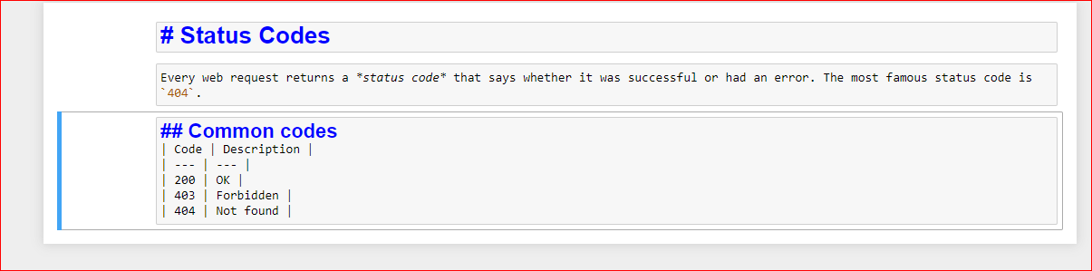

Output

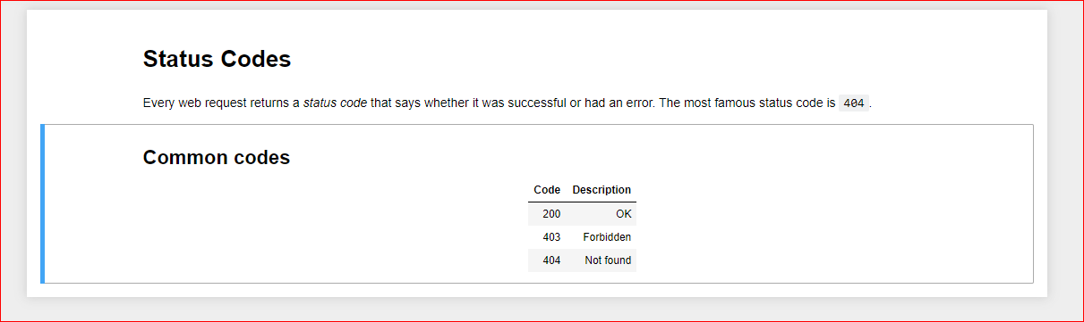

**Documenting JSON Challenge:**

Code

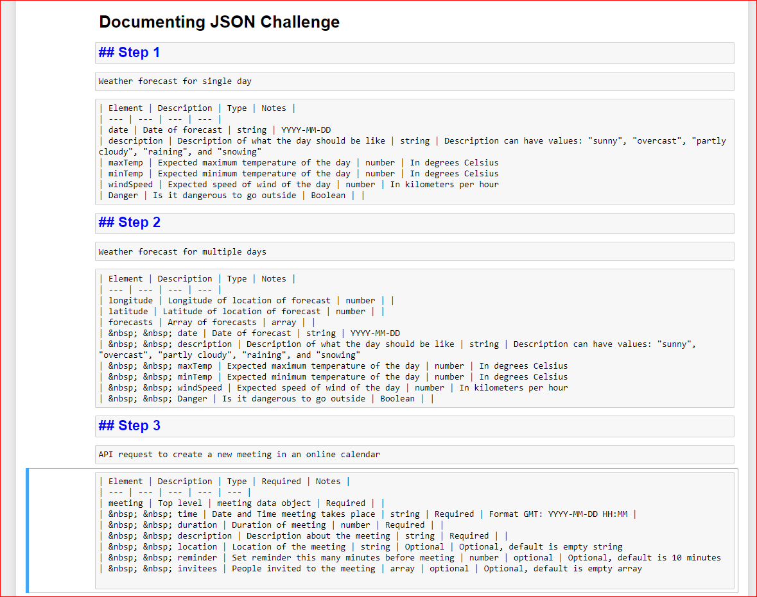

Output

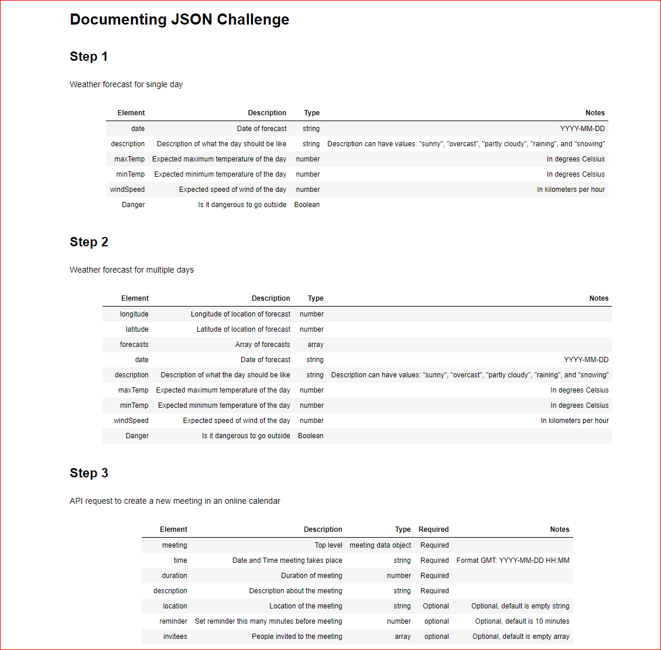

**Documenting XML Challenge**

Code

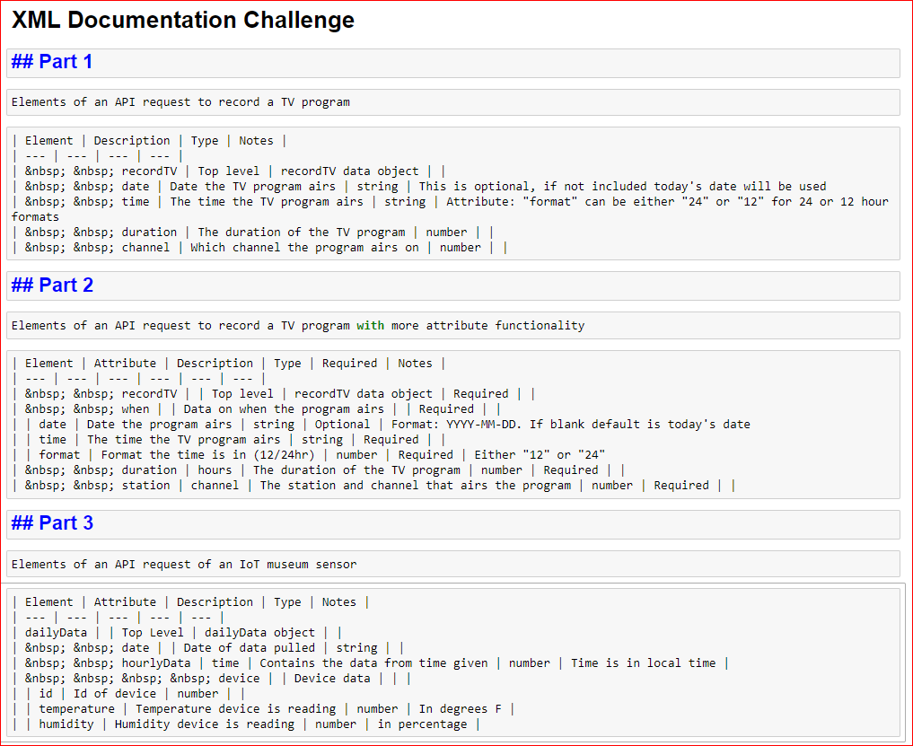

Output

