Chapter 3 stuff (processes)
Process states: New(created), Running(instructions executed), Waiting, Ready(processor), Terminated(finished)
Scheduling: Queues – Job (all processes), Ready(main memory, ready to execute)
Once process allocated to CPU: process could issue I/O request, process could create subprocesses & wait, process could be removed by CPU b/c of interrupt.
A process continues it cycle until it terminates then removed from all.
Context switch – when a user switches to another process, save old process states and loads them to new processes
Process Creation: parent processes create children processes which in turn create other processes. Process creates new process, 2 possibilities: parent continues to execute concurrently, parent waits until children have terminated. Unix example: fork system call creates process, exec sys call used to replace memory w/new program. Process termination: output from child to parent then deallocate all resources; parent can abort child process.
Chapter 4 stuff (threads)
Benefits of Multithreading: Responsiveness(program may continue even if partially blocked), Resource sharing, Economy(costly allocation of memory and resources), Utilization of multiprocessor architectures. Many-to-One ( users-to-kernel ), Many-to-Many(users-to-kernels), One-to-One( drawback requires kernel thread to be made @ time of use thread). Threading Issues: fork & exec; create two fork one to duplicate all threads and one to handles thread that invoked fork. Cancellation; Asychronous – terminates target process immediately & Deffered – allows target thread to check if needs cancellation. Schedule Activation allows upcalls allows application to store correct number of kernel threads. Each process is represnted by a process control block. Pcb = program counter + cpu registers + scheduling info + mem manage info +acct info +io info.
Chapter 5 stuff (scheduling algs)
CPU scheduling decision occur when: 1. switches from running to waiting, 2. switches from running to ready, 3. switches from waiting to ready 4. when terminated.
1&4 – non preemptive scheduling, 2&3 – preemptive scheduling. Dispatcher = Switcher.
Shortest job first--- preemptive SJF = shortest-remaining-time-first-scheduling
Starvation – process is repeatedly denied access to resource it needs
Aging-increase priority as threads get older. Non-preemptive – process keeps CPU until it terminates or switches to waiting state .Round robin scheduling – process runs for 1 time quantum, if not finished, is sent to back of queue. Each process waits no longer than (#processes-1) * time quantum. Multi-level Feedback-Queue Scheduling – allows processes to move btwn queues. Pthread Scheduling - PCS (process contention) & SCS ( system contention)
Chapter 6 stuff (synchronization)
Critical section –process has a segment of code which the process may be changing common variables, updating tables, writing to files (protected section). Must Satisfy the following three requirements: Mutual exclusion - if process is executing in critical section, then no other processes can be executing in their critical sections. Progress-if no process is executing in critical section, and some processes wish to enter critical sections, then only those processes that are not executing in their remainder sections can participate in the decision on which will enter its critical section next. Bounded waiting – there exists a bound on the number of times that other processes are allowed to enter their critical sections after that process has made a request to enter its critical section. Semaphor - doesn’t requires busy waiting. Mutual exclusion with sema:
Do{
Waiting ( mutex);
//critical section
Signal (mutex);
//remainder section
} while (TRUE); //EXAMPLE MUTUAL EXCLUSION WITH SEMAPHORES
Transaction-instructions that perform a single logical function
Stable storage = info that is never lost, replicate several non-volatile storages
Serial schedule-transactions are executed atomically
If 2 translations overlap-no longer serial
Locking protocol = shared – read not write;;;;;;;;exclusive – read & write
Growing phase – translation may obtain locks but not release
Required for Two-Phase locking protocol(ensures serializability):
Shrinking phase – translations may release locks but not obtain
w/r-timestamps – updated at execution if new read/write commands issued
Chapter 8 (mem management strategies)
base register – holds the smallest legal physical memory address
limit register – specifies the size of the range
input queue – processes on disk waiting to be brought into memory for execution
absolute code if processes memory location is know at compile time, ----relocatable code otherwise
Compile time – know at compile time where process will reside in memory, absolute code can be generated. MS-DOS .COM-format programs are bound at compile time.
Load time – if not know at compile time where process will reside in memory, then compiler must generate relocatable code.
Execution time – if process can be moved during execution from one memory segment to another, then binding must be delayed until time run time. Most general purpose operating systems use this.
Memory Allocation:
First Fit (find the first), Best Fit(find the smallest), Worst Fit(find the biggest)
Fragmentation = bestfit & worstfit suffer from external fragmentation b/c there is enough space for memory but memory not contiguous…Compaction of memory solves problem only if relocation is dynamic and done at execution
Swapping – a process can be swapped temporarly and brought back into memory
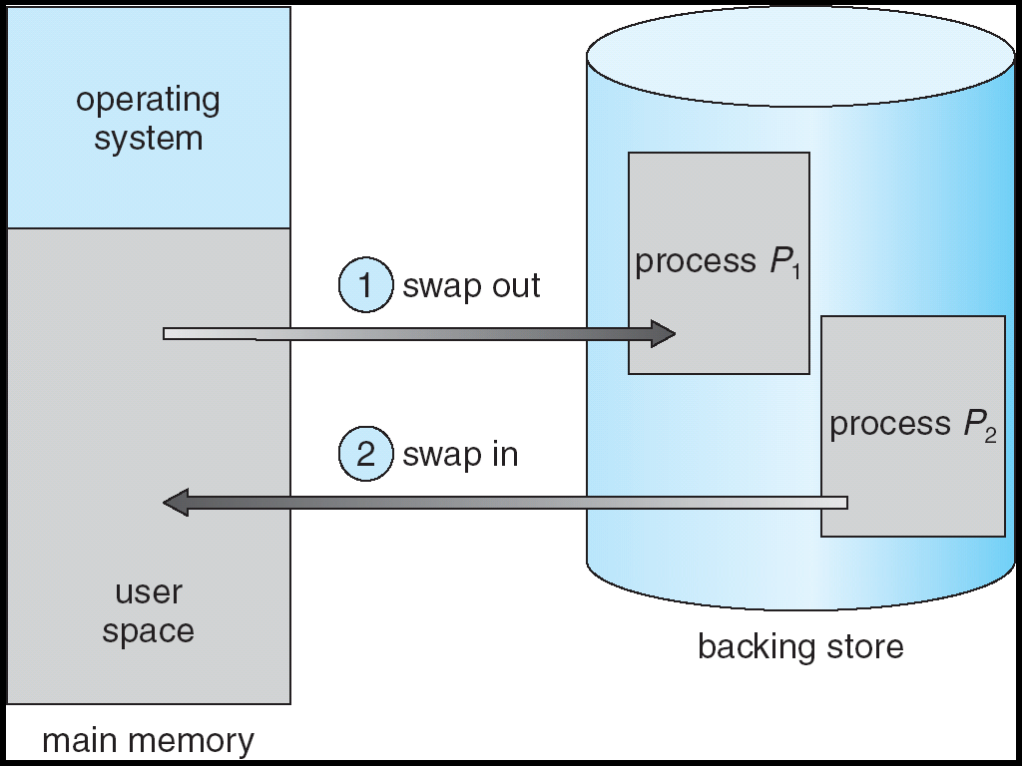

Paging – memory-management allowing noncontiguous processes of physical addresses
frame – breaking physical memory into fixed size blocks
page- same as frames but pages
Size of a page is a power of 2, bwtwn 512 bytes and 16 MB per page.
P --- D, <page #(m-n) ,(n)>
translation lookaside buffer(TLB) – fast lookup hardware cache = each entry has a key + value….holds page + frame #
when logical address is created, its page # is presented to the TLB. If found its frame is found—otherwise the memory reference to the page table must be made
Inverted page tables:
<Process-id, page#, offset>
Chapter 9 stuff ( vm management)
Vm – separation of user logical memory from physical memory
Implement via:
-Demanded paging – loading pages as they are needed
-Demanded segmentation
-lazy swapper –never swaps a page into memory unless its needed
secondary memory = swap disk, effective access time = (1 – prob. Of page fault) * mem access time + prob of page fault * fault time, handling a page fault – check if valid/invalid---if valid bring in page, otherwise terminate process-----find free frame---schedule a disk operation to read in newly allocated frame----modify internal table to indicate page in memory----restart inmstructions
copy-on-write allows parent/child to share pages
Page Replacement:
optimal replacement alg – replace the page that will not be used for the longest period—need to predict future page fault – trap op sys----save the user registers + state------determines if page fault----check that page was legal-----issue read from disk------allocate cpu to other cpu-----receive interrupt from disk io subsystem----save other info------correct page table---wait for cpu----restore everything
Counting Based Page Replacement:
-LFU – page with smalled count be replaced
-MFU – based on argument page with smallest count was probably just brought in and has yet to be used
Throughput – the number of processes that are completed per time unit.
Turnaround time – from start to end of process
-High CPU utilization and throughput minimizes turnaround, waiting, and response time.
Timestamp ordering scheme –
- use the value of the system clock as the timestamp; that is, a transactions timestamp is equal to the value of the clock when the transaction enters the system. This method will not work for transactions that occur on separate systems or for processors that do not share a clock
- use a logical counter as the timestamp; that is, a transactions timestamp is equal to the value of the counter when the transaction enters the system. The counter is incremented after a new timestamp is assigned.
Global allocation allows process to select a replacement frame from set of all frames even if allocated to another process. Local require process to select from own allocated frames
Chapter 10 stuff (File System)
File attributes kept in directory structure on secondary storage. Attributes include – Name, Identifyer, Type, Location, Size, Protection,
Basic file operation – creating a file, writing a file, reading a file, repositioning w/in, deleting, truncating
Open file associations = file pointer, file-open count, disk location of the file & access rights
Shared & exclusive locks
Access Methods = 1.Sequential Access-simplest method, processed in order: 2.Direct Access-fixed length logical records that allow programs to read & write records rapidly in no particular order
Directory Overview=Search, Create, Delete a file, list a directory, rename file, traverse file system
Acyclic-Graph Directories=graph with no cycles, directories share subdirectories; more flexible than tree(prohibits directory sharing)
Chapter 11 stuff (File System Implementation)
File Control Block  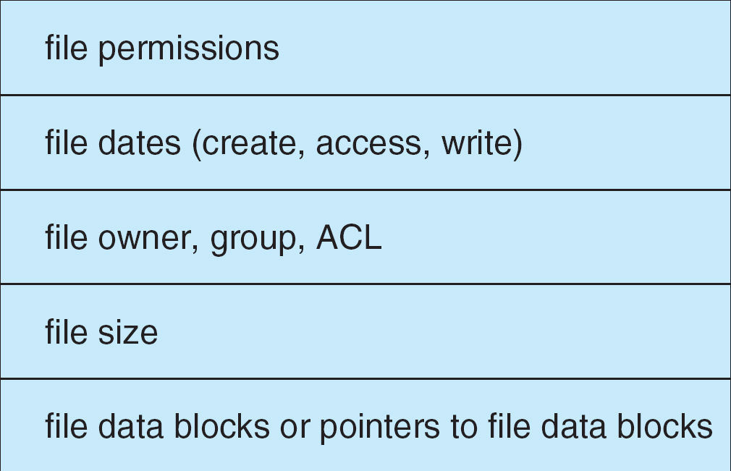 | Boot control block – info needed by system to boot os from volume.  Volume control block  Virtual File Systems:  -separates file-system-generic operations  - mechanism for uniquely representing a file throughout a network | Linear List – simplest way of implementing a directory; names w/pointer to blocks  Hash Table - decrease search time, collisions and fixed size  Allocation Methods:  Contiguous – allocation of contiguous memory blocks; cant grow files  Linked-solved problems of contiguous; linked list of blocks but reliability and space for pointers issues  Indexed - index block where all pointer are brought; for growing large files
Managing Free Space= 1.Bitmapping - block represent by a bit; 2.Linked List – to link together all free disks blocks, keeping a pointer to the first free block; 3.Grouping- modification of free-list approach to store the addresses of n free blocks in first free block: 4.Counting
Chapter12 stuff (Disk Scheduling)
FCFS – first come first serve;
SSTF – shortest-seek-time-first, selects request w/in minimum seek time from current head position, common and increases performance over FCFS;
SCAN – services request scanning disks going up then services requests going back the other direction, better for systems that place heavy load on disk;
C-SCAN – variant of scan to provide longer wait time, immediately returns to beginning of disk w/out servicing request, better for systems that place heavy load on disk;
LOOK – look for a requests before continuing to move in a given direction
*SSTF or LOOK reasonable for default algorithm so that algorithms can be replaced if necessary.
Chapter 14 (System Protection) [17]
Guilding Principle of Protection – principle of least privilege; Programs, users and systems should be given just enough privileges to perform their tasks
Domain – can be realized in variety of ways: user, process and procedure.
Unix – user association to switch domain
MULTICS – protection domains organized in hierarchically into ring structure; segment associated with a file, file associated with ring, less efficient than those used currently
Access-Matrix scheme – rows represent domains, columns represent objects; 3 additional operations are copy, owner & control.
Mechanism – Operating system provides access-matrix + rules; Policy ( user controlled)
Chapter 15 (System Security)

