Reliability and Safety Analysis

Year: 2016 Semester: Fall Team: 7 Project: ANPR Parking System

Creation Date: Nov. 7, 2016 Last Modified: December 11, 2016

Author: Zhihao Liu Email: liu869@purdue.edu

Assignment Evaluation:

|  |  |  |  |  |
| --- | --- | --- | --- | --- |
| **Item** | **Score (0-5)** | **Weight** | **Points** | **Notes** |
| **Assignment-Specific Items** | | | | |
| **Reliability Analysis** | 4 | x2 | 8 |  |
| **MTTF Tables** | 4 | x3 | 12 |  |
| **FMECA Analysis** | 4 | x2 | 8 |  |
| **Schematic of Functional Blocks (Appendix A)** | 5 | x2 | 10 |  |
| **FMECA Worksheet (Appendix B)** | 4 | x3 | 12 |  |
| **Writing-Specific Items** | | | | |
| **Spelling and Grammar** | 4.5 | x2 | 9 |  |
| **Formatting and Citations** | 4.5 | x1 | 4.5 |  |
| **Figures and Graphs** | 5 | x2 | 10 |  |
| **Technical Writing Style** | 5 | x3 | 15 |  |
| **Total Score** | 88.5 | | |  |

5: Excellent 4: Good 3: Acceptable 2: Poor 1: Very Poor 0: Not attempted

Comments:

*There is a huge space for improvement.*

*The MTTF results don’t look right. Even if they are reasonable, the reliability analysis is inconsistent with those results you got. And it will be great if more thought can be put into the part for FMECA Analysis. The FMECA Worksheet part can be much more specific & comprehensive. Also, there are a few very obvious grammar errors. And the formatting throughout the whole document can be improved, too.*

1. Reliability Analysis

PIC24FJ128GA010

The PIC24FJ128GA010 is used to control the entire system. The equation

[1] 𝝀𝑷 = (C1 · πt + C2· πe) · πl · πq

has been used to calculate 𝝀𝑷. Since microcontroller is the most complex system in our design, we choose it for reliability analysis.

Table 1, microcontroller analysis

|  |  |  |  |
| --- | --- | --- | --- |
| Parameter name | Description | Value | *Comments* |
| C1 | Die complexity | *0.28* | Based on the MIL-Hdbk-217f [1] for 16 bit microcontrollers |
| πT | Temperature coeff. | *1.3* | PIC controller |
| C2 | Pin/Package Constant | *0.0392* | 0.0022+(1.72x10-5)(100 pins) |
| πe | Environmental  Constant | *0.5* | GB |
| πl | Learning Factor | *1* | The IC is more than two  years in production |
| πq | Quality Factor | *10* | Commercial components |
| Entire design: |  |  |  |
| 𝝀𝑷 | | *5.6* | |
| MTTF | | *20* | |

SN754410

The SN754410 is used to control the motor module. The equation

[1] 𝝀𝑷 = (C1 · πt + C2· πe) · πl · πq

has been used to calculate 𝝀𝑷.  Motor module is a main part of our system for raising and lowering the barrier gate. We would like to do a reliable analysis for SN754410 Quadruple Half-H Driver.

Table 2, H bridge analysis

|  |  |  |  |
| --- | --- | --- | --- |
| Parameter name | Description | Value | *Comments.* |
| C1 | Die complexity | *0.0025* | Based on the MIL-Hdbk-  217f [1] for devices with  0 to 100 bipolar transistors |
| πT | Temperature coeff. | *0.98* | Assuming a worst case  junction temperature of 85C |
| C2 | Pin/Package Constant | *0.004952* | 0.0022+(1.72x10-5)(16 pins) |
| πe | Environmental  Constant | *0.5* | GB |
| πl | Learning Factor | *1* | The IC is more than two  years in production |
| πq | Quality Factor | *10* | Commercial components |
| Entire design: |  |  |  |
| 𝝀𝑷 | | *0.04926* | |
| MTTF | | *2317* | |

MAX6954

The MAX6954 is used to control 16-segments display. The equation

[1] 𝝀𝑷 = (C1 · πt + C2· πe) · πl · πq

has been used to calculate 𝝀𝑷.  MAX6954 LED driver is used to control multiple 16-segments displays to show information. We would like to do a reliable analysis for MAX6954 LED Driver

Table 3, LED driver analysis

|  |  |  |  |
| --- | --- | --- | --- |
| Parameter name | Description | Value | *Comments* |
| C1 | Die complexity | *0.0025* | Based on the MIL-Hdbk-  217f [1] for devices with  0 to 100 bipolar transistors |
| πT | Temperature coeff. | *0.98* | Assuming a worst case  junction temperature of 85C |
| C2 | Pin/Package Constant | *0.0028192* | 0.0022+(1.72x10-5)(36 pins) |
| πe | Environmental  Constant | *0.5* | GB |
| πl | Learning Factor | *1* | The IC is more than two  years in production |
| πq | Quality Factor | *10* | Commercial components |
| Entire design: |  |  |  |
| 𝝀𝑷 | | *0.038596* | |
| MTTF | | *2957* | |

Reliability Summary

The MTTF of all three components all meet more than half million hours. This means the ICs we picked are for our design. We could improve the reliability by optimizing the connections and programs for microcontroller and other ICs. Cooling system can also be added to our system if our design is operating at a high temperature.

1. Failure Mode, Effects, and Criticality Analysis (FMECA)

The criticality levels can be classified into three levels, Low, Medium and High. Each level refers injury or damage levels.

Low: This criticality specifies that our design is not harmful to the user or destructive of

the rest of the board under failure mode. This could be some part of our system under dysfunctional condition.

Medium: This criticality specifies as a failure that does not harm the user, but has a potential

to damage the system. When any part of our system is physically damage but user

is unlikely to get close to damaged part.

High: This criticality specifies for failures that present potential harm to the user. This level is

presented as some devices are close to user and potential harm to user such as explosion,

uncontrollable movements and etc.

3.0 Sources Cited:

[1] “Military Handbook,”1 1990. [Online]. Available: http://snebulos.mit.edu/projects/reference/MIL-STD/MIL-HDBK-217F-Notice2.pdf [Accessed 11 3 2016].

[2] Microchip, “PIC24FJ128GA010 Family Data Sheet”. [Online]. Available:

http://ww1.microchip.com/downloads/en/DeviceDoc/39747F.pdf

[Accessed 11 3 2016].

[3] Texas Instruments, “SN754410 Quadruple Half-H Driver Data Sheet”. [Online]. Available:

<http://www.ti.com/lit/ds/symlink/sn754410.pdf>

[Accessed 11 3 2016].

[4] Maxim, “MAX6954 Data Sheet”. [Online]. Available:

https://datasheets.maximintegrated.com/en/ds/MAX6954.pdf

[Accessed 11 3 2016].

Appendix A: Schematic Functional Blocks

PIC24FJ128GA010

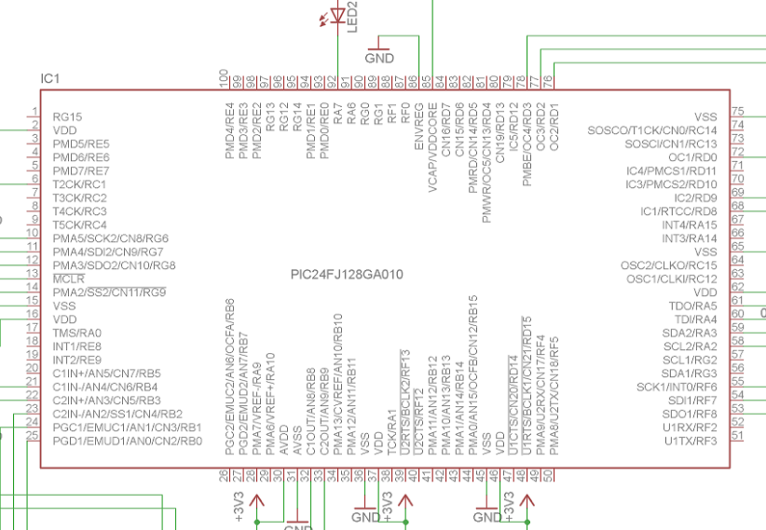

5V Power Supply

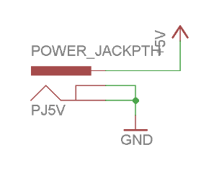

DC to DC Conterver/ Voltage Regulator

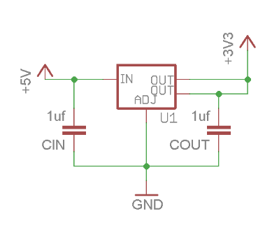

SN754410 H bridge & 12V Power Supply

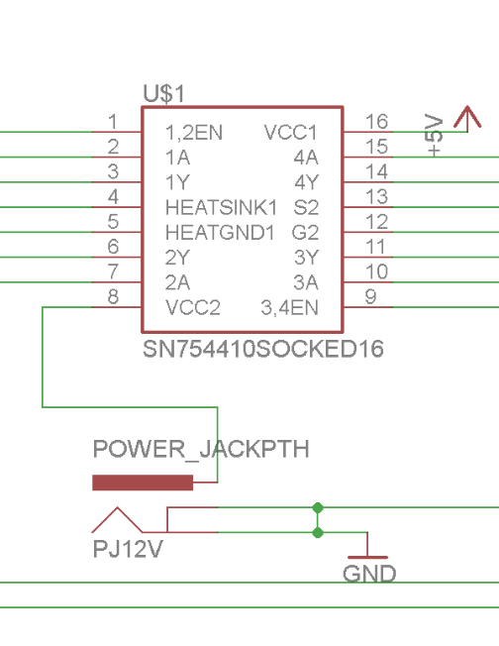

Appendix B: FMECA Worksheet

Table 4, Microcontroller

|  |  |  |  |  |  |  |
| --- | --- | --- | --- | --- | --- | --- |
| **Failure No.** | **Failure Mode** | **Possible Causes** | **Failure Effects** | **Method of Detection** | **Criticality** | **Remarks** |
| 1 | microcontroller stops executing instructions | Incorrect supply voltage. Noise, Software bugs | board is frozen | Observation | Low |  |
| 2 | Function fails on pins of microcontroller | Modules burn, Wrong configuration in software | board is frozen | Observation | High |  |
| 3 | Unexpected reset | Power supply unstable, reset button is triggered accidently | System restart | Observation | Medium |  |

Table 5, Power supply

|  |  |  |  |  |  |  |
| --- | --- | --- | --- | --- | --- | --- |
| **Failure No.** | **Failure Mode** | **Possible Causes** | **Failure Effects** | **Method of Detection** | **Criticality** | **Remarks** |
| 1 | Incorrect voltage | Voltage regulator failure, or resistor open circuit, DC to DC converter failure | Chip no response, chip burned | Observation | Low |  |

Table 5, Motor module

|  |  |  |  |  |  |  |
| --- | --- | --- | --- | --- | --- | --- |
| **Failure No.** | **Failure Mode** | **Possible Causes** | **Failure Effects** | **Method of Detection** | **Criticality** | **Remarks** |
| 1 | Wrong spin direction | Wrong wiring, software bugs | Motor spins in wrong direction | Observation | Medium |  |
| 2 | Uncontrollable movement | Wrong installation, software bugs | Motor operates unpredictably and uncontrollably | Observation | High |  |