User Manual

Year: 2016 Semester: Fall Team: 7 Project: ANPR Parking System

Creation Date: Nov. 15, 2016 Last Modified: Dec. 11, 2016

Author: Kaiwen Yu Email: yu356@purdue.edu

Assignment Evaluation:

|  |  |  |  |  |
| --- | --- | --- | --- | --- |
| **Item** | **Score (0-5)** | **Weight** | **Points** | **Notes** |
| **Assignment-Specific Items** | | | | |
| **Product Description** | 4.5 | x1 | 4.5 |  |
| **Product Illustration** | 5 | x2 | 10 |  |
| **Setup Instructions** | 4.5 | x3 | 13.5 |  |
| **Usage Instructions** | 4.5 | x3 | 13.5 |  |
| **Troubleshooting Instructions** | 5 | x3 | 15 |  |
| **Writing-Specific Items** | | | | |
| **Spelling and Grammar** | 4.5 | x2 | 9 |  |
| **Formatting and Citations** | 5 | x1 | 5 |  |
| **Figures and Graphs** | 5 | x2 | 10 |  |
| **Technical Writing Style** | 5 | x3 | 15 |  |
| **Total Score** | 95.5 | | |  |

5: Excellent 4: Good 3: Acceptable 2: Poor 1: Very Poor 0: Not attempted

Comments:

*Good job. Most of the assignment requirements have been met in general. The product illustration figure looks very nice and it does give a great job in showing what the product looks like.*

*However, more thought could be put into the setup and usage instructions. These two sections can be more comprehensive. Also, it will be great if the instructions there are more specific. What’s more, there are a few errors in writing.*

*In general, this document is well written and most part of it, especially the formatting, does feel like a professional user manual.*

1. Product Description

Nowadays, driving is the most common way for transportation. At the same time, parking cars becomes a problem that annoys you most of the time. Our project is designated to reduce the inconvenience of the process of parking in a garage. ANPR parking system provides automatic detection on incoming and leaving vehicles at the gate. With the detection, the parking time can be recorded and shown on the segment displays located at the gate. Further implementation could be automatic on calculating parking fee for each license plate owner, and this can be achieved by contacting us. Also, it provides the parking spot light indicator that helps driver find empty spaces. These features can improve the user experience of the garage and even reduce cost on employment.

1. Product Illustrations

Complete System Graph:

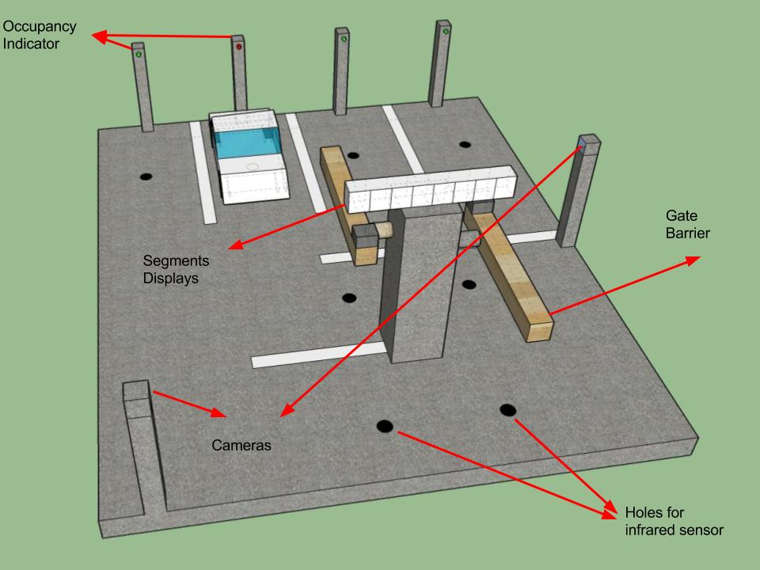

1. Setup Instructions
2. Spot indicator:
   1. Insert battery into battery jack. Place the infrared emitter and sensor at the holes on the ground. Detail placement shown below. 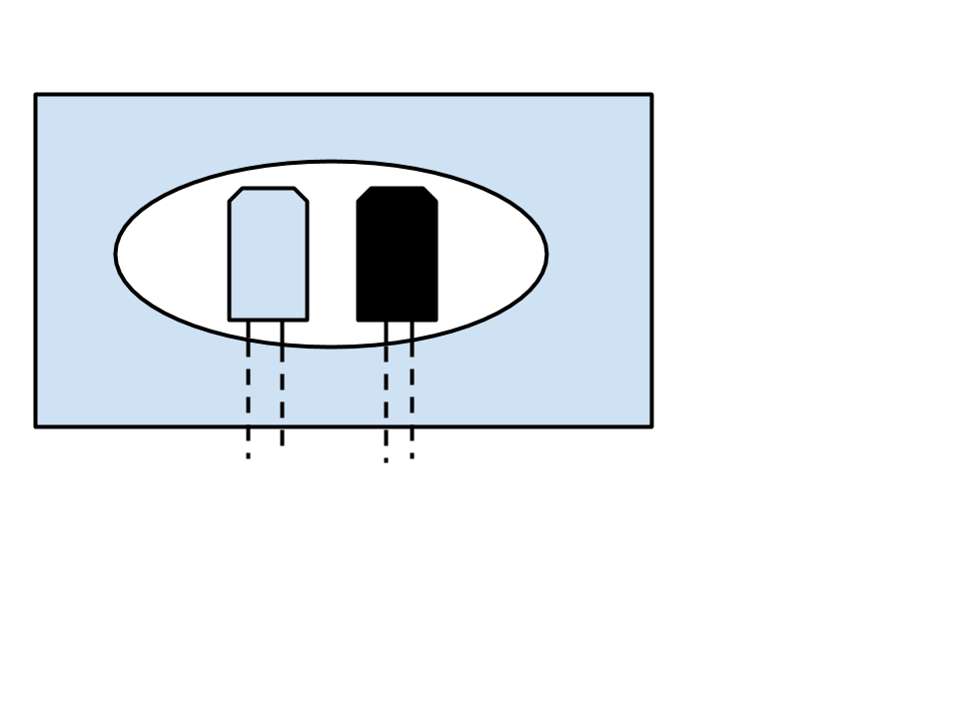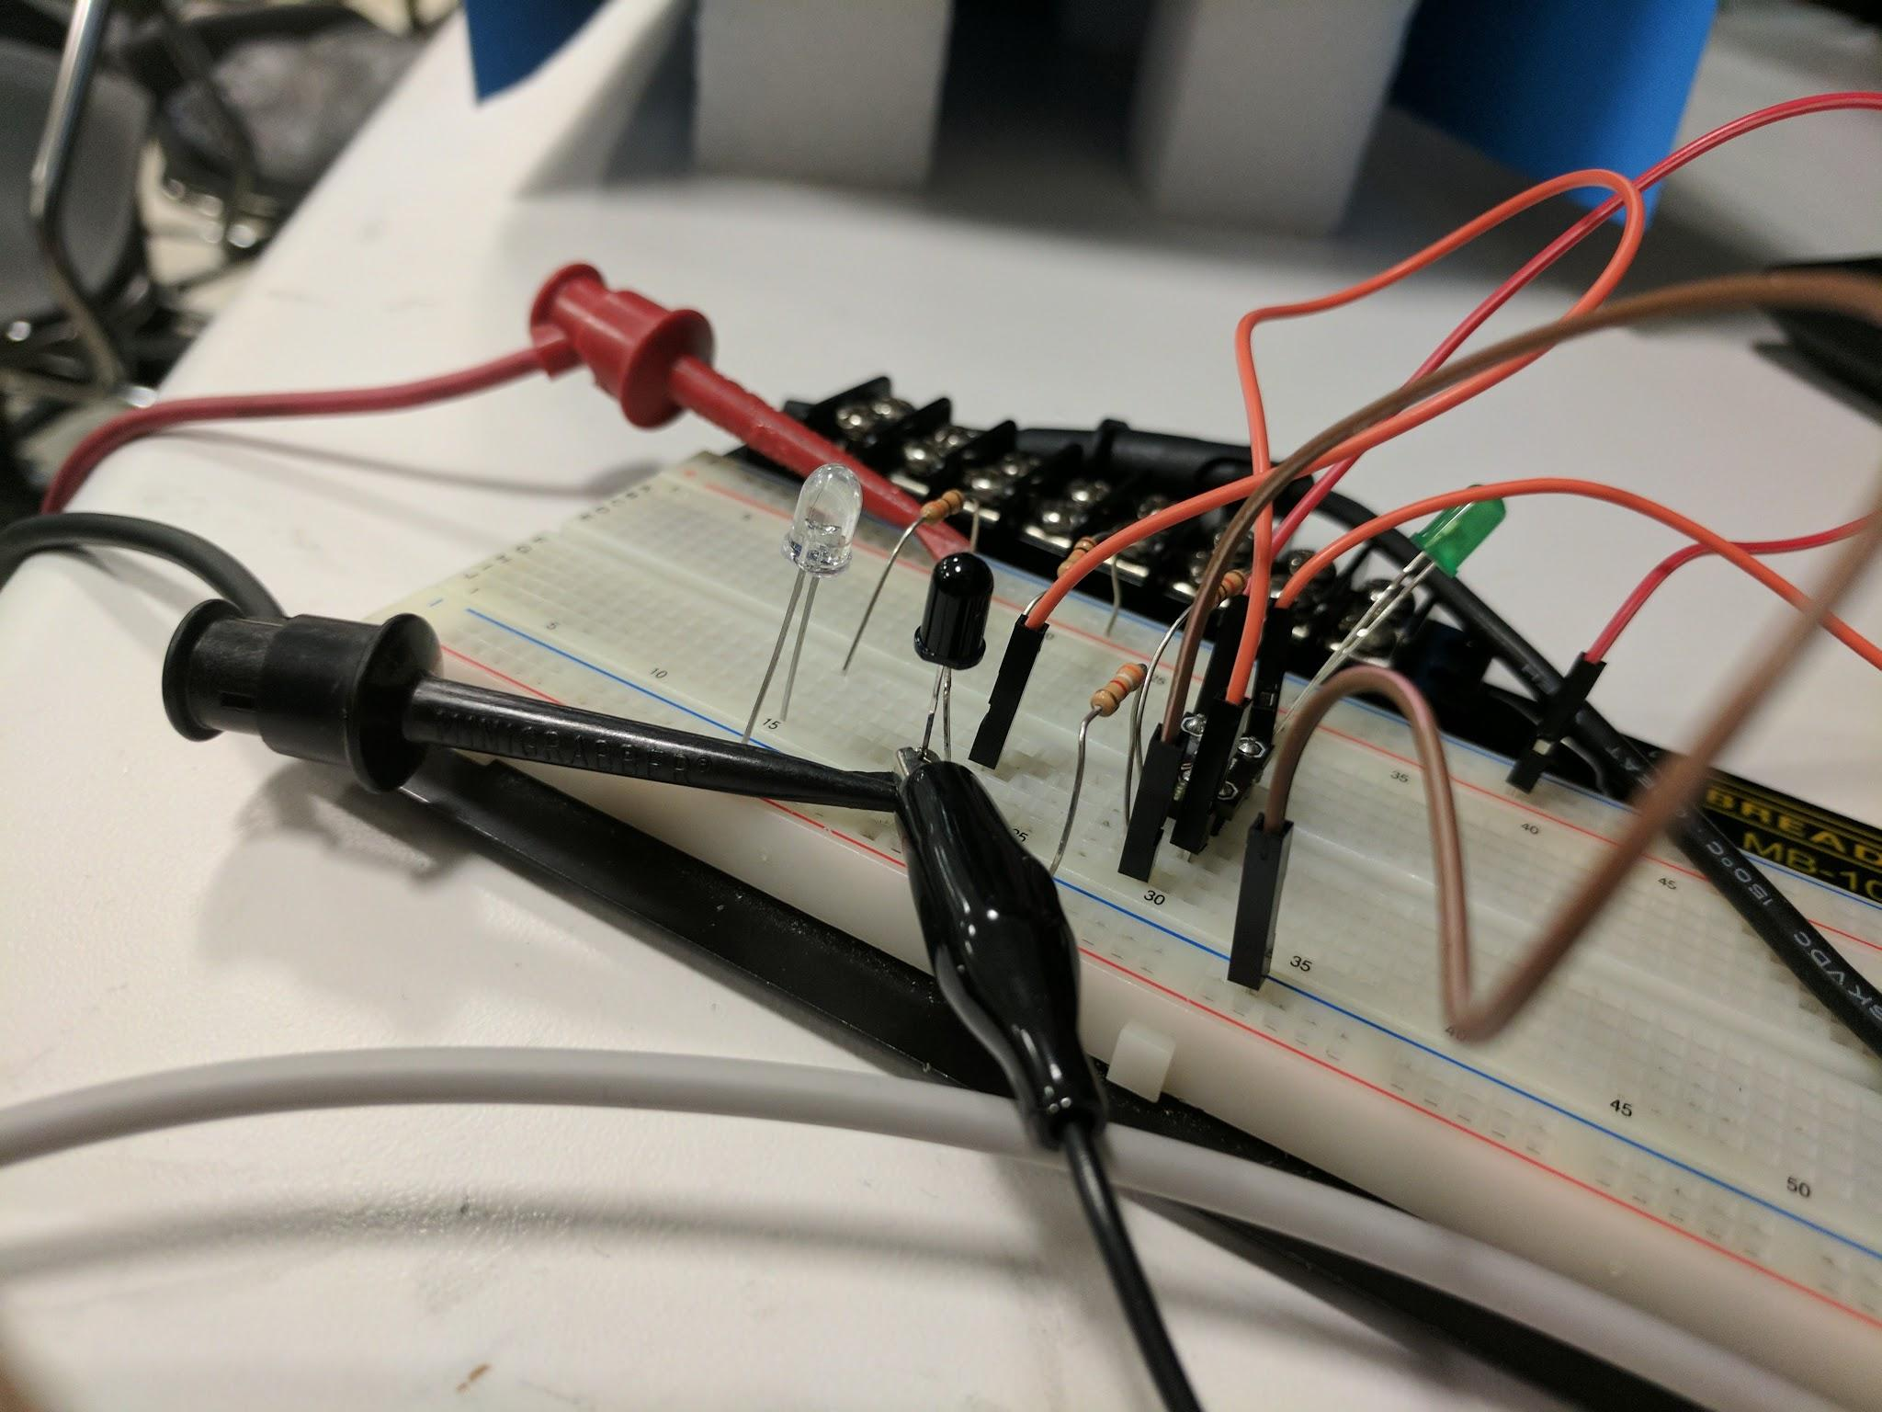
   2. Place the led indicator at the top of the pillar.
3. Gate installation:
   1. Place the gate on to the ground,
   2. Install sensors at the holes as shown in part A. The sensor groups are under: 1. entrance stopping area 2. entrance gate barrier 3. exit stopping area 4. exit gate barrier.
   3. Install the camera on two camera pillars facing gate.
   4. Connect power adapters to 110V power outlets.
4. Usage Instructions
5. Garage Management:
   1. Get the data from Raspberry PI periodically to know the garage status. The data file is stored in txt format.
   2. Replace battery of each parking spot every month.
6. Driver:
   1. When entering, stop at the gate barrier.
   2. After the gate barrier is up, process through the gate.
   3. Find parking spot using occupancy indicator.
   4. Stop at the gate barrier when leaving.
   5. Get parking information from the segment display.
   6. Leave garage.
7. Troubleshooting Instructions

|  |  |
| --- | --- |
| **Problem** | **Potential Solutions** |
| The sensor will not detect object properly. | * Place the sensors as illustrated way. * Replace spot parts. |
| The gate controller is not working. | * Check the power connection. * Re-plugin the device. * Call ANPR Support team at the number below. |
| The plate recognition is not accurate. | * Adjust camera angle. * Adjust surrounding light level. * Call ANPR Support team at the number below. |

If you have further problems, call ANPR Support team at the number below.

We are sorry you are experiencing trouble with your ANPR Parking System! 24/7 Customer Support: 1-800-123-4567.