Component Analysis

Year: 2016 Semester: Fall Team: 7 Project: ANPR Parking System

Creation Date: Sep.7 ,2016 Last Modified: Dec.11, 2016

Member 1: Zhihao Liu Email: liu869@purdue.edu

Member 2: Tian Qiu Email: tq@purdue.edu

Member 3: Kaiwen Yu Email: yu356@purdue.edu

Member 4: Zhuofan Li Email: li1365@purdue.edu

Assignment Evaluation:

|  |  |  |  |  |
| --- | --- | --- | --- | --- |
| **Item** | **Score (0-5)** | **Weight** | **Points** | **Notes** |
| **Assignment-Specific Items** | | | | |
| **Analysis of Component 1** | 5 | x2 | 10 |  |
| **Analysis of Component 2** | 5 | x2 | 10 |  |
| **Analysis of Component 3** | 5 | x2 | 10 |  |
| **Bill of Materials** | 4.5 | x6 | 27 |  |
| **Writing-Specific Items** | | | | |
| **Spelling and Grammar** | 3 | x2 | 6 |  |
| **Formatting and Citations** | 3 | x1 | 3 |  |
| **Figures and Graphs** | 4 | x2 | 8 |  |
| **Technical Writing Style** | 5 | x3 | 15 |  |
| **Total Score** | 89 | | |  |

5: Excellent 4: Good 3: Acceptable 2: Poor 1: Very Poor 0: Not attempted

General Comments:

*It is clear that this group has been putting much more effort into their project now.*

*However, there are two things that require extra attention. First of all, for the Writing-Specific Items, a huge improvement is still possible. It is highly recommended for this group to find some help on writing out of this course (e.g. from the Purdue Writing Lab). Second, a fairly large amount of effort has been put into details that may not be highly valued in this course. It may be easier for the group to come up with a good document with less effort if they have a look at the example assignments online ahead of time.*

*Still, the report is in general good. The comparisons / analyses in it are reasonable.*

1. Component Analysis:

Component list:

1. Infrared sensor pair (emitter and receiver)

Sensor for parking spot occupancy detection and gate area car location detection.

1. Microcontroller

The main controller of the system.

1. Motor

Raise and lower the gate barrier.

1. Camera

Capture image for plate recognizing.

1. Raspberry PI

Control camera and recognize plate number.

1.1 Analysis of Component 1:

Infrared sensor pair for parking spot occupancy detection.

We decide to use infrared sensors to detect whether a vehicle already occupies the spot. And we conclude 2 criteria for these sensors to meet:

1. The effective detection range should not be less than 10 inches so that it could be used to detect the chassis of the vehicle to tell whether there is a vehicle or not.
2. The cost of each pair of infrared sensor should not exceed $2, since we may need tons of pairs of sensors for a parking lot. We could reduce our cost, simultaneously get more competence.

|  |  |  |
| --- | --- | --- |
| Parts type / Standard | detection within range | cost under control |
| QSD124 / [SFH 4550](http://www.mouser.com/Search/ProductDetail.aspx?qs=K5ta8V%252bWhtavCsf0k%2fOizw%3d%3d) | Satisfied | Satisfied |
| [TCRT5000](http://www.mouser.com/Search/ProductDetail.aspx?qs=glpcD2KT6uaaYldHGIIt5g%3d%3d) | Not satisfied | Satisfied |
| [10TP583T](http://www.mouser.com/Search/ProductDetail.aspx?qs=wgO0AD0o1vsgF%2f9Ok30sag%3d%3d) | Satisfied | Not satisfied |

Table 1.1.1

The table above shows the pair of QSD124 and SFH 4550 satisfies both criteria, which is the part we select eventually. The TCRT5000 was not satisfied to detect objects in range, which only can detect up to 0.9 centimeter. The 10TP583T costs 8 dollars each pair, so we are not going to consider it as a possible solution.

1.2 Analysis of Component 2:

Microcontroller will be used to control the gate bar motor, collects infrared sensors’ data, change LEDs’ color and drive the LCD screen. After our discussion, we are going to choose a microcontroller from Microchip.

1. Microchip PIC24FJ256DA210
   1. High end product, ideal for Graphical interface applications that can benefit from the integrated Graphics, 96K byte RAM for frame buffer, mTouch, USB and other peripherals.
   2. Most powerful in PIC24F MCU series
   3. 3 SPI ports, 4 UART ports, 84 I/O pins and 1 USB module
   4. TQFO packages
   5. More expensive than PIC24FJ128GA010
2. Microchip PIC24FJ128GA010
   1. PIC24 16-bit Microcontroller, 128 KB Flash Memory, 8 KB RAM, and Advanced Peripherals, 100 Pin Package
   2. 85 I/O pins, 2 UART, 2 SPI
   3. TQFO packages
   4. Development tools available in ECE 477 lab

After discussion, we may not need such powerful microcontroller as Microchip PIC24FJ256DA210 which is ideal for graphical interface applications. Microchip PIC24FJ128GA010 is only half priced of Microchip PIC24FJ256DA210 and still meet our requirement. There also has development tools already available in ECE 477 lab for Microchip PIC24FJ128GA010, which will save time and money to start programing microcontroller.

1.3 Analysis of Component 3:

Motor for raising gate bar.

The gate bar we planned for demonstration is a wood bar with dimensions around 5 cm * 10 cm * 50. A realistic gate bar would be a 5 cm * 10 cm * 280 cm with a 0.4 cm thickness Aluminum one.

The density of Aluminum is 2712 kg/m^3 [1]. The weight calculated is 9.11 kg. The length of the bar is 2.8 m. Max torque needed in this situation is 9.11 kg force * 1.4 m = 12.7 kg-m = 1124 in-lb.

Achieving this amount of torque costs too much for a gate bars.

The alternate idea shown below:

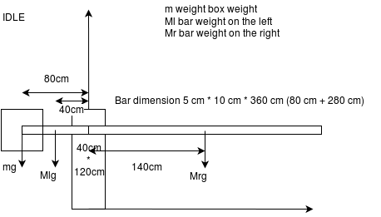

Fig 1.3.1

In this design. The Mr = 9.11 kg, Ml = 2.6 kg. To reduce the torque needed for motor, we added a weight box on the left side of the bar. In theory, the torque needed could be nearly zero. To achieve that, we have the equation:

$$mg*80 + Ml*40 = Mr*140$$

m = 14.6 kg.

GB MOV design

Fig 1.3.1

GB STOP design

Fig 1.3.3

Fig 1.3.2 and 1.3.3 shows the state while the bar is moving and the bar stop at the top. In both cases, the gravity of the bar is partly supported by the gate body. It shows that the bar needs the heavies duty while leaving IDLE state.

For our demo, we will use small material but we will keep the balancing design.

As the torque needed is dramatically reduced, the requirement for the motor are the rpm of the motor and at least a decent amount of torque to cancel calculation inaccuracy. For our design, the rpm needed is not very high. We expected the bar to be raised around 1 - 2 sec. To raise a bar for 90 degrees in 2 sec, the rpm is around 7.5 - 15 rpm.

Here are the four motors we chose from all motors in market. (Table [10] modified for better appearance).

|  |  |  |  |  |
| --- | --- | --- | --- | --- |
|  | Cytron 12V 17RPM 277oz-in Spur Gearmotor  [Cytron 12V 17RPM 277oz-in Spur Gearmotor](http://www.robotshop.com/en/cytron-12v-17rpm-277oz-in-spur-gearmotor.html)  RB-Cyt-34  USD $17.63 | 12V, 165RPM 680.5oz-in Precision Planetary Gearmotor  [12V, 165RPM 680.5oz-in Precision Planetary Gearmotor](http://www.robotshop.com/en/12v-165rpm-6805oz-in-precision-planetary-gearmotor.html)  RB-Sct-621  USD $39.99 | Lynxmotion 12V 20 rpm 323.96oz-in 1:99.5 Brushed DC Gear Motor w/ Encoder  [Lynxmotion 12V 20 rpm 323.96oz-in 1:99.5 Brushed DC Gear Motor w/ Encoder](http://www.robotshop.com/en/lynxmotion-12v-20-rpm-32396oz-in-1995-brushed-dc-gear-motor-w--encoder.html)  RB-Wtc-01  ~~Regular Price:USD $70.40~~  **Special Price:USD $49.28** | Lynxmotion 12V 10 rpm 776.34oz-in 1:264 Brushed DC Gear Motor w/ Encoder  [Lynxmotion 12V 10 rpm 776.34oz-in 1:264 Brushed DC Gear Motor w/ Encoder](http://www.robotshop.com/en/lynxmotion-12v-10-rpm-77634oz-in-1264-brushed-dc-gear-motor-w--encoder.html)  RB-Wtc-09  USD $70.40 |
| Current (No Load) [A] | 0.2200 | 0.5300 | 0.2800 | 0.2800 |
| Current (Stall) [A] | 3.4000 | 20.0000 | 10.0000 | 10.0000 |
| No Load RPM |  | 165 | 28 | 10 |
| RPM Peak Efficiency | 17 |  | 20 | 10 |
| Torque (Peak Eff.) | 0 Nm  0 oz/in | 0 Nm  0 oz/in | 2.2877 Nm  323.9656 oz/in | 5.4824 Nm  776.3733 oz/in |
| Torque (Stall) | 1.96 Nm  277.5594 oz/in | 4.8054 Nm  680.502 oz/in | 5.884 Nm  833.2446 oz/in | 8.826 Nm  1249.8669 oz/in |
| Nominal Voltage [V] | 12.0000 | 12.0000 | 12.0000 | 12.0000 |
| Voltage (Min) [V] |  | 6.0000 |  |  |

The fourth motor have the best torque potential but it is a bit pricy. The second motor have the best rpm but it might be too fast and the ROM Peak Efficiency is not provided. The first and the third motor is both acceptable. We chose the first one for a lower price.

1.4 Analysis of Component 4: Camera

First of all, we decide to use raspberry PI camera module which is designed for raspberry primarily. However, because the parking lot has not only entrance but also exit. We need one more usb camera to cover both positions. Hence, from start, the raspberry PI camera module has been certain. The constraints for our cameras are: HD resolution can just be 720p but not 1080p because the camera is close to the target; focus type should be always focus because we need to make sure camera can take the clear images whenever the car is coming. When the camera fulfills these two constraints, the last topic is to decide it peculiarly. So, in the end, we choose the HD Webcam C270 and also raspberry PI camera module, two cameras.

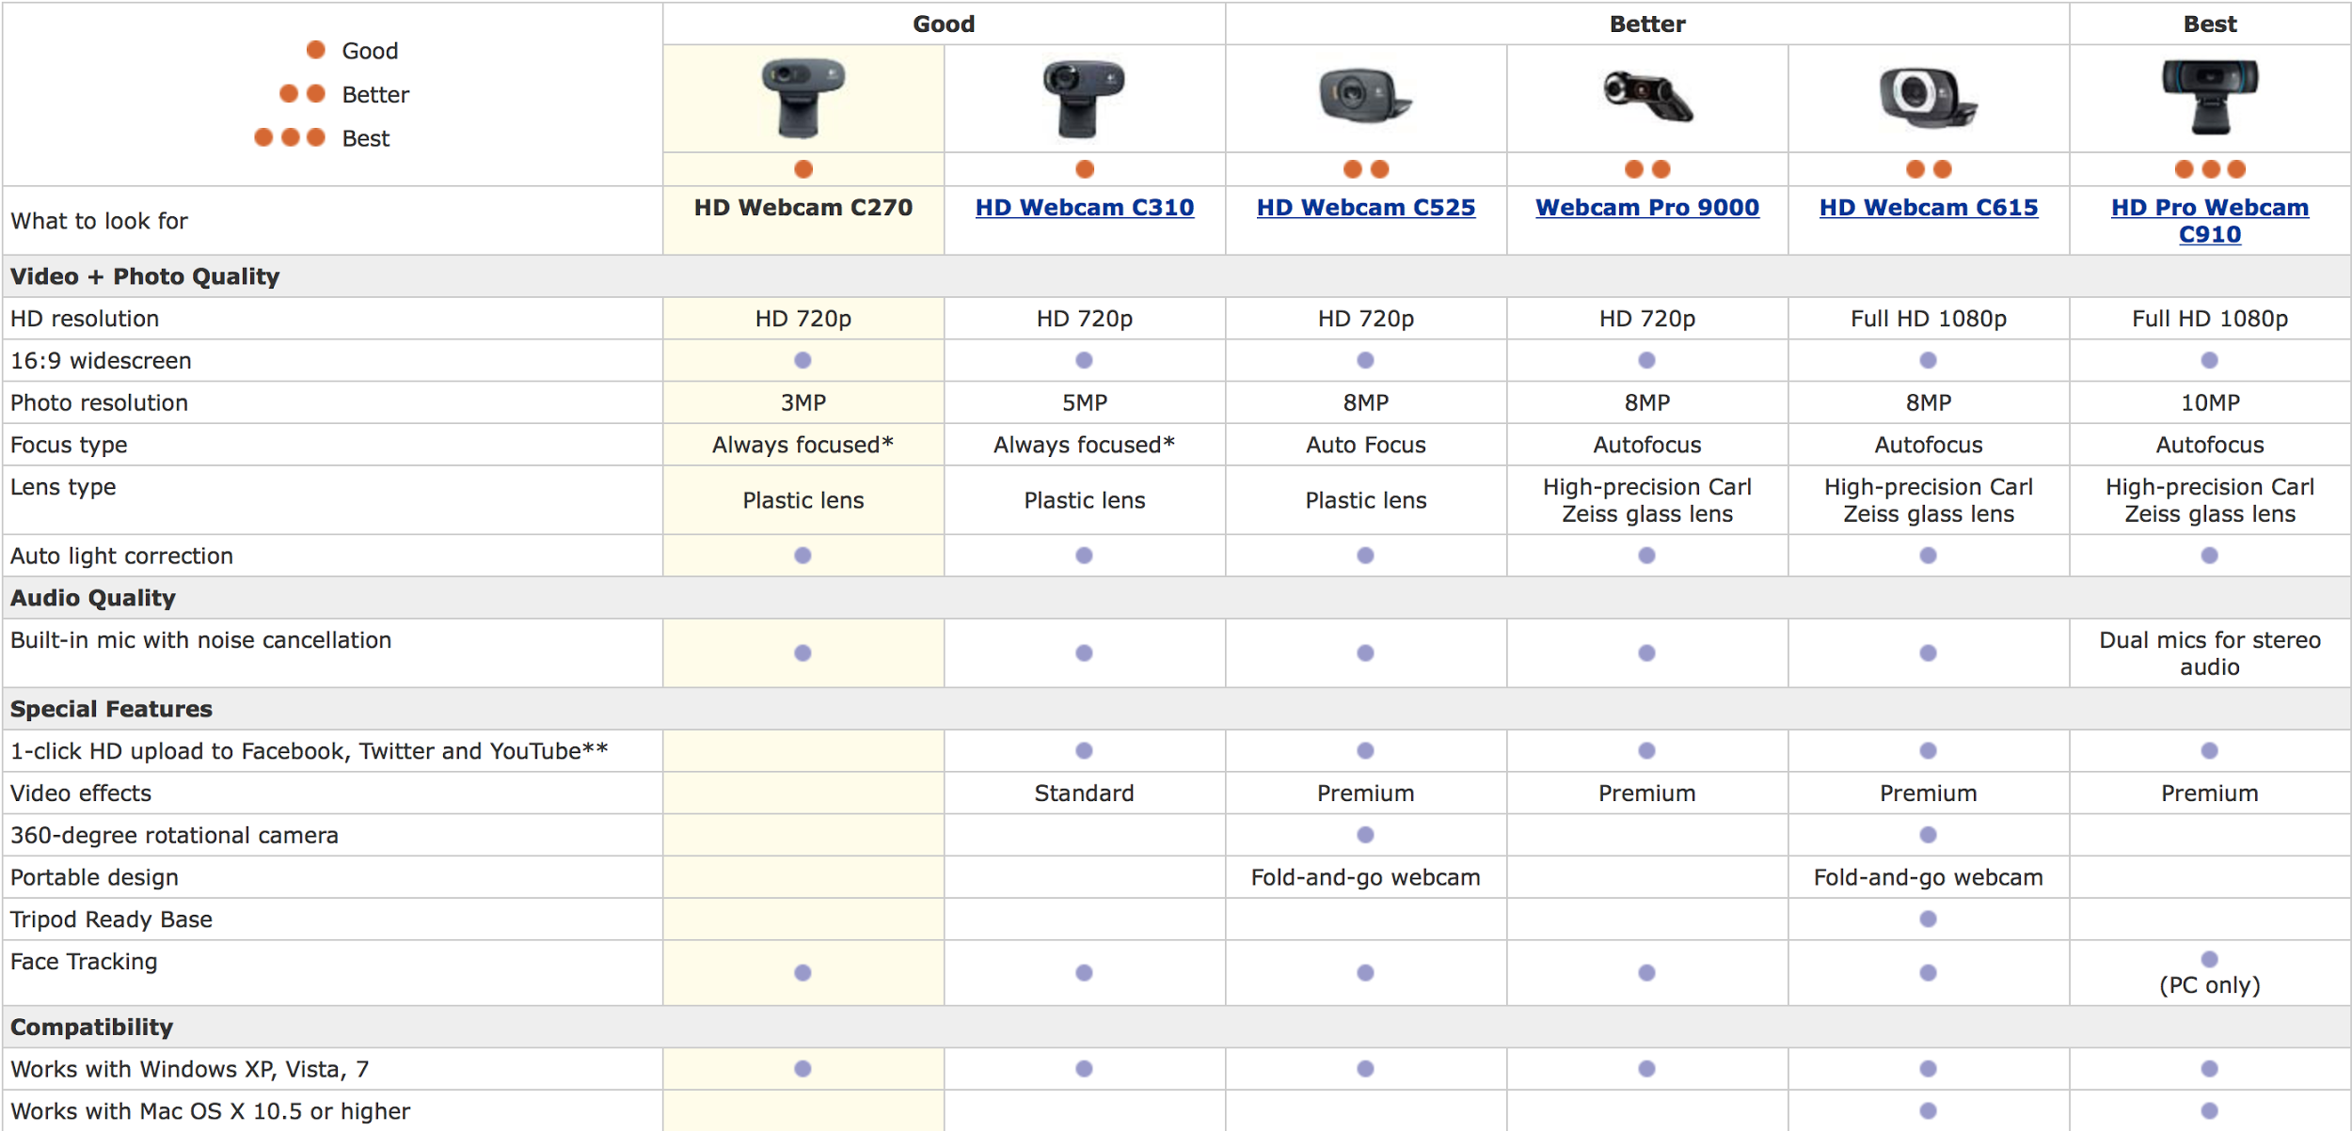

1.5 Analysis of Component 5: Raspberry PI

Because of the computational constraints of microcontroller, we decide to use another more powerful board to take charge in taking images and performing plate recognition. We choose the Raspberry Pi due to its popularity that many websites provide the tutorial to implement opencv plate recognition algorithm plus Raspberry PI. Here is the dilemma, we do not know which version of raspberry PI is best for us. So we did some research about it.We want our Raspberry to be the most powerful version. Also we do not care much about the power consumed. Most importantly, we probably need WiFi and Bluetooth LE in the future. So we bought Raspberry Pi 3 Model B.

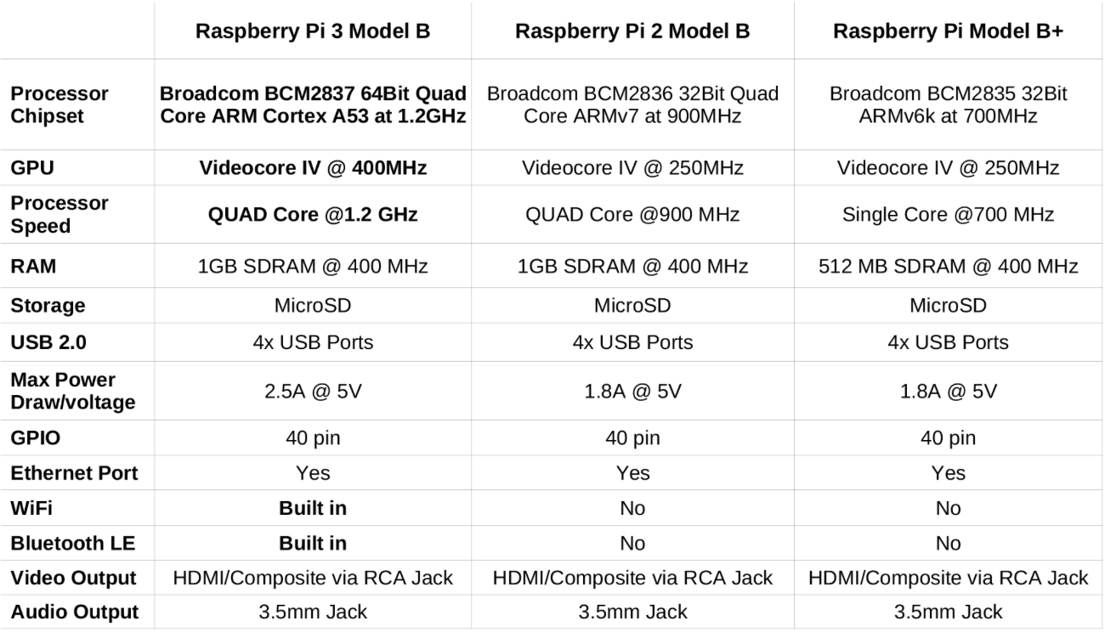

2.0 Sources Cited:

[1]. http://www.engineeringtoolbox.com/metal-alloys-densities-d_50.html

[2] [Changhyeok Bae](https://at.projects.genivi.org/wiki/display/~locust2001) ([2016, Sep 01](https://at.projects.genivi.org/wiki/pages/diffpagesbyversion.action?pageId=11569534&selectedPageVersions=38&selectedPageVersions=39)) Available: <https://at.projects.genivi.org/wiki/display/GDP/Raspberry+Pi+2,+3+(RPi2,+RPi3)+Hardware+Setup+and+Software+Installation>

[3] Amazon ( 2013, Aug 12) Available https://www.amazon.com/gp/product/B004FHO5Y6/ref=oh_aui_detailpage_o00_s00?ie=UTF8&psc=1

[4] “QSD124 Fairchild Semiconductor | Mouser,” *Mouser Electronics*. [Online]. Available: <http://www.mouser.com/search/productdetail.aspx?qs=mxr4l2/ossahagvm89m6pa==>

[5] “SFH 4550 OSRAM Opto Semiconductors | Mouser,” *Mouser Electronics*. [Online]. Available: <http://www.mouser.com/search/productdetail.aspx?qs=k5ta8v%2bwhtavcsf0k/oizw==>

[6] “TCRT5000 Vishay Semiconductors | Mouser,” *Mouser Electronics*. [Online]. Available: <http://www.mouser.com/search/productdetail.aspx?qs=glpcd2kt6uaayldhgiit5g==>

[7] “10TP583T Semitec | Mouser,” Mouser Electronics. [Online]. Available: <http://www.mouser.com/search/productdetail.aspx?qs=wgo0ad0o1vsgf/9ok30sag==>

[8] “PIC24FJ128GA010 - 16 Bit - Microcontrollers and Digital Signal Controllers” Microchip. [Online]. Available: <http://www.microchip.com/wwwproducts/en/PIC24FJ128GA010>

[9] “PIC24FJ256DA210 - 16 Bit - Microcontrollers and Digital Signal Controllers” Microchip. [Online]. Available: <http://www.microchip.com/wwwproducts/en/PIC24FJ256DA210>

[10] Self Chosen Compare Table.

Cytron 12V 17RPM 277oz-in Spur Gearmotor. Available: <http://www.robotshop.com/en/cytron-12v-17rpm-277oz-in-spur-gearmotor.html>

12V, 165RPM 680.5oz-in Precision Planetary Gearmotor. Available: <http://www.robotshop.com/en/12v-165rpm-6805oz-in-precision-planetary-gearmotor.html>

Lynxmotion 12V 20 rpm 323.96oz-in 1:99.5 Brushed DC Gear Motor w/ Encoder. Available: <http://www.robotshop.com/en/lynxmotion-12v-20-rpm-32396oz-in-1995-brushed-dc-gear-motor-w--encoder.html>

Lynxmotion 12V 10 rpm 776.34oz-in 1:264 Brushed DC Gear Motor w/ Encoder. Available: http://www.robotshop.com/en/lynxmotion-12v-10-rpm-77634oz-in-1264-brushed-dc-gear-motor-w--encoder.html