**Errors**

var a, b;

begin

a := 1 🡸since the semicolon is missing, the begin-end statement ends, but there is no end

b := 2;

if a > 2 then

b := a;

end.

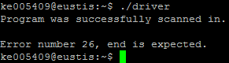

var a, b;

begin

a := 1;

b := 2;

if a > 2 🡸then is needed after if

b := a;

end.

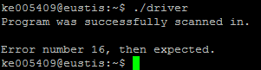

var a;

begin

while a < 20 🡸do is needed after while

a := a + 1;

end.

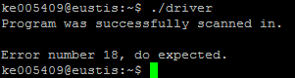

var a;

begin

while b < 20 do 🡸b is not declared

a := a + 1;

end.

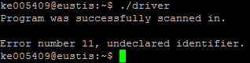

const a = 5;

begin

while a < 20 do

a := a + 1; 🡸a is a constant, assignment is not allowed

end.

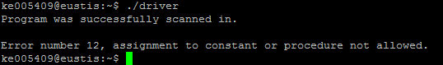

const a = 5;

var a; 🡸a is declared twice

begin

while a < 20 do

a := a + 1;

end.

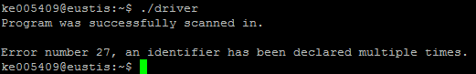

var a;

begin

while a < 20 do

a := a + 1;

end 🡸Period is missing

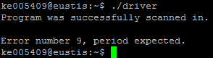

const; 🡸identifier is needed here

var a;

begin

while a < 20 do

a := a + 1;

end.

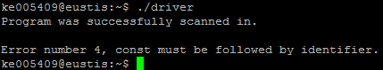

const b := 5; 🡸in a const declaration, you need to use an = not :=

var a;

begin

while a < 20 do

a := a + 1;

end.

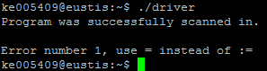

var a;

begin

while a := 20 do 🡸a relational operator is expected here instead of :=

a := a + 1;

end.

