Reflection

Tools used

Apache NetBeans IDE 12.0

jdk-16.0.1_windows-x64_bin

jre-8u291-windows-x64

Cloning Project Repository

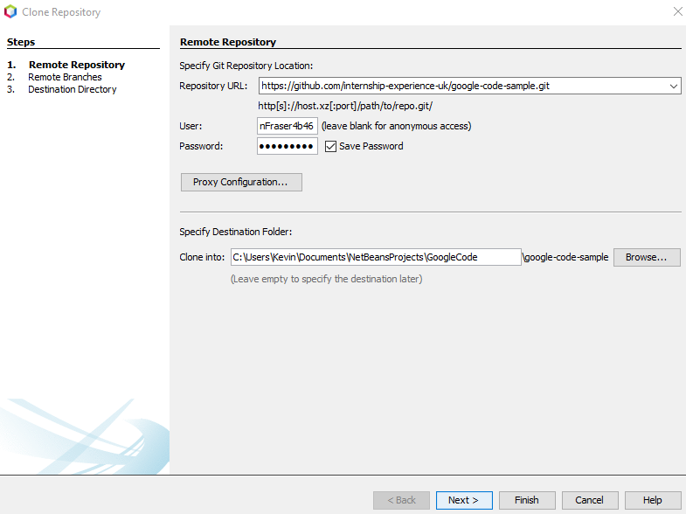

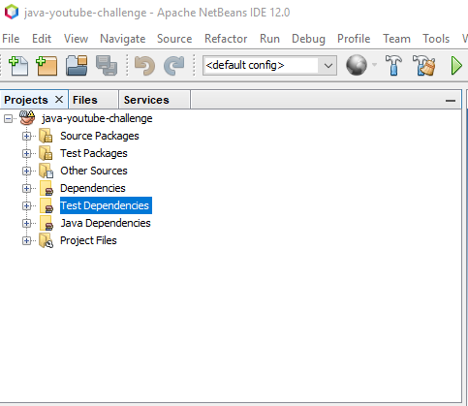Project Directories in Projects Pane

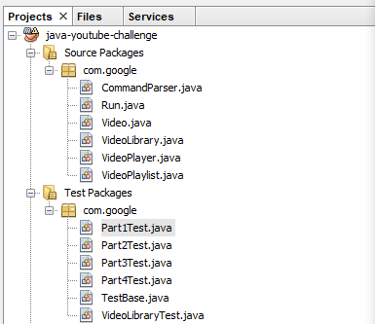

Working Classes and Test Classes Shown

A challenge was to how to perform a unit test on the Class *CommandParser.Java* . A resource use to learn JUnit testing was a course named *Java: Testing with Junit* offer by LinkedIn Learning

Good unit testing is critical to the success of your application. Errors in a program cause the end user to lose confidence in an application. So JUnit make sure that the program thoroughly tested in most possible scenario. JUnit 5.4 was installed since it was required for unit testing. JUnit 5.4 jar file was found in the JUnit website.

Good unit testing is critical to the success of your application. Errors in a program cause the end user to lose confidence in an application. So JUnit make sure that the program thoroughly tested in most possible scenario.

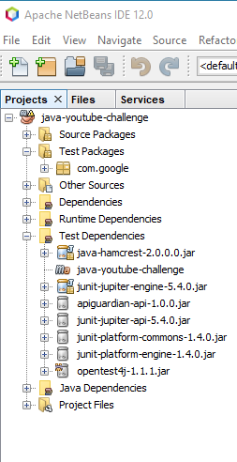

Results of Installing junit-jupiter-engine-5.4.0 .jar