Non-Functional Requirements

Performance/Response time requirement
Our response time would be relatively quick as the application does not have to process much data. The only part of the application that I think would have a slower response time would be the Log into Facebook part. This part would mean that the app would have to access the users Facebook page. That could require a good amount of processing.

Availability requirement
The user must have a Facebook account for the user to use the app fully. This account must be available for the application to access whenever it is needed to post a status on the users Facebook page.

Recover requirement
When the user signs into his Facebook account his saved data(his saved alarm times) will be put back on the device he has just logged in on.

Robustness requirement
If an error occurs in the application, the application will automatically shut down/restart
We will need to test this to have a good idea that it will work the way we wanted. To do this we must use a technique called fuzz testing which involves us purposely putting in errors in sections of the applications to see if the application restarts/shuts down when it is supposed to.

Security requirement
The only security issue that we think that user would have an issue would be that we would have access their Facebook page. But really we would have made an APP with Facebook that would automatically post the message on their wall.

Reliability requirement
For our application to fully function it relies on the internet to connect to the users Facebook and post the message on the page. The rest of the application would not require the internet as it is all manually input by the user.

Portability requirement
The app will be based on android but does require internet to function fully. This is the only thing preventing it from working in all environments. We could make a delay function on the Facebook status but we do not think there is any point. Usually when people are in their own homes they would have full access to their internet so we don’t think that is much of a big deal.

Extendibility requirement
In the future we hope to extend our application onto other mobile OS systems such as apple and windows. We would also extend our Application onto other social networks other then Facebook but we are limited to the technology at the minute. If we wanted to expand to twitter we would have to have access to a twitter build Application to access the user account.

Reusability requirement
The only part of the code that our group can think that would be re-used would be the setting the dates and times of the alarm. Its not a part of the application that would only have to be used once. It would have to used every time the user wants to set a new alarm.

GUI
This is the mock-up of our overall application, The pages include the main menu,the set alarm, the settings and the Facebook set up.
The first page the user will be greeted with will be the menu page with options to turn the alarm off, set the alarm and change the settings of the application.
When the user wants to access the alarm he wants he must enter the 'Set alarm' page to do so. When in this part of the application he must enter the date and time that he wants to set the alarm for.
If the user wants the adjust the settings to his favor he must enter the 'Settings' page to do so. In this particular part of the application he can adjust different settings such as the 24 hour setting to be on our off, the repeat setting, the vibrate setting, the volume and then access to the next page which is the facebook set up page.
On the 'Facebook Set Up' page it will link you to a facebook application that we will make that will allow our app to have access to posting on your status. The person will be greeted with a terms and conditions page which they must agree to for the application to fully function. After this stage they will be asked to fill in there facebook details.

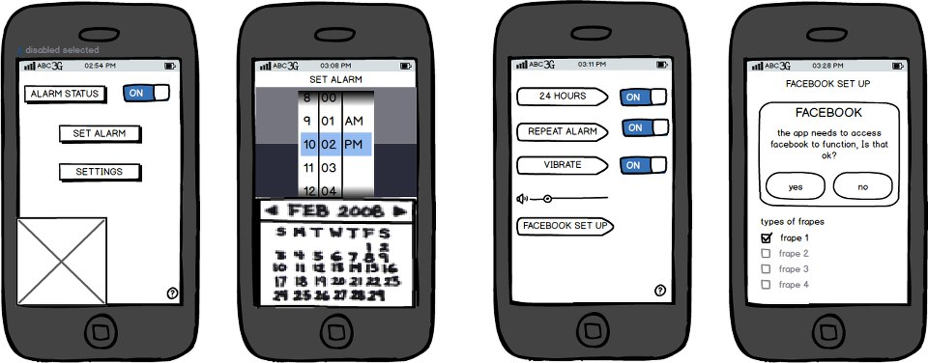

System Architecture
Use a class diagram to outline the structure of the system. Explain briefly why you have chosen this architecture. You might want to use Visio or Rational Rose to create these.

System Evolution
When we are thinking of evolving the system we think of expanding it. When expanding the system we have options of moving it to a different OS to have access to new users. We would also like to move it to another social network such as twitter.
At the moment we could not give twitter access to

