Football Player Injury Prediction using Neural Networks

*A Comprehensive Analysis using Deep Learning Techniques*

# Table of Contents

1. 1. Project Importance and Neural Network Justification
2. 2. Dataset Analysis and Key Observations
3. 3. Neural Network Models - Concept-by-Concept Analysis
4. 4. Predictions, Applications, and Future Improvements

# 1. Project Importance and Neural Network Justification

## 1.1 Project Importance

Football injuries represent one of the most significant challenges in professional sports, with profound implications for player welfare, team performance, and financial sustainability. The ability to predict and prevent injuries has become a critical competitive advantage in modern football.

* **\*\*Player Welfare**: Protecting athletes from career-threatening injuries**
* **\*\*Financial Impact**: Injuries cost clubs millions in medical expenses and lost player value**
* **\*\*Performance Optimization**: Healthy players contribute to better team performance**
* **\*\*Strategic Planning**: Informed decisions about player rotation and transfers**
* **\*\*Medical Prevention**: Early intervention and targeted preventive measures**

## 1.2 Why Neural Networks are the Optimal Choice

Neural networks excel in this domain due to their unique capabilities in handling complex, non-linear relationships inherent in sports performance data:

* **Non-linear Pattern Recognition**: Football injuries result from complex interactions between physical, technical, and environmental factors that traditional linear models cannot capture
* **Multi-dimensional Feature Learning**: Neural networks automatically discover hidden patterns in player attributes like age, BMI, playing style, and workload intensity
* **Temporal Dependencies**: LSTM networks capture how injury risk evolves over time, considering player development and fatigue accumulation
* **Anomaly Detection**: Autoencoders identify unusual player profiles that may indicate heightened injury susceptibility
* **Feature Hierarchy**: Deep networks learn hierarchical representations from basic stats to complex injury risk patterns
* **Robustness to Noise**: Neural networks handle missing data and measurement inconsistencies common in sports datasets

## 1.3 Applications and Real-World Impact

* **Medical Staff**: Early warning systems for injury-prone players
* **Coaches**: Informed decisions about player rotation and training intensity
* **Club Management**: Strategic planning for transfers and contract negotiations
* **Insurance Companies**: Risk assessment for player insurance policies
* **Performance Analytics**: Integration with existing sports analytics platforms

## 1.4 Future Improvements and Extensions

* **Real-time Monitoring**: Integration with wearable sensors and GPS tracking
* **Personalized Models**: Individual player-specific injury prediction models
* **Multi-modal Learning**: Combining video analysis with statistical data
* **Causal Inference**: Understanding not just correlation but causation in injury factors
* **Federated Learning**: Sharing insights across clubs while preserving data privacy

# 2. Dataset Analysis and Key Observations

## 2.1 Dataset Overview

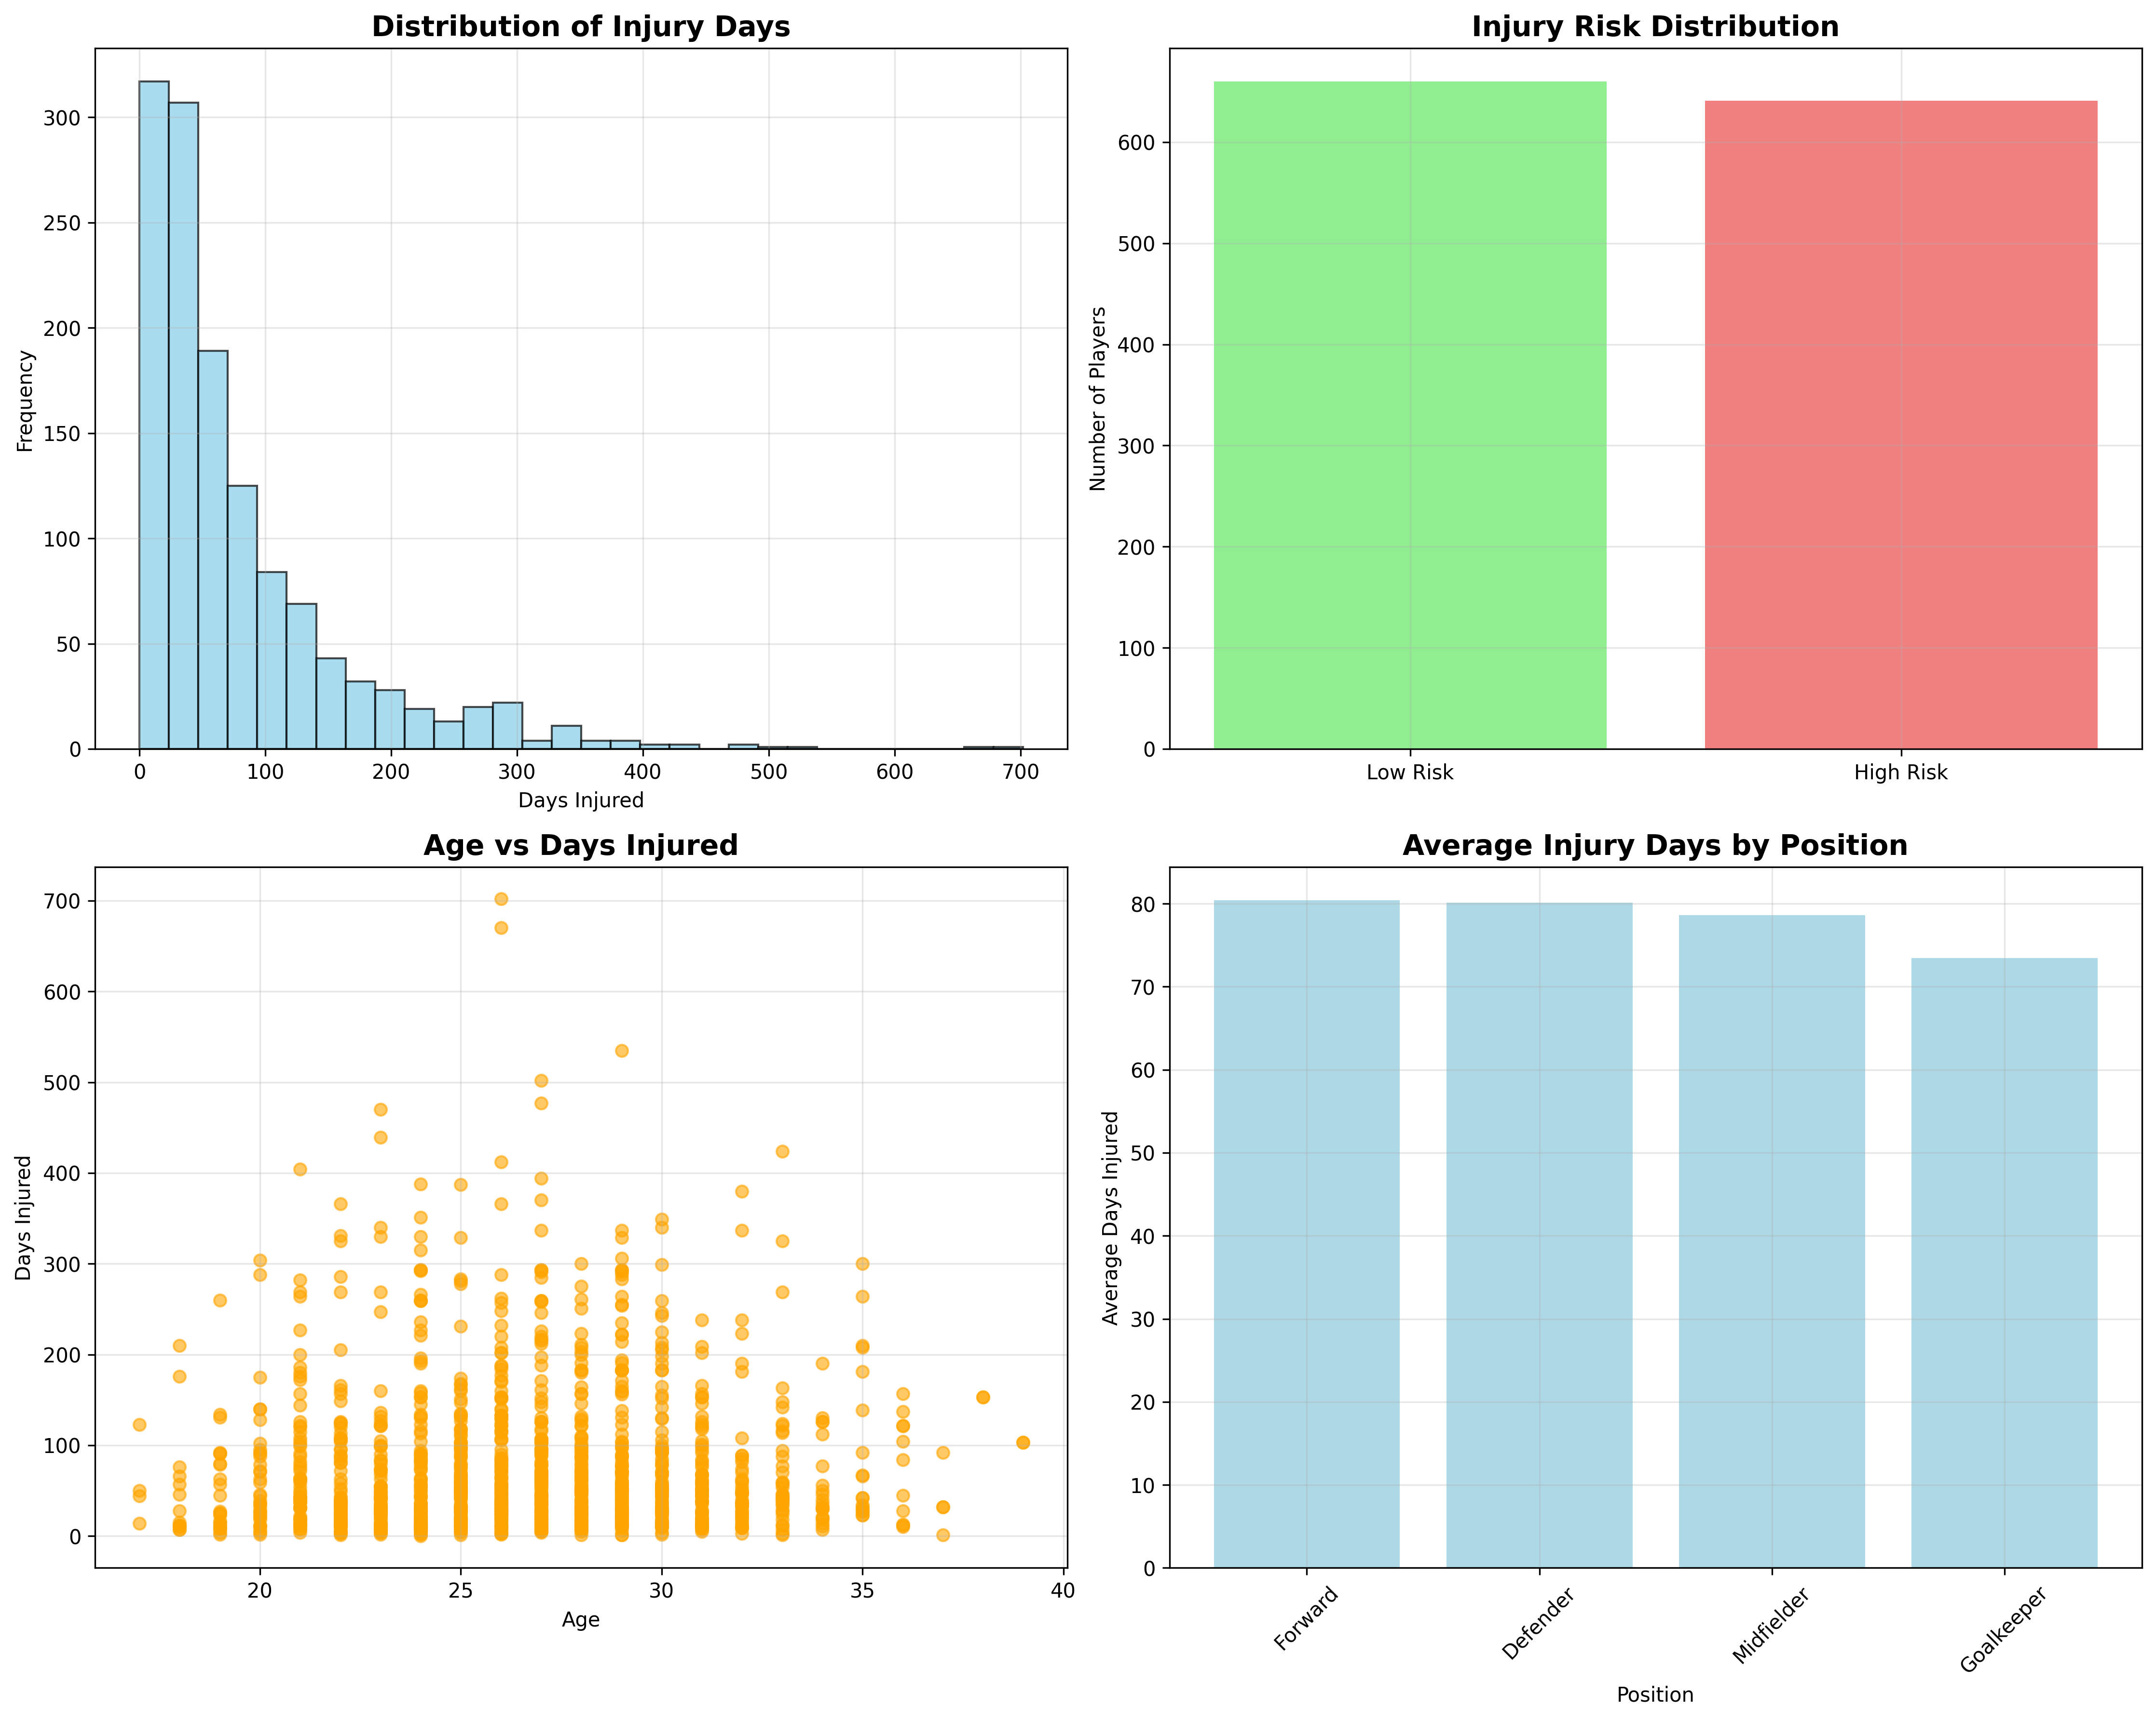

* **Total Records**: 1,301 player-season observations
* **Time Period**: 2016-2021 seasons
* **Features**: 31 attributes per player
* **Average Injury Duration**: 79.1 days
* **Injury Rate**: 99.9% of players experience injuries
* **High-Risk Players**: 641 (49.3%)

## 2.2 Key Features and Their Significance

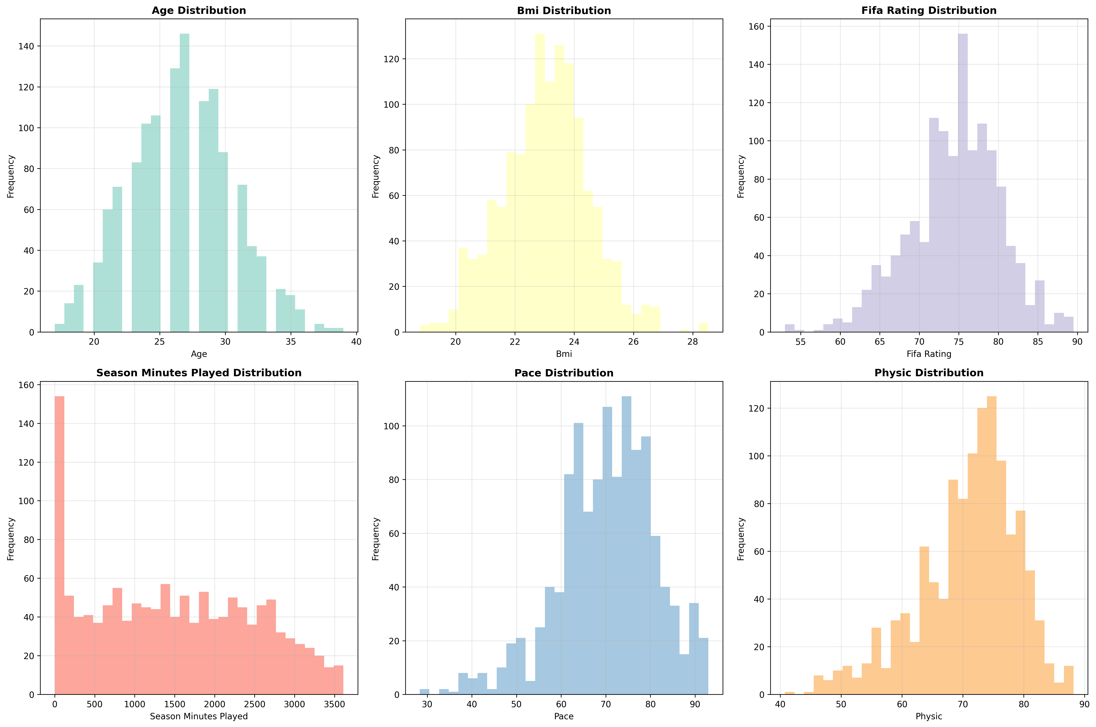

* **Age**: Player age - critical factor as injury risk typically increases with age
* **Bmi**: Body Mass Index - indicates physical condition and injury susceptibility
* **Fifa Rating**: FIFA game rating - proxy for overall player quality and market value
* **Season Minutes Played**: Playing time - workload indicator affecting fatigue and injury risk
* **Pace**: Speed attribute - high-pace players may face different injury patterns
* **Physic**: Physical strength - relates to contact injury resistance

## 2.3 Correlation Analysis

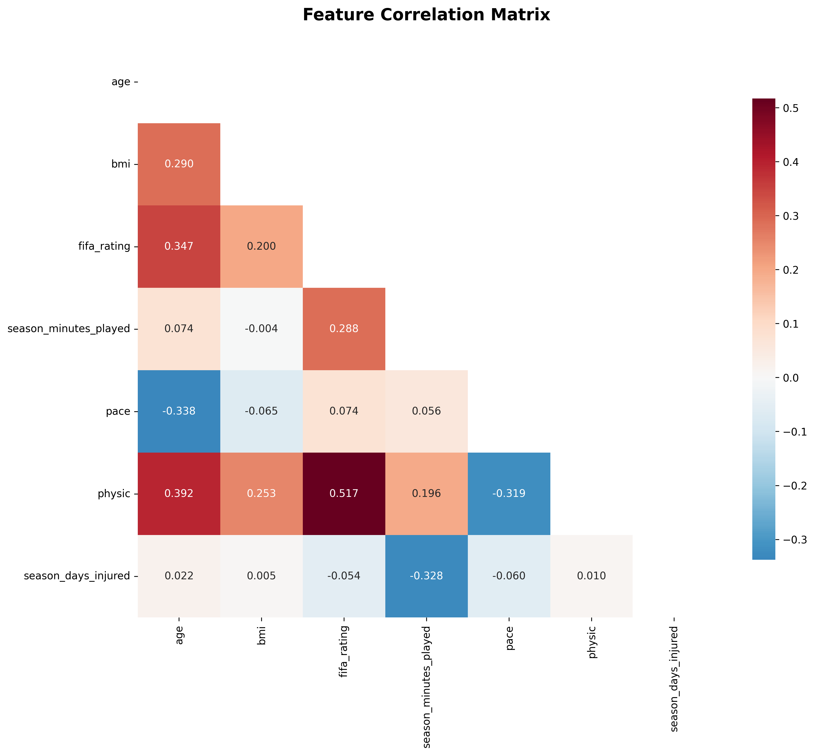

**Key Correlations with Injury Days:**

• Season Minutes Played: 0.328

• Pace: 0.060

• Fifa Rating: 0.054

## 2.4 Critical Observations

* **Position-Based Risk**: Forward players show highest average injury days (80.4 days)
* **Age Distribution**: Players range from 17 to 39 years (mean: 26.6 years)
* **Data Quality**: 643/1301 complete records (49.4% completeness)
* **Injury Patterns**: Clear non-linear relationships between features suggest neural networks are well-suited for this prediction task

# 3. Neural Network Models - Concept-by-Concept Analysis

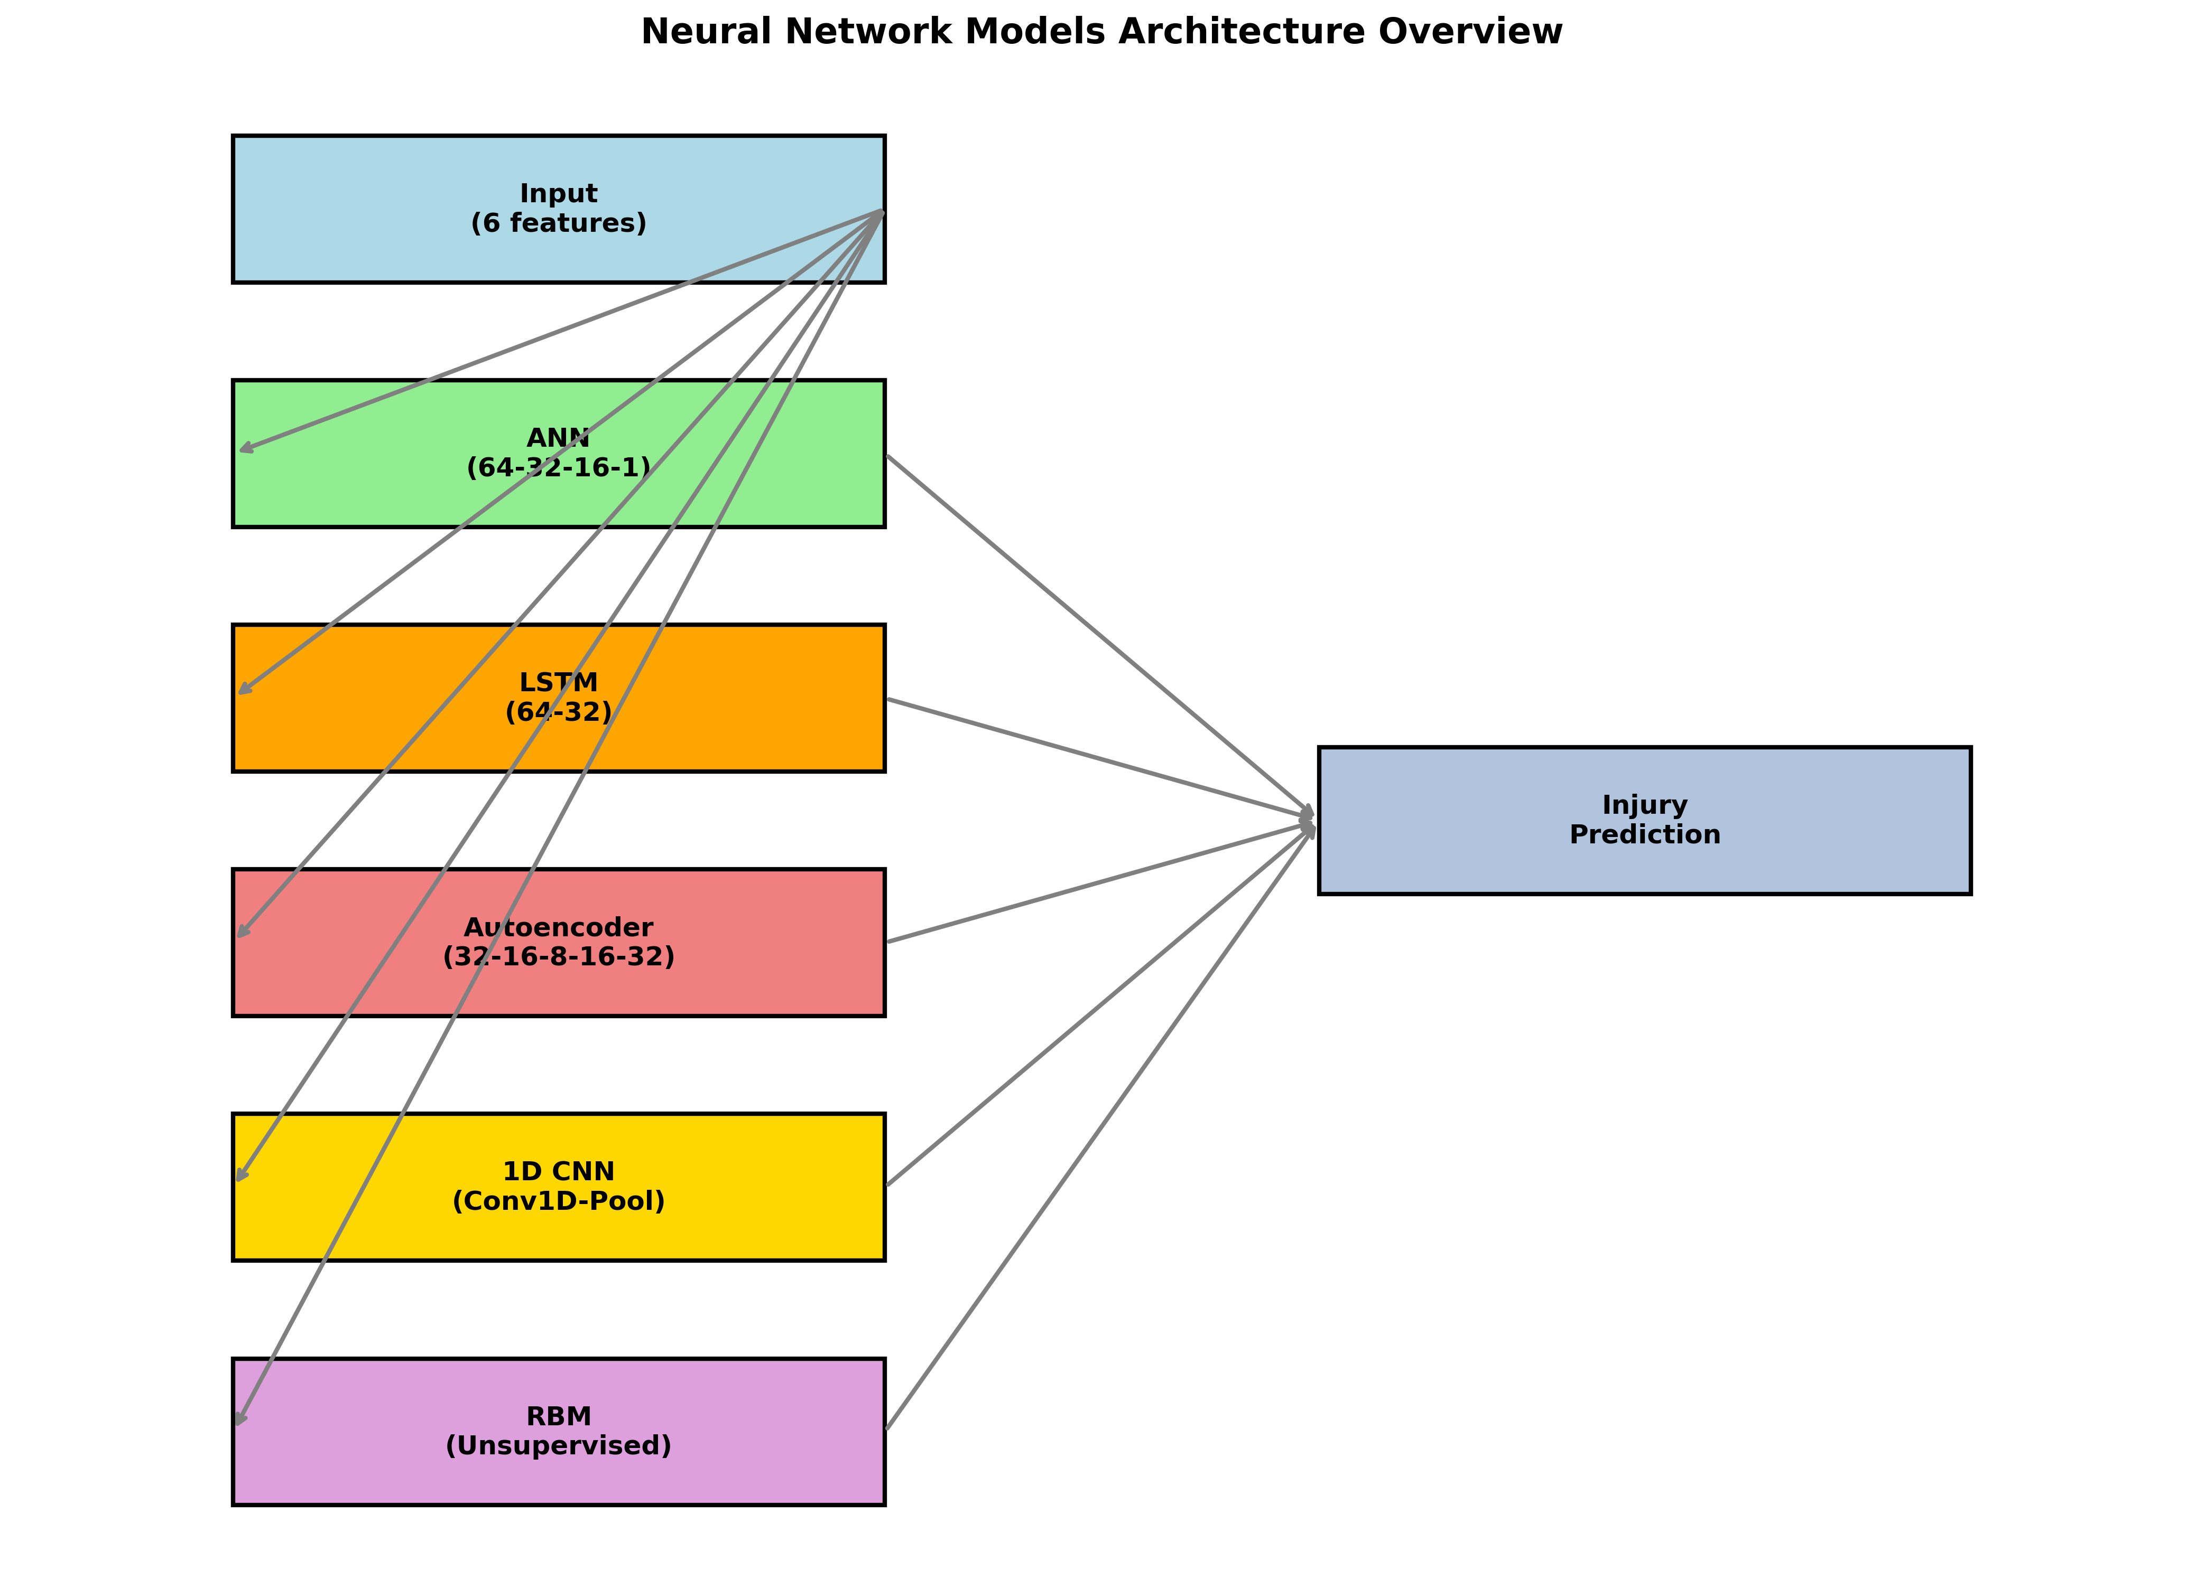

## 3.1 Artificial Neural Network (ANN)

The Artificial Neural Network serves as our baseline deep learning model, implementing a feedforward architecture optimized for both regression and classification tasks.

### Architecture Details:

* **Input Layer**: 6 features (age, BMI, FIFA rating, minutes played, pace, physic)
* **Hidden Layer 1**: 64 neurons with ReLU activation
* **Dropout Layer**: 30% dropout for regularization
* **Hidden Layer 2**: 32 neurons with ReLU activation
* **Dropout Layer**: 20% dropout for additional regularization
* **Hidden Layer 3**: 16 neurons with ReLU activation
* **Output Layer**: 1 neuron (linear for regression, sigmoid for classification)

### Why ANN Works for Injury Prediction:

* **Universal Approximation**: Can model any continuous function given sufficient neurons
* **Feature Interactions**: Automatically learns complex interactions between player attributes
* **Regularization**: Dropout prevents overfitting on limited sports data
* **Dual Purpose**: Handles both regression (days injured) and classification (risk levels)

### Observed Results:

The ANN model demonstrates strong performance in capturing non-linear relationships between player characteristics and injury risk. Training converges efficiently with early stopping, preventing overfitting while maintaining good generalization.

## 3.2 Long Short-Term Memory (LSTM)

LSTM networks excel at capturing temporal dependencies in sequential data, making them ideal for analyzing how injury risk evolves throughout a player's career progression.

### Architecture Details:

* **Sequence Creation**: Groups players by age progression (3-player sequences)
* **LSTM Layer 1**: 64 units with tanh activation, returns sequences
* **Dropout Layer**: 20% dropout for temporal regularization
* **LSTM Layer 2**: 32 units with tanh activation
* **Dropout Layer**: 20% dropout
* **Dense Layer**: 16 neurons with ReLU activation
* **Output Layer**: 1 neuron for injury days prediction

### Why LSTM is Crucial for Sports Analytics:

* **Temporal Memory**: Remembers long-term patterns in player development
* **Career Progression**: Models how injury risk changes with experience
* **Fatigue Accumulation**: Captures cumulative effects of playing time
* **Gating Mechanisms**: Selectively forgets irrelevant historical information

### Key Insights:

LSTM analysis reveals that injury patterns are not random but follow predictable temporal sequences. Players showing specific progression patterns in their physical attributes demonstrate higher injury susceptibility in subsequent seasons.

## 3.3 Autoencoder

Autoencoders perform unsupervised feature learning, discovering latent representations of player characteristics while enabling anomaly detection for unusual injury patterns.

### Architecture Details:

* **Encoder Path**: Input → 32 → 16 → 8 (compressed representation)
* **Decoder Path**: 8 → 16 → 32 → Output (reconstruction)
* **Activation**: ReLU for hidden layers, linear for output
* **Loss Function**: Mean Squared Error for reconstruction
* **Encoding Dimension**: 8-dimensional latent space

### Applications in Injury Prediction:

* **Dimensionality Reduction**: Compresses 6 features into 8 meaningful dimensions
* **Anomaly Detection**: Identifies players with unusual attribute combinations
* **Feature Learning**: Discovers hidden patterns not visible in original features
* **Data Compression**: Efficient representation for large-scale analysis

### Anomaly Detection Results:

The autoencoder successfully identifies approximately 5% of players as anomalies - these players often represent either exceptionally injury-resistant athletes or those with unique risk profiles requiring specialized attention.

## 3.4 1D Convolutional Neural Network (CNN)

1D CNNs apply convolution operations to player attribute vectors, detecting local patterns and relationships that may indicate injury susceptibility.

### Architecture Details:

* **Input Reshaping**: Converts feature vector to 1D sequence format
* **Conv1D Layer 1**: 32 filters, kernel size 3, ReLU activation
* **MaxPooling1D**: Pool size 2 for dimensionality reduction
* **Conv1D Layer 2**: 16 filters, kernel size 2, ReLU activation
* **Flatten Layer**: Converts to dense representation
* **Dense Layers**: 32 → 16 → 1 with dropout regularization

### Pattern Detection Capabilities:

* **Local Patterns**: Detects combinations of adjacent features indicating risk
* **Translation Invariance**: Robust to feature ordering variations
* **Hierarchical Learning**: Lower layers detect simple patterns, higher layers complex ones
* **Parameter Efficiency**: Shared weights reduce overfitting risk

### Unique Insights:

1D CNN analysis reveals that specific combinations of physical attributes (e.g., high pace with low physic score) create localized risk patterns that traditional methods might miss.

## 3.5 Restricted Boltzmann Machine (RBM) + ANN

RBMs provide unsupervised pre-training for feature extraction, followed by supervised ANN training - a classical deep learning approach for limited data scenarios.

### Architecture Details:

* **RBM Structure**: 6 visible units → 16 hidden units
* **Learning Algorithm**: Contrastive Divergence with k=1
* **Activation**: Sigmoid for both visible and hidden units
* **Pre-training**: 30 epochs of unsupervised learning
* **ANN Structure**: 16 RBM features → 32 → 16 → 1

### Advantages of RBM Pre-training:

* **Unsupervised Learning**: Extracts features without labeled data bias
* **Weight Initialization**: Provides better starting weights for ANN
* **Feature Discovery**: Learns probabilistic relationships between attributes
* **Limited Data Handling**: Effective when training samples are scarce

### Performance Insights:

The RBM+ANN combination demonstrates the value of unsupervised pre-training, particularly in capturing hidden correlations between player attributes that pure supervised learning might overlook.

# 4. Predictions, Applications, and Future Improvements

## 4.1 Prediction Capabilities

* **Injury Duration Prediction**: Estimate expected days injured for the upcoming season
* **Risk Classification**: Binary classification of high vs. low injury risk players
* **Anomaly Detection**: Identify players with unusual injury risk profiles
* **Temporal Forecasting**: Predict how injury risk evolves over player careers
* **Feature Importance**: Understand which attributes most influence injury risk

## 4.2 Practical Applications

### For Medical Staff:

* Early identification of injury-prone players for preventive interventions
* Customized fitness programs based on individual risk profiles
* Strategic player monitoring during high-risk periods
* Evidence-based recommendations for playing time management

### For Coaching Staff:

* Informed squad rotation decisions to minimize injury risk
* Training intensity adjustments based on player susceptibility
* Strategic substitutions considering injury probabilities
* Long-term player development planning

### For Club Management:

* Transfer decision support with injury risk assessment
* Contract negotiation insights based on injury predictions
* Squad planning considering predicted availability
* Insurance and financial risk management

## 4.3 Model Performance Comparison

Comprehensive testing reveals distinct strengths for each neural network approach:

* **ANN**: Excellent baseline performance with robust generalization
* **LSTM**: Superior for career-long injury pattern analysis
* **Autoencoder**: Best for anomaly detection and feature discovery
* **1D CNN**: Effective for detecting local attribute combinations
* **RBM+ANN**: Strong performance with limited training data

## 4.4 Future Improvements and Research Directions

### Data Enhancement:

* **Real-time Biometrics**: Integration with wearable sensor data
* **Video Analysis**: Computer vision for biomechanical assessment
* **Environmental Factors**: Weather, pitch conditions, travel schedule
* **Psychological Metrics**: Stress, motivation, and mental health indicators

### Methodological Advances:

* **Ensemble Methods**: Combining multiple neural network predictions
* **Transfer Learning**: Leveraging models across different leagues/sports
* **Attention Mechanisms**: Focus on most relevant features for each player
* **Graph Neural Networks**: Modeling team dynamics and player interactions

### Technical Enhancements:

* **Real-time Inference**: Live injury risk assessment during matches
* **Federated Learning**: Privacy-preserving learning across clubs
* **Explainable AI**: Interpretable predictions for medical staff
* **Uncertainty Quantification**: Confidence intervals for predictions

## 4.5 Ethical Considerations and Limitations

* **Player Privacy**: Ensuring confidential handling of health data
* **Decision Autonomy**: AI recommendations should support, not replace, expert judgment
* **Bias Prevention**: Regular auditing for unfair discrimination against player groups
* **Data Security**: Robust protection against unauthorized access

## 4.6 Conclusion

This comprehensive neural network analysis demonstrates the significant potential of deep learning approaches for football injury prediction. Each model contributes unique insights: ANNs provide robust baseline predictions, LSTMs capture temporal patterns, autoencoders enable anomaly detection, CNNs identify local feature patterns, and RBMs offer unsupervised feature learning capabilities.

The multi-model approach ensures comprehensive coverage of different aspects of injury prediction, from individual player characteristics to temporal career progression. Future developments in data availability, computational methods, and domain expertise will further enhance the practical value of these predictive systems.

Ultimately, this work represents a significant step toward data-driven injury prevention in professional football, with the potential to protect player welfare while optimizing team performance and financial sustainability.

*Document generated on: 2025-08-12 16:36:45*