Lesson 1 – Digital Gates

All digital components no matter how complex are made up of a few simple logic gates. These gates perform Bitwise operations on binary inputs and provide a binary output.

What is all this talk about Binary?

The binary numbering system (base 2) uses only two digits to represent numbers. These digits are 0 and 1. In the decimal system (base 10) which we all are familiar with, the digits used are 0 through 9. You may even be familiar with Hexadecimal (base 16) which uses the digits 0 through 9 as well as the letters A through F to represent 10 through 15.

You may wonder how you can represent a decimal number by only using 2 different digits. To answer this we use the Binary Coded Decimal system (BCD). This system combines 0’s and 1’s to represent decimal numbers. These 0’s and 1’s are commonly referred to as bits. Looking at the Table 1 below you will see that we can represent the decimal values 0 through 15 by using 4 bits.

Notice the first row containing the decimal values 8, 4, 2 and 1. These are the decimal values each bit is worth. To get these numbers we simply take 2 to the power of the position of the bit. So Bit 0 equals 2 to the 0 power or 2^0 = 1. Bit 1 equals 2 to the power of 1 or 2^1 = 2. Bits 2 and 3 are 2^2 = 4 and 2^3=8. You can continue adding bits to the left using this formula to calculate their values for representing decimal values over 15.

What are these values for? Well, referring to the rightmost column you can see how we use the values we calculated for each bit to combine them to make up decimal numbers. For each bit that is a 1 we add its value to the final result. So to represent a decimal 0, all bits are 0 which results in 0 + 0 + 0 + 0 = 0. To represent a decimal 7, bits 2, 3 and 1 are 1’s which results in 0 + 4 + 2 + 1 = 7.

So in order for a digital component to use this binary system it needs to be able to represent a 0 and a 1. This is accomplished by defining that 0 volts (ground) represents a 0 and that +5 Volts (Vcc) represents a 1. By switching power to a components inputs using 0V and +5V we can send numbers to it and by reading the voltages present on the components outputs we can receive numbers from it.

4 Bit Binary Coded Decimal
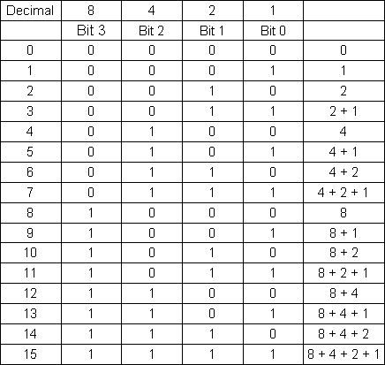
Table 1

Now that we have all these 0’s and 1’s what can we do with them?

The most basic components are called Gates. These gates perform what is known as Bitwise operations on the bits we send through the gate and present the result on the other side. These gates are represented by Logic Symbols which vary depending on the gates function.

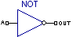
Shown here is the Logic Symbol for a NOT gate. This is the simplest of the gates. It has a single input A to feed a bit into and a singe output OUT to read a bit from.

How do we know what comes out when we put different bits into the gate?

We refer to what is called a Truth Table. A truth table shows all possible input combinations alongside the output each combination produces.

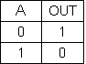
Shown here is the truth table for a NOT gate. As shown by this table, the output is always the opposite of the input or OUT is not A.

In C syntax this would be OUT = !A;

Truth tables are a common fixture in datasheets for components. Being able to understand a truth table is invaluable when choosing the right gate.

Thinking in binary hurts my head, is there a better way to visualize this?

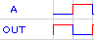
If we plot the truth table on a graph you can see 0 represented by a low line shown here in blue and a 1 represented by a high line shown here in red. This allows you to visually see the truth table in action.
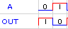
This type of graph is known in component datasheets as the Timing Diagram or AC Characteristics.

Enough symbolism how does this work in the real world?

Ok, time to put a component to work on your BananaBoard. Since we have covered a NOT gate, lets start with an Integrated Circuit (IC or chip) that has a NOT gate in it.

The 7404 chip just happens to have six NOT gates in it. The six NOT gates are physically arranged inside the 14 pin chip like this:

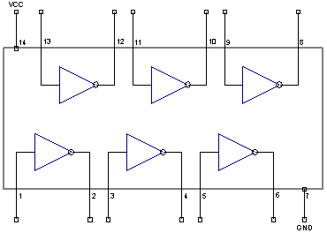

Note pins 7 and 14 are labeled GND and VCC. These pins are where you connect power to the chip for it to operate. VCC is where you would connect a +5V power source and GND is where you would connect to the ground of a power source.

Knowing the symbol for a NOT gate you can see that pin 1 is the input for the first NOT gate in the chip and pin 2 is the output for the first NOT gate in the chip. This type of diagram is known in component datasheets as a Pin out. It is often accompanied by a table listing each pin number and a brief description of that pins function.

Experiment 1 – Do NOT what I say!

Start a new BananaBoard Project and add a 7404 chip to it using the Banana Chip menu like this:
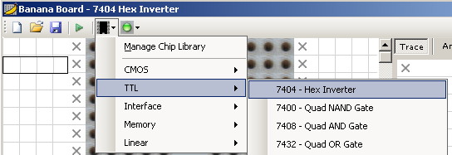

For this first experiment we will use the first NOT gate in the chip. Drag Input 1 and Output 1 to the first two empty slots in the Trace pane as shown below.

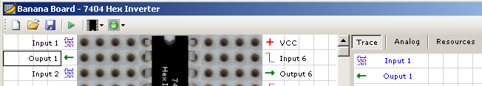

This will plot the results for the first NOT gate. Now save your project as “Experiment 1.bbp” somewhere you can find it later.

Now that BananaBoard is configured, go to your parts bucket and find a 74HC04 chip (HC is a code defining how fast the chip can operate) then plug it into the BananaBoard as shown here:
BananaBoard Top
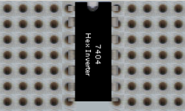

Note: The notch at one end of the chip is used to identify which pin is number 1. Shown here the upper leftmost pin is pin number 1. Pin numbers are in sequential order going counter-clockwise from pin 1. It is extremely important you place the chip in the same position shown or you could damage the chip and/or your BananaBoard.

Once you have the chip physically placed on the BananaBoard turn on power to the BananaBoard and allow it to boot up. Now that the BananaBoard is ready, press the Run button on the toolbar.

Now I have some lines on the graph, what does it mean?

After running your project you will be presented with a screen that looks like this:
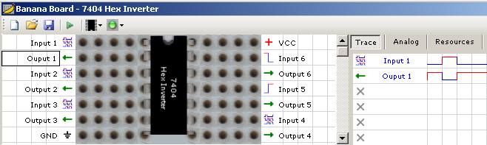

By reading the plot you can see that we fed a 0 into Input 1 and got a 1 from Output 1 then on the next cycle we fed a 1 to Input 1 and got a 0 from Output 1. This follows the logic presented in the truth table for a NOT gate.

Where did the 0 and 1 come from to send to Input 1?

That is specified in the Output Script for that pin. Click on Input 1 and at the bottom left of the screen you will see the properties for that row seen here:

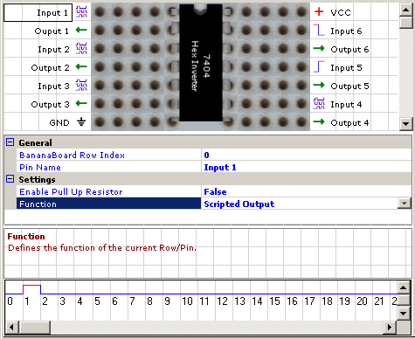

Included in these properties for a Scripted Output row are the bits that are output on each cycle plotted on a single trace graph. Looking at the Script for Input 1 you see the following:

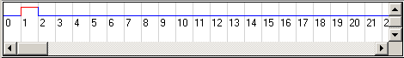

This shows us that on the first cycle (cycle 0) a low or 0 will be fed to anything connected to the row then on the next cycle (cycle 1) a high or 1 will be fed to anything connected to the row followed by 0’s for all remaining cycles. This is how data going into a chip is defined by a user.

You can double click any cycle to toggle its state. To see this in action, double click the first bit (cycle 0) and the second bit (cycle 1) so that they appear like this:

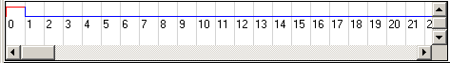

Press the Run button again and your plot will show:

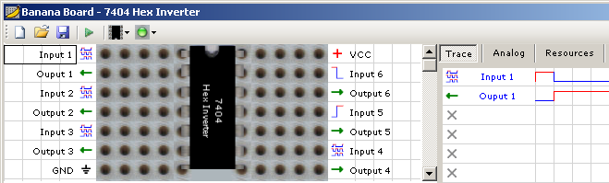

As you can see Input 1 followed the changes we made to its script and Output 1 continued to invert the value of Input 1.

Experiment with the script for Input 1 making your own pattern of bits, pressing Run and reviewing the results shown for Output 1.

That was easy! What else can gates do?

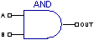
Next is the symbol for what is known as an AND gate. Here we have two inputs (A and B) to feed bits in and a single output to read a bit from.
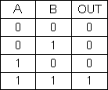
Just like the NOT gate the AND gate also has a truth table. Shown by this table, the only way to get a 1 from the output of the AND gate is to give both inputs A and B a 1. Any other combination will result in the gate outputting a 0. This is why we call this an AND gate. Both A and B must be 1 in order to get 1 from the output. This would be the same concept as two soldiers having to each turn a key to launch the missile.

In C syntax this would be equivalent to OUT = A & B;

Lets see an AND gate in action. The 7408 chip has four AND gates in this physical arrangement:

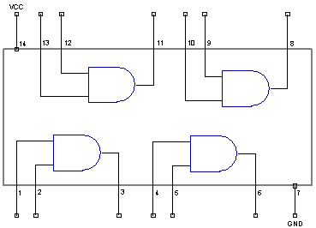

Again pins 7 and 14 are labeled GND and VCC and are to be connected to a power source as explained before.

This Pin out shows that pin 1 and 2 make up the two inputs for the first AND gate in the chip and pin 3 is the output for the first AND gate in the chip.

Experiment 2 – Can’t we all just get along?

Create a new BananaBoard project and add a 7408 chip to it like this:

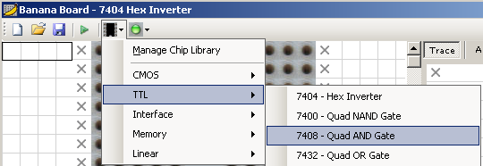

In our second experiment we will use the first AND gate in the chip. Drag Input 1A, Input 1B and Output 1 to the first three empty slots in the Trace pane as shown below:

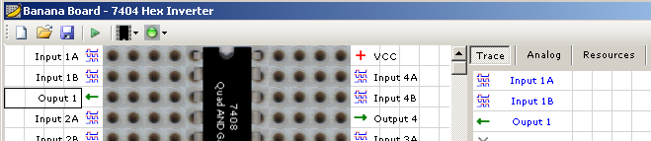

This will plot the results for the first AND gate. Save your project as “Experiment 2.bpp” in the same place you saved Experiment 1.

Back to your parts bucket and find a 74HC08 chip and plug it into the BananaBoard like before making sure pin 1 is the right location.

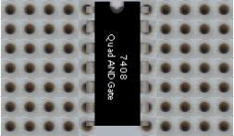

Power up the BananaBoard and when the BananaBoard is ready, press the Run button on the toolbar.
Does this mean it’s unanimous?

You should now have the following results in your trace window:

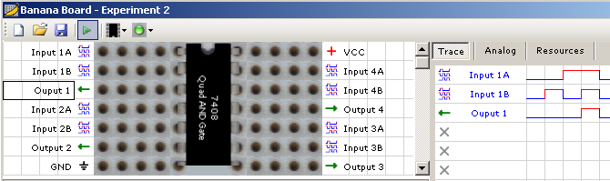

Referring to the truth table for our AND gate, compare it to the results shown in the trace window. Does the output trace show the correct value for each bit value combination provided to Inputs 1A and 1B?

You should notice that Output 1 only shows a high state when both Inputs 1A and 1B are high or 1. This proves that a circuit using an AND gate would ensure a unanimous vote to launch the missile.

Experiment with the script for Inputs 1A and 1B again creating your own pattern of bits, pressing Run and reviewing the results shown for Output 1. Compare your results against the truth table.
So there is an AND gate, what about an OR gate?

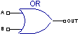
Why yes, there is an OR gate and here is the symbol for it. Similar to an AND gate it has two inputs A and B and a single output. To see how an OR gate differs in functionality can be seen by examining the truth table.

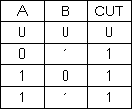
Here the truth table shows us that either A or B can be 1 in order to get a 1 from OUT. This would be equivalent to either of two soldiers being able to push an abort launch button.

In C syntax this would be equivalent to OUT = A | B;

<Insert OR experiment here>
bitwise operation
Though not directly related to the numerical interpretation of binary symbols, sequences of bits may be manipulated using Boolean logical operators. When a string of binary symbols is manipulated in this way, it is called a bitwise operation; the logical operators AND, OR, and XOR may be performed on corresponding bits in two binary numerals provided as input. The logical NOT operation may be performed on individual bits in a single binary numeral provided as input. Sometimes, such operations may be used as arithmetic short-cuts, and may have other computational benefits as well. For example, an arithmetic shift left of a binary number is the equivalent of multiplication by a (positive, integral) power of 2.
The digital logic circuits used in this laboratory are contained in
integrated circuit (IC) packages. Each IC is labeled (usually with
an SN74xx or SN54xx number) to identify the logic it performs.
The transistor-transistor logic(TTL) IC’s used in this laboratory
require a 5.0 volt power supply for operation. TTL inputs require a
voltage greater than 2 volts to represent a binary 1 and a voltage
less than 0.8 volts to represent a binary 0.

DeMorgan's

