Nama : kevin hansa wardhana

NIM : L200180004

Kelas : A

Modul 2

1. Flowchart boot.asm

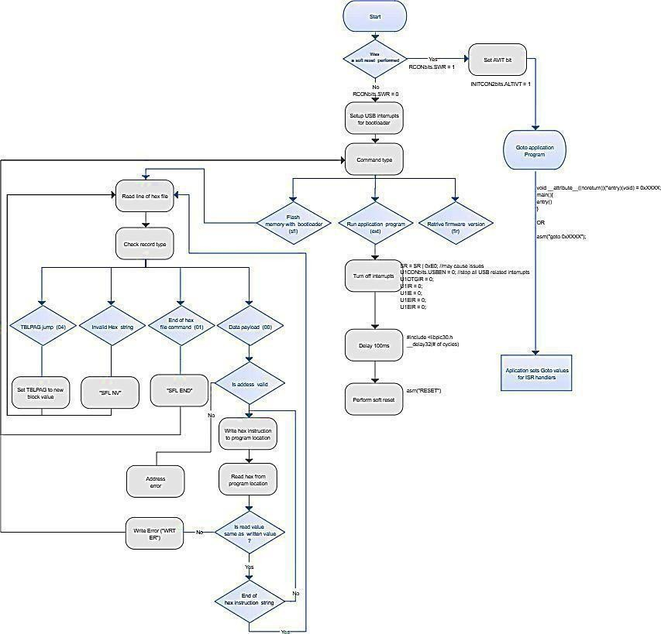

1. Flowchart “kernel.asm”

