Nama : Kevin Hansa Wardhana

NIM : L200180004

Tanggal Praktikum : 13 Maret 2019

MODUL 3

**Percobaan 1. Gerbang AND**

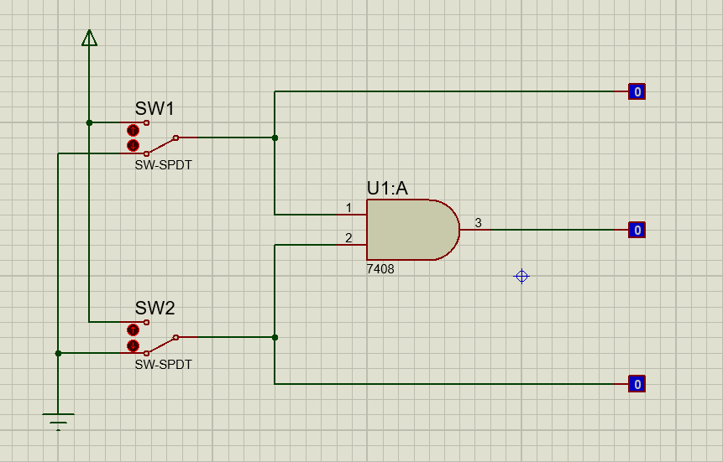

Tabel Kebenaran

|  |  |  |  |  |
| --- | --- | --- | --- | --- |
| SW 1 | SW 2 | L1 | L2 | L3 |
| 0 | 0 | 0 | 0 | 0 |
| 1 | 0 | 1 | 0 | 0 |
| 0 | 1 | 0 | 1 | 0 |
| 1 | 1 | 1 | 1 | 1 |

Diagram Waktu

L1

|  |  |  |  |
| --- | --- | --- | --- |
|  |  |  |  |
|  |  |  |  |

L2

|  |  |  |  |
| --- | --- | --- | --- |
|  |  |  |  |
|  |  |  |  |

L3

|  |  |  |  |
| --- | --- | --- | --- |
|  |  |  |  |
|  |  |  |  |

Percobaan 2. Gerbang OR

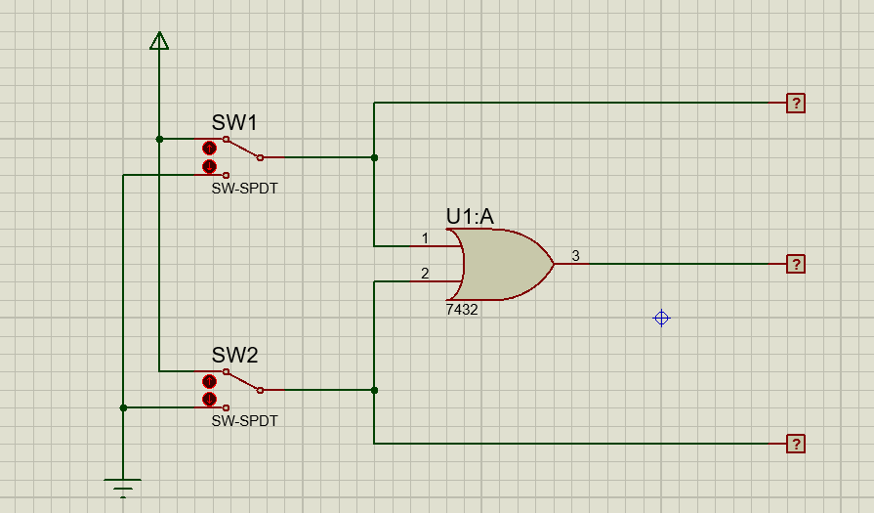

Tabel Kebenaran

|  |  |  |  |  |
| --- | --- | --- | --- | --- |
| SW 1 | SW 2 | L1 | L2 | L3 |
| 0 | 0 | 0 | 0 | 0 |
| 1 | 0 | 1 | 0 | 1 |
| 0 | 1 | 0 | 1 | 1 |
| 1 | 1 | 1 | 1 | 1 |

Diagram Waktu

L1

|  |  |  |  |
| --- | --- | --- | --- |
|  |  |  |  |
|  |  |  |  |

L2

|  |  |  |  |
| --- | --- | --- | --- |
|  |  |  |  |
|  |  |  |  |

L3

|  |  |  |  |
| --- | --- | --- | --- |
|  |  |  |  |
|  |  |  |  |

Percobaan 3. Gerbang NOT

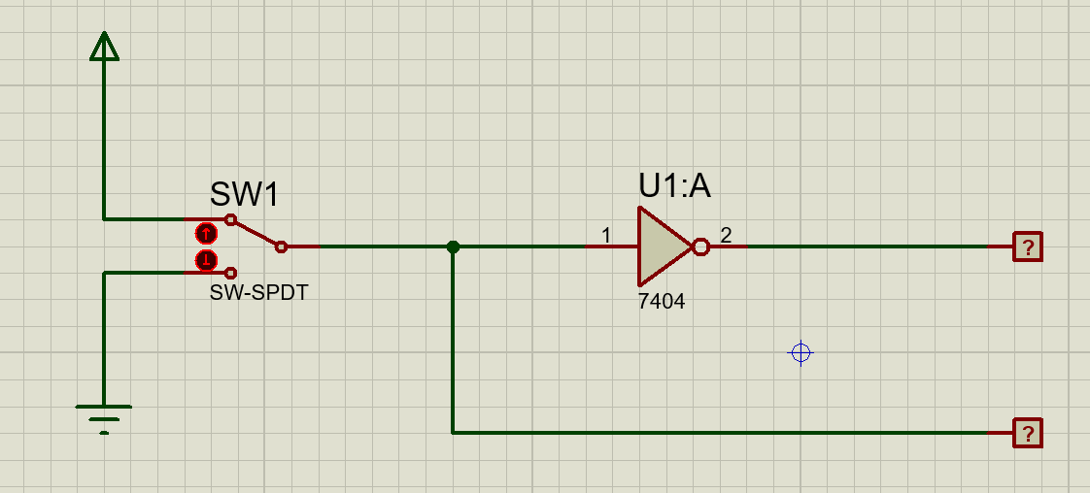

Tabel Kebenaran

|  |  |  |
| --- | --- | --- |
| SW 1 | L2 | L1 |
| 0 | 0 | 1 |
| 1 | 1 | 0 |

Diagram Waktu

L2

|  |  |
| --- | --- |
|  |  |
|  |  |

L1

|  |  |
| --- | --- |
|  |  |
|  |  |

Percobaan 4. Gerbang NAND

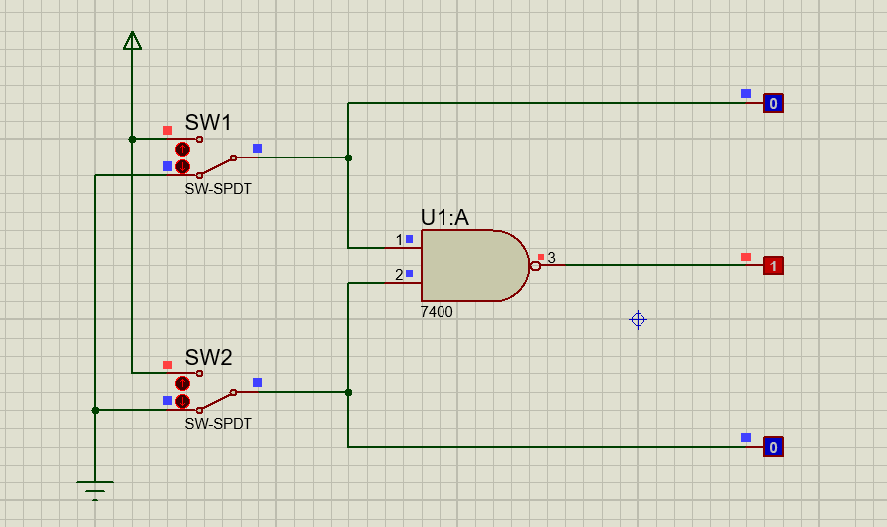

Tabel Kebenaran

|  |  |  |  |  |
| --- | --- | --- | --- | --- |
| SW 1 | SW 2 | L1 | L2 | L3 |
| 0 | 0 | 0 | 0 | 1 |
| 1 | 0 | 1 | 0 | 1 |
| 0 | 1 | 0 | 1 | 1 |
| 1 | 1 | 1 | 1 | 0 |

Diagram Waktu

L1

|  |  |  |  |
| --- | --- | --- | --- |
|  |  |  |  |
|  |  |  |  |

L2

|  |  |  |  |
| --- | --- | --- | --- |
|  |  |  |  |
|  |  |  |  |

L3

|  |  |  |  |
| --- | --- | --- | --- |
|  |  |  |  |
|  |  |  |  |

Percobaan 5. Gerbang NOR

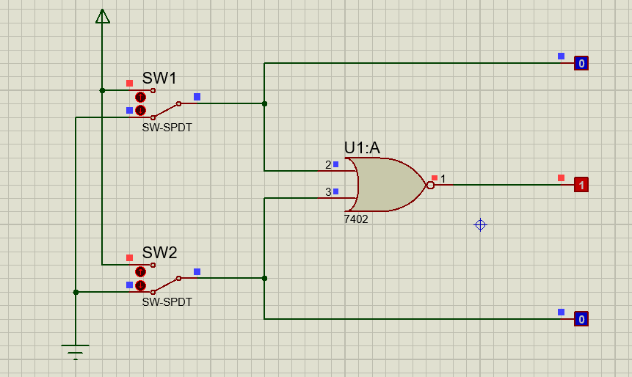

Tabel Kebenaran

|  |  |  |  |  |
| --- | --- | --- | --- | --- |
| SW 1 | SW 2 | L1 | L2 | L3 |
| 0 | 0 | 0 | 0 | 1 |
| 1 | 0 | 1 | 0 | 0 |
| 0 | 1 | 0 | 1 | 0 |
| 1 | 1 | 1 | 1 | 0 |

Diagram Waktu

L1

|  |  |  |  |
| --- | --- | --- | --- |
|  |  |  |  |
|  |  |  |  |

L2

|  |  |  |  |
| --- | --- | --- | --- |
|  |  |  |  |
|  |  |  |  |

L3

|  |  |  |  |
| --- | --- | --- | --- |
|  |  |  |  |
|  |  |  |  |

Percobaan 6. Gerbang XOR

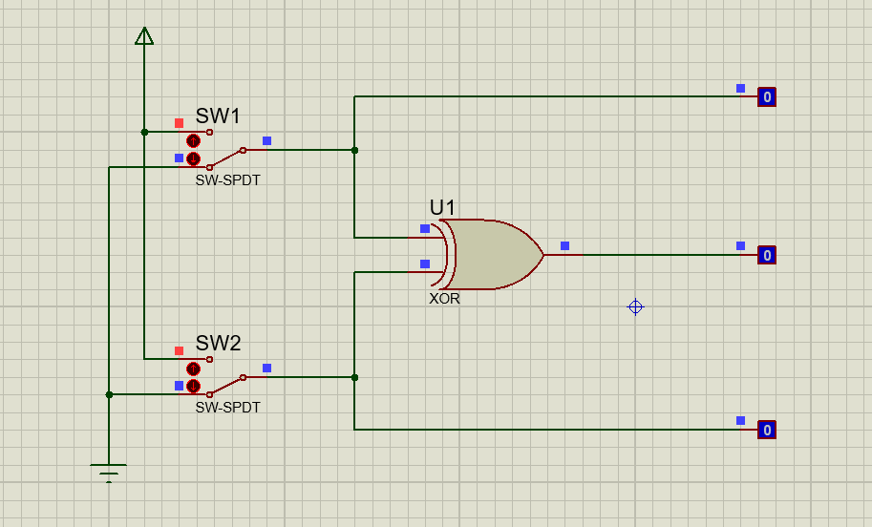

Tabel Kebenaran

|  |  |  |  |  |
| --- | --- | --- | --- | --- |
| SW 1 | SW 2 | L1 | L2 | L3 |
| 0 | 0 | 0 | 0 | 0 |
| 1 | 0 | 1 | 0 | 1 |
| 0 | 1 | 0 | 1 | 1 |
| 1 | 1 | 1 | 1 | 0 |

Diagram Waktu

L1

|  |  |  |  |
| --- | --- | --- | --- |
|  |  |  |  |
|  |  |  |  |

L2

|  |  |  |  |
| --- | --- | --- | --- |
|  |  |  |  |
|  |  |  |  |

L3

|  |  |  |  |
| --- | --- | --- | --- |
|  |  |  |  |
|  |  |  |  |

Percobaan 7. Gerbang XNOR

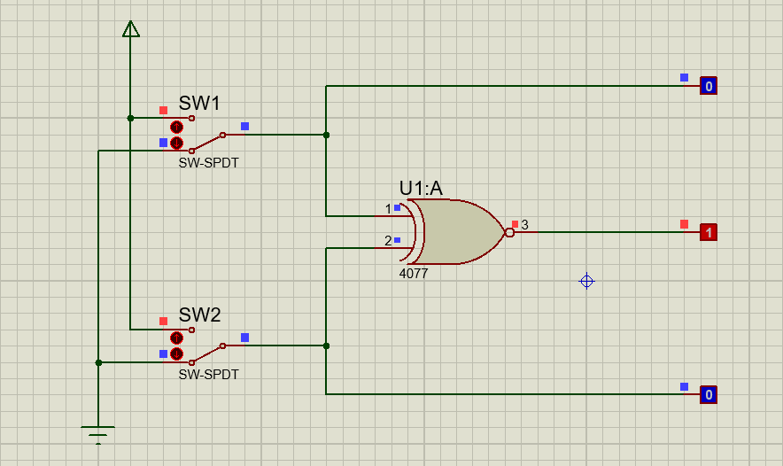

Tabel Kebenaran

|  |  |  |  |  |
| --- | --- | --- | --- | --- |
| SW 1 | SW 2 | L1 | L2 | L3 |
| 0 | 0 | 0 | 0 | 1 |
| 1 | 0 | 1 | 0 | 0 |
| 0 | 1 | 0 | 1 | 0 |
| 1 | 1 | 1 | 1 | 1 |

Diagram Waktu

L1

|  |  |  |  |
| --- | --- | --- | --- |
|  |  |  |  |
|  |  |  |  |

L2

|  |  |  |  |
| --- | --- | --- | --- |
|  |  |  |  |
|  |  |  |  |

L3

|  |  |  |  |
| --- | --- | --- | --- |
|  |  |  |  |
|  |  |  |  |