Nama : kevin hansa wardhana

NIM : L200180004

Tanggal praktikum : 27 maret 2019

MODUL 5

PERCOBAAN 1

a. Buat kombinasi gerbang logiika sebagaimana pada gambar di bawah ini!

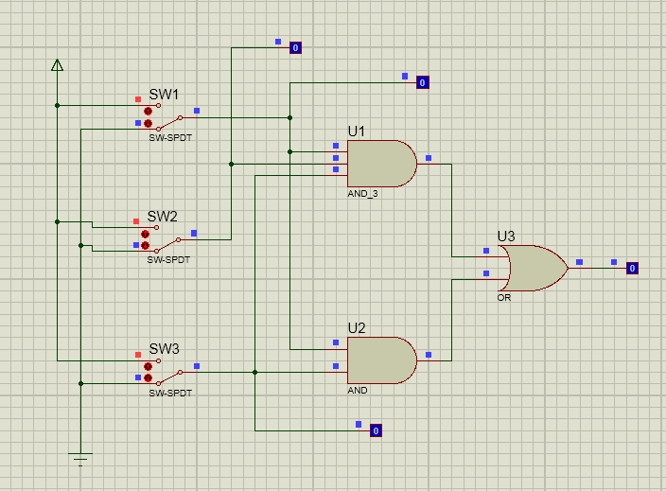

1. Fungsi boolean : **F = ABC + AC**
2. Isi titik-titik dalam tabel!

|  |  |  |  |
| --- | --- | --- | --- |
| **A** | **B** | **C** | **F** |
| 0 | 0 | 0 | 0 |
| 1 | 0 | 0 | 0 |
| 0 | 1 | 0 | 0 |
| 1 | 1 | 0 | 0 |
| 0 | 0 | 1 | 0 |
| 1 | 0 | 1 | 1 |
| 0 | 1 | 1 | 0 |
| 1 | 1 | 1 | 1 |

1. Isi titik-titik dalam karnaugh map

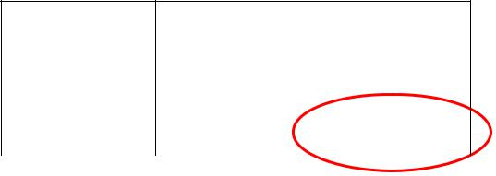AB

|  |  |  |  |  |  |
| --- | --- | --- | --- | --- | --- |
|  |  | 00 | 01 | 11 | 10 |
| C | 0 |  |  |  |  |
|  | 1 |  |  | 1 | 1 |

1. Sederhanakan fungsi boolean berdasarkan karnaugh map : **F = AC**
2. Gambar kombinasi gerbang logika berdasarkan fungsi boolean baru!

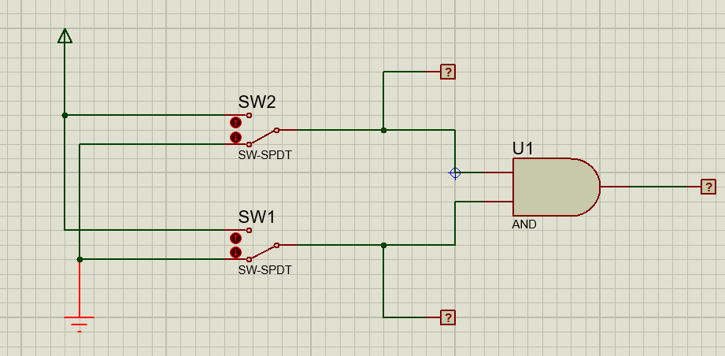

PERCOBAAN 2

a. Buat kombinasi gerbang logiika sebagaimana pada gambar di bawah ini!

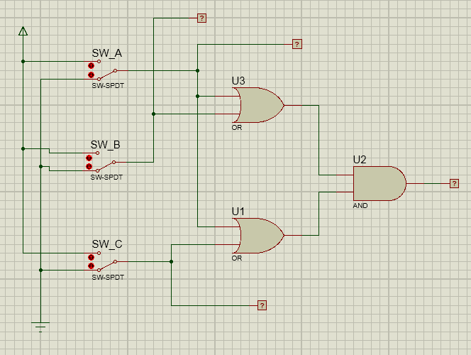

1. Fungsi boolean : **F = (A + B).(A + C)**
2. Isi titik-titik dalam tabel!

|  |  |  |  |
| --- | --- | --- | --- |
| **A** | **B** | **C** | **F** |
| 0 | 0 | 0 | 0 |
| 1 | 0 | 0 | 1 |
| 0 | 1 | 0 | 0 |
| 1 | 1 | 0 | 1 |
| 0 | 0 | 1 | 0 |
| 1 | 0 | 1 | 1 |
| 0 | 1 | 1 | 1 |
| 1 | 1 | 1 | 1 |

1. Isi titik-titik dalam karnaugh map

AB

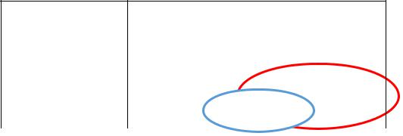

|  |  |  |  |  |  |
| --- | --- | --- | --- | --- | --- |
|  |  | 00 | 01 | 11 | 10 |
| C | 0 |  |  | 1 | 1 |
|  | 1 |  | 1 | 1 | 1 |

1. Sederhanakan fungsi boolean berdasarkan karnaugh map : **F = A + BC**
2. Gambar kombinasi gerbang logika berdasarkan fungsi boolean baru!

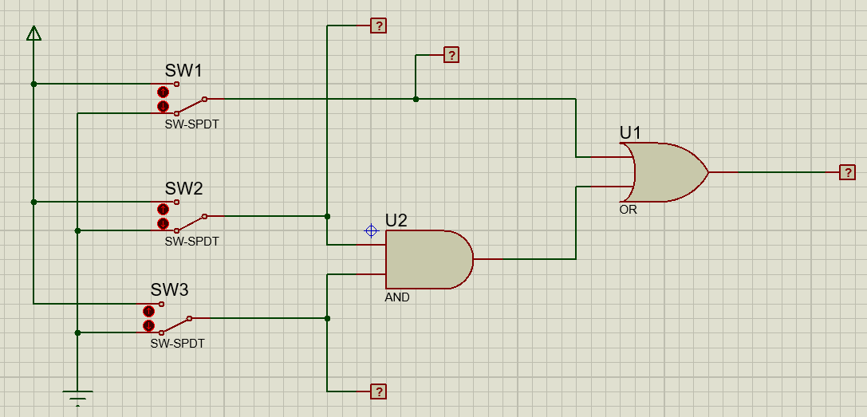

PERCOBAAN 3

1. Buat kombinasi gerbang logiika sebagaimana pada gambar di bawah ini!

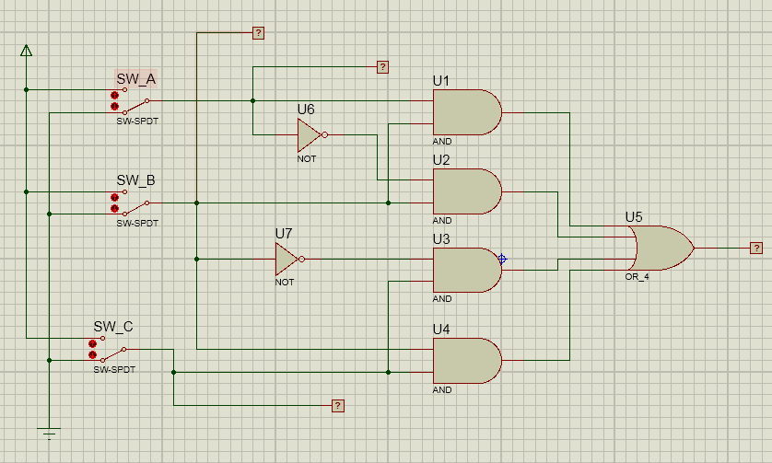

1. Fungsi boolean : **F =** **AB + A’B + B’C +** **BC**
2. Isi titik-titik dalam tabel!

|  |  |  |  |
| --- | --- | --- | --- |
| **A** | **B** | **C** | **F** |
| 0 | 0 | 0 | 0 |
| 1 | 0 | 0 | 0 |
| 0 | 1 | 0 | 1 |
| 1 | 1 | 0 | 1 |
| 0 | 0 | 1 | 1 |
| 1 | 0 | 1 | 1 |
| 0 | 1 | 1 | 1 |
| 1 | 1 | 1 | 1 |

d. Isi titik-titik dalam karnaugh map

|  |  |  |  |  |  |  |
| --- | --- | --- | --- | --- | --- | --- |
|  |  |  |  | AB | |  |
|  |  | 00 | 01 |  | 11 | 10 |
| C | 0 |  | 1 |  | 1 |  |
|  | 1 | 1 | 1 |  | 1 | 1 |

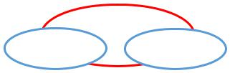

1. Sederhanakan fungsi boolean berdasarkan karnaugh map : **F = B + C**
2. Gambar kombinasi gerbang logika berdasarkan fungsi boolean baru!

