BILL-07
Majesco Billing
Screen ↔ Process Mapping (L3 → L6)
Majesco Billing — Commercial Lines Workstream
Date 14 August 2026
Version 1.0
Applied by backend/scripts/add-majesco-billing.ts (NodeAppUsage, usageType: performed)

Maps the Majesco Billing for P&C screen inventory onto the Transformation Bridge process taxonomy.

Contents

Evidence legend
[Confirmed] directly evidenced in a cited public source. [Inferred] reasonable inference from industry-standard P&C billing capability sets, Majesco marketing language, or sibling-product documentation — validate before treating as fact.

Maps the Majesco Billing for P&C screen inventory (see majesco-billing-research-dossier.md, §3) onto the Transformation Bridge process taxonomy. Data wiring is applied by backend/scripts/add-majesco-billing.ts, which registers the Majesco Billing application and links it (NodeAppUsage, usageType: performed) to every L5 task listed below — and to any generated L6 child tasks of those L5s present in the live environment (the AAA-rollout task layer; the seed itself is L1–L5).
Evidence: Confirmed = the screen/workspace is directly evidenced in Majesco public material; Inferred = standard screen implied by a confirmed capability (Majesco publishes no public screen catalog).
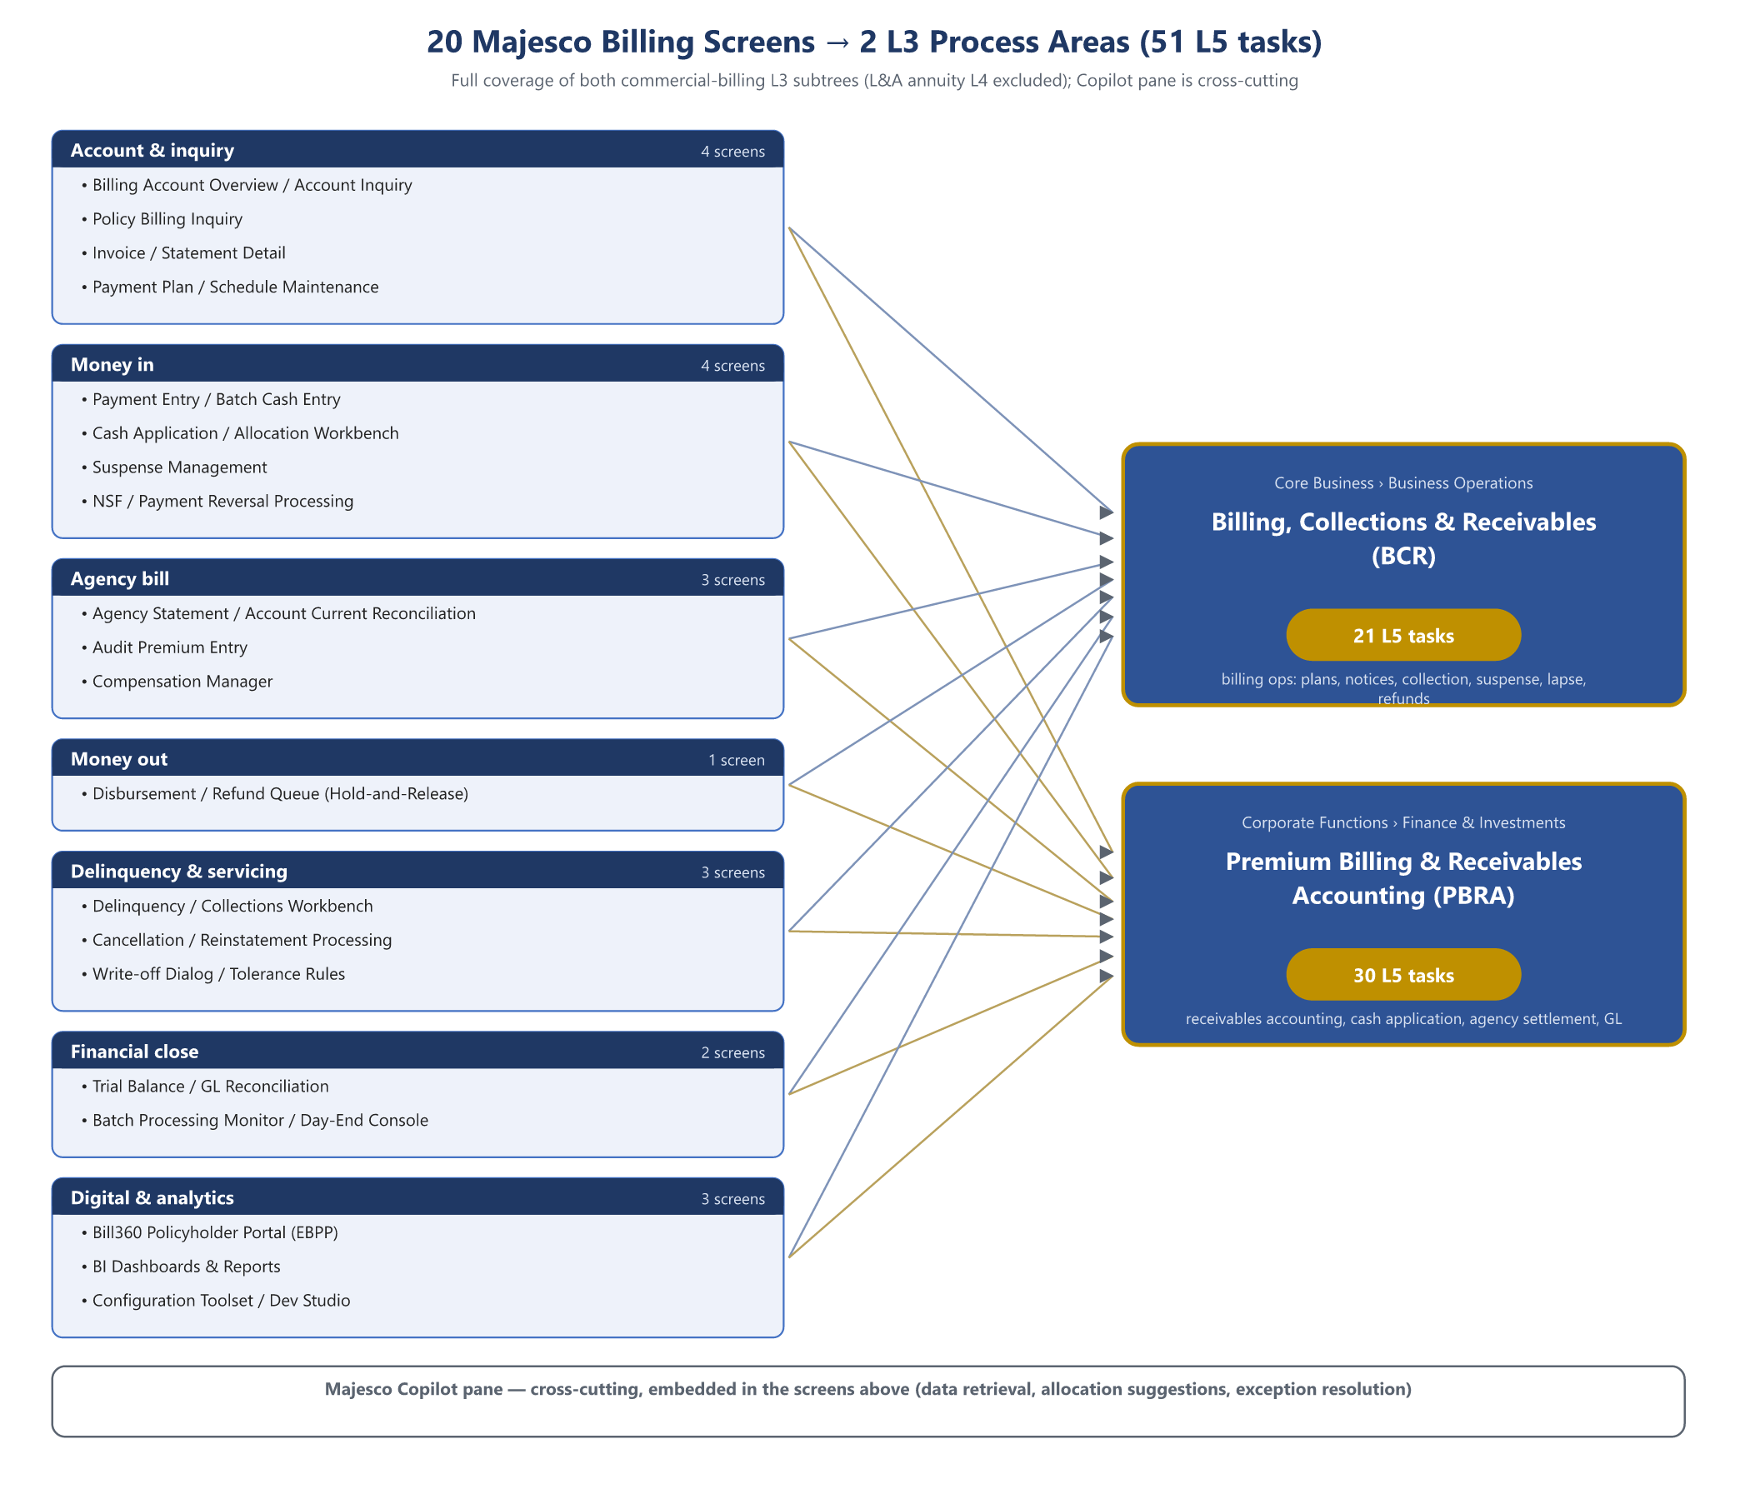
Figure 1 — Coverage: 20 Majesco screens grouped by function, mapped to the two L3 process areas — Billing, Collections & Receivables (21 tasks) and Premium Billing & Receivables Accounting (30 tasks).

High-level mapping (Majesco module → L3 process areas)
Majesco functional module | L1 | L2 | L3
Billing operations (plans, notices, collection, suspense, lapse, refunds) | Core Business | Business Operations | Billing, Collections & Receivables
Receivables accounting, cash application, agency/broker settlement, GL | Corporate Functions | Finance & Investments | Premium Billing & Receivables Accounting

Adjacent areas touched but not mapped (different owning systems in the estate): Finance & Investments > Treasury & Cash Management (bank-side cash), Finance & Investments > Statutory & Regulatory Reporting > Escheatment & Unclaimed Property Compliance (escheat is unverified for Majesco — dossier §2.8), Claims > Settlement & Payment (claims money-out), Reinsurance > Premium & Settlement Accounting. The L4 Annuity Purchase Payment Processing under Billing, Collections & Receivables is L&A-side and out of scope for a commercial-lines P&C billing platform.

Screen-level mapping (L3 → L4 → L5)
Abbreviations: BCR = Core Business › Business Operations › Billing, Collections & Receivables; PBRA = Corporate Functions › Finance & Investments › Premium Billing & Receivables Accounting.

Account & inquiry
Screen | Evidence | L3 | L4 | L5 task
Billing Account Overview / Account Inquiry | [Inferred] | BCR | Premium Refunds & Overpayment Processing | Identify credit balances and overpayments for refund
 |  | PBRA | Delinquency Monitoring & Receivables Collections | Identify and prioritize past-due premium accounts
Policy Billing Inquiry | [Inferred] | BCR | Billing Mode Setup & Premium Notice Generation | Generate and proof premium notice for the upcoming installment
 |  | PBRA | Invoice & Receivable Creation | Validate invoice data against policy before release
Invoice / Statement Detail | [Inferred] | PBRA | Invoice & Receivable Creation | Generate premium invoice from bound policy terms
 |  | BCR | Billing Mode Setup & Premium Notice Generation | Generate and proof premium notice for the upcoming installment
Payment Plan / Schedule Maintenance | [Inferred] | BCR | Billing Mode Setup & Premium Notice Generation | Configure billing plan and payment schedule on the policy account
 |  | BCR | Billing Mode Setup & Premium Notice Generation | Apply mid-term billing changes from endorsements to the schedule
 |  | PBRA | Invoice & Receivable Creation | Calculate installment schedule and down-payment amounts

Money in
Screen | Evidence | L3 | L4 | L5 task
Payment Entry / Batch Cash Entry | [Inferred] | BCR | Premium Collection & Payment Processing | Capture and validate inbound premium payment against the account
 |  | BCR | Premium Collection & Payment Processing | Post lockbox and bank file payments to policyholder accounts
 |  | PBRA | Cash Application & Suspense Resolution | Process lockbox and ACH/EFT receipt files
 |  | PBRA | Premium Invoice & Payment Processing | Process customer premium payments across channels
Cash Application / Allocation Workbench | [Inferred] (AI cash allocation [Confirmed]) | PBRA | Cash Application & Suspense Resolution | Match incoming payments to open premium invoices
 |  | PBRA | Cash Application & Suspense Resolution | Reconcile applied cash to daily bank deposits
Suspense Management | [Inferred] | BCR | Cash-with-Application & Premium Suspense Management | Record cash-with-application receipt prior to policy issuance
 |  | BCR | Cash-with-Application & Premium Suspense Management | Match suspense items to issued policies and release funds
 |  | BCR | Cash-with-Application & Premium Suspense Management | Investigate and age unidentified premium suspense items
 |  | PBRA | Cash Application & Suspense Resolution | Investigate and clear unapplied cash in suspense
NSF / Payment Reversal Processing | [Inferred] | BCR | Premium Collection & Payment Processing | Resolve declined and returned payment exceptions
 |  | PBRA | Premium Invoice & Payment Processing | Handle payment exceptions, NSF and chargebacks

Agency bill
Screen | Evidence | L3 | L4 | L5 task
Agency Statement / Account Current Reconciliation | [Inferred] (bill types [Confirmed]) | PBRA | Agent & Broker Account Reconciliation | Reconcile broker statement-of-account to ledger balances
 |  | PBRA | Agent & Broker Account Reconciliation | Research and resolve broker account discrepancies
 |  | PBRA | Agent & Broker Account Reconciliation | Confirm aged broker balances and request settlement
Audit Premium Entry | [Confirmed] ("direct entry of commissionable audit premiums") | BCR | Billing Mode Setup & Premium Notice Generation | Apply mid-term billing changes from endorsements to the schedule
Compensation Manager | [Confirmed] | PBRA | Agent & Broker Account Reconciliation | Verify commission netting on producer remittances

Money out
Screen | Evidence | L3 | L4 | L5 task
Disbursement / Refund Queue (Hold-and-Release) | [Confirmed] (capability) | BCR | Premium Refunds & Overpayment Processing | Calculate return-premium amount on cancellation or reduction
 |  | BCR | Premium Refunds & Overpayment Processing | Validate refund payee and disbursement details
 |  | BCR | Premium Refunds & Overpayment Processing | Approve and release premium refund disbursement
 |  | BCR | Cash-with-Application & Premium Suspense Management | Disposition declined applications by refunding suspended funds
 |  | PBRA | Premium Invoice & Payment Processing | Process premium refunds and overpayment returns

Delinquency & servicing
Screen | Evidence | L3 | L4 | L5 task
Delinquency / Collections Workbench | [Inferred] (capabilities [Confirmed]) | BCR | Grace Period & Lapse Billing Administration | Identify past-due accounts entering the grace period
 |  | BCR | Grace Period & Lapse Billing Administration | Issue cancellation and lapse warning notices with statutory timing
 |  | PBRA | Delinquency Monitoring & Receivables Collections | Identify and prioritize past-due premium accounts
 |  | PBRA | Delinquency Monitoring & Receivables Collections | Execute dunning notices and collection outreach
 |  | PBRA | Delinquency Monitoring & Receivables Collections | Negotiate and set up premium payment arrangements
Cancellation / Reinstatement Processing | [Inferred] | BCR | Grace Period & Lapse Billing Administration | Execute lapse or cancellation for unpaid policies at deadline
 |  | BCR | Grace Period & Lapse Billing Administration | Reinstate lapsed policy upon qualifying payment
 |  | PBRA | Delinquency Monitoring & Receivables Collections | Trigger cancellation for non-payment after grace
Write-off Dialog / Tolerance Rules | [Confirmed] | PBRA | Premium Receivable Accounting | Write off uncollectible premium receivables with approval
 |  | PBRA | Premium Receivable Accounting | Compute and book allowance for doubtful premium accounts

Financial close
Screen | Evidence | L3 | L4 | L5 task
Trial Balance / GL Reconciliation | [Confirmed] (daily auto-reconciliation, v12) | PBRA | Billing-to-Ledger Reconciliation | Reconcile billing system premium totals to GL
 |  | PBRA | Billing-to-Ledger Reconciliation | Reconcile suspense and clearing accounts to zero
 |  | PBRA | Billing-to-Ledger Reconciliation | Document reconciliation controls for period close
 |  | PBRA | Premium Receivable Accounting | Reconcile AR subledger to general ledger control account
 |  | PBRA | Premium Receivable Accounting | Record earned premium recognition entries for the period
 |  | PBRA | Invoice & Receivable Creation | Post premium receivable to the general ledger
Batch Processing Monitor / Day-End Console | [Confirmed] | BCR | Premium Collection & Payment Processing | Process recurring auto-pay (EFT) draft run for due installments
 |  | PBRA | Billing-to-Ledger Reconciliation | Investigate billing-to-GL interface posting failures

Digital & analytics
Screen | Evidence | L3 | L4 | L5 task
Bill360 Policyholder Portal (EBPP) | [Confirmed] | BCR | Premium Collection & Payment Processing | Enable policyholder self-service payment and auto-pay enrollment
 |  | BCR | Billing Mode Setup & Premium Notice Generation | Distribute premium notices through print and e-delivery channels
 |  | PBRA | Premium Invoice & Payment Processing | Administer auto-pay and recurring premium enrollment
BI Dashboards & Reports | [Confirmed] | PBRA | Premium Receivable Accounting | Prepare premium receivable aging and rollforward report
 |  | PBRA | Delinquency Monitoring & Receivables Collections | Report collections performance and roll-rate metrics
Configuration Toolset / Dev Studio | [Confirmed] | BCR | Billing Mode Setup & Premium Notice Generation | Configure billing plan and payment schedule on the policy account
Majesco Copilot pane | [Confirmed] | — | — | Cross-cutting: embedded in the screens above (data retrieval, allocation suggestions, exception resolution); no separate task mapping

L6 note
The live database carries a generated L6 task layer under some L5s (created out-of-band by the AAA rollout; ProcessLevelType L6 exists only in the environment, not the seed). add-majesco-billing.ts therefore propagates each mapped L5's link to its isTask L6 children at run time, so the mapping is L3→L6-complete wherever L6 decomposition exists, without hardcoding environment-specific ids.

Coverage summary
20 screens → 51 distinct L5 tasks: all 21 P&C tasks of Billing, Collections & Receivables (the 4 L&A annuity tasks excluded) and all 30 tasks of Premium Billing & Receivables Accounting — full coverage of both commercial-billing L3 subtrees minus the annuity L4.

