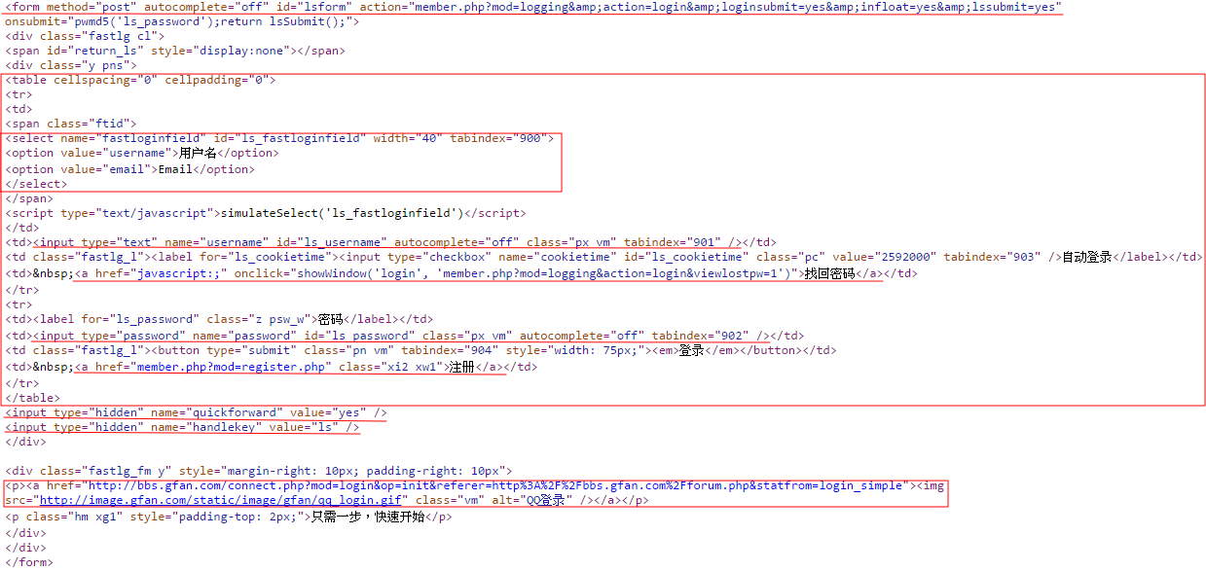

參考網址 : 機鋒論壇<http://bbs.gfan.com/member.php?mod=register.php>

