A dynamic adaptive search algorithm for CoSpace Rescue robot

Li Chengbo
Dalian Free Trade Zone No.1 High School
Dalian, China
e-mail: lichengbo518@163.com
Huang Zixi
Shenzhen Middle School
Shenzhen, China
e-mail: 1138193387@qq.com
Han Xinyu
Advanced Robotics and Intelligent Control Centre Singapore Polytechnic
Dover Road, Singapore
e-mail: hanxinyunus@gmail.com

Wang Xiaoming
Key Laboratory of Modern Teaching Technology Ministry of Education
Xi’an, China
e-mail: wangxm@snnu.edu.cn
Pang Guangyao
School of Data Science and Software Engineering
Wuzhou University
Wuzhou, China
e-mail: pangguangyao@gmail.com
Lin Yaguang
Key Laboratory of Modern Teaching Technology Ministry of Education
Xi’an, China
e-mail: light@snnu.edu.cn

Abstract—The application of robots to assist humans in earthquake rescue has always been an important topic that researchers are constantly studying. CoSpace Rescue is an abstract modeling and simulation of earthquake rescue and a simulation platform for studying robot rescue search algorithms. Its mathematical model is a multi-objective optimization problem. In this paper, we propose a search algorithm design framework for the CoSpace Rescue robot. Based On this framework and the idea of the heuristic search algorithm, we design and implement the "Multi-objective Optimal Dynamic Adaptive On-Demand Search Algorithm". The results of the experiment show that the algorithm can dynamically adapt to the changes in the environment and significantly improve the search efficiency of the rescue robot.
Keywords- Robot; Robot Recuse; Search Algorithm; CoSpace Rescue; RoboCup

Introduction
CoSpace Rescue [1] is an abstract modeling and simulation of earthquake rescue activities and is one of the most popular competitions in the RoboCup and RoboCup Asia-Pacific (RCAP). CoSpace Rescue is a platform for robot education, competition, and research based on a combination of real and virtual technology, designed to study the control and search algorithms for rescue robots.
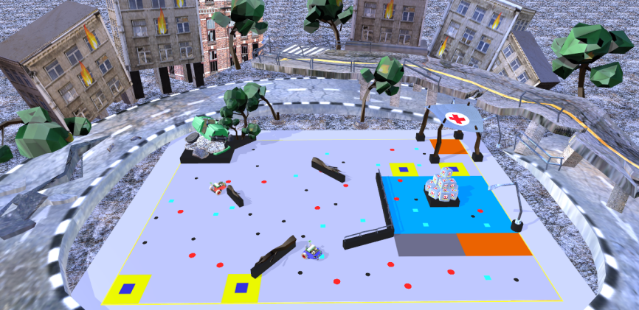
- CoSpace Rescue U19/University
Current studies mainly focus on the auxiliary aspects of CoSpace Rescue for computer and robot education, as well as how to improve students' programming ability, computational thinking, and innovation ability [2] [3] [4].
However, there is very little research on the search algorithm for CoSpace Rescue. Therefore, the research of this paper is meaningful.
In this paper, we not only propose the search algorithm design framework for the CSR robot, but also design and implement the Multi-objective Optimal Dynamic Adaptive On-demand Search Algorithm(MODAOSA) according to this framework. The "Modaosa" allows the CSR robot to make decisions according to the requirements of the current optimal decision and select the area to be searched.

Related Works
The object of this paper is to study the search algorithm of a single autonomous mobile rescue robot in an environment with partially known information.
The search algorithm primarily solves the problem of deciding the next targeted search area, i.e., where the rescue robot should go next to search for objects. Search algorithms include traditional search algorithms and modern search algorithms. Traditional search algorithms applied to mobile robots searching for rescue targets include exhaustive search algorithm, lawnmower search algorithm, and random search algorithm [5] [6]. Modern search algorithms applied to mobile robots searching for rescuing targets include Hill Climbing Algorithm [7]Error: Reference source not found, Tabu List Algorithm [8]Error: Reference source not found, Simulated Annealing Algorithm [9], and Genetic Algorithm [10] [11].
In the CoSpace Rescue U19/University arena, different types of objects are randomly distributed in specified zones. Therefore, the information of the distribution zones is known, but the objects within each zone are randomly distributed and their exact location information is unknown. The CSR robot needs not only to search and locate as many target objects as possible but also to obtain the maximum possible value.
Algorithms such as exhaustive search algorithm and random search algorithm are simple to apply, but they fail to make full use of known information and are therefore inefficient. Hill Climbing algorithm, Tabu List algorithm, Simulated Annealing algorithm, and Genetic algorithm are good heuristic methods, but some of their key parameters are relatively complicated to set and therefore the algorithms take a long time to run. None of these algorithms is suitable for the CoSpace Rescue environment where partial information is known.
Given the partially known environment of CoSpace Rescue, we propose the "Modaosa" based on the core idea of the heuristic search algorithm. The algorithm utilizes known environmental information to guide the CSR robot to the optimal object clustering zone that can meet its current demand.

Problem description
The mission of the CSR robot is to search for multiple randomly distributed objects of varying value and deposit them in the given object collection boxes within a limited time. Red, cyan, and black objects were randomly distributed in the rescue environment. Each red object is worth 10, each cyan is worth 15, and each black is worth 20. The CSR robot scores the corresponding point for successfully loading an object and depositing an object. The loading capacity of the CSR robot is 6 objects, i.e., the CSR robot cannot load more objects when it has already loaded 6 objects, and it needs to deposit the objects in the given object collection boxes before it can continue to load objects. In addition, when the CSR robot deposits a set or two sets of objects containing three colors (combined objects, RCBXXX or RRCCBB), a Super object or Super⁺ object will be randomly generated in the field. A successful deposit containing at least one of each of red, cyan, and black objects will generate a random Super object worth 90, and a successful deposit containing 2 red, cyan, and black objects will generate a random Super⁺ object worth 180.
The mission objective of the CSR robot is to search and deposit as many objects as possible in a limited time. This problem needs to consider not only the spatial-temporal distribution of the objects but also the type and value of the objects. Thus, the rescue mission of CoSpace Rescue U19/University is a multi-objective optimization problem, and the multi-objective optimization problem is a complex NP-hard problem that is difficult to solve.
In addition to all kinds of objects in the rescue environment, there are obstacles, traps, swampland, borders, signal block zones, special zones, and so on. All of these environmental factors create difficulties and challenges for the CSR robot to complete the rescue mission.
Building a mathematical model can help to better analyze and study this problem. Let the set O represent the type of object, then O={red, cyan, black, Super, Super⁺}.
Let represent the number of objects of type i loaded by the CSR robot at time t, and T represent the duration of rescue activities. The constraint conditions of multi-objective optimization for the CSR robot are shown in (1) :
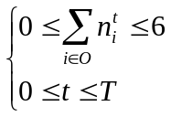 (1)
Let 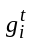 represent the score of object of type i collected by the CSR robot at time t, and let 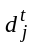 represent the score of object of type j deposited by the CSR robot at time t. Then, the scores obtained by the CSR robot up to moment T is:
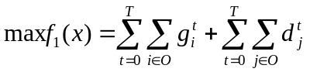 (2)
Set a_{t} to indicate whether the CSR robot performs the avoidance action at time t, a_{t}=0 indicates that the action is not executed, and a_{t}=1 indicates that the action is executed. Therefore, the optimization goal of collision avoidance can be expressed by (3).
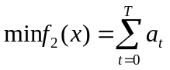 (3)
Let p_{t} represent the position of the CSR robot at time t, and 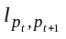represent the moving distance of the CSR robot from time t to time t+1. Therefore, the moving length optimization goal of the CSR robot can be expressed by (4).
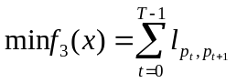 (4)
In summary, we can derive the multi-objective search optimization function.
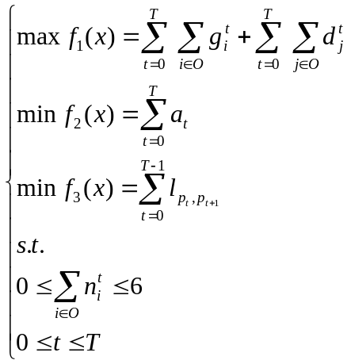 (5)
According to (5), increasing the income of the CSR robot in each unit time can improve the income of the whole rescue process. The ways to improve the income per unit time are as follows: first, reduce the consumption of invalid time as much as possible and spend more time searching and depositing objects as much as possible; second, search and deposit high-value objects as many as possible.

System models
In the rescue environment, the autonomous mobile CSR robot must complete the following tasks: avoid obstacles, traps, borders, swampland, decide where to search in the next time slot, and whether to search for objects or search the object collection boxes. Based on the design principles of the search algorithm, this paper designs the search algorithm design framework for the CSR robot, as shown in the following Fig. 2.
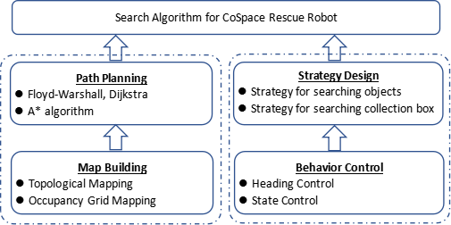
- the search algorithm design framework for CSR robot
- Map Building: to solve the problem of how to digitize the rescue environment information. There are two common ways to digitize environmental information: topological mappingError: Reference source not found [12] and occupancy grid mapping Error: Reference source not found [13].
- Path Planning: to solve the problem of planning the CSR robot's path to the pending search zones. Many algorithms are dedicated to calculating the shortest path, including Floyd algorithm, Dijkstra's algorithm, Bellman-Ford's algorithm, A* algorithm. All of these algorithms can calculate a feasible path from the start point to the target point with the shortest distance.
- Behavior Control: to solve the problem of how to control the CSR robot to move along the path and how to control the CSR robot to search for objects in the pending search zones. In this paper, for the CSR robot, we use the Line-of-Sight algorithm as its guidance law Error: Reference source not found[14], PID algorithm to control its heading Error: Reference source not found[15], and Finite Automata to control its task state [16].
- Strategy Design: to solve the problem of how to select the CSR robot's pending search zones.

The proposed algorithm
Heuristic search algorithm evaluates each pending search zones in terms of the known information, chooses the optimal search zone, and searches the zone until the target is reached.
Since CoSpace Rescue U19/University is a multi-objective optimal problem and the search environment is dynamic, we propose the Multi-objective Optimal Dynamic Adaptive On-demand Search Algorithm (MODAOSA) based on the idea of the heuristic search algorithm. The core idea of this algorithm is that this algorithm makes full use of the known environmental information to reduce the frequency of ineffective actions and maximize the time spent on searching objects and object collection boxes.
This algorithm records and updates the environmental information promptly and implements a multi-objective optimal method to make decisions based on the environmental information and robot's current state.

Strategy Design
Assuming that the red, cyan, and black objects are in sufficient quantity and evenly distributed in the arena, and the time consumption for searching every object to be the same. The robot performs two round searches, using the strategy of searching any object (strategy I) and the strategy of combining objects (strategy II), respectively. The scores are shown in the following table:
- Use strategy I to search for objects
limit | round | action | objects | scores | total
minimum | 1st | load | RRRRRR | 60 | 140
minimum | 1st | deposit | RRRRRR | 60 | 140
minimum | 2nd | load | R | 10 | 140
minimum | 2nd | deposit | R | 10 | 140
maximum | 1st | load | BBBBBB | 120 | 280
maximum | 1st | deposit | BBBBBB | 120 | 280
maximum | 2nd | load | B | 20 | 280
maximum | 2nd | deposit | B | 20 | 280
- Use strategy II to search for objects
limit | round | action | objects | scores | total
minimum | 1st | load | RCBRRR | 75 | 330
minimum | 1st | deposit | RCBRRR | 75 | 330
minimum | 2nd | load | Super | 90 | 330
minimum | 2nd | deposit | Super | 90 | 330
maximum | 1st | load | RCBRCB | 90 | 540
maximum | 1st | deposit | RCBRCB | 90 | 540
maximum | 2nd | load | Super⁺ | 180 | 540
maximum | 2nd | deposit | Super⁺ | 180 | 540
As can be seen from the above table, the score of strategy I is [140, 280], and that of strategy II is [330, 540]. The score of strategy II is 1.18 to 3.86 times higher than strategy I. Therefore, searching for combined objects is the superior search strategy that achieves higher scores.

Algorithm Design
The CSR robot dynamically decides the optimal pending search zone according to the distribution of objects in the field and the type and quantity of objects loaded on the CSR robot. Then, the CSR robot plans the optimal path via the shortest path algorithm and navigates to the pending search zone. The dynamic adaptive on-demand search strategy is designed as follows:

Strategy for searching object
- Common Object: The algorithm employs a strategy that combines the LOS navigation algorithm and random search algorithm. It determines the optimal pending search zone based on the number and type of objects loaded in the CSR robot and the number and type of objects required to form combined objects. When the CSR robot arrives at the pending search zone, it implements the "Random Search Algorithm" to continue searching in the zone until it finds the target object that meets the current demand for combined objects or exceeds the search time limit and leaves for the next optimal object clustering zone. The search time limits in an object clustering zone is proportional to its size.
- Super Object: The algorithm implements the LOS navigation algorithm to search for the super object along the shortest path.

Strategy for searching object collection box
- When the CSR robot is fully loaded or loads a super object, the algorithm implements the LOS navigation algorithm to search for an object collection box along the shortest path.

Optimal Object Clustering Zone Selection
Since the types and quantities of the objects in each object clustering zone are different, the CSR robot will obtain different results when the pending search zone differs. The heuristic function evaluates the supply capacity of each object clustering zone to the CSR robot as the criteria for deciding the pending search zone. The heuristic function is designed as follows:
Let the supply capacity of each object clustering zone comprises availability score, quantity score, and distance score, defined as follows:
Availability Score: i.e., whether the object clustering zone is available. The value is 1 if the object clustering zone is available and 0 if the object clustering zone is unavailable. An object clustering zone is available means that the type of object in the object clustering zone is the type that the loaded object is missing for constituting combined objects, otherwise, it is unavailable. Let 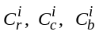denote whether the object clustering zone 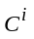contains red, cyan, and black objects respectively, and the value of 1 indicates that the object clustering zone contains that particular type of an object and 0 indicates it does not. Let n_{r}, n_{c}, n_{b} denote the number of red objects, cyan objects, and black objects loaded by the CSR robot respectively. The availability Y_{i} is calculated as shown in the following equation.
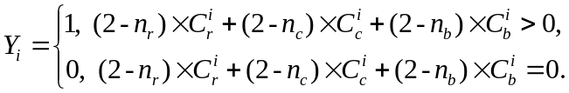 (6)
Quantity Score N_{i}: When the CSR robot enters an object clustering zone and keeps searching, if the CSR robot can find the type and quantity of objects required to form combined objects, the quantity score of the object clustering zone remains unchanged; if the CSR robot finds the desired object but the quantity is insufficient, the quantity score is reduced by 1; if the CSR robot does not find the desired object, the quantity score is reduced by 2. Let n_{get} denote the number of objects successfully loaded in the object clustering zone from the time the CSR robot enters the object clustering zone to the time it leaves; let t denote the type of object contained in the object clustering zone, and the seven types of object combination are respectively r=1, c=2, b=3, rc=4, rb=5, cb=6, rcb=7; let n_{t} denote the number of type t objects loaded when the CSR robot leaves the object clustering zone. The supply score N_{i} is calculated as shown in the following equation.
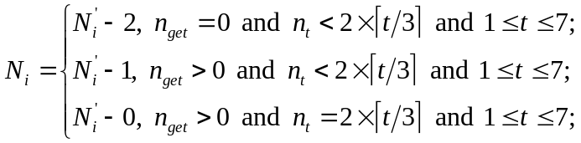 (6)
Distance Score L_{i}: The path length from the center of the pending object clustering zone to the CSR robot's current location, which is calculated by the shortest path algorithm. Assume that the path contains n waypoints, and the distance between waypoint k and its adjacent next waypoint is l[k][k+1].
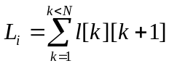 (7)
The optimal pending object clustering zone is selected according to the priority order of availability score, quantity score, and distance score of each object clustering zone. The algorithm for selecting the optimal pending object clustering zone is shown below:

Algorithm I: Select the optimal pending object clustering zone

Input：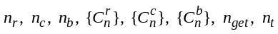
Output: s
1
2 for each 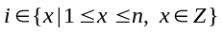:
3 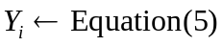
4 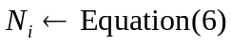
5 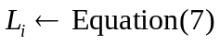;
6 if 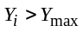 then: ;
7 else if 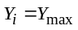 and 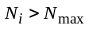 then:
8 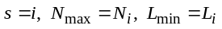;
9 else if and 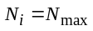 and 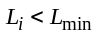 then:
10 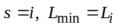;
11 end for
12 return s ;

Algorithm Implementation
We design the finite automata M = (S, Σ, δ, S₀, F) to describe the "MODAOSA", as shown below.

The set of finite states Si S is defined as follows:
- S₀ (start): i.e., start state; when t=0, the CSR robot performs the task of initializing the parameters.
- S₁ (decision): i.e., decision state, in which the CSR robot selects the target zone according to Algorithm I and calculates the shortest path from the current location to the target zone.
- S₂ (followPath): i.e., following the path state, in which the CSR robot follows the planned path.
- S₃ (searchCluster): i.e., search object clustering zone state, in which the CSR robot continues to search for objects in an object clustering zone.
- S₄ (goToBox): i.e., the search object collection box state, in which the CSR robot performs the task of searching for an object collection box.
- S₅ (deposit): i.e., the deposit state, in which the CSR robot performs the task of moving to the object collection box.
- S₆ (wait): i.e., wait state, in which the CSR robot's left and right wheel speed are set to 0 and it waits for the current task to be completed
- S₇ (goToSuper): i.e., search super object state, in which the CSR robot performs the task of searching for the super object.
- S₈ (end): i.e., the end state, in which the CSR robot stops searching.

The set of input data ci Σ is defined as follows:
- c₁: time>0, the start of the rescue mission.
- c₂: after completing the selection of the optimal pending search zone and calculation of the shortest path.
- c₃: the CSR robot moves to the target zone.
- c₄: the CSR robot's left color sensor or right color sensor detects an object.
- c₅: waiting for the remaining time to be 0.
- c₆: the CSR robot is fully loaded or has insufficient time left for the rescue mission.
- c₇: the CSR robot's left color sensor or right color sensor detects an object collection box.
- c₈: both the CSR robot's left and right color sensors detect an object collection box.
- c₉: the number of the super object in the field is greater than 0.
- c₁₀: the CSR robot detects Super or Super⁺ object.
- c₁₁: when time>T, i.e., the rescue time is exhausted.

The transition function δ is shown in the following table:
- Transition Function δ of M
S_{i}\C_{i} | c₁ | c₂ | c₃ | c₄ | c₅ | c₆ | c₇ | c₈ | c₉ | c₁₀ | c₁₁
S₀ | S₁
S₁ |  | S₂ |  |  |  |  |  |  |  |  | S₈
S₂ |  |  | S₃ |  |  |  |  |  |  |  | S₈
S₃ |  |  |  | S₆ |  |  |  |  | S₇ |  | S₈
S₄ |  |  |  |  |  |  | S₅ |  |  |  | S₈
S₅ |  |  |  |  |  |  |  | S₆ |  |  | S₈
S₆ |  |  |  |  | S₁ |  |  |  |  |  | S₈
S₇ |  |  |  |  |  |  |  |  |  | S₆ | S₈
S₈
The initial state is S₀, and the final state is S₈.
Consequently, the “MODAOSA” is designed as follows:
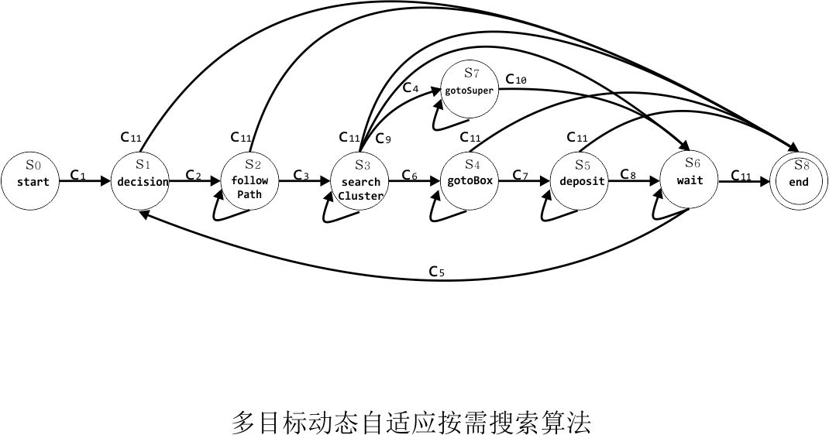
- MODAOSA: M

Experiments

Algorithm Evaluation
The indicators for evaluating the search algorithm are designed as follows:
- Total scores s: i.e., the total scores of loading objects and successfully depositing objects in the specified time frame. Higher total scores lead to better algorithm performance.
- Average one round search time t: the average one round search time is the time from when the CSR robot is empty to when it is fully loaded and successfully deposits the objects. The average one-round search time is the average of all search round from the start to the end of the task. A shorter average one-round search time indicates a more efficient algorithm.
- Total number of depositing super objects α: i.e., the total number of super objects successfully deposited by the CSR robot within the specified time frame. A greater total number of depositing super objects leads to higher efficiency and better performance of the algorithm.
- Total number of avoidance β: the sum of the number of times the CSR robot avoids obstacles, traps, borders, and swampland. Greater total number of avoidance indicates that the CSR robot makes more invalid actions and wastes more time. Conversely, a smaller total number of avoidance indicates a more efficient algorithm.
- Search coverage rate θ: i.e., the ratio of the area searched by the CSR robot to the total area of all object clustering zones. A higher search coverage rate indicates fewer missed objects and better performance of the algorithm.

Simulation setup
We selected four types of scenarios, including environment with few obstacles, environment with many obstacles, environment with dispersed objects distribution, and environment with clustered objects distribution, to evaluate the performance of the following algorithms.

Random Walk Search Algorithm
The Random Walk Search Algorithm (RWSA) is an improvement of the random algorithm. When running the RWSA algorithm, the rescue robot does not need to plan a path, but only needs to move forward. When it detects an obstacle or a dangerous area, it performs an avoidance action.

The Shortest Loop Search Algorithm
The Shortest Loop Search Algorithm (SLSA) is based on the core idea of exhaustive search algorithm to search each object clustering zone in turn. The shortest loop is the shortest path that extends from a certain zone, passes through all the objects zones on the field, and returns to the starting zone. The shortest loop can be calculated through the DFS algorithm. When running SLSA, the shortest loop only needs to be calculated once and remains unchanged throughout the rescue process.

MODAOSA
The proposed “MODAOSA” is a heuristic search algorithm that makes full use of the known environmental information and dynamically records and updates the environmental information.

Experiment Data and Analysis
We ran RWSA, SLSA, and MODAOSA several times in each environment for 6 minutes. The average values of the five evaluation indicators of the three algorithms were calculated as follows.

Environment with few obstacles
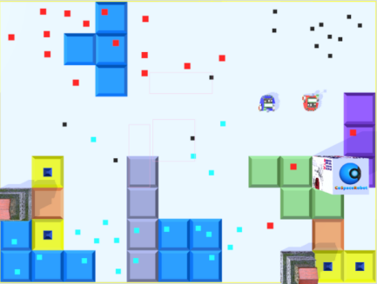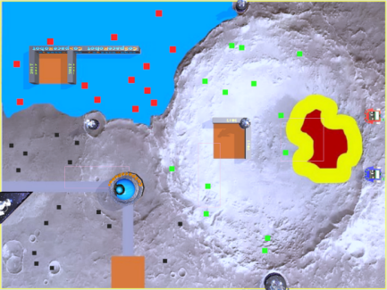
- Environment with few obstacles M1, M2
Environment M1 and M2 have simple terrain with few obstacles, and the CSR robot is subjected to less resistance when performing the search mission. The experimental data are shown in Table II:
- Performance comparison in M1 and M2
Indicators | RWSA | SLSA | MODAOSA
s | 830 | 1460 | 2890
t | 158 | 83 | 38
α | 1 | 2 | 7
β | 50 | 20 | 5
θ | 1.0 | 1.0 | 1.0

Environment with many obstacles
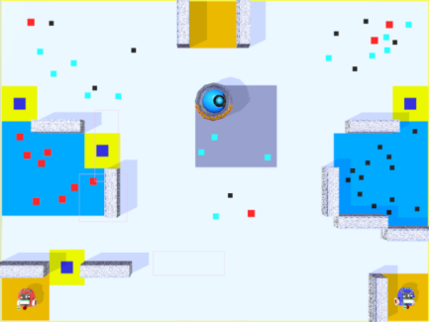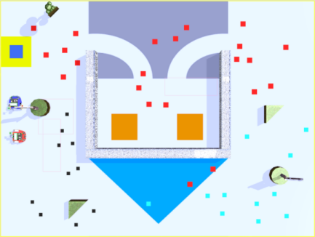
- Environment with many obstacles M3, M4
Environments M3 and M4 have complex terrain with many obstacles, and the CSR robot is subjected to more resistance when performing the search mission. The experimental data are shown in Table III:
- Performance comparison in M3 and M4
Indicators | RWSA | SLSA | MODAOSA
s | 560 | 1250 | 2580
t | 127 | 93 | 41
α | 0 | 3 | 6
β | 55 | 26 | 8
θ | 0.6 | 1.0 | 1.0

Environment with concentrated object distribution
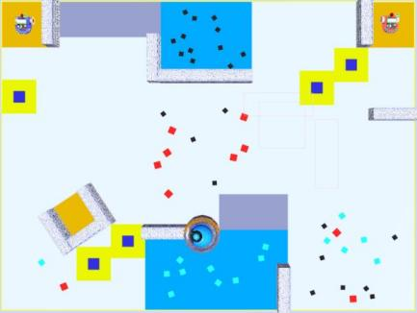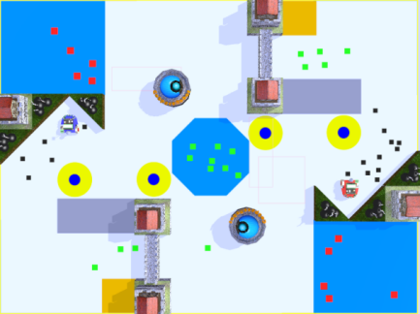
- Environment with concentrated object distribution M5, M6
In environments M5 and M6, objects are distributed in a clustered manner, and the object clustering zones are clearly delineated, and the CSR robot can search for combined objects more easily. The experimental data are shown in Table IV.
- Performance comparison in M5 and M6
Indicators | RWSA | SLSA | MODAOSA
s | 680 | 1890 | 3850
t | 180 | 88 | 35
α | 0 | 3 | 9
β | 45 | 12 | 3
θ | 0.6 | 1.0 | 1.0

Environment with dispersed object distribution
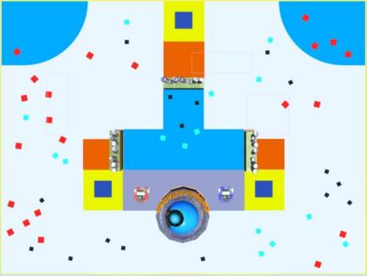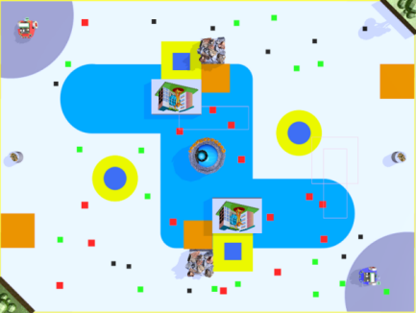
- Environment with dispersed object distribution M7, M8
In environments M7 and M8, objects are distributed in a dispersed manner, and the object clustering zones are vaguely delineated, and the CSR robot can search for combined objects more difficultly. The experimental data are shown in Table V.
- Performance comparison in M7 and M8
Indicators | RWSA | SLSA | MODAOSA
s | 1050 | 1690 | 3560
t | 145 | 95 | 40
α | 1 | 3 | 9
β | 30 | 14 | 3
θ | 1.0 | 1.0 | 1.0
RWSA is simple to implement, but because of the aimless searching, it may not always find the target and may be caught in a local dead loop.
SLLA Searching for objects and object collection box along the shortest loop reduces unnecessary time consumption and maximizes the number of objects to be searched.
Through the analysis of the experimental data, we can conclude that the heuristic search algorithm "MODAOSA" achieves better results in all five indicators than "RWSA" and "SLSA", and is more suitable for the search task of CoSpace Rescue U19/University. The performance comparison of the three algorithms is shown in the following table:
- Performance comparison of three algorithms
Algorithm Name | RWSA | SLSA | MODAOSA
Algorithm Category | Random Search | Exhaustive Search | Heuristic Search  Algorithm
Mapping | None | Topological Mapping | Topological Mapping  Occupancy Grid Mapping
Decision Strategy | Random | Static | Dynamic adaptive
Path Planning | None | Backtracking | A* algorithm
Adaptiveness | Low | Medium | High

Conclusion
In this paper, we design and implement "MODAOSA" and compare this algorithm with random search algorithm and exhaustive search algorithm. The experimental results show that the "MODAOSA" can dynamically adapt to the changes of the environment and has the best performance. Our teams applied this algorithm and achieved outstanding results in CoSpace Rescue U19: team “ChuanQi” won second place in the 2019 RCAP, team “Invictus” won the championship in 2020 VRCAP, and team “ChocoTaco” won the championship in the RCAP Tianjin International tournament 2021. Besides disaster rescue, this algorithm can shed light on logistics scheduling and multi-source information collection problems. At present, we are using human-assisted mapping. In the future, we are going to plan to design and implement an intelligent search algorithm that enables the CSR robot to collect data, build maps, and self-learning, expecting to further improve the intelligence and the adaptability of the search algorithm.

Acknowledgment
We acknowledge the Key Laboratory of Modern Teaching Technology of the Ministry of Education for funding the open project. We acknowledge the organizing committee of the RoboCup Asia-Pacific for their support and assistance.

References
- RoboCup (Singapore) Association. “CoSpace Robot Simulator.” CoSpace Robot, cospacerobot.org/about/cospace-robot-simulator-progamming. Accessed 10 Sept. 2021.
- Eguchi, A. , C. Zhou , and J. Shen . "Integrating Simulation Game with Educational Robotics - Introducing CoSpace Educational Robotics." Titlesociety for Information Technology & Teacher Education International Conference 2011.
- Eguchi, A. , and J. Shen . "Student Learning Experience through CoSpace Educational Robotics: 3D Simulation Educational Robotics Tool." Cases Ond Technology Application & Integration in Education (2013). Crossref, doi:10.4018/978-1-4666-2815-1.ch005
- Hughes, J. . "Robotic rescue simulation for computing teaching in the UK: A case study." 2016 IEEE Global Engineering Education Conference (EDUCON) IEEE, 2016.
- Konstantinov, S. V., et al. “Comparative Research of Random Search Algorithms and Evolutionary Algorithms for the Optimal Control Problem of the Mobile Robot.” Procedia Computer Science, vol. 150, 2019, pp. 462–70. Crossref, doi:10.1016/j.procs.2019.02.080.
- Pang, Bao, et al. “Effect of Random Walk Methods on Searching Efficiency in Swarm Robots for Area Exploration.” Applied Intelligence, vol. 51, no. 7, 2021, pp. 5189–99. Crossref, doi:10.1007/s10489-020-02060-0.
- Sivakumar, R., and H. Mangalam. “Ensemble Hill Climbing Optimization in Adaptive Cruise Control for Safe Automated Vehicle Transportation.” The Journal of Supercomputing, vol. 76, no. 8, 2019, pp. 5780–800. Crossref, doi:10.1007/s11227-019-02994-4.
- Camacho-Vallejo, José-Fernando, et al. “A Tabu Search Algorithm to Solve a Green Logistics Bi-Objective Bi-Level Problem.” Annals of Operations Research, 2021. Crossref, doi:10.1007/s10479-021-04195-w.
- Huo, Lisu, et al. “A Novel Simulated Annealing Based Strategy for Balanced UAV Task Assignment and Path Planning.” Sensors, vol. 20, no. 17, 2020, p. 4769. Crossref, doi:10.3390/s20174769.
- Pehlivanoglu, Y. Volkan, and Perihan Pehlivanoglu. “An Enhanced Genetic Algorithm for Path Planning of Autonomous UAV in Target Coverage Problems.” Applied Soft Computing, vol. 112, 2021, p. 107796. Crossref, doi:10.1016/j.asoc.2021.107796.
- Xin, Junfeng, et al. “An Improved Genetic Algorithm for Path-Planning of Unmanned Surface Vehicle.” Sensors, vol. 19, no. 11, 2019, p. 2640. Crossref, doi:10.3390/s19112640.
- Xue, W. , et al. "SLAM Based Topological Mapping and Navigation." 2020 IEEE/ION Position, Location and Navigation Symposium (PLANS) IEEE, 2020.
- Tabatabaeipour, Morteza, et al. “Application of Ultrasonic Guided Waves to Robotic Occupancy Grid Mapping.” Mechanical Systems and Signal Processing, vol. 163, 2022, p. 108151. Crossref, doi:10.1016/j.ymssp.2021.108151.
- Rout, Raja, et al. “Modified Line-of-Sight Guidance Law With Adaptive Neural Network Control of Underactuated Marine Vehicles With State and Input Constraints.” IEEE Transactions on Control Systems Technology, vol. 28, no. 5, 2020, pp. 1902–14. Crossref, doi:10.1109/tcst.2020.2998798.
- Shi, Liwei, et al. “A Fuzzy PID Algorithm for a Novel Miniature Spherical Robots with Three-Dimensional Underwater Motion Control.” Journal of Bionic Engineering, vol. 17, no. 5, 2020, pp. 959–69. Crossref, doi:10.1007/s42235-020-0087-3.
- Shuai, Yin, and A. S. Yuschenko. “Dialogue System of Controlling Robot Based on the Theory of Finite-State Automata.” Mekhatronika, Avtomatizatsiya, Upravlenie, vol. 20, no. 11, 2019, pp. 686–95. Crossref, doi:10.17587/mau.20.686-695.

Authors’ background

Your Name | Title* | Research Field | Personal website
Li Chengbo | master | Robot rescue,  algorithm design
Wang Xiaoming | full professor | Internet of Things,  social computing,  artificial intelligence | http://ccs.snnu.edu.cn/info/1018/1035.htm
Huang ZiXi | high school student | Robot rescue,  algorithm design
Han Xinyu | master student | Robot rescue,
Pang Guangyao | Phd | Internet of Things,  social computing,  artificial intelligence
Lin Yaguang | Phd | Internet of Things,  social computing,  information diffusion | http://ccs.snnu.edu.cn/info/1201/9714.htm
*This form helps us to understand your paper better, the form itself will not be published.

*Title can be chosen from: master student, Phd candidate, assistant professor, lecturer, senior lecture, associate professor, full professor

