crypto++

下载：
https://github.com/weidai11/cryptopp

或

https://www.cryptopp.com/

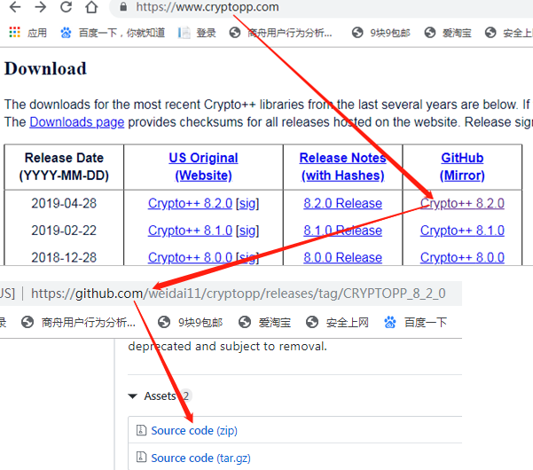

VS2013 + Crypto++8.2.0
error : Element <EnableEnhancedInstructionSet> has an invalid value of "AdvancedVectorExtensions2".

VS2013 + Crypto++5.6.5

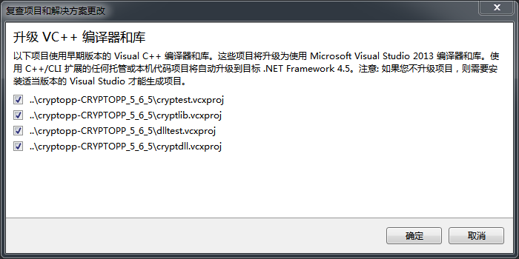
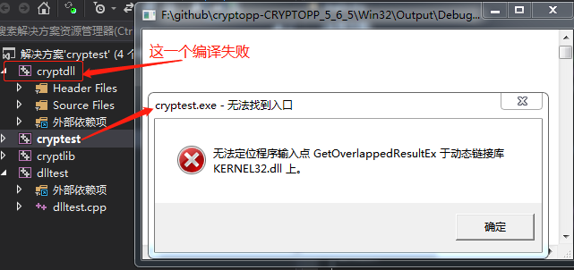

VS2013 + Crypto++6.0.0
编译报错情况如上，但cryptest Release版可以正常运行

VS2017 + Git下最新版本
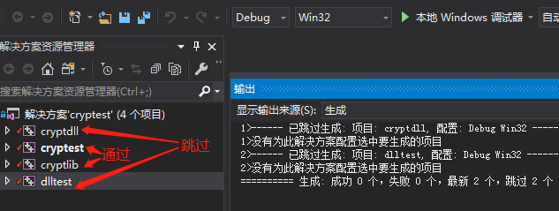

https://blog.csdn.net/qq_26341675/article/details/79448754
https://www.cnblogs.com/findumars/p/6009249.html
http://www.metsky.com/archives/584.html
https://www.topomel.com/archives/282.html

